**Heat Measurement, Heat Transfer, Speed Calculation, Data Conversion and Data Management in Quantum and DNA Computing**

**Part 1**

**Overview about Heat calculation and Speed calculation**

Our main objective is to provide information for calculating heat and speed in different types of computation including DNA and Quantum computation system.

The importance of heat calculation cannot be described in limited words. Depending on the produced heat from DNA operational circuit, Quantum operational circuit, DNA-Quantum operational circuit, Quantum-DNA operational circuit, multivalued DNA operational circuit, multivalued Quantum operational circuit, multivalued DNA-Quantum operational circuit and multivalued Quantum-DNA operational circuit, one can identify the useful one for daily life or for research. In addition, produced heat or required heat for quantum computing and DNA computing is an arresting matter for researchers. In chapter one, we are describing the procedure for calculating heat from mentioned operational circuits. In case of calculating heat from Quantum operational circuits, we have used thermodynamics law and its theory for capturing the produced heat of each quantum qubit. The produced heat from a circuit is proportional to the number of quantum qubits used in the circuit. In DNA operational circuit we need a certain amount of heat to perform any computing operation. It performs on some specific steps as synthesizing, mixing, annealing, melting, amplifying, separating, extracting, cutting, ligating, subtracting, marking DNA sequence, destroying, detecting and reading DNA sequence. According to research of Zheng and Yang we got that, each specific steps of DNA computation needs different amounts of heat and it never exceeds 98 degree celsius. The melting step requires heat which depends on its sequence where, number of adenines, guanine, cytosine, and thymine molecule is considered.

Besides accuracy of a system, speed is a metric which can be used to measure the performance of a system. The main objectives of third chapter are to calculate the operational speed of DNA operational circuit, Quantum operational circuit, DNA-Quantum operational circuit, Quantum-DNA operational circuit, multivalued DNA operational circuit, multivalued Quantum operational circuit, multivalued DNA-Quantum operational circuit and multivalued Quantum-DNA operational circuits. According to mass research, researchers converged at an opinion or convention that single qubit need one microsecond to perform its operation and double qubit needs ten microseconds to perform its assigned operation. In quantum operational circuits, we have only three basic quantum operational gate as NOT, C-NOT, v+ and v, which needs one or two quantum qubits for completion of its task. By using these quantum operational gates and number of qubits, chapter three calculated the operational speed of complex quantum circuits. In calculating speed of DNA operational gate, the provided information of Zheng and yang’s research is followed. According to their research, a particular DNA operational gate (AND, OR, NOT, NAND, NOR, XOR and XNOR etc.) needs more or less 2 hours to perform. Thus, we can combine these findings in case of speed calculation of DNA-quantum operational circuits.

Table of Contents

Chapter I 8

Heat Calculation 8

1.1 Introduction 8

1.2 Basic Definitions for Heat calculation in Quantum circuit 10

1.3 Heat Calculation for Quantum Operational circuit 15

1.4 Basic Definitions for Heat calculation in DNA circuit 19

1.5 Heat Calculation in DNA Circuit 29

1.6 Heat calculation in Multivalued Quantum Circuit 36

1.7 Heat calculation in Multivalued DNA Circuit 43

1.8 Heat calculation in Quantum-DNA Circuit 48

1.9 Heat calculation in DNA-Quantum Circuit 52

1.10 Heat calculation in Multivalued Quantum-DNA Circuit 56

1.11 Heat calculation in Multivalued DNA-Quantum Circuit 60

1.12 Applications 64

1.13 Summary 66

Reference 67

Chapter III 68

Speed Calculation 68

2.1 Introduction 68

2.2 Speed Calculation for Quantum Operation 69

2.2 Speed Calculation in Quantum Operational Circuit 76

2.3 Speed Calculation for DNA operation 80

2.4 Speed Calculation in DNA Operational Circuit 81

2.5 Speed Calculation in Multivalued Quantum Circuit 87

2.6 Speed Calculation in Multivalued DNA Circuit 101

2.7 Speed Calculation in Quantum-DNA Circuit 105

3.8 Speed Calculation in DNA-Quantum Circuit 117

2.9 Speed Calculation in Multivalued Quantum-DNA Circuit 125

2.10 Speed Calculation in Multivalued DNA-Quantum Circuit 136

3.11 Applications 139

3. 12 Summary 141

Reference: 142

Chapter II 146

Heat Transfer 146

2.1 Introduction 146

2.2 Basic Definitions 148

2.3 Heat Transfer in Quantum-DNA Circuits 155

2.4 Heat Transfer in Multi-valued Quantum-DNA Circuits 161

2.5 Applications 167

2.6 Summary 169

References: 170

Chapter IV 171

Data Conversion 171

4.1 Introduction 171

4.2 Data Conversion in Quantum-DNA Circuits 173

4.3 Data Conversion in DNA-Quantum Circuits 202

4.4 Summary 245

Reference: 246

Chapter V 247

Data Management 247

5.1 Introduction 247

5.2 Basic Definition 248

5.3 Data management in Quantum-DNA circuits 252

5.4 Data management in DNA-Quantum circuits 264

5.5 Applications 274

5.6 Summary 276

Reference: 277

**List of Figures**

**List of Tables**

Preface

Acknowledgements

Acronyms

# Chapter I

## Heat Calculation

### **1.1 Introduction**

Quantum computing is a field of study that focuses on the creation of computer-based technologies based on quantum theoretical principles. On the quantum (atomic and subatomic) level, quantum theory describes the nature and behavior of energy and matter. To execute certain computational tasks, quantum computing employs a combination of qubits. All of this is done at a far higher rate than their traditional computing equipment. Quantum computers represent a significant advancement in computing capability, with enormous performance benefits for specific use cases. The ability of bits to be in several states at the same time gives the quantum computer a lot of computing capability. They can accomplish jobs with a mix of | 1 >, | 0 >, and both | 1 > and | 0 > at the same time. So, quantum computing can be defined as an area of computing which is focused on the development of computer technology based on the principles of quantum theory. In addition, quantum computing is much faster than classical bit-wise computing.

Quantum computers are frequently characterized as a revolutionary invention that will influence the outcome of history. The rapid computing behavior of quantum computers is one of its primary advantages and capabilities. Quantum computers are extremely powerful and speedy. They can conduct calculations that today's supercomputers would take decades or perhaps millennia to complete. Quantum supremacy is a term used by specialists to describe this occurrence. This was only a theory for a long time. Google's quantum computer prototype, on the other hand, was able to do such a calculation and demonstrate quantum superiority in practice in 2019. Quantum computer calculations are especially promising for analyzing or simulating extremely complicated processes with large volumes of data. The quantum computation can be applied in cryptography, data analysis, task scheduling, predicting and forecasting, medical research and in artificial intelligence.

On the other hand, instead of using typical silicon chips, DNA computing uses biological molecules to do computations. The four-character genetic alphabet (A-adenine, G-guanine, C-cytosine, and T-thymine) is used in DNA computing instead of the binary alphabet (1 and 0) utilized by standard computers. This is possible due to the ability to create small DNA molecules with any arbitrary sequence. Input of any DNA operation can be represented by DNA molecules with specific sequences. The instructions are carried out by laboratory operations on the molecules, and the result is defined as some property of the final set of molecules. DNA computing promises significant and meaningful linkages between computers and life systems, as well as massively parallel computations. DNA computing can actually carry out millions of operations at the same time.

The key advantage of DNA computing over classical computing—and even quantum computing to some extent—is that it can do numerous calculations in parallel, as proved by Adleman's article. Parallel computing isn't a new concept; it's been used in traditional computing for decades. When two apps are running on a computer at the same time, they aren't actually operating concurrently; only one instruction is executed at any one time. So, if you're using a browser to listen to music while shopping online, the computer is actually employing something called context switching to give the appearance of concurrency. It executes a single program's instruction, saves the program's state after the instruction is completed, and then removes the program from active memory. It then loads the second program's previously saved state, executes the next instruction, saves the new state, and finally unloads it from active memory. The first program is then reloaded to carry out the following instruction, and so on. The appearance of concurrency is obtained by performing millions of incremental steps per second across multiple programs, although nothing is ever actually done in parallel. DNA computing is capable of performing these millions of processes in parallel. A single cubic centimeter can contain over 10 trillion DNA molecules. This cubic centimeter of particles could effectively do 10 trillion calculations at the same time and store up to 10 terabytes of information. In many ways, DNA computing is capable of much of the breathless but erroneous coverage that quantum computing receives.

Nanotechnology, combinatorial optimization, Boolean circuit construction, and scheduling are just a few of the disciplines where DNA computing can be used. In addition, DNA word sets problem, estimating Markov chains limits, estimating sequence complexity, traveling salesman problem, and molecular nanotechnology are also applied domains of DNA computing.

By observing quantum and DNA computing, we can find out advantages from both computation systems. To make some operation, we always need some circuit design, which can lead us towards some expected output.

Produced heat from a circuit is always an important topic for each type of computing circuit. Nowadays, produced heat or required heat for quantum computing and DNA computing is an arresting matter for researchers. This chapter is going to express some way to find out the amount of heat produced from a quantum computing circuit. And further, we will calculate the amount of required heat for DNA computation. As, different stages of a DNA computation operation need heat for a particular task.

### 1.2 **Basic Definitions for Heat calculation in Quantum circuit**

In this section, we are providing basic information and theory to calculate produced heat from quantum circuits and required heat to perform a DNA gate operation in quantum computation and DNA computation.

In quantum operation qubit is generating heat when they become isolated and start to computation. In quantum physics thermodynamics exists and the thermodynamics rule is quite the same for qubit also. When a quantum system is a single qubit then we can write Hamiltonian matrix as follows:

$H=\frac{-1}{2}€σ$ (1)

This may correspond to an electric spin in vertical magnetic field where $€$ is the energy difference between the states |↑> = |0> and |↓> = |1>. The same Hamilton matrix may also refer to a two=level atom where we identify its ground and excited states as |0> and |1>, respectively. The Gibbs state of the qubit takes the form

$ρ_{β}=\frac{1}{2cosh⁡\left(β\frac{€}{2}\right)}e^{β€\frac{σ}{2}}=\frac{1}{1+ e^{-β€} }\left(\left|0>0\right|+e^{-β€}\left|1>1\right|\right)$ (2)

Researcher have introduced the inverse temperature $β=$ 1 / KBT. Then the occupation number,

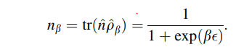

So, the average energy of thermal qubit,

$E=\frac{1}{1+exp\left(β€\right)},0<E<\frac{1}{2}€$ (3)

This we shall identify as the thermodynamic energy of the thermal qubit. We can calculate the von Neumann entropy of the Gibbs state according to, and with one eye on thermodynamics, we express the r.h.s. in terms of the energy E.

$S\left(E\right)=\frac{-€-E}{€}log\frac{€-E}{€}-\frac{E}{€}log\frac{E}{€},0<E<\frac{1}{2}€$

Then Sth Energy will, $S_{th}\left(E\right)=\left(k_{B}ln2\right)S\left(E\right)$

So, the entropy of a single thermal qubit is,

$$\frac{dS_{th}\left(E\right)}{dE}=\frac{1}{T}$$

And, the entropy for n thermal qubit is,

$\frac{dS_{th}\left(E\right)}{dE}=\frac{n}{T}$ (4)

We know that,

$$β=\frac{1}{K_{B}T}$$

Here 𝛃 is the inverse temperature and kb is Boltzmann constant and T is the room temperature initially.

=

= 39 ev-1

So, the average energy of thermal qubit, E = $\frac{1}{1±e^{39Xϵ}}$

= $\frac{1}{1±e^{39x0.9}}$

=5.7051 x 10-16

Here, is emissivity and this value will 0 to 1 respect to the molecule. We assume $ϵ$ = 0.9 for ideal purposes.

Now, according to Qubit Thermodynamics we get Sth energy as,

Sth (E) = (Kb ln 2) S(E)

= $-k_{B}\frac{ϵ-E}{ϵ}ln\frac{ϵ-E}{ϵ}-k_{B}\frac{E}{ϵ}ln\frac{E}{ϵ}$

= 1.9118 x 10-18  and Sth (E) is quantum mechanics qubit entropy.

Now, we are going to calculate heat produced by a quantum operation of “N” qubits. At first, we have to identify the number of qubits used in the operation. Then we calculate Sth (E, N) to use in equation (4). To calculate Sth (E, N), we have to use the following equation as:

Sth (E, N) = N (Kb ln 2) S(E/N)

= $-k_{B}\frac{ϵ-E/N}{ϵ}ln\frac{ϵ-E/N}{ϵ}-k_{B}\frac{E/N}{ϵ}ln\frac{E/N}{ϵ}$ (5)

Here, € = 0.9

E = 5.7051 x 10-16

N = Number of qubits in the operation

KB = Boltzmann constant, evT-1

Now, by using equation (3), (4) and (5), we can calculate produced heat from any quantum circuit. Some basic quantum operational circuit are described below for calculating produced heat, where N is the number of quantum qubit. Produced heat from CNOT, AND, OR, XOR, NAND, NOR and XOR operational quantum gate operation is calculated below using total number or quantum qubits.

1. **Quantum NOT gate**

We know that Quantum NOT gate is a one qubit gate. So, if we want to measure produced heat from Quantum NOT operational gate then we have to follow these following steps where, Figure 1 describes quantum NOT gate.

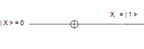

Figure 1: Quantum NOT Gate

We know $\frac{dS_{th}\left(E\right)}{dE}=\frac{N}{T}$, where N = 1;

So, T = $\frac{dE x N}{dS_{th}\left(E\right)}$

= $\frac{5.7051X{10}^{-16} X 1}{1.9118X{10}^{-18}}$

= $298.148k$

So, produced heat from Quantum NOT gate is $298.148$ Kelvin.

1. **Quantum CNOT gate**

We know that the Quantum controlled NOT gate (CNOT) is a double qubit gate. So, if we want to measure produced heat from Quantum CNOT operational gate then we have to follow these following steps where, Figure 2 describes quantum CNOT gate.

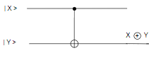

Figure 2: Quantum CNOT Gate

We know, for N qubit gate, Sth (E, N) = N (Kb ln 2) S(E/N)

= $-k_{B}\frac{ϵ-E/N}{ϵ}ln\frac{ϵ-E/N}{ϵ}-k_{B}\frac{E/N}{ϵ}ln\frac{E/N}{ϵ}$

Quantum CNOT operational gate is double qubit gate. So, N =2.

Thus, Sth

T = $\frac{dE x N}{dS_{th}\left(E\right)}$

= $\frac{5.7051X{10}^{-16} X 2}{1.948X{10}^{-18}}$

= 585.32 k

So, the heat produced from Quantum CNOT gate is 585.32 Kelvin.

1. **Quantum AND gate**

We know that the Quantum AND operational gate is a triple qubit gate. So, if we want to measure produced heat from Quantum AND operational gate then we have to follow these following steps where, Figure 3 describes quantum AND operational gate.

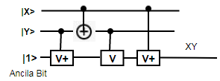

Figure 3: Quantum AND operational gate

We know, for N qubit gate, Sth (E, N) = N (Kb ln 2) S(E/N)

= $-k_{B}\frac{ϵ-E/N}{ϵ}ln\frac{ϵ-E/N}{ϵ}-k_{B}\frac{E/N}{ϵ}ln\frac{E/N}{ϵ}$

Quantum AND operational gate is a triple qubit gate. So, N = 3.

Thus, Sth

T = $\frac{dE x N}{dS_{th}\left(E\right)}$

= $\frac{5.7051X{10}^{-16} X 3}{1.97144X{10}^{-18}}$

= 868.162 k

Thus, produced heat from Quantum AND operational gate is 868.162 Kelvin.

1. **Quantum OR gate**

We know that the Quantum OR operational gate is a triple qubit gate. So, if we want to measure produced heat from Quantum OR operational gate then we have to follow these following steps where, Figure 4 describes quantum OR operational gate.

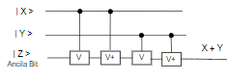

Figure 4: Quantum OR operational Gate

We know, for N qubit gate, Sth (E, N) = N (Kb ln 2) S(E/N)

= $-k_{B}\frac{ϵ-E/N}{ϵ}ln\frac{ϵ-E/N}{ϵ}-k_{B}\frac{E/N}{ϵ}ln\frac{E/N}{ϵ}$

Quantum OR operational gate is triple qubit gate. So, N = 3.

Thus, Sth

T = $\frac{dE x N}{dS_{th}\left(E\right)}$

= $\frac{5.7051X{10}^{-16} X 3}{1.97144X{10}^{-18}}$

= 868.162 k

Thus, produced heat from Quantum OR operational gate is 868.162 Kelvin.

### 1.3 Heat Calculation for Quantum Operational circuit

In this section, we are going to calculate the total produced heat of a quantum operational circuit. The basic information for calculating produced heat from a particular quantum operational gate is provided in the previous section.

1.3.1 Quantum Full subtractor

A Full subtractor is a combinational circuit that is developed to overcome the drawback of the half subtractor circuit. It can take three inputs and after subtracting them creates two outputs. Here, Full subtractor is implemented using the Quantum circuit. To create a Full Subtractor, two NOT, two XOR, two AND, and an OR gate is required. Figure 5 describes the quantum circuit of a full subtractor. A full subtractor receives three inputs and produce two output containing “D” and “Bout”.

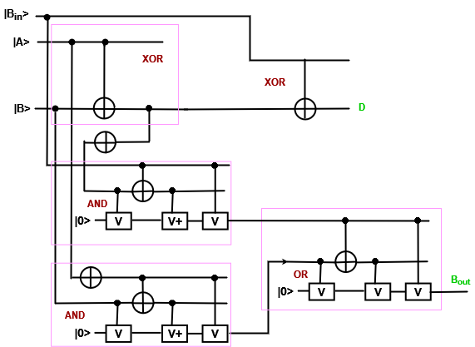

Figure 5: Quantum Full subtractor circuit.

Full subtractor is a 4 qubit quantum operation (considering 1 ancilla qubit and 3 input qubit) and for this quantum operation heat measurement will be calculated using the following formula (i).

$\frac{dS_{th}\left(E\right)}{dE}=\frac{n}{T}$... (i)

We know, for N qubit gate, Sth (E, N) = N (Kb ln 2) S(E/N)

= $-k_{B}\frac{ϵ-E/N}{ϵ}ln\frac{ϵ-E/N}{ϵ}-k_{B}\frac{E/N}{ϵ}ln\frac{E/N}{ϵ}$

Quantum Full Subtractor operation has 4 qubits in the figure. So, N = 4.

Thus, Sth

T = $\frac{dE x N}{dS_{th}\left(E\right)}$

= $\frac{5.7051X{10}^{-16} X 4}{1.9791X{10}^{-18}}$

= 1153.05 k

Thus, produced heat from Quantum Full Subtractor operation is 1153.05 Kelvin.

1.3.2 Quantum 3-bit even parity bit checker

A circuit that checks the parity in the receiver is called Parity Checker. A combined circuit or device of parity generators and parity checkers are commonly used in digital systems to detect the single bit errors in the transmitted data. To create a 3 bit even parity bit checker, three XOR gates are required. Figure 6 describes the digital and quantum circuit of a 3 bit even parity bit checker. A 3 bit even parity bit checker receives four inputs and produces one output containing “E”.

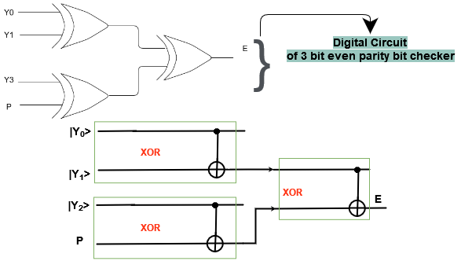

Figure 6: Quantum 3 bit even parity bit checker

3 bit even parity bit checker is a 4 qubit quantum operation and for this quantum operation heat measurement will be calculated using the following formula.

$\frac{dS_{th}\left(E\right)}{dE}=\frac{n}{T}$

We know, for N qubit gate, Sth (E, N) = N (Kb ln 2) S(E/N)

= $-k_{B}\frac{ϵ-E/N}{ϵ}ln\frac{ϵ-E/N}{ϵ}-k_{B}\frac{E/N}{ϵ}ln\frac{E/N}{ϵ}$

Quantum parity bit checker operation has 4 qubits in the figure. So, N = 4.

Thus, Sth

T = $\frac{dE x N}{dS_{th}\left(E\right)}$

= $\frac{5.7051X{10}^{-16} X 4}{1.9791X{10}^{-18}}$

= 1153.05 k

Thus, the heat produced from Quantum Parity bit checker is 1153.05 Kelvin.

1.3.3 Quantum 3:1 Multiplexer

A multiplexer (MUX) is a device that can receive multiple input signals and synthesize a single output signal in a recoverable manner for each input signal. It is also an integrated system that usually contains a certain number of data inputs and a single output. To create a multiplexer, one NOT, two AND, and an OR gate is required. Figure 7 describes the quantum circuit of the Multiplexer. A Multiplexer receives three inputs and produce one output containing “Y”.

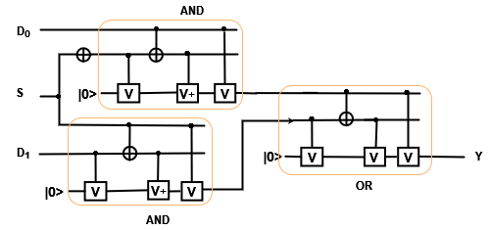

Figure 7: Quantum Multiplexer circuit.

2 to 1 Multiplexer is a 4-qubit quantum operation (considering 1 ancilla bit and 3 input qubit) and for this quantum operation heat measurement will be calculated using the following formula.

$\frac{dS_{th}\left(E\right)}{dE}=\frac{n}{T}$

We know, for N qubit gate, Sth (E, N) = N (Kb ln 2) S(E/N)

= $-k_{B}\frac{ϵ-E/N}{ϵ}ln\frac{ϵ-E/N}{ϵ}-k_{B}\frac{E/N}{ϵ}ln\frac{E/N}{ϵ}$

Quantum Multiplexer operation has 4 qubits in the figure. So, N = 4.

Thus, Sth

T = $\frac{dE x N}{dS_{th}\left(E\right)}$

= $\frac{5.7051X{10}^{-16} X 4}{1.9791X{10}^{-18}}$

= 1153.05 k

Thus, produced heat from Quantum Multiplexer operation is 1153.05 Kelvin.

### 1.4 Basic Definitions for Heat calculation in DNA circuit

DNA has the characteristics of enabling classical logical operation using DNA sequence. DNA prefers to be in double stranded form, while single stranded DNA naturally migrates towards complementary sequences to form double stranded complexes. Complementary sequences pair the bases adenine (A) with thymine (T) and cytosine (C) with guanine (G). DNA sequences pair in an antiparallel manner, with the 5’ end of one sequence pairing with the 3’ end of the complementary sequence.

Each DNA gate input will be the single standard sequence which if we assume true then the complementary DNA sequence will be false. Suppose ACTCGT is the input sequence then the complementary sequence TGAGCA . In DNA computing, when we design the logic gate , a predetermined single strand sequence can be supplied to induce appropriate chemical reaction. This sequence also helps to evaluate output value whether it is true or false.

When the mixing step appears we need to mix the two sequences to achieve union of DNA sequences. In the mixing step we need to give some heat to mixing these. Then annealing appears and in annealing we need to cool this little and make a double sequence bond. After annealing the step appears which is melting. In melting we need to heat up the double strand DNA sequence to make them a single strand complementary sequence and this sequence will be used in the DNA logic gate then after some step. So, we need to know the DNA melting temperature.

Depending on the nature of the sequence, we use one of two methods to calculate melting temperature, Tm:

* Nearest Neighbors
* Basic

1. **Nearest Neighbors:**

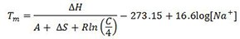

Where:

* *Tm* = melting temperature in °C
* Δ*H* = enthalpy change in kcal mol-1 (accounts for the energy change during annealing / melting)
* *A* = constant of -0.0108 kcal K-1mol-1 (accounts for helix initiation during annealing / melting)
* Δ*S* = entropy change in kcal K-1mol-1 (accounts for energy unable to do work, i.e. disorder)
* *R* = gas constant of 0.00199 kcal K-1mol-1 (constant that scales energy to temperature)
* *C* = oligonucleotide concentration in M or mol L-1 (we use 0.0000005, i.e. 0.5 µM)
* -273.15 = conversion factor to change the expected temperature in Kelvins to °C
* [*Na+*] = sodium ion concentration in M or mol L-1 (we use 0.05, i.e. 50 mM)

This example will demonstrate the manual calculation of the Tm for the following sequence:

5'-AAAAACCCCCGGGGGTTTTT-3'

This is the above sequence paired with its reverse complement:

5'-AAAAACCCCCGGGGGTTTTT-3'

3'-TTTTTGGGGGCCCCCAAAAA-5'



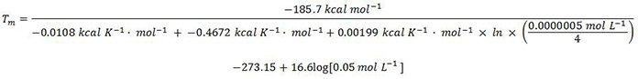

Tm = 69.6 degree Celsius,

1. **Basic:**

A secondary method we use to calculate Tm is the basic method a modified Marmur Doty formula, which we use for oligonucleotides with short sequences lengths, (those that are 14 bases or less):

***Tm* = 2(*A* + *T*) + 4(*C* + *G*) – 7**

* *Tm* = melting temperature in °C
* *A* = number of adenosine nucleotides in the sequence
* *T* = number of thymidine nucleotides in the sequence
* *C* = number of cytidine nucleotides in the sequence
* *G* = number of guanosine nucleotides in the sequence
* *-7* = correction factor accounting for in solution

So, for example we can calculate the melting temperature of a DNA sequence in different operational DNA gate as AND, OR, NOT, NAND, NOR, XOR and XNOR.

1. Heat calculation of DNA AND operational Gate:

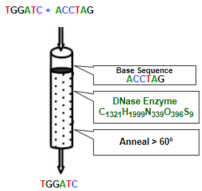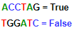

Figure 8: DNA AND operational Gate

Here, Input 1 = TGGATC

*Tm1 =* 2*(A* + *T)* +4*(C* + *G)* - 7

= 2(1 + 2) + 4(1 + 2) - 7

= 11.0 °C

Again, Input 2 = ACCTAG

*Tm2 =* 2*(A* + *T)* +4*(C* + *G)* - 7

= 2(1 + 1) + 4(2 + 1) - 7

*Tm2* = 9.0 °C

We have to do other processes for finding an output in DNA computing. That’s why we have to perform other generalize process within all steps and all following steps are applicable for each tube for performing a DNA operation.

Preparing, Mixing and Annealling: Allosteric DNAzyme-based DNA logic circuit [4], described a procedure to make a DNAzyme-based logic circuit. Here, All DNA logic gates were formed by annealing twice: firstly, the mixture of the inhibitor DNA strands and E6-type DNAzymes in 1× TAE*/*Mg2+ buffer (40 mM Tris, 20 mM acetic acid, 1 m MEDTA2Na and 12.5 mM Mg(OAc)2, pH 8.0) was heated at 95◦C for 4 min, 65◦C for 30 min, 50◦C for 30 min, 37◦C for 30 min, 22◦C for 30 min, and preserved at 20◦C; and then the substrates were added into the annealed mixture and incubated at constant temperature 20◦C for 4 h (total 6hr for preparing the DNA logic gate).

Melting, Amplifying, Seperating, Extracting, Cutting, Ligating, Substituting, Marking and Destroying sequences: After that Logic gates were triggered through displacement reaction in 1× TAE*/*Mg2+ buffer (40 mM Tris, 20 mM acetic acid, 1 mM EDTA2Na, and 12.5 mM Mg(OAc)2, pH 8.0). The input DNA strands were added to a solution containing DNA logic gates and reacted for *>* 2 h at 20◦C. Next, the displaced products were stored at 20◦C for native PAGE or fluorescence detection. In addition, polyacrylamide gel electroghoresis (PAGE) needs 2hr and PCR process for fluoresence detection needs less than 2 hr.

Detecting and Reading sequences: Here we are going to describe a specific biochemical process briefly which serves as the basis of our DNA computing approach as Polymerase Chain Reaction (PCR). Polymerases perform several functions, including the repair and duplication of DNA. PCR is a process that quickly amplifies the amount of specific DNA molecules in a given solution, using primer extension by polymerase. Each cycle of the reaction doubles the quantity of this molecule, leading to an exponential growth in the number of sequences. It consists of the following key processes:

1. Initialization: a mix solution of template, primer, dNTP and enzyme is heated to 94 *−* 98*◦C* for 1 *−* 9 minutes to ensure that most of the DNA template and primers are denatured;
2. Denaturation: heat the solution to 94 *−* 98*◦C* for 20 *−* 30 seconds for separation of DNA duplexes;
3. Annealing: lower the temperature enough (usually between 50*−*64*◦C*) for 20*−*40 seconds for primers to anneal specifically to the ssDNA template;
4. Elongation/Extention: raise temperature to optimal elongation temperature of *Taq* or similar DNA polymerase (70 *−* 74*◦C*) for the polymerase adds dNTP’s from the direction of 5’ to 3’ that are complementary to the template;
5. Final Elongation/Extention: after the last cycle, a 5 *−* 15 minutes elongation may be performed to ensure that any remaining ssDNA is fully extended.

Step 2 to 4 is repeated for 20*−*35 times; less cycles results less product, too many cycles increase fraction of incomplete and erroneous products. PCR is a routine job in the laboratory that can be performed by an apparatus named *thermal cycler*. According to PCR process, to produce an operational output of DNA computation we need around 2 hours.

Specific steps with heat for DNA computations:

1. Gate operation preparing (98 oC - 94 oC)
2. Synthesising (98 oC - 94 oC)
3. Mixing (95 oC - 22 oC)
4. Annealing (70 oC - 20 oC)
5. Melting. (Depends on the sequence )
6. Amplifying
7. Seperating
8. Extracting
9. Cutting

20 oC

1. Ligating
2. Substituting
3. Marking
4. Destroying
5. Detecting and Reading. (98 oC - 25 oC)

So, in DNA AND gate overall maximum required heat = (98+98+95+70+11+20+98) oC,

= 490 oC,

and minimum required heat = (94+94+22+20+9+20+25) oC,

= 284 oC.

Again, in DNA AND gate all the processes are occurring in the test tube after mixing is completed. Here sometimes we need to keep the temperature high and sometimes we need to keep temperature low for several steps. So, we need to keep the temperature at maximum 94 -98°C. When DNA gate logic operation applies then we need to keep the temperature around 20°C and at detection time we need to keep it as 25°C.

1. Heat calculation of DNA OR operational Gate: 

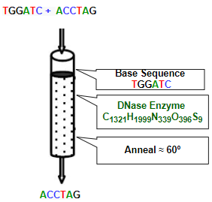

Figure 9: DNA OR operational Gate

Here, Input 1 = TGGATC

*Tm1 =* 2*(A* + *T)* +4*(C* + *G)* - 7

= 2(1 + 2) + 4(1 + 2) - 7

= 11.0 °C

Again,

Input 2 = ACCTAG

*=* 2*(A* + *T)* +4*(C* + *G)* - 7

= 2(1 + 1) + 4(2 + 1) - 7

*Tm2* = 9.0 °C

Specific steps with heat for DNA computations:

1. Gate operation preparing (98 oC - 94 oC)
2. Synthesising (98 oC - 94 oC)
3. Mixing (95 oC - 22 oC)
4. Annealing (70 oC - 20 oC)
5. Melting. (Depends on the sequence )
6. Amplifying
7. Seperating
8. Extracting
9. Cutting

20 oC

1. Ligating
2. Substituting
3. Marking
4. Destroying
5. Detecting and Reading. (98 oC - 25 oC)

So, in DNA OR gate overall maximum required heat = (98+98+95+70+11+20+98) oC,

= 490 oC,

and minimum required heat = (94+94+22+20+9+20+25) oC,

= 284 oC,

.

Again, in DNA OR gate all the processes are happening in the test tube after mixing is completed. Here sometimes we need to keep the temperature high and sometimes we need to keep temperature low for several steps. So, we need to keep the temperature at maximum 94 -98°C. When DNA gate logic operation applies then we need to keep the temperature around 20°C and at detection time we need to keep it as 25°C.

1. Heat calculation of DNA NOT operational Gate:

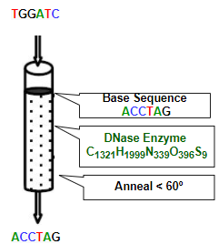

Figure 9: DNA NOT operational Gate

Here, Input DNA sequence = TGGATC

So, Melting temperature*, Tm =* 2*(A* + *T)* +4*(C* + *G)* - 7

= 2(1 + 2) + 4(1 + 2) - 7

= 11.0 °C

Specific steps with heat for DNA computations:

1. Gate operation preparing (98 oC - 94 oC)
2. Synthesising (98 oC - 94 oC)
3. Mixing (95 oC - 22 oC)
4. Annealing (70 oC - 20 oC)
5. Melting. (Depends on the sequence )
6. Amplifying
7. Seperating
8. Extracting
9. Cutting

20 oC

1. Ligating
2. Substituting
3. Marking
4. Destroying
5. Detecting and Reading. (98 oC - 25 oC)

So, in DNA NOT gate overall maximum required heat = (98+98+95+70+11+20+98) oC,

= 490 oC,

and minimum required heat = (94+94+22+20+11+20+25) oC,

= 286 oC.

Again, in DNA NOT operational gate, all the processes are happening in the test tube after mixing is completed. Here sometimes we need to keep the temperature high and sometimes we need to keep temperature low for several steps. So, we need to keep the temperature at maximum 94 -98°C. When DNA gate logic operation applies then we need to keep the temperature around 20°C and at detection time we need to keep it at 25°C.

1. Heat calculation of DNA XOR Gate:

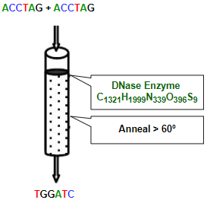****

Figure 10: DNA XOR Gate

Again, Input1 = ACCTAG

*So, Tm1 =* 2*(A* + *T)* +4*(C* + *G)* - 7

= 2(1 + 1) + 4(2 + 1) - 7

= 9.0 °C

Again, Input2 = ACCTAG

*So, Tm2 =* 2*(A* + *T)* +4*(C* + *G)* - 7

= 2(1 + 1) + 4(2 + 1) - 7

= 9.0 °C

Specific steps with heat for DNA computations:

1. Gate operation preparing (98 oC - 94 oC)
2. Synthesising (98 oC - 94 oC)
3. Mixing (95 oC - 22 oC)
4. Annealing (70 oC - 20 oC)
5. Melting. (Depends on the sequence )
6. Amplifying
7. Seperating
8. Extracting
9. Cutting

20 oC

1. Ligating
2. Substituting
3. Marking
4. Destroying
5. Detecting and Reading. (98 oC - 25 oC)

So, in DNA XOR gate overall maximum required heat = (98+98+95+70+11+20+98) oC,

= 490 oC,

and minimum required heat = (94+94+22+20+9+20+25) oC,

= 284 oC.

Again, in DNA XOR gate all the processes are happening in the test tube after mixing is completed. Here sometimes we need to keep the temperature high and sometimes we need to keep temperature low for several steps. So, we need to keep the temperature at maximum 94 -98°C. When DNA gate logic operation applies then we need to keep the temperature around 20°C and at detection time we need to keep it as 25°C.

### 1.5 Heat Calculation in DNA Circuit

This subsection is going to describe some DNA operational circuit to calculate its performing Heat in an approximate value based on the theory described in Section 1.4.

1.5.1 DNA Full Subtractor

A full subtractor is a combinational circuit that performs subtraction of two bits, one is minuend and other is subtrahend, taking into account borrow of the previous adjacent lower minuend bit. This circuithas three inputs and two outputs**.** The three inputs A, B and Bin, denote the minuend, subtrahend, and previous borrow, respectively. The two outputs, D and Bout represent the difference and output borrows, respectively. To create a full subtractor, one OR, two AND, two OR and 2 XOR gate are required. Figure 11 describes the DNA circuit of full subtractor.

Here, we have three input sequence as follows:

1. Bin  = TGGATC
2. A = ACCTAG
3. B = ACCTAG

Calculating Melting temperature of a specific DNA sequence:

For Input1,  Bin = TGGATC

*Tm(Bin) =* 2*(A* + *T)* +4*(C* + *G)* - 7

= 2(1 + 2) + 4(1 + 2) - 7

= 11.0 °C

Again, Input2 and Input3, A = B = ACCTAG

*So, Tm(A or B) =* 2*(A* + *T)* +4*(C* + *G)* - 7

= 2(2 + 1) + 4(2 + 1) - 7

= 11.0 °C

Specific steps with heat for DNA full subtractor (for each tube):

1. basic gate operation preparing (98 oC - 94 oC)
2. Synthesising (98 oC - 94 oC)
3. Mixing (95 oC - 22 oC)
4. Annealing (70 oC - 20 oC)
5. Melting. (Depends on the sequence )
6. Amplifying
7. Seperating
8. Extracting
9. Cutting

20 oC

1. Ligating
2. Substituting
3. Marking
4. Destroying
5. Detecting and Reading. (98 oC - 25 oC)

So, in DNA Full subtractor overall maximum required heat = (98+98+95+70+11+20+98) oC,

= 490 oC,

and minimum required heat = (94+94+22+20+11+20+25) oC,

= 286 oC.

Again, in specific basic DNA gate all the processes are happening in the test tube after mixing is completed. Here in specific cases, we need to keep the temperature high and sometimes we need to keep temperature low for several steps. So, we have to keep the temperature at maximum 94 -98°C. When DNA gate logic operation applies then we need to keep the temperature around 20°C and at detection time we need to keep it as 25°C.

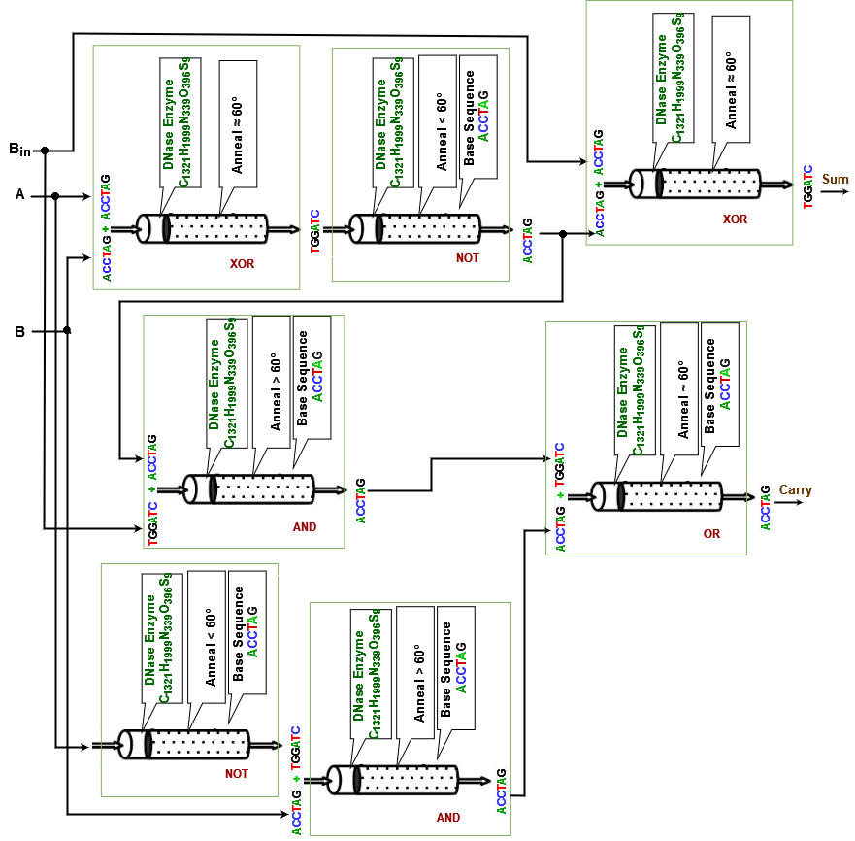

Figure 11: DNA Full Subtractor circuit.

1.5.2 DNA Full Adder

Full Adder is the adder which adds three inputs and produces two outputs. The first two inputs are A and B and the third input is an input carry as C-IN. The output carry is designated as Cout and the normal output is designated as S which is SUM. A full adder logic is designed in such a manner that can take eight inputs together to create a byte-wide adder and cascade the carry bit from one adder to the another. To create a Full Adder, one OR, two NAND, one XOR and 2 NOT gate is required. Figure 12 describes the DNA circuit of the Full Adder.

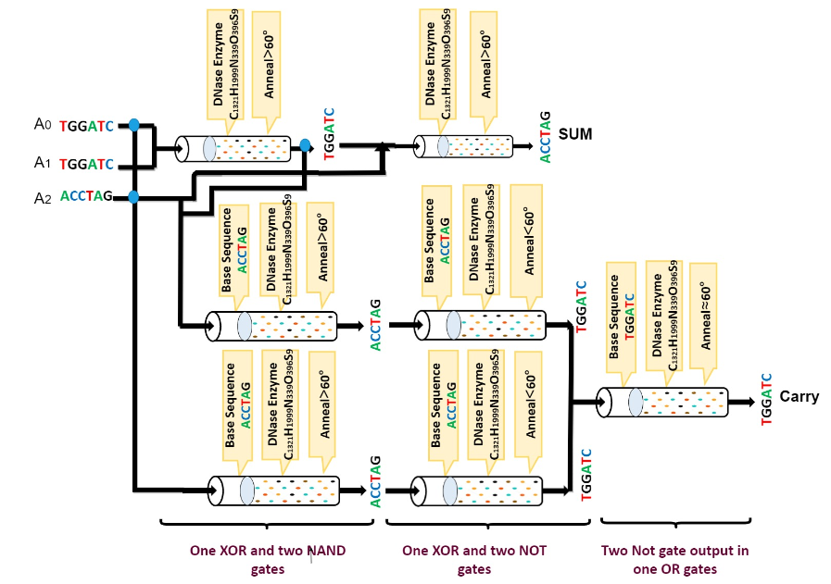

Figure 12: DNA Full Adder circuit.

Here, we have three input sequence as follows:

1. A0  = TGGATC
2. A1 = TGGATC
3. A2 = ACCTAG

Calculating Melting temperature of a specific DNA sequence:

For Input, A0 and A1 = TGGATC

*Tm(A0 or A1) =* 2*(A* + *T)* +4*(C* + *G)* - 7

= 2(1 + 2) + 4(1 + 2) - 7

= 11.0 °C

Again, Input, A3 = ACCTAG

*So, Tm(A3) =* 2*(A* + *T)* +4*(C* + *G)* - 7

= 2(2 + 1) + 4(2 + 1) - 7

= 11.0 °C

Specific steps with heat for DNA full Adder (for each tube):

1. basic gate operation preparing (98 oC - 94 oC)
2. Synthesising (98 oC - 94 oC)
3. Mixing (95 oC - 22 oC)
4. Annealing (70 oC - 20 oC)
5. Melting. ( 11 oC)
6. Amplifying
7. Separating
8. Extracting
9. Cutting

20 oC

1. Ligating
2. Substituting
3. Marking
4. Destroying
5. Detecting and Reading. (98 oC - 25 oC)

So, in DNA Full Adder overall maximum required heat = (98+98+95+70+11+20+98) oC,

= 490 oC,

and minimum required heat = (94+94+22+20+11+20+25) oC,

= 286 oC.

Again, in specific basic DNA gate all the processes are happening in the test tube after mixing is completed. Here in specific cases, we need to keep the temperature high and sometimes we need to keep temperature low for several steps. So, we have to keep the temperature at maximum 94 -98°C. When DNA gate logic operation applies then we need to keep the temperature around 20°C and at detection time we need to keep it as 25°C.

1.5.3 DNA Multiplication circuit

A binary multiplier is a combinational logic circuit or digital device used for multiplying two binary numbers. The two numbers are more specifically known as multiplicand and multiplier and the result is known as a product. The multiplicand and multiplier can be of various bit sizes. The product’s bit size depends on the bit size of the multiplicand & multiplier. The bit size of the product is equal to the sum of the bit size of multiplier multiplicand. To create a Multiplication circuit, six NAND, two XOR and 6 NOT gates are required. Figure 13 describes the DNA circuit of the 2-bit multiplication.

Here, we have four input sequence as follows:

1. A0  = ACCTAG
2. A1 = TGGATC
3. B0 = TGGATC
4. B1 = ACCTAG

Calculating Melting temperature of a specific DNA sequence:

For Input, A0 and B1 = ACCTAG

*Tm(A0 or B1) =* 2*(A* + *T)* +4*(C* + *G)* - 7

= 2(2 + 1) + 4(2 + 1) - 7

= 11.0 °C

Again, Input, A1 and B0 = TGGATC

*So, Tm(A3) =* 2*(A* + *T)* +4*(C* + *G)* - 7

= 2(1 + 2) + 4(1 + 2) - 7

= 11.0 °C

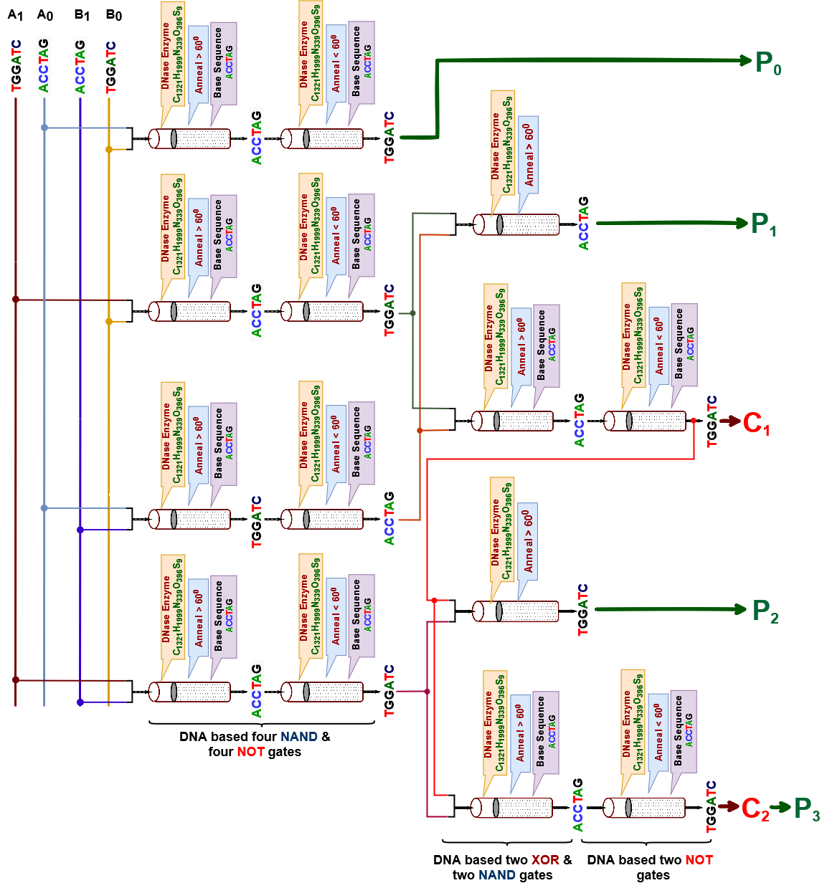

Figure 13: Quantum Multiplier circuit.

Specific steps with heat for DNA full Adder (for each tube):

1. basic gate operation preparing (98 oC - 94 oC)
2. Synthesising (98 oC - 94 oC)
3. Mixing (95 oC - 22 oC)
4. Annealing (70 oC - 20 oC)
5. Melting. ( 11 oC)
6. Amplifying
7. Seperating
8. Extracting
9. Cutting

20 oC

1. Ligating
2. Substituting
3. Marking
4. Destroying
5. Detecting and Reading. (98 oC - 25 oC)

So, in DNA Multiplier overall maximum required heat = (98+98+95+70+11+20+98) oC,

= 490 oC,

and minimum required heat = (94+94+22+20+11+20+25) oC,

= 286 oC.

Again, in specific basic DNA gate all the processes are happening in the test tube after mixing is completed. Here in specific cases, we need to keep the temperature high and sometimes we need to keep temperature low for several steps. So, we have to keep the temperature at maximum 94 -98°C. When DNA gate logic operation applies then we need to keep the temperature around 20°C and at detection time we need to keep it as 25°C.

### 1.6 Heat calculation in Multivalued Quantum Circuit

Quantum computing embraces emerging technological areas such as quantum information system, quantum cryptography. Its behavior is defined by quantum algorithms which exploit the quantum mechanical phenomenon of matter. The advantage of quantum computing is parallelism based on linear superposition of quantum states. It has been shown that certain problems can be solved in fewer steps by quantum algorithms than by existing classical ones. A 2-state quantum system is usually defined with the two pure states ∣0 > and ∣1 > as basis states, and the unit of information is known as qubit. Presently, multivalued quantum computing is gaining importance in the field of quantum information theory and quantum cryptography as it can represent an n-dimensional quantum system, defined by the basic states ∣0 >, ∣1 >, ..., ∣𝑛−1 >. The unit of information is called a qubit. For a ternary quantum system, this unit is termed a qutrit. A ternary quantum system exists in linear superposition of three basis states, labeled ∣0 >, ∣1 > and ∣2 >.

Multivalued logic is one of the cases that drew the attention of the researchers. Meanwhile the ternary circuits were more accepted because of their advantages over the binary circuits. Ternary quantum computation has high fault tolerance and high speed as compared to the binary, and is useful for quantum simulation, quantum tomography, and quantum games.

1.6.1 Quantum Multivalued Half Adder

A ternary half adder is a type of adder, an electronic circuit that performs the addition of ternary numbers. The half adder is able to add two single ternary digits and provide the output plus a carry value. It has two inputs, called A and B, and two outputs S (sum) and C (carry). Figure 14 describes quantum operational circuit of multivalued half adder.

Quantum Ternary Half Adder will add two bits from the quantum ternary digit |0>, |1>, and |2> and produce two outputs as quantum sum |S> and quantum carry bit |C>.

Ternary Half Adder is 16 qubit (considering 14 ancilla bit and 2 input qubit) quantum operation and for this quantum operation heat measurement will be calculated using following formula.

$\frac{dS_{th}\left(E\right)}{dE}=\frac{n}{T}$

We know, for N qubit gate, Sth (E, N) = N (Kb ln 2) S(E/N)

= $-k_{B}\frac{ϵ-E/N}{ϵ}ln\frac{ϵ-E/N}{ϵ}-k_{B}\frac{E/N}{ϵ}ln\frac{E/N}{ϵ}$

Quantum multivalued Half Adder has 16 qubit in the figure. So, N = 16.

Thus, Sth

T = $\frac{dE x N}{dS_{th}\left(E\right)}$

= $\frac{5.7051X{10}^{-16} X 16}{2.0607X{10}^{-18}}$

= 4429.64 k

Thus, produced heat from Quantum multivalued Half Adder is 4429.64 Kelvin.

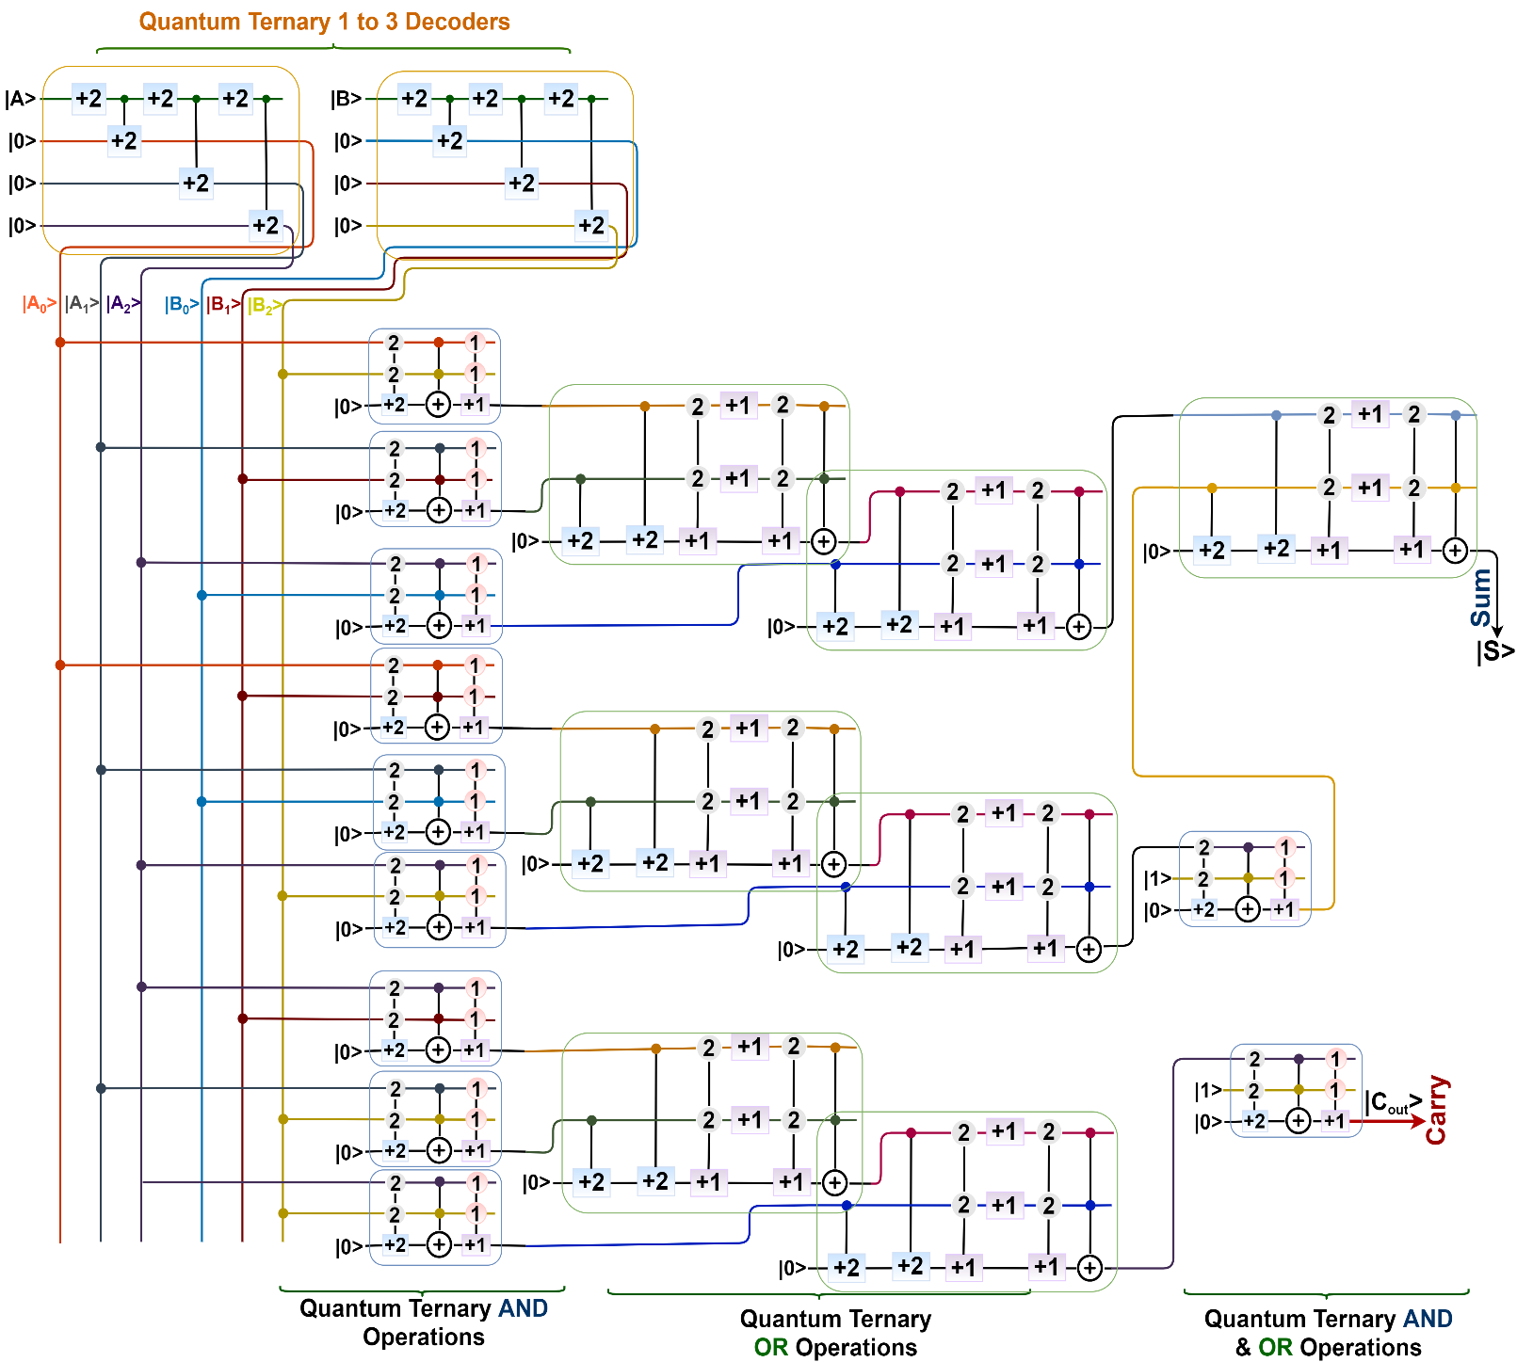

Figure 14:The Circuit diagram of Quantum Multivalued Half Adder

1.6.2 Quantum Multivalued Half Subtractor

A ternary half subtractor is a type of subtractor, an electronic circuit that performs the subtractions of ternary numbers. The half subtractor is able to subtract two single ternary digits and provide the output plus a borrow value. It has two inputs, called A and B, and two outputs D (difference) and B (borrow). Quantum Ternary Half Subtractor will subtract two bits from the quantum ternary digit |0>, |1>, and |2> and produce two outputs as quantum difference |D> and quantum borrow bit |B>. The Quantum circuit for the ternary half subtractor is shown in Figure 15.

Ternary half subtractor is 16 qubit (considering 14 ancilla bit and 2 input qubit) quantum operation and for this quantum operation heat measurement will be calculated using following formula.

$\frac{dS_{th}\left(E\right)}{dE}=\frac{n}{T}$

We know, for N qubit gate, Sth (E, N) = N (Kb ln 2) S(E/N)

= $-k_{B}\frac{ϵ-E/N}{ϵ}ln\frac{ϵ-E/N}{ϵ}-k_{B}\frac{E/N}{ϵ}ln\frac{E/N}{ϵ}$

Quantum multivalued Half Subtractor has 16 qubits in the figure. So, N = 16.

Thus, Sth

T = $\frac{dE x N}{dS_{th}\left(E\right)}$

= $\frac{5.7051X{10}^{-16} X 16}{2.0607X{10}^{-18}}$

= 4429.64 k

Thus, produced heat from Quantum multivalued Half Subtractor is 4429.64 Kelvin.

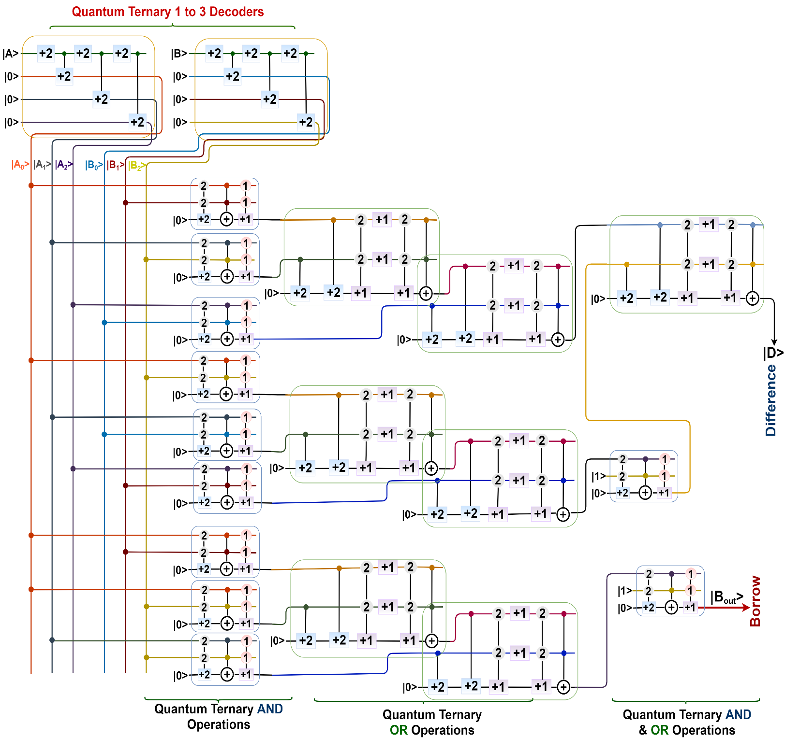

Figure 15:The Circuit diagram of Quantum Ternary Half subtractor

1.6.3 Quantum Multivalued 3:1 Multiplexer

A multiplexer (MUX) is a device that can receive multiple input signals and synthesize a single output signal in a recoverable manner for each input signal. It is also an integrated system that usually contains a certain number of data inputs and a single output. A ternary multiplexer of 3n input has n select line. And the selected line is used as the selection input that is sent to the output. The Quantum circuit for the multivalued quantum 3 to 1multiplexer is shown in Figure 16.

A ternary multiplexer is 10 qubit (considering 6 ancilla qubit and 4 input qubit) quantum operation and for this quantum operation heat measurement will be calculated using following formula.

$\frac{dS_{th}\left(E\right)}{dE}=\frac{n}{T}$

We know, for N qubit gate, Sth (E, N) = N (Kb ln 2) S(E/N)

= $-k_{B}\frac{ϵ-E/N}{ϵ}ln\frac{ϵ-E/N}{ϵ}-k_{B}\frac{E/N}{ϵ}ln\frac{E/N}{ϵ}$

Quantum multivalued Multiplexer has 10 qubit in the figure. So, N = 10.

Thus, Sth

T = $\frac{dE x N}{dS_{th}\left(E\right)}$

= $\frac{5.7051X{10}^{-16} X 16}{2.034X{10}^{-18}}$

= 2802.35 k

Thus, produced heat from Quantum multivalued Multiplexer is 2802.35 Kelvin.

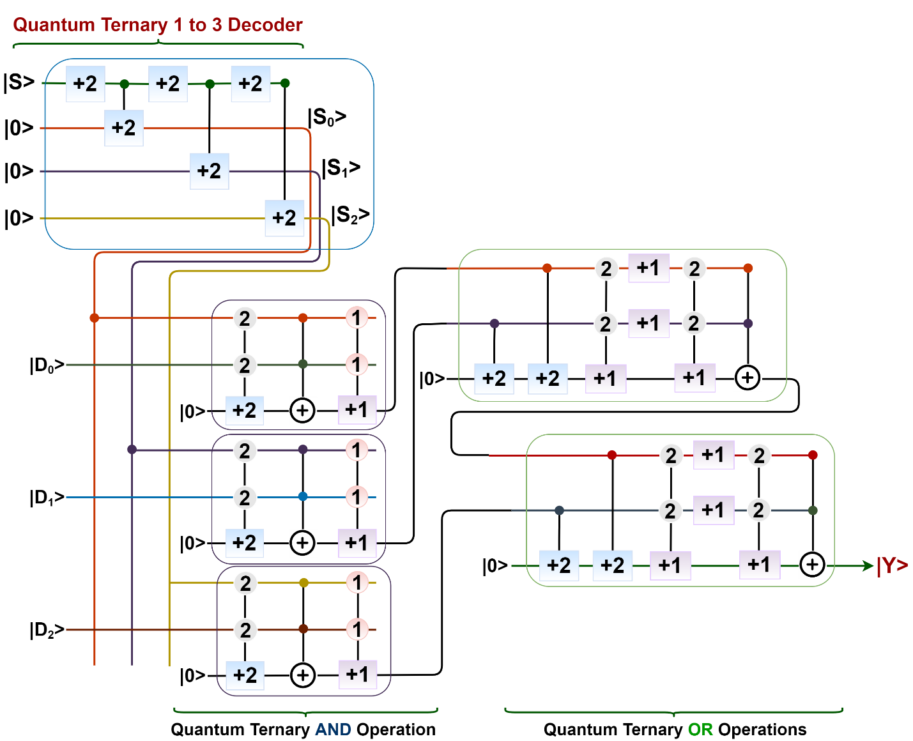

Figure 16:The Circuit diagram of Quantum Ternary 3 to 1 Multiplexer

### 1.7 Heat calculation in Multivalued DNA Circuit

DNA computing embraces emerging biology-dependent technological areas such as DNA computing systems, DNA security and scheduling systems. The advantage of DNA computing is parallelism based on DNA strands, which is composed of Adenine, Thymine, Guanine, and Cytosine. It has been shown that certain problems can be solved in fewer steps and with fewer memory by DNA computing algorithms than by existing classical computing systems. A 2-strand base DNA system is usually defined with the two pure strands as CAAGCT and ACCTAG. At the same time, multivalued DNA computing can be used as an important one in the field of DNA computation system, DNA scheduling and security system as it can represent multiple DNA strands in the system for carrying information. For a ternary DNA computation system, the basic three strands can be TGGATC, CAAGCT and ACCTAG.

Multivalued DNA computation systems can draw the attention from the researchers because of their advantages over the binary computation system. For ensuring security as intrusion detection, job scheduling and huge data clustering can be solved using a multivalued DNA computing system.

1.7.1 DNA Ternary Decoder

Decoder is a combinational circuit that has ‘n’ input lines and maximum of 2n output lines. One of these outputs will be active High based on the combination of inputs present, when the decoder is enabled. That means the decoder detects a particular code. In figure 17, Decoder is the unary functions for input variable A as A0, A1 and A2 which is used for ternary function implementation. Figure 10 describes DNA ternary Decoder.

Here, we can take one input sequence “A” as follows:

1. A = ACCTAG

Calculating Melting temperature of a specific DNA sequence:

For Input, A= ACCTAG

*Tm(A) =* 2*(A* + *T)* +4*(C* + *G)* - 7

= 2(2 + 1) + 4(2 + 1) - 7

= 11.0 °C

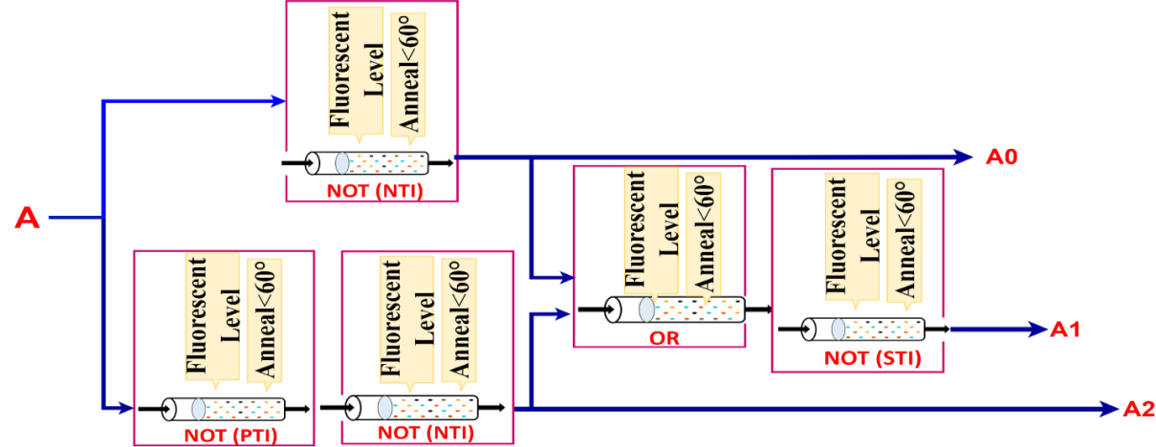

Figure 17: DNA Ternary Decoder

According to section 1.3, specific steps with heat for DNA Ternary Decoder (for each tube):

1. basic gate operation preparing (98 oC - 94 oC)
2. Synthesising (98 oC - 94 oC)
3. Mixing (95 oC - 22 oC)
4. Annealing (70 oC - 20 oC)
5. Melting. (11 oC)
6. Amplifying
7. Seperating
8. Extracting
9. Cutting

20 oC

1. Ligating
2. Substituting
3. Marking
4. Destroying
5. Detecting and Reading. (98 oC - 25 oC)

So, in DNA Ternary Decoder overall maximum required heat = (98+98+95+70+11+20+98) oC,

= 490 oC,

and minimum required heat = (94+94+22+20+11+20+25) oC,

= 286 oC.

Again, in specific basic DNA gate all the processes are happening in the test tube after mixing is completed. Here in specific cases, we need to keep the temperature high and sometimes we need to keep temperature low for several steps. So, we have to keep the temperature at maximum 94 -98°C. When DNA gate logic operation applies then we need to keep the temperature around 20°C and at detection time we need to keep it as 25°C.

1.7.2 DNA Ternary 3 to 1 Multiplexer

The multiplexer is one of the most important block designs of a binary digital system. It is such a device that allows only one input from several input signals and the input which is selected by Multiplexer is transmitted into a single medium. Actually, multiplexers aid to improve the efficiency of the communication system. It allows the transmission of data such as audio, video etc from different channels via cables. And here, we will implement this using MVL that helps us to simulate the circuit so easily than the digital binary Multiplexer. Then we can make a design of DNA 1 to 3 multivalued Multiplexer circuit based on a combinational digital 1 to 3 ternary circuit. Figure 18 describes multivalued DNA 3 to 1 Multiplexer.

Here, we have four input sequence as follows:

1. I0  = TGGATC
2. I1 = CAAGCT
3. I2 = ACCTAG
4. S = TGGATC

Calculating Melting temperature of a specific DNA sequence:

For Input, I0 and S= TGGATC

*Tm(I0 or S) =* 2*(A* + *T)* +4*(C* + *G)* - 7

= 2(1 + 2) + 4(1 + 2) - 7

= 11.0 °C

Again, Input, I1 = CAAGCT

*So, Tm(I1) =* 2*(A* + *T)* +4*(C* + *G)* - 7

= 2(2 + 1) + 4(2 + 1) - 7

= 11.0 °C

Again, Input, I2 = ACCTAG

*So, Tm(I2) =* 2*(A* + *T)* +4*(C* + *G)* - 7

= 2(2 + 1) + 4(2 + 1) - 7

= 11.0 °C

Specific steps with heat for DNA full Adder (for each tube):

1. basic gate operation preparing (98 oC - 94 oC)
2. Synthesising (98 oC - 94 oC)
3. Mixing (95 oC - 22 oC)
4. Annealing (70 oC - 20 oC)
5. Melting. (11 oC)
6. Amplifying
7. Seperating
8. Extracting
9. Cutting

20 oC

1. Ligating
2. Substituting
3. Marking
4. Destroying
5. Detecting and Reading. (98 oC - 25 oC)

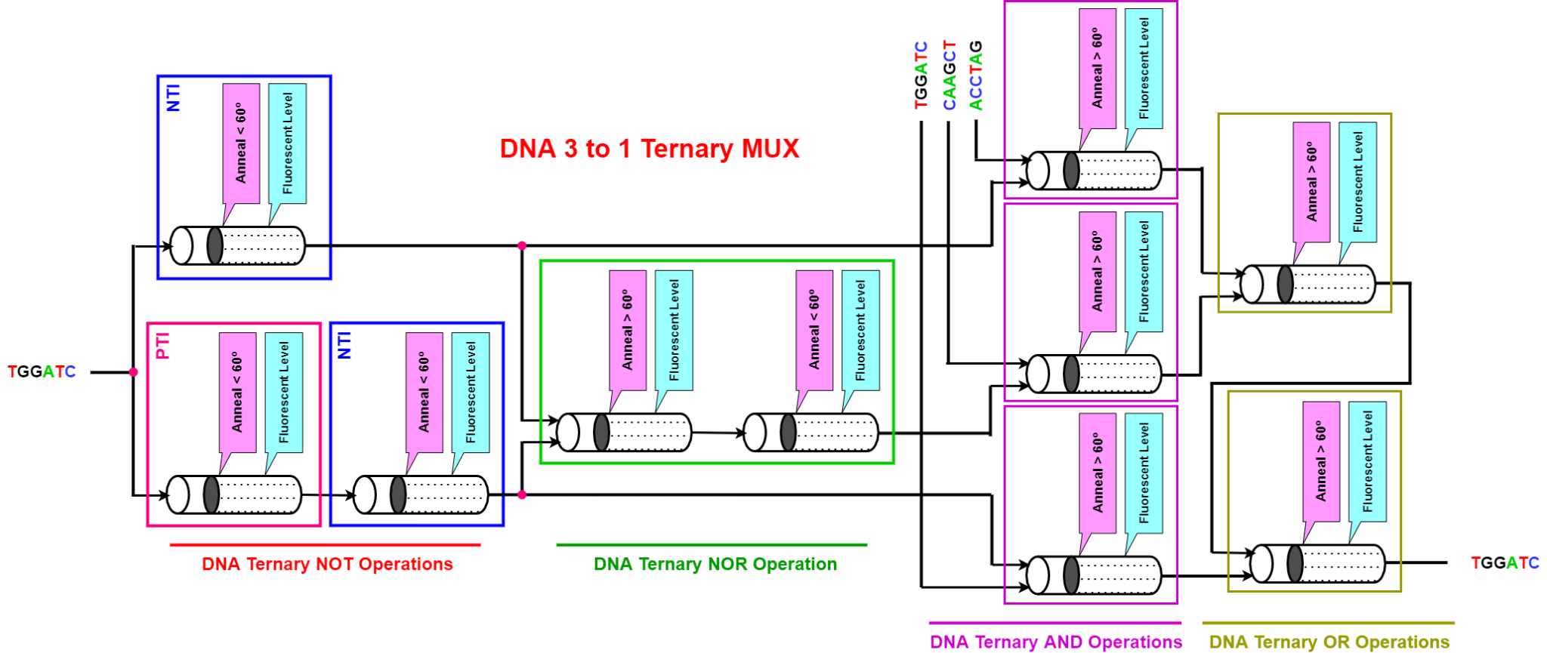

Figure 18: DNA ternary 3 input one output Multiplexer

So, in DNA Ternary Multiplexer overall maximum required heat

= (98+98+95+70+11+20+98) oC

= 490 oC,

and minimum required heat = (94+94+22+20+11+20+25) oC,

= 286 oC.

Again, in specific basic DNA gate all the processes are happening in the test tube after mixing is completed. Here in specific cases, we need to keep the temperature high and sometimes we need to keep temperature low for several steps. So, we have to keep the temperature at maximum 94 -98°C. When DNA gate logic operation applies then we need to keep the temperature around 20°C and at detection time we need to keep it as 25°C.

### 1.8 Heat calculation in Quantum-DNA Circuit

According to quantum computing, quantum computation is faster than classical computation systems. Quantum computers are also more powerful than supercomputers in terms of computing. They are 1000 times faster than regular computers and supercomputers at processing data. Quantum computers can execute calculations that would take a regular computer 1000 years to complete in a matter of seconds. On the other hand, the use of DNA strands to compute has led to high parallel computation that makes up for the slow processing of the chip. Memory space required by DNA is around 1 bit per cubic nanometer which is much less when compared to regular storage systems Consumption of power is almost nil as the chemical bonds in DNA produce energy to build or repair new strands. So, for finding a super faster computation system with huge memory, we can develop a Quantum-DNA computation system. This Quantum-DNA computation system can merge all advantages of quantum computing and DNA computing.

In a Quantum-DNA computing system, input will be received as qubit and after performing in a certain number of quantum operational gates these qubits will be turned into DNA sequences by NMR relaxation.

1.8.1 Quantum-DNA Full Adder

Full Adder is the adder which adds three inputs and produces two outputs. The first two inputs are A and B and the third input is an input carry as Cin. The output carry is designated as Cout and the normal output is designated as S which is SUM. A full adder logic is designed in such a manner that can take eight inputs together to create a byte-wide adder and cascade the carry bit from one adder to the another. To create a Full Adder, one OR, two AND and two XOR gate are required. Figure 19 describes the Quantum-DNA circuit of the Full Adder. From the figure we can assume that three quantum operational gates and two DNA operational gates are required to find the expected output from Quantum-DNA Full adder.

A Quantum-DNA Full Adder is 5 qubit (considering 2 ancilla qubit and 3 input qubit) quantum operation. The output qubit from the Quantum operation will be converted in DNA sequence by using NMR relaxation at letter. The produced heat generated from quantum operation will be calculated using the following formula.

$\frac{dS_{th}\left(E\right)}{dE}=\frac{n}{T}$

We know, for N qubit gate, Sth (E, N) = N (Kb ln 2) S(E/N)

= $-k_{B}\frac{ϵ-E/N}{ϵ}ln\frac{ϵ-E/N}{ϵ}-k_{B}\frac{E/N}{ϵ}ln\frac{E/N}{ϵ}$

Quantum-DNA Full adder has 5 qubit in the figure. So, N = 5.

Thus, Sth

T = $\frac{dE x N}{dS_{th}\left(E\right)}$

= $\frac{5.7051X{10}^{-16} X 5}{1.984X{10}^{-18}}$

= 1436.49 k

Thus, produced heat from Quantum-DNA Full adder is 1436.49 Kelvin.

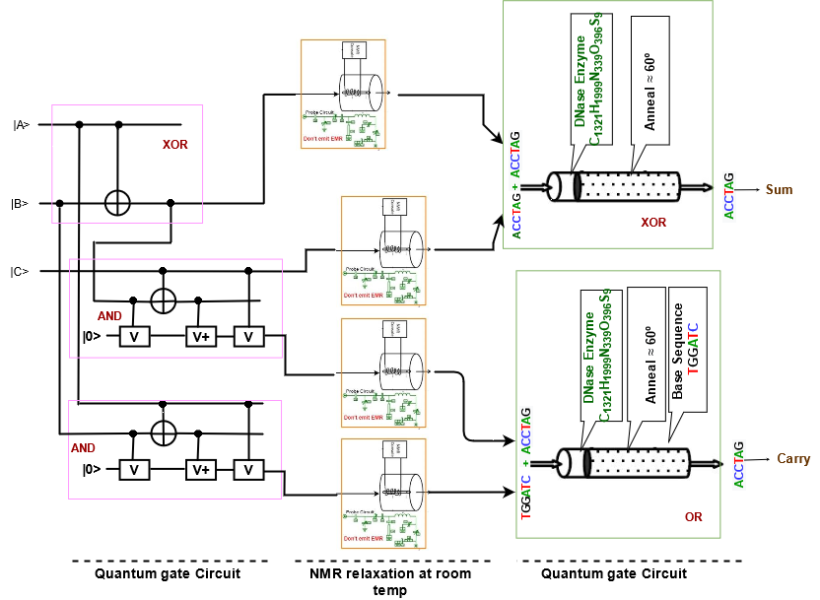

Figure 19: Quantum-DNA Full Adder at room temperature

Here, we can have at most two DNA sequence for DNA operational gate in the Quantum-DNA Full adder as follows:

1. TGGATC
2. ACCTAG

Calculating Melting temperature of a specific DNA sequence:

For TGGATC

*Tm =* 2*(A* + *T)* +4*(C* + *G)* - 7

= 2(1 + 2) + 4(1 + 2) - 7

= 11.0 °C

Again, For ACCTAG

*So, Tm =* 2*(A* + *T)* +4*(C* + *G)* - 7

= 2(2 + 1) + 4(2 + 1) - 7

= 11.0 °C

Specific steps with heat for Quantum-DNA Full Adder in DNA operation (for each tube):

1. basic gate operation preparing (98 oC - 94 oC)
2. Synthesising (98 oC - 94 oC)
3. Mixing (95 oC - 22 oC)
4. Annealing (70 oC - 20 oC)
5. Melting. (Depends on the sequence )
6. Amplifying
7. Seperating
8. Extracting
9. Cutting

20 oC

1. Ligating
2. Substituting
3. Marking
4. Destroying
5. Detecting and Reading. (98 oC - 25 oC)

So, in DNA operation overall maximum required heat = (98+98+95+70+11+20+98) oC,

= 490 oC,

and minimum required heat = (94+94+22+20+11+20+25) oC,

= 286 oC.

Again, in specific basic DNA gate all the processes are happening in the test tube after mixing is completed. Here in specific cases, we need to keep the temperature high and sometimes we need to keep temperature low for several steps. So, we have to keep the temperature at maximum 94 -98°C. When DNA gate logic operation applies then we need to keep the temperature around 20°C and at detection time we need to keep it as 25°C.

### 1.9 Heat calculation in DNA-Quantum Circuit

Quantum computation, according to quantum computing, is faster than traditional processing systems. Quantum computers are also more powerful in terms of computation than supercomputers. They process data 1000 times faster than normal computers and supercomputers. Quantum computers can perform computations in a fraction of a second that would take a traditional computer 1000 years to finish. The usage of DNA strands to calculate, on the other hand, has resulted in high parallel computation, which compensates for the chip's slow processing. When compared to traditional storage systems, DNA requires just about 1 bit per cubic nanometer of memory space. The chemical interactions in DNA provide energy to make or repair new strands, therefore there is essentially no power use. As a result, we may create a Quantum-DNA computation system to find a super-fast computation system with a lot of memory. This quantum-DNA computation device combines the benefits of both quantum and DNA computing.

In a DNA-Quantum computing system, input will be received in DNA sequences and after performing in a certain number of DNA operational gates these DNA sequences will be turned into quantum qubits by NMR process.

1.9.1 DNA-Quantum Full Adder

Full Adder is the adder which adds three inputs and produces two outputs. The first two inputs are A and B and the third input is an input carry as Cin. The output carry is designated as Cout and the normal output is designated as S which is SUM. A full adder logic is designed in such a manner that can take eight inputs together to create a byte-wide adder and cascade the carry bit from one adder to the another. To create a Full Adder, one OR, two AND and two XOR gate are required. Figure 20 describes the DNA-Quantum circuit of the Full Adder. From the figure we can assume that two DNA operational gate and three quantum operational gate are required to find the expected output from DNA-Quantum Full adder.

Here, we can have at most two DNA sequence for DNA operational gate in the DNA-Quantum Full adder as follows:

1. TGGATC
2. ACCTAG

Calculating Melting temperature of a specific DNA sequence:

For TGGATC

*Tm =* 2*(A* + *T)* +4*(C* + *G)* - 7

= 2(1 + 2) + 4(1 + 2) - 7

= 11.0 °C

Again, For ACCTAG

*So, Tm =* 2*(A* + *T)* +4*(C* + *G)* - 7

= 2(2 + 1) + 4(2 + 1) - 7

= 11.0 °C

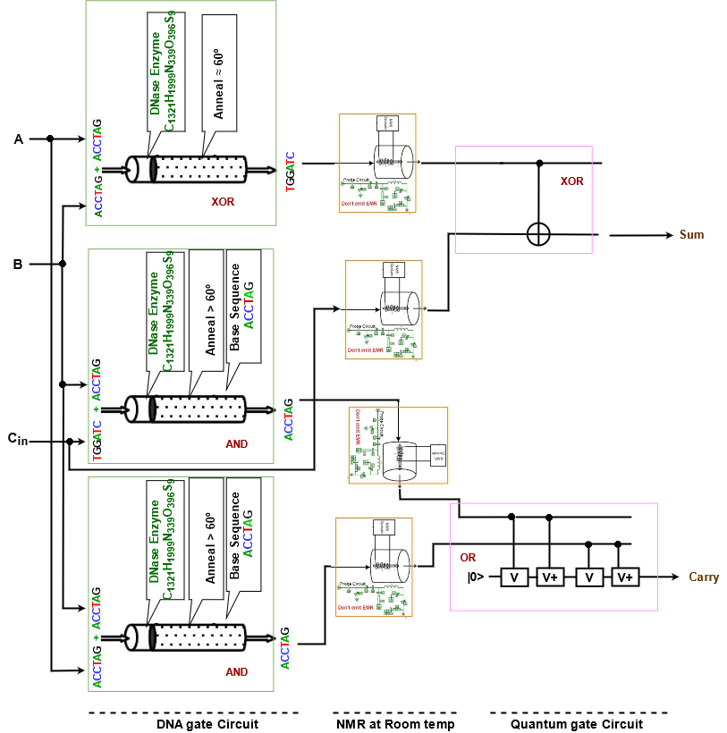

Figure 20: DNA-Quantum Full Adder at room temperature

Specific steps with heat for DNA-Quantum Full Adder in DNA operation (for each tube):

1. basic gate operation preparing (98 oC - 94 oC)
2. Synthesising (98 oC - 94 oC)
3. Mixing (95 oC - 22 oC)
4. Annealing (70 oC - 20 oC)
5. Melting. (Depends on the sequence )
6. Amplifying
7. Seperating
8. Extracting
9. Cutting

20 oC

1. Ligating
2. Substituting
3. Marking
4. Destroying
5. Detecting and Reading. (98 oC - 25 oC)

So, in DNA Full subtractor overall maximum required heat = (98+98+95+70+11+20+98) oC,

= 490 oC,

and minimum required heat = (94+94+22+20+11+20+25) oC,

= 286 oC.

Again, in specific basic DNA gate all the processes are happening in the test tube after mixing is completed. Here in specific cases, we need to keep the temperature high and sometimes we need to keep temperature low for several steps. So, we have to keep the temperature at maximum 94 -98°C. When DNA gate logic operation applies then we need to keep the temperature around 20°C and at detection time we need to keep it as 25°C.

Further, a DNA-Quantum Full Adder is 5 qubit (considering 1 ancilla qubit and 4 input qubit) quantum operation. The output of a DNA operational gate is DNA sequence, which is converted into quantum qubit after processing through NMR at room temperature.

The produced heat generated from quantum operation in the DNA-Quantum Full Adder will be calculated using the following formula.

$\frac{dS_{th}\left(E\right)}{dE}=\frac{n}{T}$

We know, for N qubit gate, Sth (E, N) = N (Kb ln 2) S(E/N)

= $-k_{B}\frac{ϵ-E/N}{ϵ}ln\frac{ϵ-E/N}{ϵ}-k_{B}\frac{E/N}{ϵ}ln\frac{E/N}{ϵ}$

DNA-Quantum Full adder has 5 qubit in the figure. So, N = 5.

Thus, Sth

T = $\frac{dE x N}{dS_{th}\left(E\right)}$

= $\frac{5.7051X{10}^{-16} X 5}{1.984X{10}^{-18}}$

= 1436.49 k

Thus, produced heat from DNA-Quantum Full adder is 1436.49 Kelvin.

### 1.10 Heat calculation in Multivalued Quantum-DNA Circuit

Multivalued quantum computation, according to multivalued quantum computing, is far more advantageous than classical computation systems. Quantum computers are also more powerful in terms of computation than supercomputers. They process data 1000 times faster than normal computers and supercomputers. Quantum computers can perform computations in a fraction of a second that would take a traditional computer 1000 years to finish. Parallelism based on linear superposition of quantum states is a benefit of multivalued quantum computing. It has been demonstrated that multivalued quantum algorithms can solve some problems in fewer steps than conventional classical algorithms.

The use of multivalued (more than two DNA strands) DNA strands to compute, on the other hand, has resulted in high parallel computation, which compensates for the chip's slow processing. When compared to traditional storage systems, DNA requires just about 1 bit per cubic nanometer of memory space. The chemical interactions in DNA provide energy to make or repair new strands, therefore there is essentially no power use. As a result, we may create a multivalued Quantum-DNA computation system to find a super-fast computation system with a lot of memory.The advantages of multivalued quantum computing and multivalued DNA computing can be combined in this multivalued Quantum-DNA computation system.

In a multivalued Quantum-DNA computing system, input is received as a qubit, which is then converted into DNA sequences by NMR relaxation after passing through a specific number of quantum operational gates.

1.10.1 Multivalued Quantum-DNA Half Adder

A multivalued Half Adder is a type of adder, an electronic circuit that performs the addition of ternary numbers. The half adder is able to add two single ternary digits and provide the output plus a carry value. It has two inputs, called A and B, and two outputs S (sum) and C (carry). Multivalued Quantum-DNA Half Adder will add two bits from the quantum ternary digit |0>, |1>, and |2> and produce two outputs as quantum sum |S> and quantum carry bit |C> in a DNA sequence.

To create a Half Adder, seven OR, eleven AND and two Decoder operations are required. Figure 21 describes the multivalued Quantum-DNA circuit of the Half Adder. From the figure we can assume that seventeen quantum operational gates and three DNA operational gates are required to find the expected output from multivalued Quantum-DNA Half Adder.

A multivalued Quantum-DNA Half Adder is 16 qubit (considering 14 ancilla qubit and 2 input qubit) quantum operation. The output qubit from the Quantum operation will be converted in DNA sequence by using NMR relaxation at letter. The produced heat generated from quantum operation will be calculated using the following formula.

$\frac{dS_{th}\left(E\right)}{dE}=\frac{n}{T}$

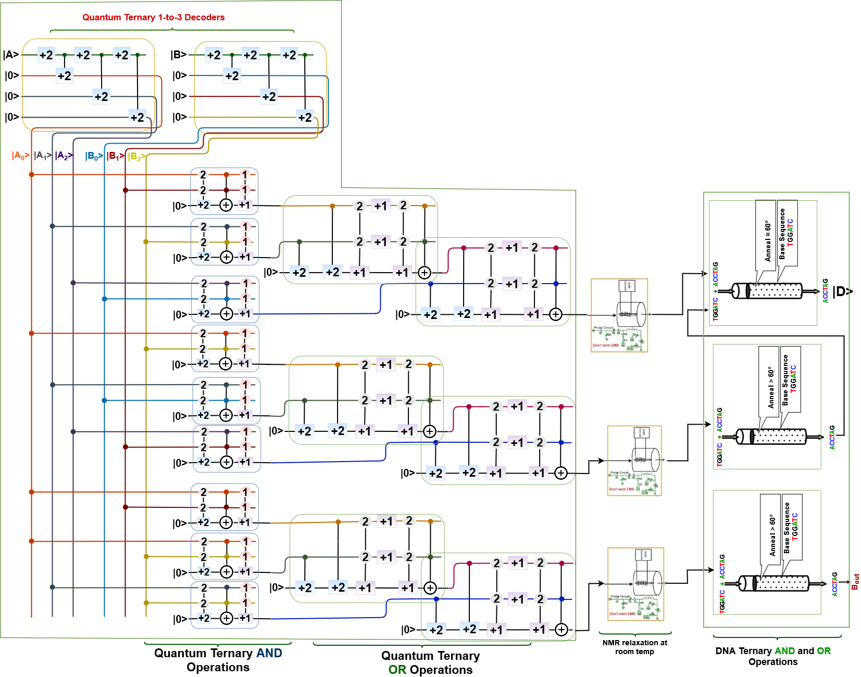

Figure 21: Multivalued Quantum-DNA Half Adder at room temperature

We know, for N qubit gate, Sth (E, N) = N (Kb ln 2) S(E/N)

= $-k_{B}\frac{ϵ-E/N}{ϵ}ln\frac{ϵ-E/N}{ϵ}-k_{B}\frac{E/N}{ϵ}ln\frac{E/N}{ϵ}$

Quantum multivalued Half Adder has 16 qubits in the figure. So, N = 16.

Thus, Sth

T = $\frac{dE x N}{dS_{th}\left(E\right)}$

= $\frac{5.7051X{10}^{-16} X 16}{2.0607X{10}^{-18}}$

= 4429.64 k

Thus, produced heat from Quantum-DNA multivalued Half Adder is 4429.64 Kelvin.

Now, we can have at most two DNA sequence for DNA operational gate in the Quantum-DNA Full adder as follows:

1. TGGATC
2. ACCTAG

Calculating Melting temperature of a specific DNA sequence:

For TGGATC

*Tm =* 2*(A* + *T)* +4*(C* + *G)* - 7

= 2(1 + 2) + 4(1 + 2) - 7

= 11.0 °C

Again, For ACCTAG

*So, Tm =* 2*(A* + *T)* +4*(C* + *G)* - 7

= 2(2 + 1) + 4(2 + 1) - 7

= 11.0 °C

Specific steps with heat for multivalued Quantum-DNA Full Adder in DNA operation (for each tube):

1. Basic gate operation preparing (98 oC - 94 oC)
2. Synthesising (98 oC - 94 oC)
3. Mixing (95 oC - 22 oC)
4. Annealing (70 oC - 20 oC)
5. Melting. (Depends on the sequence )
6. Amplifying
7. Seperating
8. Extracting
9. Cutting

20 oC

1. Ligating
2. Substituting
3. Marking
4. Destroying
5. Detecting and Reading. (98 oC - 25 oC)

So, in DNA operation overall maximum required heat = (98+98+95+70+11+20+98) oC,

= 490 oC,

and minimum required heat = (94+94+22+20+11+20+25) oC,

= 286 oC.

Again, in specific basic DNA gates all the processes are happening in the test tube after mixing is completed. Here in specific cases, we need to keep the temperature high and sometimes we need to keep temperature low for several steps. So, we have to keep the temperature at maximum 94 -98°C. When DNA gate logic operation applies then we need to keep the temperature around 20°C and at detection time we need to keep it as 25°C.

### 1.11 Heat calculation in Multivalued DNA-Quantum Circuit

The use of multivalued (more than two DNA strands) DNA strands to compute, has resulted in high parallel computation, which compensates for the chip's slow processing. When compared to traditional storage systems, DNA requires just about 1 bit per cubic nanometer of memory space. The chemical interactions in DNA provide energy to make or repair new strands, therefore there is essentially no power use. On the other hand, multivalued quantum computation, according to multivalued quantum computing, is far more advantageous than classical computation systems. Quantum computers are also more powerful in terms of computation than supercomputers. They process data thousands times faster than normal computers and supercomputers. Quantum computers can perform computations in a fraction of a second that would take a traditional computer 1000 years to finish. Parallelism based on linear superposition of quantum states is a benefit of multivalued quantum computing. It has been demonstrated that multivalued quantum algorithms can solve some problems in fewer steps than conventional classical algorithms.

As a result, we may create a multivalued DNA-Quantum computation system to find a super-fast computation system with a lot of memory. The advantages of multivalued quantum computing and multivalued DNA computing can be combined in this multivalued DNA-Quantum computation system.

In a multivalued DNA-Quantum computing system, input is received as a DNA sequence, which is then converted into quantum qubits by NMR after passing through a specific number of quantum operational gates.

1.11.1 Multivalued DNA-Quantum Half Subtractor

A Multivalued Half Subtractor is a type of subtractor, an electronic circuit that performs the subtractions of ternary numbers. The half subtractor is able to subtract two single ternary digits and provide the output plus a borrow value. It has two inputs, called A and B, and two outputs D (difference) and B (borrow). DNA-Quantum multivalued Half Subtractor will subtract two DNA sequence from the ternary inputted DNA sequence (TGGATC, ACCTAG and CAAGTC) and produce two outputs as difference |D> and borrow |B> in quantum qubits. The multivalued DNA-Quantum circuit for the ternary half subtractor is shown in Figure 22.

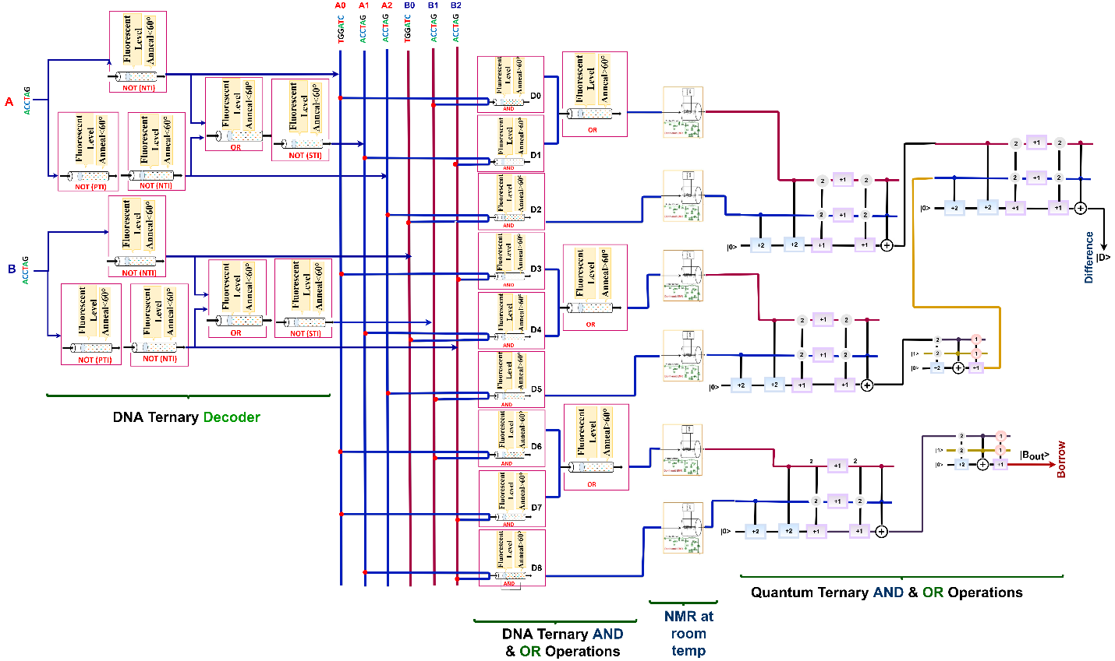

Figure 22: Multivalued DNA-Quantum Half Subtractor at room temperature

From the figure we can assume that twenty-two DNA operational gate and six quantum operational gate are required to find the expected output from multivalued DNA-Quantum Half Subtractor.

Here, we can have at most two DNA sequence for DNA operational gate in the multivalued DNA-Quantum Half Subtractor as follows:

1. TGGATC
2. ACCTAG

Calculating Melting temperature of a specific DNA sequence:

For TGGATC

*Tm =* 2*(A* + *T)* +4*(C* + *G)* - 7

= 2(1 + 2) + 4(1 + 2) - 7

= 11.0 °C

Again, For ACCTAG

*So, Tm =* 2*(A* + *T)* +4*(C* + *G)* - 7

= 2(2 + 1) + 4(2 + 1) - 7

= 11.0 °C

Specific steps with heat for multivalued DNA-Quantum Half Subtractor in DNA operation (for each tube):

1. basic gate operation preparing (98 oC - 94 oC)
2. Synthesising (98 oC - 94 oC)
3. Mixing (95 oC - 22 oC)
4. Annealing (70 oC - 20 oC)
5. Melting. (Depends on the sequence )
6. Amplifying
7. Seperating
8. Extracting
9. Cutting

20 oC

1. Ligating
2. Substituting
3. Marking
4. Destroying
5. Detecting and Reading. (98 oC - 25 oC)

So, in DNA operations overall maximum required heat = (98+98+95+70+11+20+98) oC,

= 490 oC,

and minimum required heat = (94+94+22+20+11+20+25) oC,

= 286 oC.

Again, in specific basic DNA gate all the processes are happening in the test tube after mixing is completed. Here in specific cases, we need to keep the temperature high and sometimes we need to keep temperature low for several steps. So, we have to keep the temperature at maximum 94 -98°C. When DNA gate logic operation applies then we need to keep the temperature around 20°C and at detection time we need to keep it as 25°C.

Further, a multivalued DNA-Quantum Half Subtractor is 9 qubit (considering 3 ancilla qubit and 6 input qubit) quantum operation. The output of a DNA operational gate is DNA sequence, which is converted into quantum qubit after processing through NMR at room temperature.

The produced heat generated from quantum operation in the multivalued DNA-Quantum Half Subtractor will be calculated using the following formula.

$\frac{dS_{th}\left(E\right)}{dE}=\frac{n}{T}$

We know, for N qubit gate, Sth (E, N) = N (Kb ln 2) S(E/N)

= $-k_{B}\frac{ϵ-E/N}{ϵ}ln\frac{ϵ-E/N}{ϵ}-k_{B}\frac{E/N}{ϵ}ln\frac{E/N}{ϵ}$

Multivalued DNA-Quantum Half Subtractor has 9 qubit in the figure. So, N = 9.

Thus, Sth

T = $\frac{dE x N}{dS_{th}\left(E\right)}$

= $\frac{5.7051X{10}^{-16} X 9}{1.996X{10}^{-18}}$

= 2572.43 k

Thus, produced heat from multivalued DNA-Quantum Half Subtractor is 2572.43 Kelvin.

### 1.12 Applications

This section describes some real-life applications of DNA and Quantum operation, where it is used and provides superior performance against classical computing systems. In case of different applications classical computing systems might fail but Quantum and DNA computing systems can show its capability.

***Traveling salesman problem***: The first theory of DNA computation was proposed by Leonard Adleman in 1994. He put his experimental theory into the test with a seven-point Hamiltonian path problem or also called the traveling salesman problem. The salesman in this problem needs to find the shortest path between seven cities whose distances are known in such a way that he crosses no city twice and returns to the original city. Adleman represented each city with a short DNA sequence with about 20 bases and a complementary strand with 20 bases as the street between the cities. All the fragments are capable of linking with each other. When the fragments were put in a tube and mixed, the natural bonding tendencies of the DNA created 109 formations or solutions in less than a second. Not all were correct and he took a week to extrapolate and filter out the shortest path through various techniques. Though this solution was not ideal, this demonstration opened floodgates to a wide range of possibilities and applications.

***Security*:** Deploying DNA algorithms in cryptography to build an intrusion detection model is the most recent development. The ability to store 108 terabytes of data in 1 gram of DNA has led to the potential holding a huge one time pad. Another example is DNA steganography, in which a novel method was used to hide the messages in a microdot. Instead of the traditional binary encoding, each letter was denoted by three chemical bases i.e. the letter A was encoded by CGA. These messages are then encoded into DNA sequences and concealed by mixing it in a tube with a large amount of sonicated random human DNA. This led to the formation of microdots, which was then decoded by the receiver with appropriate primers(short sequence with complementary bases). However such encryption techniques have been posed with problems. The lack of a theoretical basis to explain the implementation and come up with good schemes seem to be a challenge. These are also expensive to apply, and analyze which requires modern infrastructure.

***Artificial intelligence and machine learning***: Artificial intelligence and machine learning are some of the prominent areas right now, as the emerging technologies have penetrated almost every aspect of humans’ lives. Some of the widespread applications we see every day are in voice, image and handwriting recognition. However, as the number of applications increases, it becomes a challenging task for traditional computers, to match up the accuracy and speed. And, that’s where quantum computing can help in processing complex problems in very less time, which would have taken traditional computers thousands of years.

### 1.13 Summary

Quantum computing focuses on speedy technology based on quantum theoretical principles, which is the behavior of energy and matter of a qubit. Combination of qubits is used to perform any specific task in quantum computing. Quantum computers represent a significant advancement in computing capability, with enormous performance benefits for specific use cases. The ability of bits to be in several states at the same time gives the quantum computer a lot of computing capability and it is much faster than classical bitwise computing.

Furthermore, DNA computing uses biological molecules to do computations. The four-character genetic alphabet (A-adenine, G-guanine, C-cytosine, and T-thymine) is used in DNA computing. Input of any DNA operation can be represented by DNA molecules with specific sequences. The instructions are carried out by laboratory operations on the molecules, and the result is defined as some property of the final set of molecules. DNA computing promises significant and meaningful linkages between computers and life systems, as well as massively parallel computations. DNA computing can actually carry out millions of operations at the same time.

To advance computation, we can make or use DNA-Quantum computing and Quantum-DNA computing systems, which will merge all the advantages of both DNA computing and Quantum computing.

Heat is an important property of any operation for computation. We have found that, in quantum computing operation, much heat is produced by circuits, which is dependent on the number of qubits in the operational circuit. On the other hand, in DNA computing, we have to provide heat in the test tube to execute the operation. Its different stage needs different amounts of time and heat, which is highlighted in this chapter. In addition, we can use the produced heat of quantum computing in the DNA computing operation by using some heat transfer nanotube. The mechanism of heat transfer will be discussed in chapter 2.

### Reference

1. Diósi, L. (2011). Qubit Thermodynamics. In *A Short Course in Quantum Information Theory* (pp. 123-133). Springer, Berlin, Heidelberg.
2. Freier, S. M., Kierzek, R., Jaeger, J. A., Sugimoto, N., Caruthers, M. H., Neilson, T., & Turner, D. H. (1986). Improved free-energy parameters for predictions of RNA duplex stability. *Proceedings of the National Academy of Sciences*, *83*(24), 9373-9377.
3. Breslauer, K. J., Frank, R., Blöcker, H., & Marky, L. A. (1986). Predicting DNA duplex stability from the base sequence. *Proceedings of the National Academy of Sciences*, *83*(11), 3746-3750.
4. Zheng, X., Yang, J., Zhou, C., Zhang, C., Zhang, Q., & Wei, X. (2019). Allosteric DNAzyme-based DNA logic circuit: Operations and dynamic analysis. *Nucleic acids research*, *47*(3), 1097-1109.
5. Watada, J. (2008). DNA computing and its application. In *Computational intelligence: a compendium* (pp. 1065-1089). Springer, Berlin, Heidelberg.
6. Adleman, L. M. (1994). Molecular computation of solutions to combinatorial problems. *Science*, *266*(5187), 1021-1024.

# Chapter III

## Speed Calculation

### 2.1 **Introduction**

DNA computing is a kind of natural computing that uses the molecular characteristics of DNA to conduct logical and arithmetic operations instead of typical carbon/silicon chips. The four-character genetic alphabet (A-adenine, G-guanine, C-cytosine, and T-thymine) is used in DNA computing instead of the binary alphabet (1 and 0) utilized by standard computers. This enables massively parallel computation, making it possible to answer difficult mathematical equations or problems in a fraction of the time. As a result, computation is far more efficient with a large volume of self-replicating DNA than with a standard computer, which would require a lot more hardware. Information or data will now be kept in the form of the bases A, T, G, and C, rather than binary digits. The capacity to generate short DNA sequences artificially allows these sequences to be used as inputs for algorithms. This is possible due to the ability to create small DNA molecules with any arbitrary sequence.  Input of any DNA operation can be represented by DNA molecules with specific sequences. The instructions are carried out by laboratory operations on the molecules, and the result is defined as some property of the final set of molecules. DNA computing promises significant and meaningful linkages between computers and life systems, as well as massively parallel computations. DNA computing can actually carry out millions of operations at the same time.

On the other hand, Quantum computing is a field of study that focuses on the creation of computer-based technologies based on quantum theoretical principles. On the quantum (atomic and subatomic) level, quantum theory describes the nature and behavior of energy and matter. To execute certain computational tasks, quantum computing employs a combination of qubits. All of this is done at a far higher rate than their traditional computing equipment. Quantum computers represent a significant advancement in computing capability, with enormous performance benefits for specific use cases. The ability of bits to be in several states at the same time gives the quantum computer a lot of computing capability. They can accomplish jobs with a mix of | 1 >, | 0 >, and both | 1 > and | 0 > at the same time. So, quantum computing can be defined as an area of computing which is focused on the development of computer technology based on the principles of quantum theory. In addition, quantum computing is much faster than classical bit-wise computing.

Besides accuracy of a system, time or speed is a metric which can be used to measure the performance of a system. In this chapter, we are going to provide calculated speed or consumed time for different operations in Quantum, DNA, Quantum-DNA and DNA-Quantum computation systems.

### 2.2 Speed Calculation for Quantum Operation

Researchers have proposed the theory and formula to calculate the average required operational time in any quantum computation. Numerous researchers have also applied it in their work and research studies. The average computation time needed for an operation is calculated by equation (1), as follows:

|  |  |
| --- | --- |
| $$τ=\frac{h}{4E}$$ | (1) |

Where, $τ$ is the required operational time, *h* is the plank’s constant and E is the quantum mechanical average energy of the performing system. It has also shown that the minimum operation time of any digital logic gate in quantum computation is given below:

|  |  |
| --- | --- |
| $$τ=\frac{h}{4E}\left(1+2\frac{θ}{π}\right)$$ | (2) |

Here, $τ$ is the required operational time, *h* is the plank’s constant, E is the quantum mechanical average energy of the performing system, and $θ$ is the phase shift modulo $π$. It considers any basic quantum gate that complements the state of a qubit and then adds to it an arbitrary phase shift.

Numerous researches have noted that, any basic quantum operation needs some basic amount of time which is tabulated in Table 1. It describes that a single gate operation as NOT needs 1 µs and a double qubit gate as CNOT, V, V+ needs approximately 10 µs. Sometimes one output of a gate operation in quantum computing can be needed in another gate operation to perform. In that case we need movement time approximately 20 µs and in future it can be required more or less 10 µs.

Table **1**: Execution times for basic quantum gate operations.

|  |  |
| --- | --- |
| **Operations** | **Time (µs) now (future)** |
| Single qubit gate | 1 (1) |
| Double qubit gate | 10 (10) |
| Movement | 20 (10) |

As a basic quantum operational gate is composed of a single or double qubit gate, we can easily calculate the required operational time for a quantum operation by using the information provided in Table 1.

Now, we are going to calculate basic quantum operational time in their operational gates like AND, OR, XOR, NAND, NOR, and XNOR Quantum operational gates. These Quantum operational gates are prepared with Quantum gates as NOT, CNOT, V+, and V.

1. **Speed Calculation for Quantum AND operation:**

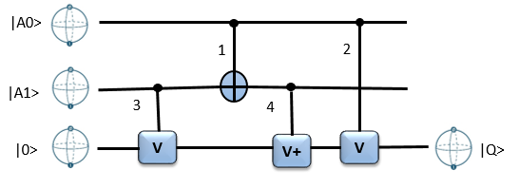

Figure 1: Quantum AND operation circuit

Here, Figure 1 describes Quantum AND gate operation, which is nothing but a circuit that is composed of four Quantum gates (CNOT, V and V+). It has three lines to the output, where only the last one can provide the expected output as AND operations do.

The CNOT (1) and V (3) quantum gates can operate in parallel in this operational circuit. So, required operational time for both of them is = 10 µs.

The V+ (4) gate operates sequentially and its input depends on the output of CNOT (1) and V (2) quantum gates. So, the required operational time for V+ (4) gate is = 10 µs.

Again, the V (2) gate operates sequentially and its input depends on the input A0 and output of V+ (4) quantum gate. So, the required operational time for V (2) gate is = 10 µs.

So, Total required time for AND operation = (Operational time for CNOT (1) or V (3) gate + Operational time for V+ (4) gate + Operational time for V (2) gate)

= (10 + 10 + 10) µs

= 30 µs.

Thus, the total required operation time for Quantum AND operation is 30 µs.

1. **Speed Calculation for Quantum OR operation:**

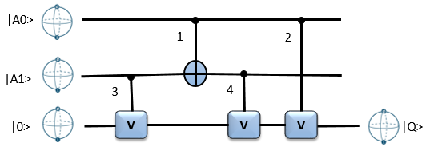

Figure 2: Quantum OR operation circuit

Here, Figure 2 describes Quantum OR gate operation, which is nothing but a circuit that is composed of four Quantum gates (CNOT and V). It has three lines to the output, where only the last one can provide the expected output as OR operations do.

The CNOT (1) and V (3) quantum gates can operate in parallel in this operational circuit. So, required operational time for both of them is = 10 µs.

The V (4) gate operates sequentially and its input depends on the output of CNOT (1) and V (2) quantum gates. So, the required operational time for V (4) gate is = 10 µs.

Again, the V (2) gate operates sequentially and its input depends on the input A0 and output of V (4) quantum gate. So, the required operational time for V (2) gate is = 10 µs.

So, Total required time for OR operation = (Operational time for CNOT (1) or V (3) gate + Operational time for V (4) gate + Operational time for V (2) gate)

= (10 + 10 + 10) µs

= 30 µs.

Thus, the total required operation time for Quantum OR operation is 30 µs.

1. **Speed Calculation for Quantum XOR operation:**

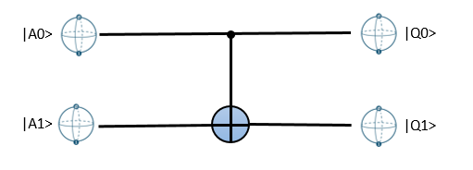

Figure 3: Quantum XOR operation circuit

Here, Figure 3 describes Quantum XOR gate operation, which is nothing but a circuit that is composed of one basic Quantum gate (CNOT). It has two lines to the output, where only the last one can provide the expected output as XOR operations do.

The total required time for XOR operation depends on the operational time of double qubit gate CNOT gate.

So, the required time for XOR operation is 10 µs.

1. **Speed Calculation for Quantum NAND operation:**

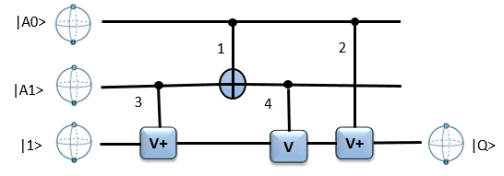

Figure 4: Quantum NAND operation circuit

Here, Figure 4 describes Quantum NAND gate operation, which is nothing but a circuit that is composed of four Quantum gates (CNOT, V+ and V). It has three lines to the output, where only the last one can provide the expected output as NAND operations do.

The CNOT (1) and V+ (3) quantum gates can operate in parallel in this operational circuit. So, required operational time for both of them is = 10 µs.

The V (4) gate operates sequentially and its input depends on the output of CNOT (1) and V+ (3) quantum gates. So, the required operational time for V (4) gate is = 10 µs.

Again, the V+ (2) gate operates sequentially and its input depends on the input A0 and output of V (4) quantum gate. So, the required operational time for V+ (2) gate is = 10 µs.

So, Total required time for NAND operation = (Operational time for CNOT (1) or V+ (3) gate + Operational time for V (4) gate + Operational time for V+ (2) gate)

= (10 + 10 + 10) µs

= 30 µs.

Thus, the total required operation time for Quantum NAND operation is 30 µs.

1. **Speed Calculation for Quantum NOR operation:**

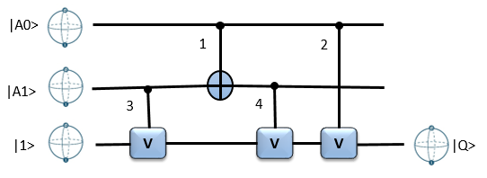

Figure 5: Quantum NOR operation circuit

Here, Figure 5 describes Quantum NOR gate operation, which is nothing but a circuit that is composed of four Quantum gates (CNOT and V). It has three lines to the output, where only the last one can provide the expected output as NOR operations do.

The CNOT (1) and V (3) quantum gates can operate in parallel in this operational circuit. So, required operational time for both of them is = 10 µs.

The V (4) gate operates sequentially and its input depends on the output of CNOT (1) and V (3) quantum gates. So, the required operational time for V (4) gate is = 10 µs.

Again, the V (2) gate operates sequentially and its input depends on the input A0 and output of V (4) quantum gate. So, the required operational time for V (2) gate is = 10 µs.

So, Total required time for NOR operation = (Operational time for CNOT (1) or V (3) gate + Operational time for V (4) gate + Operational time for V (2) gate)

= (10 + 10 + 10) µs

= 30 µs.

Thus, the total required operation time for Quantum NOR operation is 30 µs.

1. **Speed Calculation for Quantum XNOR operation:**

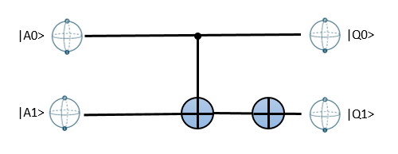

Figure 6: Quantum XNOR operation circuit

Here, Figure 6 describes Quantum XNOR gate operation, which is nothing but a circuit that is composed of two Quantum gates (CNOT and NOT). It has two lines to the output, where only the last one can provide the expected output as XNOR operations do.

The CNOT gate operates sequentially and its input depends on the input of A1 and A0. So, the required operational time for the CNOT gate is = 10 µs.

Again, the NOT gate operates sequentially and its input depends on the output of the CNOT quantum gate. So, the required operational time for NOT gate is = 1 µs.

So, Total required time for XNOR operation = (Operational time for CNOT gate + Operational time for NOT gate)

= (10 + 1) µs

= 11 µs.

Thus, the total required operation time for Quantum XNOR operation is 11 µs.

### 2.2 **Speed Calculation in Quantum Operational Circuit**

In this section, we are going to calculate the total operational time of a quantum operational circuit. The basic information for calculating operational time of a circuit is provided in the previous section.

#### 3.2.1 Quantum Full subtractor

A Full subtractor is a combinational circuit that is developed to overcome the drawback of the half subtractor circuit. It can take three inputs and after subtracting them creates two outputs. Here, Full subtractor is implemented using the Quantum circuit. To create a Full Subtractor, two NOT, two XOR, two AND, and an OR gate is required. Figure 7 describes the quantum circuit of a full subtractor. A full subtractor receives three inputs and produces two outputs containing “D” and “Bout”.

To find the required performing time of a Quantum full subtractor, we divide it in three pipelines as some of the basic quantum gate operations are performed in parallel. Three pipelines are as follows:

1. XOR, XOR
2. XOR, NOT, AND, OR
3. NOT, AND, OR

According to subsection 3.1, we can perceive that XOR, AND and OR quantum gate operation needs 10µs, 30 µs and 30µs respectively. And, a single qubit quantum operation as NOT need 1 µs. As the second pipeline is the largest pipeline for providing output of the full subtractor, we are taking it for measuring total required performing time. Other’s quantum basic gate operations will be performed within this time in parallel.

Required time for full subtractor is = (XOR+ NOT+ AND+ OR) µs.

Where, required time for basic quantum NOT gate = 1 µs,

required time for basic quantum XOR gate = 10 µs,

required time for basic quantum AND gate = 30 µs,

required time for basic quantum OR gate = 30 µs,

Required time for full subtractor is = (10+ 1+ 30+ 30) µs = 71 µs.



Figure 7: Quantum Full subtractor circuit.

#### 3.2.2 Quantum 3-bit even parity bit checker

A circuit that checks the parity in the receiver is called Parity Checker. A combined circuit or device of parity generators and parity checkers are commonly used in digital systems to detect the single bit errors in the transmitted data. To create a 3 bit even parity bit checker, three XOR gates are required. Figure 8 describes the digital and quantum circuit of a 3 bit even parity bit checker. A 3 bit even parity bit checker receives four inputs and produces one output containing “E”.

To find the required performing time of Quantum 3 bit even parity bit checker, we divide it in two pipelines as some of the basic quantum gate operations are performed in parallel. Two pipelines are as follows:

1. XOR, XOR
2. XOR, XOR

According to subsection 3.1, we can perceive that XOR quantum gate operation needs 10µs. As both pipelines are equal pipeline for providing output of the 3 bit even parity bit checker, we are taking any of them for measuring total required performing time. Other quantum basic gate operations will be performed within this time in parallel.

Performing time for 3 qubits even parity bit checkers will be (XOR+ XOR) µs.

Where, required time for basic quantum XOR gate = 10 µs.

So, the required time for a 3 bit even parity bit checker is = (10 + 10) = 20 µs.



Figure 8: Quantum 3 bit even parity bit checker

#### 3.2.3 Quantum 2:1 Multiplexer

A multiplexer (MUX) is a device that can receive multiple input signals and synthesize a single output signal in a recoverable manner for each input signal. It is also an integrated system that usually contains a certain number of data inputs and a single output. To create a multiplexer, one NOT, two AND, and an OR gate is required. Figure 9 describes the quantum circuit of the Multiplexer. A Multiplexer receives three inputs and produces one output containing “Y”.

To find the required performing time of a Quantum Multiplexer, we divide it in two pipelines as some of the basic quantum gate operations are performed in parallel. Two pipelines are as follows:

1. NOT, AND, OR
2. AND, OR

According to subsection 3.1, we can perceive that AND and OR quantum gate operation needs 30µs respectively. And, a single qubit quantum operation as NOT need 1 µs. As the first pipeline is the largest pipeline for providing output of the Multiplexer, we are taking it for measuring total required performing time. Other quantum basic gate operations will be performed within this time in parallel.

Performing time for full Multiplexer will be (NOT+ AND+ OR) µs.

Where, required time for basic quantum NOT gate = 1 µs,

required time for basic quantum AND gate = 30 µs,

required time for basic quantum OR gate = 30 µs,

So, the required time for Multiplexer is = (1 + 30 + 30) = 61 µs.



Figure 9: Quantum Multiplexer circuit.

### 2.3 Speed Calculation for DNA operation

DNA molecules can be used as information storage media. Usually, DNA sequences of around 8-20 base-pairs are used to represent bits, and numerous methods have been developed to manipulate and evaluate these. In order to manipulate a wet technology to perform computations, one or more of the following techniques are used as computational operators for copying, sorting, splitting or concatenating the information contained within DNA molecules as ligation, hybridization, polymerase chain reaction (PCR), gel electrophoresis, and enzyme reaction.

Allosteric DNAzyme-based DNA logic circuit, described a procedure to make a DNAzyme-based logic circuit. Here, All DNA logic gates were formed by annealing twice: firstly, the mixture of the inhibitor DNA strands and E6-type DNAzymes in 1× TAE*/*Mg2+ buffer (40 mM Tris, 20 mM acetic acid, 1 m MEDTA2Na and 12.5 mM Mg(OAc)2, pH 8.0) was heated at 95◦C for 4 min, 65◦C for 30 min, 50◦C for 30 min, 37◦C for 30 min, 22◦C for 30 min, and preserved at 20◦C; and then the substrates were added into the annealed mixture and incubated at constant temperature 20◦C for 4 h (total 6hr for preparing the DNA logic gate).

After that Logic gates were triggered through displacement reaction in 1× TAE*/*Mg2+ buffer (40 mM Tris, 20 mM acetic acid, 1 mM EDTA2Na, and 12.5 mM Mg(OAc)2, pH 8.0). The input DNA strands were added to a solution containing DNA logic gates and reacted for *>* 2 h at 20◦C. Next, the displaced products were stored at 20◦C for native PAGE or fluorescence detection. In addition, polyacrylamide gel electroghoresis (PAGE) needs 2hr and PCR process for fluoresence detection needs less than 2 hr.

Here we are going to describe a specific biochemical process briefly which serves as the basis of our DNA computing approach as Polymerase Chain Reaction (PCR). Polymerases perform several functions, including the repair and duplication of DNA. PCR is a process that quickly amplifies the amount of specific DNA molecules in a given solution, using primer extension by polymerase. Each cycle of the reaction doubles the quantity of this molecule, leading to an exponential growth in the number of sequences. It consists of the following key processes:

1. Initialization: a mix solution of template, primer, dNTP and enzyme is heated to 94 *−* 98*◦C* for 1 *−* 9 minutes to ensure that most of the DNA template and primers are denatured;
2. Denaturation: heat the solution to 94 *−* 98*◦C* for 20 *−* 30 seconds for separation of DNA duplexes;
3. Annealing: lower the temperature enough (usually between 50*−*64*◦C*) for 20*−*40 seconds for primers to anneal specifically to the ssDNA template;
4. Elongation/Extention: raise temperature to optimal elongation temperature of *Taq* or similar DNA polymerase (70 *−* 74*◦C*) for the polymerase adds dNTP’s from the direction of 5’ to 3’ that are complementary to the template;
5. Final Elongation/Extention: after the last cycle, a 5 *−* 15 minutes elongation may be performed to ensure that any remaining ssDNA is fully extended.

Step 2 to 4 is repeated 20*−*35 times; less cycles results in less product, too many cycles increase the fraction of incomplete and erroneous products. PCR is a routine job in the laboratory that can be performed by an apparatus named *thermal cycler*. According to the PCR process, to produce an operational output of DNA computation we need around 2 hours.

So, except initial preparation and the last phase of fluoresence detection for each operation in a particular test-tube, we need more or less 2hr.

### 2.4 **Speed Calculation in DNA Operational Circuit**

This subsection is going to describe some DNA circuit to calculate its performing time or speed in an approximate value based on the theory described in Section 3.3.

#### 2.4.1 DNA Full Subtractor

A full subtractor is a combinational circuit that performs subtraction of two bits, one is minuend and other is subtrahend, taking into account borrow of the previous adjacent lower minuend bit. This circuit has three inputs and two outputs**.** The three inputs A, B and Bin, denote the minuend, subtrahend, and previous borrow, respectively. The two outputs, D and Bout represent the difference and output borrows, respectively. To create a full subtractor, one OR, two AND, two OR and 2 XOR gates are required. Figure 10 describes the DNA circuit of a full subtractor. Here, two input will be DNA sequences and it also provide two output which contains DNA sequence.

To find the required performing time of a DNA Full Subtractor, we divide it in three pipelines as some of the basic DNA gate operations are performed in parallel. Three pipelines are as follows:

1. XOR, NOT, XOR
2. XOR, NOT, AND, OR
3. NOT, AND, OR

According to subsection 3.3, we can perceive that any DNA basic gate (i.e. AND, OR, NOT and XOR) operation needs more or less 2hr to perform. In addition, we need 6hr for preparing any DNA basic gate operation and 2hr for fluoresence detection which is fixed for any multi-(basic) gate operation.

As the second pipeline is the largest pipeline for processing input to output of the Full Subtractor, we are taking it for measuring total required performing time. Other DNA basic gate operations will be performed within this time in parallel.

So, required time for four basic gate operations in DNA is = (2 + 2 + 2 +2)

= 8hr.

Where, performing time for DNA gate (AND, OR, NOT and XOR) operation needs more or less 2hr.

The total performing time/ required time for performing DNA Full Subtractor is summation of initial preparation time, fluoresence detection time and DNA gate operational time.

So, required time for DNA Multiplexer is

= (Basic gate preparation time + Four basic DNA gate operational time + Fluoresence detection)

= (6 + 8 + 2)

= 16hr (approximately).



Figure 10: DNA Full Subtractor circuit.

#### 2.4.2 DNA Full Adder

Full Adder is the adder which adds three inputs and produces two outputs. The first two inputs are A and B and the third input is an input carry as C-IN. The output carry is designated as Cout and the normal output is designated as S which is SUM. A full adder logic is designed in such a manner that can take eight inputs together to create a byte-wide adder and cascade the carry bit from one adder to the another. To create a Full Adder, one OR, two NAND, one XOR and 2 NOT gate is required. Figure 11 describes the DNA circuit of the Full Adder.



Figure 11: DNA Full Adder circuit.

To find the required performing time of DNA Full Adder, we divide it in three pipelines as some of the basic DNA gate operations are performed in parallel. Three pipelines are as follows:

1. XOR, XOR
2. XOR, NAND, NOT, OR
3. NAND, NOT, OR

According to subsection 3.3, we can perceive that any DNA basic gate (i.e., AND, OR, NOT and XOR) operation needs more or less 2hr to perform. In addition, we need 6hr for preparing any DNA basic gate operation and 2hr for fluoresence detection which is fixed for any multi-(basic) gate operation.

As the second pipeline is the largest pipeline for processing input to output of the Full Adder, we are taking it for measuring total required performing time. Other DNA basic gate operations will be performed within this time in parallel.

So, required time for four basic gate operations in DNA is = (2 + 2 + 2 +2)

= 8hr.

Where, performing time for DNA gate (NAND, OR, NOT and XOR) operation needs more or less 2hr.

The total performing time/ required time for performing DNA Full Adder is summation of initial preparation time, fluoresence detection time and DNA gate operational time.

So, required time for DNA Full Adder is

= (Basic gate preparation time + Four basic DNA gate operational time + Fluoresence detection)

= (6 + 8 + 2) hr

= 16hr (approximately).

#### 2.4.3 DNA Multiplication circuit

A binary multiplier is a combinational logic circuit or digital device used for multiplying two binary numbers. The two numbers are more specifically known as multiplicand and multiplier and the result is known as a product. The multiplicand and multiplier can be of various bit sizes. The product’s bit size depends on the bit size of the multiplicand & multiplier. The bit size of the product is equal to the sum of the bit size of multiplier multiplicand. To create a Multiplication circuit, six NAND, two XOR and 6 NOT gates are required. Figure 12 describes the DNA circuit of the 2-bit multiplication.

To find the required performing time of a DNA multiplication circuit, we divide it in multiple pipelines as some of the basic DNA gate operations are performed in parallel. Among all of the pipelines, five are as follows:

1. NAND, NOT
2. NAND, NOT, XOR
3. NAND, NOT, NAND, NOT, NAND, NOT
4. NAND, NOT, NAND, NOT
5. NAND, NOT, XOR

According to subsection 3.3, we can perceive that any DNA basic gate (i.e., AND, OR, NOT and XOR) operation needs more or less 2hr to perform. In addition, we need 6hr for preparing any DNA basic gate operation and 2hr for fluoresence detection which is fixed for any multi-(basic) gate operation.

As the third pipeline is the longest pipeline for processing input to output of the 2-bit multiplication circuit, we are taking it for measuring total required performing time. Other DNA basic gate operations will be performed within this time in parallel.

So, required time for four basic gate operations in DNA is = (2 x 6)

= 12hr.

Where, performing time for DNA gate (NAND and NOT) operation needs more or less 2hr.

The total performing time/ required time for performing DNA 2-bit multiplication circuit is summation of initial preparation time, fluoresence detection time and DNA gate operational time.

So, required time for DNA 2-bit multiplication circuit is

= (Basic gate preparation time + Six basic DNA gate operational time + fluoresence detection)

= (6 + 12 + 2) hr

= 20hr (approximately).



Figure 12: Quantum Multiplier circuit.

### 2.5 Speed Calculation in Multivalued Quantum Circuit

Quantum computing embraces emerging technological areas such as quantum information system, quantum cryptography. Its behavior is defined by quantum algorithms which exploit the quantum mechanical phenomenon of matter. The advantage of quantum computing is parallelism based on linear superposition of quantum states. It has been shown that certain problems can be solved in fewer steps by quantum algorithms than by existing classical ones. A 2-state quantum system is usually defined with the two pure states ∣0 > and ∣1 > as basis states, and the unit of information is known as qubit. Presently, multivalued quantum computing is gaining importance in the field of quantum information theory and quantum cryptography as it can represent an n-dimensional quantum system, defined by the basics states ∣0 >, ∣1 >, ..., ∣𝑛-1>. The unit of information is called qubit. For a ternary quantum system, this unit is termed as qutrit. A ternary quantum system exists is linear superposition of three basis states, labeled | 0 >, | 1 > and | 2 >.

Multivalued logic is one of the cases that drew the attention of the researchers. Meanwhile the ternary circuits were more accepted because of their advantages over the binary circuits. Ternary quantum computation has high fault tolerance and high speed as compared to the binary, and is useful for quantum simulation, quantum tomography, and quantum games.

In multivalued quantum computing, we have single qubit gate (NOT, shift operation as, 1 and 2), double qubit gate (CNOT, controlled shift operation), and triple qubit gate (C2NOT, controlled shift operation). The calculation of required time for a quantum gate and operational gate is described in this section.

1. ***Speed calculation in Multivalued 1-bit controlled operation*:**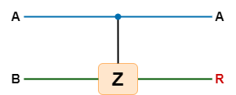

Figure 13: Ternary 1-qubit Controlled Operation

Here, Figure 13 describes multivalued Quantum 1-qubit controlled operation, which is an important and basic gate for multivalued Quantum computing. It is a two-qubit gate and according to Section 3.1, we can assume that it needs 10 µs to perform.

According to Section 3.1, all double qubit gates are 1-qubit controlled operation and all 1-qubit shift operations need almost 10 µs to perform.

1. ***Speed calculation in C2NOT operation:***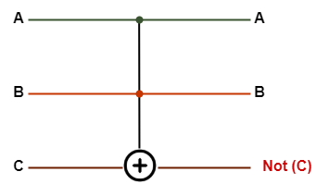

Figure 14: Ternary 3-qubit C2NOT gate Operation

Here, Figure 14 describes a multivalued Quantum 2-qubit controlled operation, which is named as C2NOT gate. It can be used to implement all multivalued quantum operations. It is a three-qubit gate and it can be implemented as two double-qubit operational gates. Further, according to Section 3.1, we can assume that each double qubit gate needs 10µs to perform.

According to Section 3.1, required time for the C2NOT gate operation = (10 + 10) µs.

= 20 µs.

In addition, all triple qubit gate operations are 2-qubit controlled operations and all 2-qubit shift operations need almost 20 µs to perform.

1. ***Speed calculation in Quantum Multivalued AND operation:***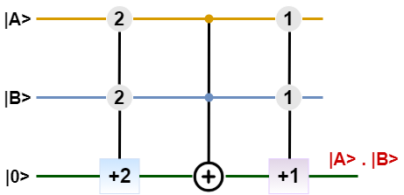

Figure 15: The circuit diagram of Multivalued AND Operation

Here, Figure 15 describes multivalued Quantum AND operation. The Quantum multivalued AND operation requires the shifting operations that include (+1) and (+2) shifting. Where one (+2) operation is controlled by both inputs and will open only if the value of both inputs is |2>. Other one (+1) operation is controlled by both inputs and will open only if the value of both inputs is |1>. And a C2NOT gate is used which will work only if the inputs A and B meet conditions of A != B and A,B != 0.

The following steps can help us to calculate required time for multivalued quantum AND operation as:

1. Triple qubit (+2) shift operations required time = 20 µs,
2. Triple qubit C2NOT operations required time = 20 µs,
3. Triple qubit (+1) shift operations required time = 20 µs

So, required time for the AND gate operation = (operational time for (+2) shift operation + operational time for C2NOT gate + operational time for (+1) shift operation) µs.

= (20 + 20 + 20) microseconds

= 60 microseconds

Thus, Total required time for Quantum multivalued AND operation is 60 microseconds.

1. ***Speed calculation in Quantum Multivalued OR operation:*** 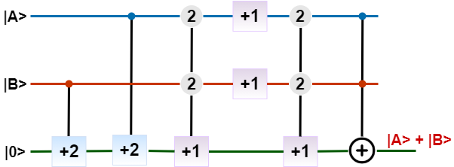

Figure 16: The circuit diagram of Multivalued OR Operation

Here, Figure 16 describes multivalued Quantum OR operation. The Quantum multivalued OR operation requires the shifting operations that include (+1) and (+2) shifting. Where two (+1) operation is not controlled, and two (+1) operation is controlled by two inputs. Further, two (+2) operations are controlled by each input. And, a two-input controlled C2 NOT gate is also required to get the expected result.

The following steps can help us to calculate required time for multivalued quantum OR operation as:

1. Double qubit (+2) shift operation required time = 10 µs,
2. Double qubit (+2) shift operation, whose input depends on the output of first (+2) shift operation requires time = 10 µs,
3. Triple qubit (+1) shift operations, whose input depends on the output of first and second (+2) shift operation requires time = 20 µs,
4. Next, two one qubit operation (+1) shift will perform parallelly. So, we can avoid it.
5. Triple qubit (+1) shift operations, whose input depends on the output of previous operations requires time = 20 µs,
6. Last Triple qubit C2NOT operation, whose input depends on the output of the previous operation, requires time = 20 µs.

So, required time for the AND gate operation = (2 x 10 + 3 x 20) microseconds

= 80 microseconds

Thus, Total required time for Quantum multivalued OR operation is 80 microseconds.

1. ***Speed calculation in Quantum Multivalued XOR operation:*** 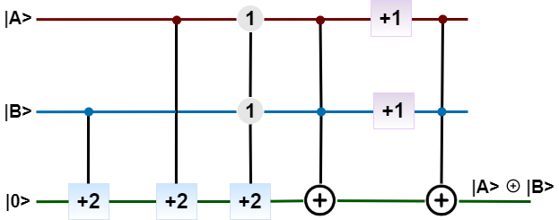

Figure 17: The circuit diagram of Multivalued XOR Operation

Here, Figure 17 describes a multivalued Quantum XOR operation. The Quantum Multivalued XOR operation requires the shifting operations that include (+1) and (+2) shifting. Where two (+1) operation is not controlled, and two (+2) operation is controlled by respective one input. And one (+2) operation is controlled by both inputs. And, two two-input controlled C2 NOT gates are also required to get the expected result.

The following steps can help us to calculate required time for multivalued quantum OR operation as:

1. Double qubit (+2) shift operation required time = 10 µs,
2. Double qubit (+2) shift operation, whose input depends on the output of first (+2) shift operation requires time = 10 µs,
3. Triple qubit (+2) shift operations, whose input depends on the output of first and second (+2) shift operation requires time = 20 µs,
4. Triple qubit C2NOT operation, whose input depends on the output of the previous operation, requires time = 20 µs.
5. Next, two one qubit operation (+1) shift will perform parallelly. So, we can avoid its operational time.
6. Last Triple qubit C2NOT operation, whose input depends on the output of the previous operation, requires time = 20 µs.

So, required time for the XOR gate operation = (2 x 10 + 3 x 20) microseconds

= 80 microseconds

Thus, Total required time for Quantum multivalued XOR operation is 80 microseconds.

1. ***Speed calculation in Quantum Multivalued NAND operation:***

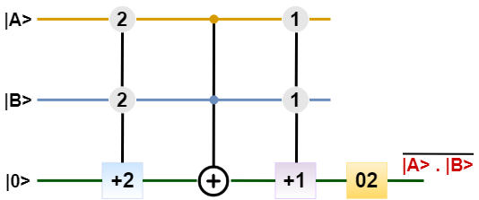

Figure 18: The circuit diagram of Multivalued NAND Operation

The Quantum Ternary NAND operation is nothing but the !(AND) operation. Therefore, we only need to invert the output of the quantum multivalued AND operation outputs. The circuit diagram of the Quantum multivalued NAND operation is shown in Figure 18.

The following steps can help us to calculate required time for multivalued quantum NAND operation as:

1. Triple qubit (+2) shift operation required time = 20 µs,
2. Triple qubit C2NOT operation, whose input depends on the output of the previous operation, requires time = 20 µs.
3. Triple qubit (+1) shift operations, whose input depends on the output of first and second operation requires time = 20 µs,

So, required time for the NAND gate operation = (3 x 20) microseconds

= 60 microseconds

Thus, Total required time for Quantum multivalued NAND operation is 60 microseconds.

1. ***Speed calculation in Quantum Multivalued NOR operation:***

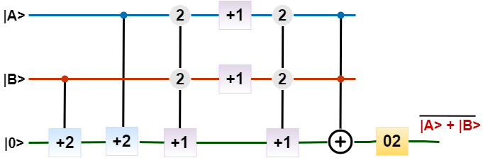

Figure 19: The circuit diagram of Multivalued NOR Operation

The Quantum multivalued NOR operation is nothing but the !(OR) operation. Therefore, we only need to invert the output of the quantum ternary OR operation’s outputs. The circuit diagram of The Quantum Ternary NOR operation is shown in Figure 19.

The following steps can help us to calculate required time for multivalued quantum OR operation as:

1. Double qubit (+2) shift operation required time = 10 µs,
2. Double qubit (+2) shift operation, whose input depends on the output of first (+2) shift operation requires time = 10 µs,
3. Triple qubit (+1) shift operations, whose input depends on the output of first and second (+2) shift operation requires time = 20 µs,
4. Next, two one qubit operation (+1) shift will perform parallelly. So, we can avoid its operational time.
5. Triple qubit (+1) shift operation, whose input depends on the output of previous operation, requires time = 20 µs.
6. Triple qubit C2NOT operation, whose input depends on the output of previous operation, requires time = 20 µs.
7. Last single qubit operation needs 1 µs.

So, required time for the XOR gate operation = (2 x 10 + 3 x 20 + 1) microseconds

= 81 microseconds

Thus, Total required time for Quantum multivalued NOR operation is 81 microseconds.

1. ***Speed calculation in Quantum Multivalued Decoder:***

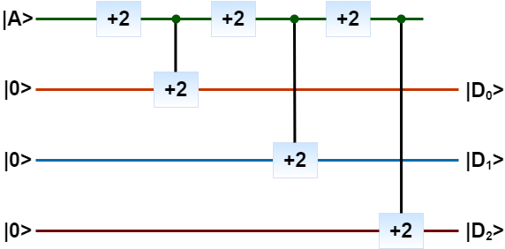

Figure 20: The circuit diagram of Multivalued Decoder

The Quantum multivalued 1-to-3 decoder operation requires the shifting operations that include (+2) shifting only. Where three (+2) operations are not controlled, and three (+2) operations are controlled by respective one input. The circuit of Quantum multivalued 1 to 3 decoder operation is shown in Figure 20.

The following three output pipeline can help us to calculate required time for multivalued quantum OR operation as:

1. D0, it gives output after performing one single qubit operation (+2) shift operation and one double qubit (+2) shift operation, which requires total (1 + 10) = 11 µs,
2. D1, it gives output after performing two single qubit operation (+2) shift operation and one double qubit (+2) shift operation, which requires total (1 + 1 + 10) = 12 µs,
3. D2, it gives output after performing three single qubit operation (+2) shift operation and one double qubit (+2) shift operation, which requires total (1 + 1 + 1 + 10) = 13 µs,

So, maximum required time for the Decoder operation = 13 microseconds

#### 2.5.1 Quantum Ternary 3 to 1 Multiplexer

A multiplexer (MUX) is a device that can receive multiple input signals and synthesize a single output signal in a recoverable manner for each input signal. It is also an integrated system that usually contains a certain number of data inputs and a single output. A ternary multiplexer of 3n input has n select line. And the selected line is used as the selection input that is sent to the output.

The quantum circuit for the quantum ternary 3 to 1 multiplexer is depicted in Figure 21. Where D0, D1, and D2 are input bits and Y is the output bit that is selected by a selection bit S.



Figure 21:The Circuit diagram of Quantum Ternary 3 to 1 Multiplexer

To find the required performing time of Quantum Ternary 3 to 1 Multiplexer, we divide it in three pipelines as some of the basic quantum ternary gate operations are performing in parallel. Three pipelines are as follows:

1. Decoder, AND, OR, OR
2. Decoder, AND, OR, OR
3. Decoder, AND, OR

According to Section 3.5, we can perceive that AND and OR ternary quantum gate operation needs 60 and 80µs respectively. Further, a multivalued quantum decoder needs 13µs to perform. As both the first and second pipeline is the largest pipeline for providing output of the Quantum Ternary 3 to 1 Multiplexer, we are taking it for measuring total required performing time. Other quantum basic ternary gate operations will be performed within this time in parallel.

Required time for Ternary 3 to 1 Multiplexer is = (Decoder + AND + OR + OR) µs.

Where, required time for Ternary quantum Decoder = 13 µs,

required time for basic Ternary quantum AND gate = 60 µs,

required time for basic Ternary quantum OR gate = 80 µs,

Required time for Ternary 3 to 1 Multiplexer is = (13 + 60 + 80+ 80) µs = 233 µs.

#### 2.5.2 Quantum Ternary Half Adder

A ternary half adder is a type of adder, an electronic circuit that performs the addition of ternary numbers. The half adder is able to add two single ternary digits and provide the output plus a carry value. It has two inputs, called A and B, and two outputs S (sum) and C (carry).

Quantum Ternary Half Adder will add two bits from the quantum ternary digit |0>, |1>, and |2> and produce two outputs as quantum sum |S> and quantum carry bit |C>. Figure 22 describes a Quantum multivalued Half adder.

To find the required performing time of Quantum Ternary Half adder, we can divide it in multiple pipelines, where just five of them are presented below. As well as, these five pipelines of quantum ternary operations and some of other basic quantum ternary gate operations are performing in parallel. Five pipelines are as follows:

1. Decoder, AND, OR, OR, OR
2. Decoder, AND, OR, OR, OR
3. Decoder, AND, OR, OR, AND
4. Decoder, AND, OR, OR, AND
5. Decoder, AND, OR, OR, AND, OR

According to subsection 1.5, we can perceive that AND and OR ternary quantum gate operation needs 60µs and 80µs respectively. And Decoder needs 13µs to perform. Among all pipelines input



Figure 22:The Circuit diagram of Quantum Ternary Half Adder

to output, the last pipeline is the largest pipeline for providing output of the Quantum Ternary Half adder, we are taking it for measuring total required performing time. Other quantum basic ternary gate operations will be performed within this time in parallel.

Required time for Ternary Half adder is = (Decoder + AND + OR + OR + AND + OR) µs.

Where, required time for Ternary quantum Decoder = 13 µs,

required time for basic Ternary quantum AND operation = 60 µs,

required time for basic Ternary quantum OR operation = 80 µs,

Required time for Ternary 3 to 1 Multiplexer is = (13+ 2 x 60 + 3 x 80) µs

= 373 µs.

#### 2.5.3 Quantum Ternary Half subtractor

A ternary half subtractor is a type of subtractor, an electronic circuit that performs the subtractions of ternary numbers. The half subtractor is able to subtract two single ternary digits and provide the output plus a borrow value. It has two inputs, called A and B, and two outputs D (difference) and B (borrow). Quantum Ternary Half Subtractor will subtract two bits from the quantum ternary digit |0>, |1>, and |2> and produce two outputs as quantum difference |D> and quantum borrow bit |B>. The Quantum circuit for the ternary half subtractor is shown in figure 23.

To find the required performing time of a Quantum Ternary Half subtractor, we can divide it in multiple pipelines, where just five of them are presented below. As well as, these five pipelines of quantum ternary operations and some other basic quantum ternary gate operations are performing in parallel. Five pipelines are as follows:

1. Decoder, AND, OR, OR, OR
2. Decoder, AND, OR, OR, OR
3. Decoder, AND, OR, OR, AND
4. Decoder, AND, OR, OR, AND
5. Decoder, AND, OR, OR, AND, OR

According to subsection 3.1, we can perceive that AND and OR ternary quantum gate operation needs 60µs and 80µs respectively. And Decoder needs 13µs to perform. Among all pipelines input to output, the last pipeline is the largest pipeline for providing output of the Quantum Ternary Half subtractor, we are taking it for measuring total required performing time. Other quantum basic ternary gate operations will be performed within this time in parallel.

Required time for Ternary Half subtractor is = (Decoder + AND + OR + OR + AND + OR) µs.

Where, required time for Ternary quantum Decoder = 13 µs,

required time for basic Ternary quantum AND operation = 60 µs,

required time for basic Ternary quantum OR operation = 80 µs,

Required time for Ternary Half subtractor is = (13 + 2 x 60 + 3 x 80) µs

= 373 µs.



Figure 23:The Circuit diagram of Quantum Ternary Half subtractor

### 2.6 Speed Calculation in Multivalued DNA Circuit

DNA computing embraces emerging biology-dependent technological areas such as DNA computing systems, DNA security and scheduling systems. The advantage of DNA computing is parallelism based on DNA strands, which is composed of Adenine, Thymine, Guanine, and Cytosine. It has been shown that certain problems can be solved in fewer steps and with fewer memory by DNA computing algorithms than by existing classical computing systems. A 2-strand base DNA system is usually defined with the two pure strands as CAAGCT and ACCTAG. At the same time, multivalued DNA computing can be used as an important one in the field of DNA computation system, DNA scheduling and security system as it can represent     multiple DNA strands in the system for carrying information. For a ternary DNA computation system, the basic three strands can be TGGATC, CAAGCT and ACCTAG.

Multivalued DNA computation systems can draw the attention from the researchers because of their advantages over the binary computation system. For ensuring security as intrusion detection, job scheduling and huge data clustering can be solved using a multivalued DNA computing system.

#### 2.6.1 DNA Ternary Decoder

Decoder is a combinational circuit that has ‘n’ input lines and maximum of 2n output lines. One of these outputs will be active High based on the combination of inputs present, when the decoder is enabled. That means the decoder detects a particular code. In figure 24, Decoder is the unary functions for input variable A as A0, A1 and A2 which is used for ternary function implementation.



Figure 24: DNA Ternary Decoder

To find the required performing time of DNA Ternary Decoder, we divide it in four pipelines as some of the basic ternary DNA gate operations are performed in parallel. Four pipelines are as follows:

1. NOT
2. NOT, OR, NOT
3. NOT, NOT, OR, NOT
4. NOT, NOT

According to subsection 3.3, we can perceive that any DNA basic gate (i.e., OR and NOT) operation needs more or less 2hr to perform. In addition, we need 6hr for preparing any DNA basic gate operation and 2hr for fluoresence detection which is fixed for any DNA multi-(basic) gate operation.

As the third pipeline is the largest pipeline for processing input to output of the ternary decoder, we are taking it for measuring total required performing time. Other DNA ternary basic gate operations will be performed within this time in parallel.

So, required time for four basic gate operations in DNA is = (2 + 2 + 2 +2)

= 8hr.

Where, performing time for DNA gate (OR and NOT) operation needs more or less 2hr.

The total performing time/ required time for performing ternary DNA Decoder is summation of initial preparation time, fluoresence detection time and ternary DNA gate operational time.

So, required time for DNA Ternary Full Adder is

= (Basic gate preparation time + Four basic DNA ternary gate operational time + Fluoresence detection time)

= (6 + 8 + 2) hr

= 16hr (approximately).

#### 2.6.2 DNA Ternary 3 to 1 Multiplexer

The multiplexer is one of the most important block designs of a binary digital system. It is such a device that allows only one input from several input signals and the input which is selected by Multiplexer is transmitted into a single medium. Actually, multiplexers aid to improve the efficiency of the communication system. It allows the transmission of data such as audio, video etc from different channels via cables. And here, we will implement this using MVL that helps us to simulate the circuit so easily than the digital binary Multiplexer. Then we will propose the designing of a DNA 1 to 3 ternary Multiplexer circuit based on a combinational digital 1 to 3 ternary circuit.

To find the required performing time of DNA 3 to 1 multiplexer circuit, we divide it in four pipelines as some of the basic DNA gate operations are performed in parallel. All these pipelines are as follows:

1. NOT, AND, OR, OR
2. NOT, NOR, NOR, AND, OR, OR
3. NOT, NOT, NOR, NOR, AND, OR, OR.
4. NOT, NOT, AND, OR

According to subsection 3.3, we can perceive that any ternary DNA basic gate (i.e. AND, OR, NOT and NOR) operation needs more or less 2hr to perform. In addition, we need 6hr for preparing any ternary DNA basic gate operation and 2hr for fluoresence detection which is fixed for any multi-(basic) gate operation.

As the third pipeline is the longest pipeline for processing input to output of the 3 to 1 multiplexer circuit, we are taking it for measuring total required performing time. Other ternary DNA basic gate operations will be performed within this time in parallel.

So, required time for seven (7) ternary basic gate operation in DNA is = (2 x 7)

= 14hr.

Where, performing time for ternary DNA gate (AND, OR, NOT and NOR) operation needs more or less 2hr.

The total performing time/ required time for performing ternary DNA 3 to 1 multiplexer circuit is summation of initial preparation time, fluoresence detection time and DNA gate operational time.

So, required time for DNA 3 to 1 multiplexer circuit is

= (Basic gate preparation time + Seven basic DNA gate operational time + fluoresence detection)

= (6 + 14 + 2) hr

= 24hr (approximately).



Figure 25: DNA ternary 3 input one output Multiplexer

### 2.7 Speed Calculation in Quantum-DNA Circuit

According to quantum computing, quantum computation is faster than classical computation systems. Quantum computers are also more powerful than supercomputers in terms of computing. They are thousands of times faster than regular computers and supercomputers at processing data. On the other hand, the use of DNA strands to compute has led to high parallel computation that makes up for the slow processing of the chip. Memory space required by DNA is around 1 bit per cubic nanometer which is much less when compared to regular storage systems Consumption of power is almost nil as the chemical bonds in DNA produce energy to build or repair new strands. So, for finding a super faster computation system with huge memory, we can develop a Quantum-DNA computation system. This Quantum-DNA computation system can merge all advantages of quantum computing and DNA computing.

In a Quantum-DNA computing system, input will be received as qubit and after performing in a certain number of quantum operational gates these qubits will be turned into DNA sequences by NMR relaxation.

#### 2.7.1 Full Subtractor at 0-kelvin

A Full Subtractor is a combinational circuit that is developed to overcome the drawback of the half Subtractor circuit. It can take inputs and after subtracting them creates two outputs. Here the full Subtractor is implemented using the Quantum-DNA Circuit. To create a Full Subtractor, two Not, two XOR, two AND and an OR operational circuit are required. Figure 26 describes the Quantum-DNA circuit for Full Subtractor. A Full Subtractor receives three inputs and produces two outputs containing “D” and “Bout”.

From the Quantum-DNA circuit in Figure 26, we find that 1 XOR, 2 NOT and 2 AND quantum gate operational circuits perform with quantum qubits. The output of all quantum operational gates goes through NMR relaxation at 0-kelvin. It produces DNA sequence as an output and it can be used as an input in all DNA operational circuits.

Here 2 DNA operational circuits (1 XOR and 1 OR) are used to find the expected output. Four (4) DNA sequence is the output from the NMR relaxation process and is used as input sequence in XOR and OR DNA operational gate.

To find the required performing time of a Quantum-DNA Full Subtractor, we can divide it in three pipelines as some of the basic quantum and DNA operational gates are performing in parallel. Three pipelines are as follows:

1) Quantum XOR, DNA XOR

2) Quantum (XOR, NOT, AND), DNA OR

3) Quantum (NOT, AND), DNA OR

Figure 26: A Quantum-DNA Full Subtractor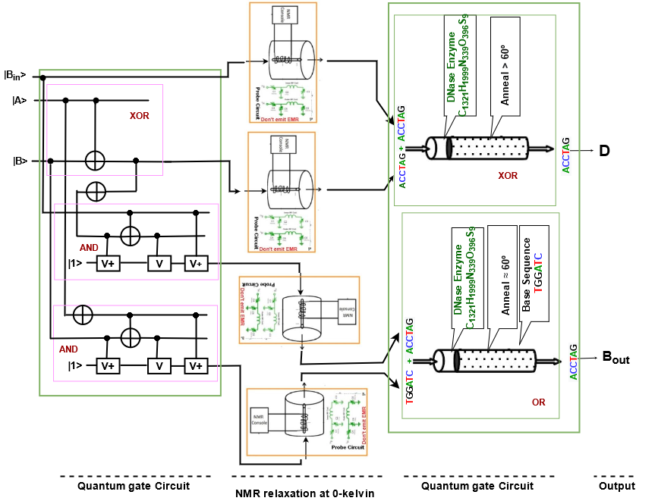

As the second pipeline is the largest pipeline for providing output of the Full Subtractor, we are taking it for measuring total required performing time. Other quantum and DNA basic operational gates will perform in parallel within this time. Three pipelines for extracting the output, one can understand that last one operational gate will perform with DNA sequence and others will perform with qubit quantum operational gate. According to Section 3.1, we can perceive that XOR and AND quantum operational gates need 10 microseconds and 30 µs respectively. And a single qubit quantum operation as NOT needs 1 microsecond.

So, the required time for three basic quantum operational gates is = (10 + 1 + 30) µs.

= 41 µs.

Furthermore, from Section 3.3, we can find that any DNA basic gate (i.e., AND, OR, NOT and XOR) operation needs more or less 2hr to perform. In addition, we need 6hr for preparing any DNA basic gate operation and 2hr for fluoresence detection which is fixed for any multi-(basic) gate operation.

The total performing time required for DNA OR operation is summation of initial preparation time, fluoresence detection time and DNA gate operational time.

So, required time for DNA OR operation is

= (Basic gate preparation time + OR gate operational time + Fluoresence detection)

= (6 + 2 + 2)

= 10hr (approximately).

Thus, to find the expected output of Quantum-DNA Full Subtractor, the required time will be the summation of Quantum operation and DNA operation.

So, total required time for Quantum-DNA Full Subtractor is

= (Required time for Quantum operation + Required time for DNA operation)

= (41 microseconds + 10hr)

= 10hr (approximately).

#### 2.7.2 Full Adder at 0-kelvin

Full Adder is the adder which adds three inputs and produces two outputs. The first two inputs are A and B and the third input is an input carry as Cin. The output carry is designated as Cout and the normal output is designated as S which is Sum. A Full Adder logic is designated in such a manner that can take eight inputs together to create a qubit adder and cascade the carry qubit from one adder to the another. To create a Full Adder, one OR, to NAND one XOR and two NOT gate is required. Figure 27 describes the Quantum-DNA circuit of the Full Adder.

From the Quantum-DNA circuit in Figure 27, we find that 1 XOR and 2 AND quantum gate operational circuit performs with quantum qubits. The output of all quantum operational gates goes through NMR relaxation at 0-kelvin. It produces DNA sequence as an output and it can be used as an input in all DNA operational circuits.

Here 2 DNA operational circuits (1 XOR and 1 OR) are used to find the expected output. Four (4) DNA sequence is the output from the NMR relaxation process and is used as input sequence in XOR and OR DNA operational gate.

To find the required performing time of Quantum-DNA Full Adder, we can divide it in four pipelines as some of the basic quantum and DNA operational gates are performing in parallel. Three pipelines are as follows:

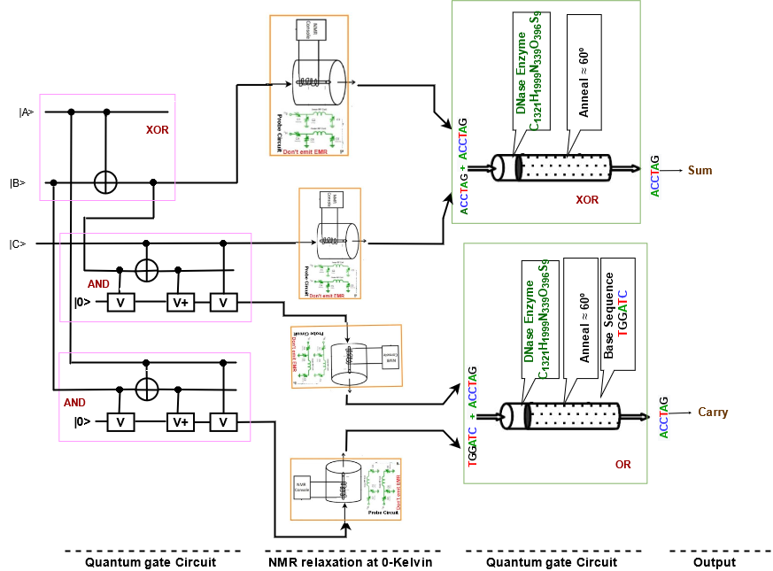

Figure 27: A Quantum-DNA Full Adder

1) Quantum XOR, DNA XOR

2) Quantum (XOR, AND), DNA OR

3) Quantum (AND), DNA XOR

4) Quantum AND, DNA OR

As the second pipeline is the largest pipeline for providing output of the Full Adder, we are taking it for measuring total required performing time. Other quantum and DNA basic operational gates will perform in parallel within this time. Four pipelines for extracting the output, one can understand that last one operational gate will perform with DNA sequence and others will perform with qubit in quantum operational gate. According to subsection 3.1, we can perceive that XOR and AND quantum operational gates need 10 µs and 30 µs respectively.

So, the required time for two basic quantum operational gate is = (10 + 30) µs.

= 40 µs.

Furthermore, from subsection 3.3, we can find that any DNA basic operational gate (i.e., AND, OR, NOT and XOR) needs more or less 2hr to perform. In addition, we need 6hr for preparing any DNA basic gate operation and 2hr for fluoresence detection which is fixed for any multi-(basic) gate operation.

The total performing time required for DNA OR operation is summation of initial preparation time, fluoresence detection time and DNA gate operational time.

So, required time for DNA OR operation is

= (Basic gate preparation time + OR gate operational time + Fluoresence detection)

= (6 + 2 + 2)

= 10hr (approximately).

Thus, to find the expected output of Quantum-DNA Full Subtractor, the required time will be the summation of Quantum operation and DNA operation.

So, total required time for Quantum-DNA Full Subtractor is

= (Required time for Quantum operation + Required time for DNA operation)

= (40 microseconds + 10hr)

= 10hr (approximately).

#### 2.7.3 Multiplier at 0-kelvin

A binary multiplier is a combinational logic circuit or digital device used for multiplying two binary numbers. The two numbers are more specifically known as multiplicand and multiplier and the result is known as a product. The multiplicand and multiplier can be of various bit size. The product’s bit size depends on the bit size of the multiplicand & multiplier. The bit size of the product is equal to the sum of the bit size of multiplier multiplicand. To create a Quantum-DNA Multiplier circuit, four AND operations in quantum, two XOR and two AND DNA operational gates are required. Figure 28 describes the Quantum-DNA circuit of the 2-bit multiplication.

From the Quantum-DNA circuit in Figure 28, we find that four (4) AND quantum gate operational circuits perform with quantum qubits. The output of all quantum operational gates goes through NMR relaxation at 0-kelvin. It produces DNA sequence as an output and it can be used as an input in all DNA operational circuits.

To find the required performing time of a Quantum-DNA Multiplier, we can divide it in five pipelines as some of the basic quantum and DNA operational gates are performing in parallel. five pipelines are as follows:

1) Quantum AND, DNA XOR

2) Quantum AND, DNA (AND, XOR)

3) Quantum AND, DNA (AND, AND)

4) Quantum AND

5) Quantum AND, DNA AND

As the second or third pipeline is the largest pipeline for providing output of the Multiplier, we are taking any of these two for measuring total required performing time. Other’s quantum and DNA basic operational gates will perform in parallel within this time. Five pipelines for extracting the output, one can understand that the last two operational gates will perform with DNA sequence and others will perform with qubit in quantum operational gate. According to subsection 3.1, we can perceive that an AND quantum operational gate needs 30 microseconds for providing the output.

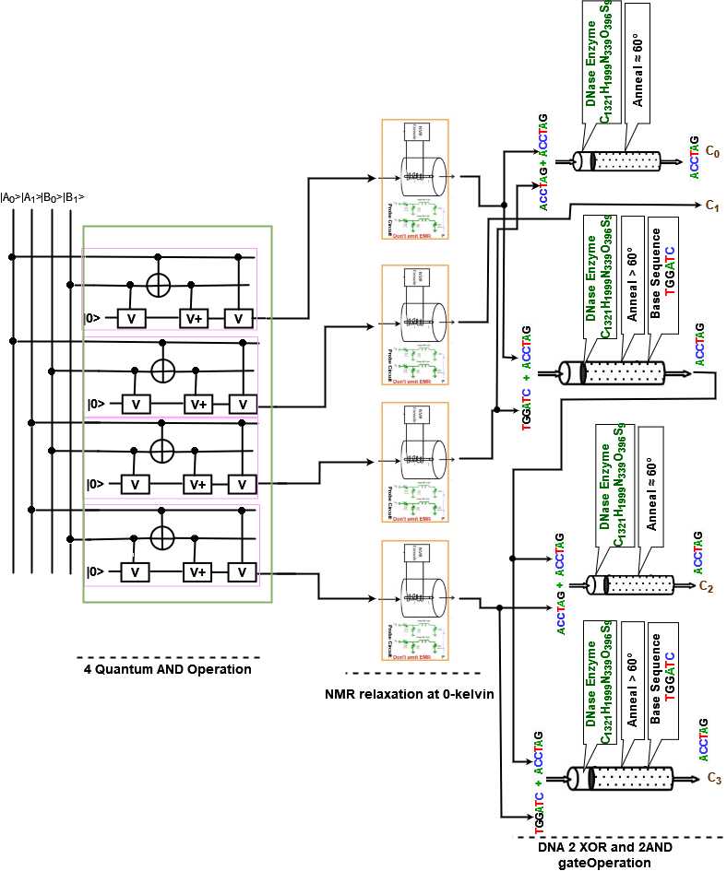

Figure 28: Quantum-DNA Multiplier Circuit.

So, the required time for the basic quantum operational gate is = (30) µs.

Furthermore, from subsection 3.3, we can find that any DNA basic operational gate (i.e., AND, OR, NOT and XOR) needs more or less 2hr to perform. In addition, we need 6hr for preparing any DNA basic gate operation and 2hr for fluoresence detection which is fixed for any multi-(basic) gate operation.

So, required time for DNA XOR and AND operations are = (2 + 2) hr

= 4 hr

The total performing time required for DNA OR operation is summation of initial preparation time, fluoresence detection time and DNA gate operational time.

So, required time for DNA OR operation is

= (Basic gate preparation time + DNA gate operational time + Fluoresence detection)

= (6 + 4 + 2)

= 12hr (approximately).

Thus, to find the expected output of Quantum-DNA Multiplier, the required time will be the summation of Quantum operation and DNA operation.

So, total required time for Quantum-DNA Multiplier is

= (Required time for Quantum operation + Required time for DNA operation)

= (30 microseconds + 12hr)

= 12hr (approximately).

#### 2.7.4 Multiplexer at 0-kelvin

A multiplexer (MUX) is a device that can receive multiple input signals and synthesize a single output signal in a recoverable manner for each input signal. It is also an integrated system that usually contains a certain number of data inputs and a single output. To create a multiplexer, one NOT, two AND, and an OR gate are required. Figure 29 describes the Quantum-DNA circuit of Multiplexer. A Multiplexer receive three inputs and produce one output containing “Y”.

From the Quantum-DNA circuit in Figure 29, we find that two (4) AND quantum gate operational circuit performs with quantum qubits. The output of all quantum operational gate goes through NMR relaxation at 0-kelvin. It produces DNA sequence as an output and it can be used as an input in all DNA operational circuit. Here a DNA operational circuit (OR) is used to find the expected output. Two (2) DNA sequence is the output from the NMR relaxation process and is used as input sequence in OR DNA operational gate.

To find the required performing time of Quantum-DNA Multiplexer, we can divide it in five pipelines as some of the basic quantum and DNA operational gate is performing in parallel. five pipelines are as follows:

1) Quantum AND, DNA OR

2) Quantum AND, DNA OR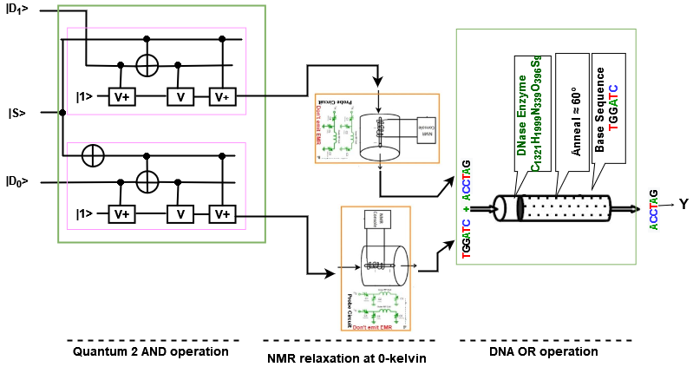

Figure 29: Quantum-DNA 2:1 Multiplexer Circuit

As both pipeline is equal for providing output of the Multiplexer, we are taking any of these two for measuring total required performing time. Other quantum and DNA basic operational gate will perform in parallel within this time. Two pipelines for extracting the output, one can understand that last one operational gate will perform with DNA sequence and others will perform with qubit in quantum operational gate. According to subsection 3.1, we can perceive that AND quantum operational gate needs 30 microseconds for providing the output.

So, required time for basic quantum operational gate is = (30) µs.

Furthermore, from subsection 3.3, we can find that any DNA basic operational gate (i.e., AND, OR, NOT and XOR) needs more or less 2hr to perform. In addition, we need 6hr for preparing any DNA basic gate operation and 2hr for fluoresence detection which is fixed for any multi-(basic) gate operation.

So, required time for DNA OR operations is = 2 hrs

The total performing time required for DNA OR operation is summation of initial preparation time, fluoresence detection time and DNA gate operational time.

So, required time for DNA OR operation is

= (Basic gate preparation time + DNA gate operational time + Fluoresence detection)

= (6 + 2 + 2)

= 10hr (approximately).

Thus, to find the expected output of Quantum-DNA Multiplier, the required time will be summation of Quantum operation and DNA operation.

So, total required time for Quantum-DNA Multiplier is

= (Required time for Quantum operation + Required time for DNA operation)

= (30 microseconds + 10hr)

= 10hr (approximately).

### 3.8 Speed Calculation in DNA-Quantum Circuit

The usage of DNA strands to calculate, has resulted in high parallel computation, which compensates for the chip's slow processing. When compared to traditional storage systems, DNA requires just about 1 bit per cubic nanometer of memory space. The chemical interactions in DNA provide energy to make or repair new strands, therefore there is essentially no power use. On the other hand, quantum computation, according to quantum computing, is faster than traditional processing systems. Quantum computers are also more powerful in terms of computation than supercomputers. They process data thousands of times faster than normal computers and supercomputers. As a result, we may create a DNA-Quantum computation system to find a super-fast computation system with a lot of memory. This DNA-Quantum computation device combines the benefits of both quantum and DNA computing.

In a DNA-Quantum computing system, input will be received in DNA sequences and after performing in a certain number of DNA operational gates these DNA sequences will be turned into quantum qubits by NMR process.

#### 2.8.1 3-bit parity bit checker at 0-kelvin

A circuit that checks the parity in the receiver is called Parity Checker. A combined circuit or device of parity generators and parity checkers are commonly used in digital systems to detect the single bit errors in the transmitted data. To create a 3 bit even parity bit checker, three XOR gate are required. Figure 30 describes the DNA-Quantum circuit of 3 bit even parity bit checker. A 3 bit even parity bit checker receives four inputs and produce one output containing “E”.

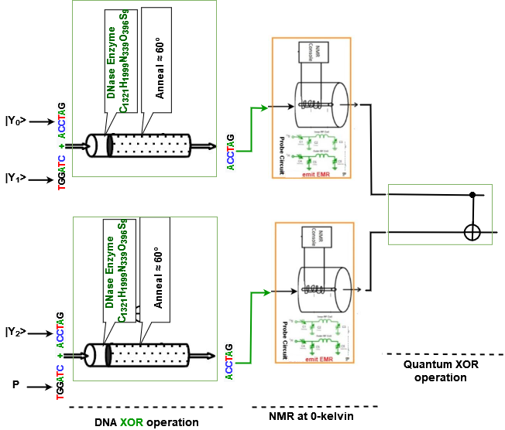

Figure 30: DNA-Quantum circuit of 3 bit even parity bit checker

From the DNA-Quantum circuit in Figure 30, we find that two (2) XOR DNA operational gate performs with DNA sequence. The output of all DNA operational gate goes through NMR at 0-kelvin. It produces quantum qubit as an output and it can be used as an input in all quantum operational circuit. Here a DNA operational circuit (XOR) is used to find the expected output. Two (2) quantum qubit is the output from the NMR process and is used as input qubit in OR Quantum operational gate.

To find the required performing time of DNA-Quantum 3-bit Even parity bit checker, we can divide it in two pipelines as some of the basic quantum and DNA operational gate is performing in parallel. two pipelines are as follows:

1) DNA XOR, Quantum XOR

2) DNA XOR, Quantum XOR

As both pipeline is equal for providing output of the 3-bit Even parity bit checker, we are taking any of these two for measuring total required performing time. Others DNA and Quantum basic operational gate will perform in parallel within this time. From subsection 3.3, we can find that any DNA basic operational gate (i.e., AND, OR, NOT and XOR) needs more or less 2hr to perform. In addition, we need 6hr for preparing any DNA basic gate operation and 2hr for fluoresence detection which is fixed for any multi-(basic) gate operation.

So, required time for DNA XOR operations is = 2 hrs.

The total performing time required for DNA XOR operation is summation of initial preparation time, fluoresence detection time and DNA gate operational time.

So, required time for DNA OR operation is

= (Basic gate preparation time + DNA gate operational time + Fluoresence detection)

= (6 + 2 + 2)

= 10hr (approximately).

Furthermore, according to subsection 3.1, we can perceive that XOR quantum operational gate needs 10 microseconds for providing the output.

So, required time for basic quantum operational gate is = (10) µs.

Thus, to find the expected output of DNA-Quantum 3-bit Even parity bit checker, the required time will be summation of Quantum operation and DNA operation.

So, total required time for DNA-Quantum 3-bit Even parity bit checker is

= (Required time for DNA operation + Required time for Quantum operation)

= (10hr + 10 µs)

= 10 hrs (approximately).

#### 2.8.2 Full Subtractor at 0-kelvin

Figure 31: DNA-quantum circuit of Full Subtractor at 0-kelvin operation

A Full Subtractor is a combinational circuit that is developed to overcome the drawback of the half Subtractor circuit. It can take inputs and after subtracting them creates two outputs. Here full Subtractor is implemented using the DNA- Quantum Circuit. To create a Full Subtractor, two Not, two XOR, two AND and an OR operational circuit are required. Figure 31 describes the DNA-Quantum circuit for Full Subtractor. A Full Subtractor receive three inputs and produce two output containing “D” and “Bout”.

From the Quantum-DNA circuit in Figure 31, we find that 1 XOR, 2 NOT and 2 AND DNA gate operational circuit performs with DNA sequences. The output of all DNA operational gate goes through NMR at 0-kelvin. It produces Quantum qubit as an output and it can be used as an input in all Quantum operational circuit.

Here 2 quantum operational circuit (1 XOR and 1 OR) is used to find the expected output. Four (4) quantum qubit is the output from the NMR process and is used as input qubit in XOR and OR quantum operational gate.

To find the required performing time of DNA-Quantum Full Subtractor, we can divide it in three pipelines as some of the basic DNA and Quantum operational gate is performing in parallel. Three pipelines are as follows:

1) DNA (XOR, NOT), Quantum XOR

2) DNA (XOR, NOT, AND), Quantum OR

3) DNA (NOT, AND), Quantum OR

As second pipeline is the largest pipeline for providing output of the Full Subtractor, we are taking it for measuring total required performing time. Other quantum and DNA basic operational gate will perform in parallel within this time. Three pipelines for extracting the output, one can understand that last one operational gate will perform with quantum qubit and others will perform with DNA sequence.

From subsection 3.3, we can find that any DNA basic gate (i.e., AND, OR, NOT and XOR) operation needs more or less 2hr to perform. In addition, we need 6hr for preparing any DNA basic gate operation and 2hr for fluoresence detection which is fixed for any multi-(basic) gate operation.

The total performing time required for DNA operations is summation of initial preparation time, fluoresence detection time and DNA gate operational time.

So, required time for DNA operations is

= (Basic gate preparation time + DNA gate operational time + Fluoresence detection)

= [6 + ( 2 + 2 + 2 ) + 2)

= 14hr (approximately).

According to subsection 3.1, we can perceive that OR quantum operational gate needs 30 microseconds respectively.

So, required time OR quantum operational gate is = 30 µs.

Thus, to find the expected output of DNA-Quantum Full Subtractor, the required time will be summation of Quantum operation and DNA operation.

So, total required time for Quantum-DNA Full Subtractor is

= (Required time for DNA operation + Required time for Quantum operation)

= (30 microseconds + 14hr)

= 14hr (approximately).

#### 2.8.3 Full Adder at 0-kelvin

Full Adder is the adder which adds three inputs and produces two outputs. The first two inputs are A and B and the third input is an input carry as Cin. The output carry is designated as Cout and the normal output is designated as S which is Sum. A Full Adder logic is designated in such a manner that can create a qubit adder and cascade the carry qubit from one adder to the another. To create a Full Adder, one OR, two NAND one XOR and two NOT gate is required. Figure 32 describes the DNA-Quantum circuit of the Full Adder.

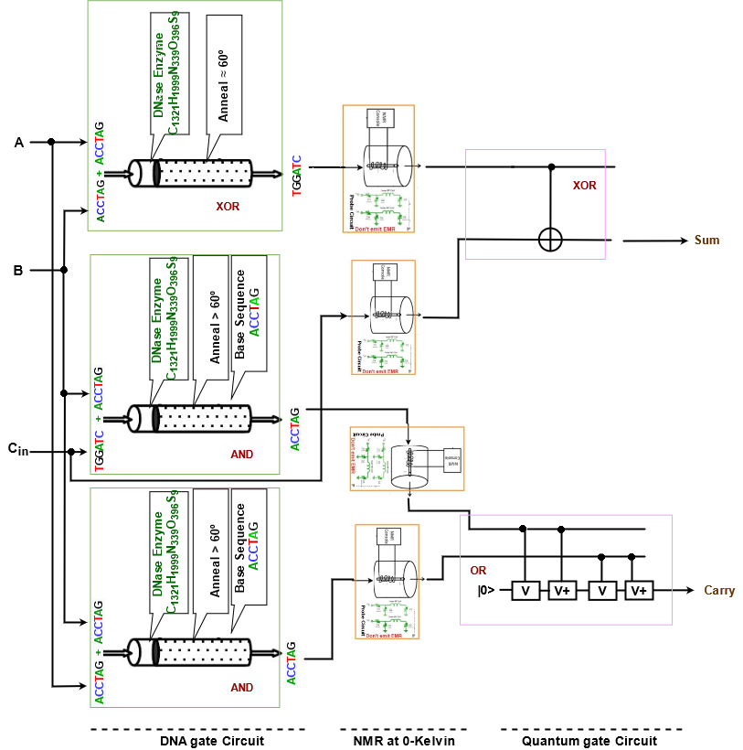

Figure 32: DNA-Quantum operational circuit for Full Adder at 0-kelvin

From the DNA-Quantum circuit in Figure 32, we find that 1 XOR and 2 AND DNA gate operational circuit performs with DNA sequence. The output of all DNA operational gate goes through NMR at 0-kelvin. It produces Quantum qubit as an output which can be used as an input in all Quantum operational circuit.

Here 2 Quantum operational circuit (1 XOR and 1 OR) is used to find the expected output. Four (4) quantum qubit is the output from the NMR process and is used as input in XOR and OR Quantum operational gate.

To find the required performing time of DNA-Quantum Full Adder, we can divide it in four pipelines as some of the basic quantum and DNA operational gate is performing in parallel. four pipelines are as follows:

1) DNA XOR, Quantum XOR

2) DNA AND, Quantum OR

3) Quantum XOR

4) DNA AND, Quantum OR

As first, second and fourth pipeline is the equal and largest pipeline for providing output of the Full Adder, we are taking any of them for measuring total required performing time. Others DNA and quantum basic operational gate will perform in parallel within this time. Four pipelines for extracting the output, one can understand that last one operational gate will perform with Quantum qubit and others will perform with DNA operational gate.

From subsection 3.3, we can find that any DNA basic operational gate (i.e., AND, OR, NOT and XOR) needs more or less 2hr to perform. In addition, we need 6hr for preparing any DNA basic gate operation and 2hr for fluoresence detection which is fixed for any multi-(basic) gate operation.

The total performing time required for DNA XOR operation is summation of initial preparation time, fluoresence detection time and DNA gate operational time.

So, required time for DNA XOR operation is

= (Basic gate preparation time + OR gate operational time + Fluoresence detection)

= (6 + 2 + 2)

= 10hr (approximately).

According to subsection 3.1, we can perceive that XOR quantum operational gate needs 10 microseconds respectively.

So, required time for XOR quantum operational gate is = 10 microseconds.

Thus, to find the expected output of DNA-Quantum Full Adder, the required time will be summation of DNA operation and Quantum operation.

So, total required time for Quantum-DNA Full Subtractor is

= (Required time for DNA operation + Required time for Quantum operation)

= (20 microseconds + 10hr)

= 10hr (approximately).

### 2.9 Speed Calculation in Multivalued Quantum-DNA Circuit

Multivalued quantum computation, according to multivalued quantum computing, is far more advantageous than classical computation systems. Quantum computers are also more powerful in terms of computation than supercomputers. They process data thousands of times faster than normal computers and supercomputers. Parallelism based on linear superposition of quantum states is a benefit of multivalued quantum computing. It has been demonstrated that multivalued quantum algorithms can solve some problems in fewer steps than conventional classical algorithms.

The use of multivalued (more than two DNA strands) DNA strands to compute, on the other hand, has resulted in high parallel computation, which compensates for the chip's slow processing. When compared to traditional storage systems, DNA requires just about 1 bit per cubic nanometer of memory space. The chemical interactions in DNA provide energy to make or repair new strands, therefore there is essentially no power use. As a result, we may create a multivalued Quantum-DNA computation system to find a super-fast computation system with a lot of memory. The advantages of multivalued quantum computing and multivalued DNA computing can be combined in this multivalued Quantum-DNA computation system.

In a multivalued Quantum-DNA computing system, input is received as a qubit, which is then converted into DNA sequences by NMR relaxation after passing through a specific number of quantum operational gates.

#### 2.9.1 Multivalued Half adder at 0-kelvin

A ternary half adder is a type of adder, an electronic circuit that performs the addition of ternary numbers. The half adder is able to add two single ternary digits and provide the output plus a carry value. It has two inputs, called A and B, and two outputs S (sum) and C (carry).

Quantum-DNA Ternary Half Adder will add two bits from the quantum ternary digit |0>, |1>, and |2> and produce two outputs as quantum sum |S> and quantum carry bit |C>.

From the Multivalued Quantum-DNA circuit in Figure 33, we find that 11 AND, 7 OR and 2 Decoder operational circuit performs to provide the output in DNA sequence. In this circuit nine AND, six OR and two decoder performs with ternary quantum qubit and the rest performs with DNA sequences. The output of all Quantum operational gate goes through NMR relaxation at 0-kelvin. It produces DNA sequences as an output and it can be used as an input in all DNA operational circuit.

To find the required performing time of Quantum-DNA Ternary Half adder, we can divide it in multiple pipelines, where just five of them are presented below. As well as, these five pipelines of quantum-DNA ternary operations some of other basic quantum ternary gate operations are performing in parallel. Five pipelines are as follows:

1. Quantum (Decoder, AND, OR, OR), DNA (OR)
2. Quantum (Decoder, AND, OR, OR), DNA (OR)
3. Quantum (Decoder, AND, OR, OR), DNA (AND)
4. Quantum (Decoder, AND, OR, OR), DNA (AND)
5. Quantum (Decoder, AND, OR, OR), DNA (AND, OR)

According to subsection 5.1, we can perceive that AND and OR ternary quantum gate operation needs 60µs and 80µs respectively. And Decoder needs 13µs to perform. Among all pipelines input to output, last pipeline is the largest pipeline for providing output of the Quantum-DNA Ternary Half adder, we are taking it for measuring total required performing time. Others Quantum and DNA basic ternary gate operation will be performed within this time in parallel.

Required time for Quantum operation in Ternary Half adder is = (Decoder + AND + OR + OR) µs.

Where, required time for Ternary quantum Decoder = 13 µs,

required time for basic Ternary quantum AND gate = 60 µs,

required time for basic Ternary quantum OR gate = 80 µs,

Required time for Quantum operations is = (13+ 60 + 80 +80) µs

= 233 µs.

Furthermore, from subsection 3.3, we can find that any DNA basic operational gate (i.e., AND, OR, NOT and XOR) needs more or less 2hr to perform. In addition, we need 6hr for preparing any DNA basic gate operation and 2hr for fluoresence detection which is fixed for any multi-(basic) gate operation.

So, required time for DNA AND and OR operations are = (2 + 2) hr

= 4 hr

The total performing time required for DNA operations is summation of initial preparation time, fluoresence detection time and DNA gate operational time.

So, required time for DNA operations is

= (Basic gate preparation time + DNA gate operational time + Fluoresence detection)

= (6 + 4 + 2)

= 12hr (approximately).

Thus, to find the expected output of Quantum-DNA Multivalued Half Adder, the required time will be summation of Quantum operations and DNA operations.

So, total required time for Quantum-DNA Multivalued Half Adder is

= (Required time for Quantum operation + Required time for DNA operation)

= (233 microseconds + 12hr)

= 12hr (approximately).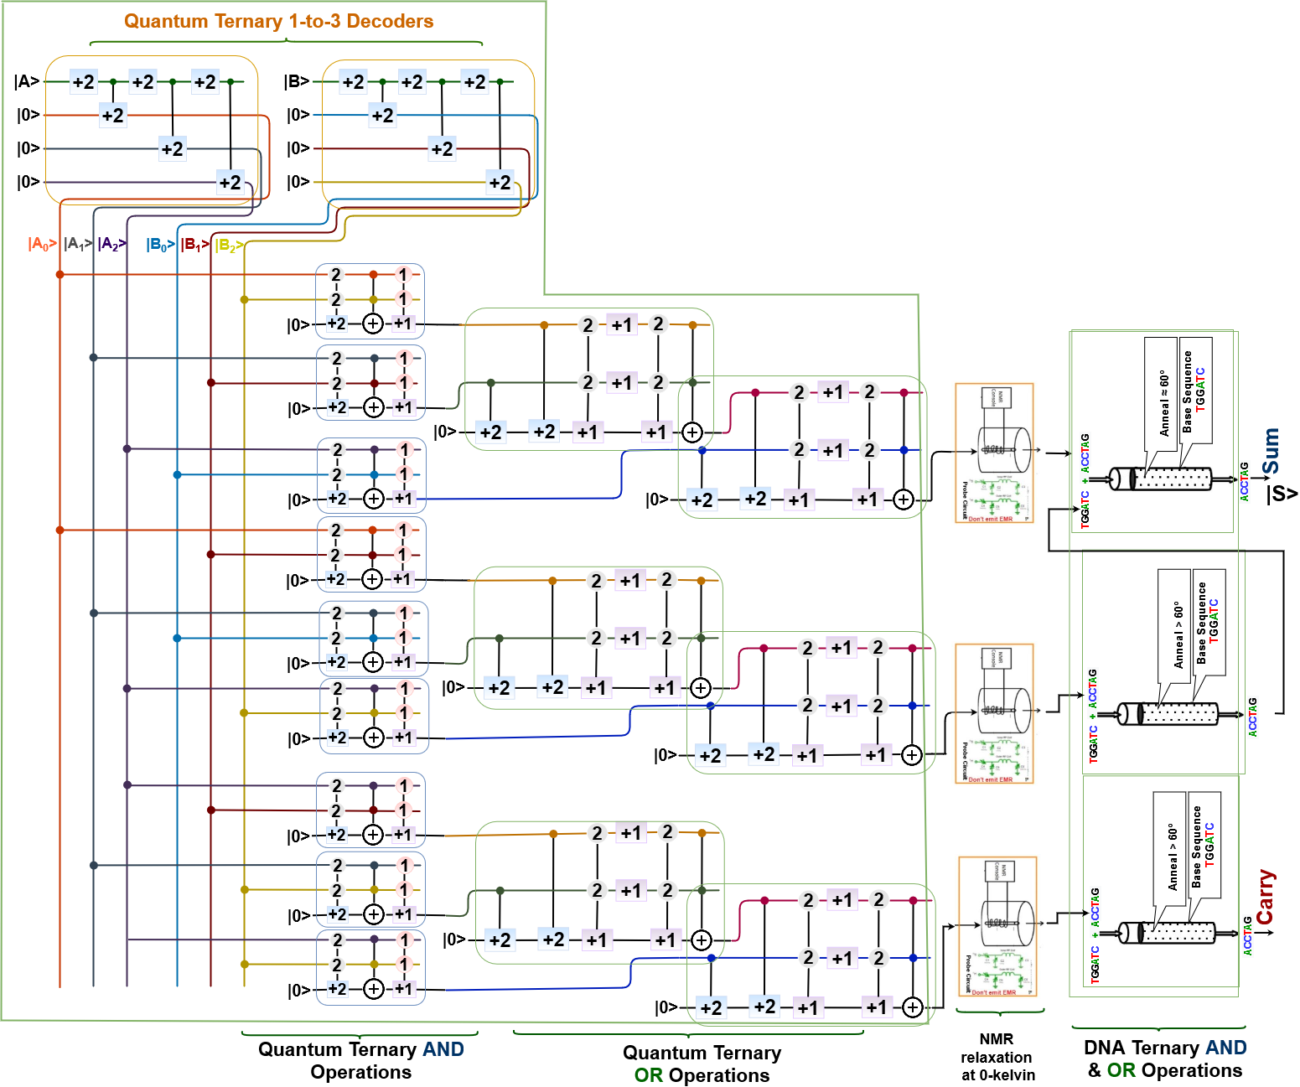

Figure 33: Quantum-DNA circuit for Multivalued Half Adder

#### 2.9.2 Multivalued Half Subtractor at 0-kelvin

A Multivalued Half Subtractor is a type of subtractor, an electronic circuit that performs the subtractions of ternary numbers. The half subtractor is able to subtract two single ternary digits and provide the output with a borrow value. It has two inputs, called A and B, and two outputs D (difference) and B (borrow). Quantum-DNA Multivalued or Ternary Half Subtractor will subtract two qubits from the quantum ternary digit |0>, |1>, and |2> and produce two outputs as quantum difference |D> and quantum borrow bit |B>. The Quantum-DNA circuit for the Multivalued half subtractor is shown in Figure 34.

From the Multivalued Quantum-DNA Half Subtractor circuit in Figure 34, we find that 11 AND, 7 OR and 2 Decoder operational circuit performs to provide the output in DNA sequence. In this circuit nine AND, six OR and two decoder performs with ternary quantum qubit and the rest performs with DNA sequences. The output of all Quantum operational gate goes through NMR relaxation at 0-kelvin. It produces DNA sequences as an output and it can be used as an input in all DNA operational circuit.

To find the required performing time of Quantum-DNA Ternary Half Subtractor, we can divide it in multiple pipelines, where just five of them are presented below. As well as, these five pipelines of Quantum-DNA ternary operations some of other basic Quantum and DNA ternary gate operations are performing in parallel. Five pipelines are as follows:

1. Quantum (Decoder, AND, OR, OR), DNA (OR)
2. Quantum (Decoder, AND, OR, OR), DNA (OR)
3. Quantum (Decoder, AND, OR, OR), DNA (AND)
4. Quantum (Decoder, AND, OR, OR), DNA (AND)
5. Quantum (Decoder, AND, OR, OR), DNA (AND, OR)

According to subsection 5.1, we can perceive that AND and OR ternary quantum gate operation needs 60µs and 80µs respectively. And Decoder needs 13µs to perform. Among all pipelines input to output, last pipeline is the largest pipeline for providing output of the Quantum-DNA Ternary Half Subtractor, we are taking it for measuring total required performing time. Others Quantum and DNA basic ternary operational gate will be performed within this time in parallel.

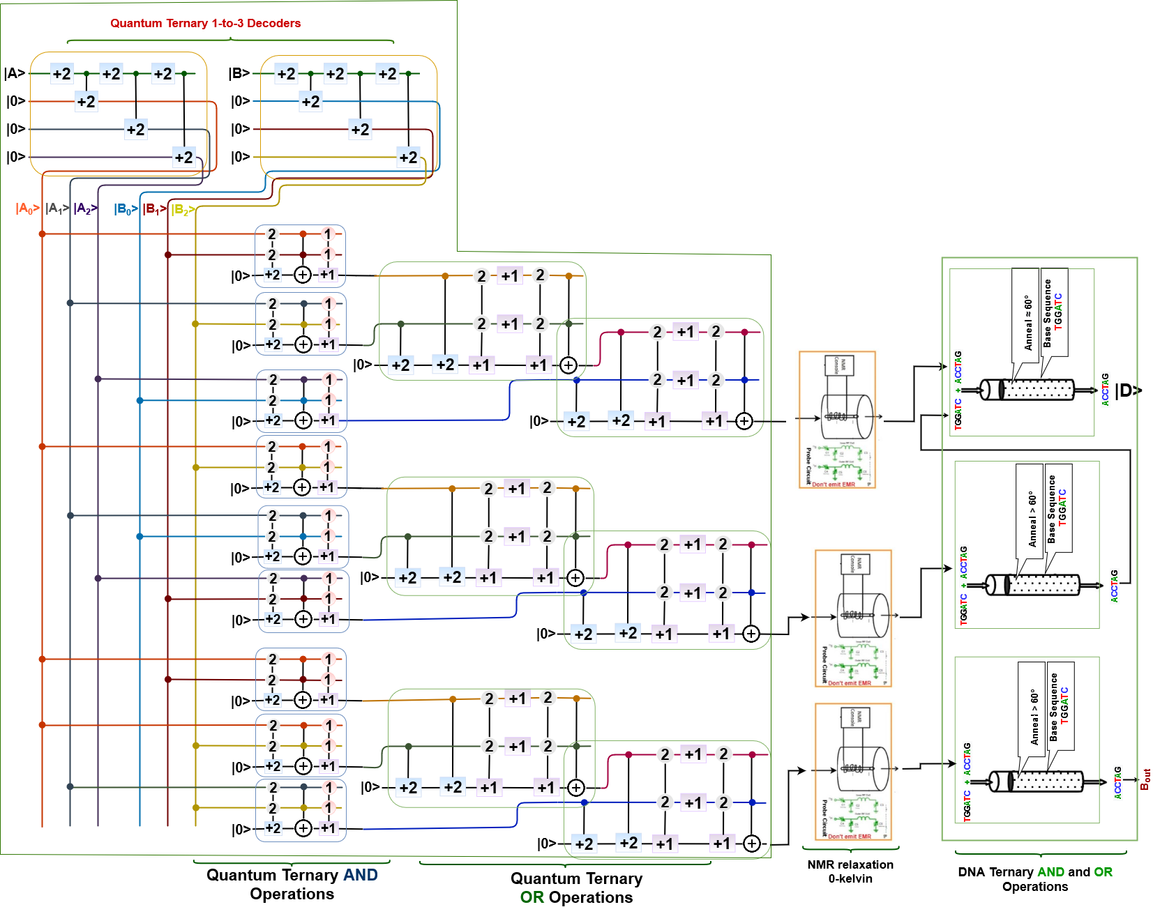

Figure 34: Quantum-DNA circuit for Multivalued Half Subtractor

Required time for Quantum operation in Ternary Half adder is = (Decoder + AND + OR + OR) µs.

Where, required time for Ternary quantum Decoder = 13 µs,

required time for basic Ternary quantum AND gate = 60 µs,

required time for basic Ternary quantum OR gate = 80 µs,

Required time for Quantum operations is = (13+ 60 + 80 + 80) µs

= 233 µs.

Furthermore, from subsection 3.3, we can find that any DNA basic operational gate (i.e., AND, OR, NOT and XOR) needs more or less 2hr to perform. In addition, we need 6hr for preparing any DNA basic gate operation and 2hr for fluoresence detection which is fixed for any multi-(basic) gate operation.

So, required time for DNA AND and OR operations are = (2 + 2) hr

= 4 hr

The total performing time required for DNA operations is summation of initial preparation time, fluoresence detection time and DNA gate operational time.

So, required time for DNA operations is

= (Basic gate preparation time + DNA gate operational time + Fluoresence detection)

= (6 + 4 + 2)

= 12hr (approximately).

Thus, to find the expected output of Quantum-DNA Multivalued Half Subtractor, the required time will be summation of Quantum operations and DNA operations.

So, total required time for Quantum-DNA Multivalued Half Adder is

= (Required time for Quantum operation + Required time for DNA operation)

= (233 microseconds + 12hr)

= 12hr (approximately).

#### 2.9.3 Multivalued Multiplexer at 0-kelvin

The multiplexer is one of the most important block designs of a multivalued system. It is such a device that allows only one input from several input signals and the input which is selected by Multiplexer is transmitted into a single medium. Actually, multiplexers aid to improve the efficiency of the communication system. It allows the transmission of data such as audio, video etc from different channels via cables. And here, we will implement this using Quantum-DNA Multivalued system that helps us to simulate the circuit so easily than the digital binary Multiplexer. Figure 35 describes Quantum-DNA 1 to 3 Multivalued Multiplexer circuit based on a combinational digital 1 to 3 Multivalued circuit. 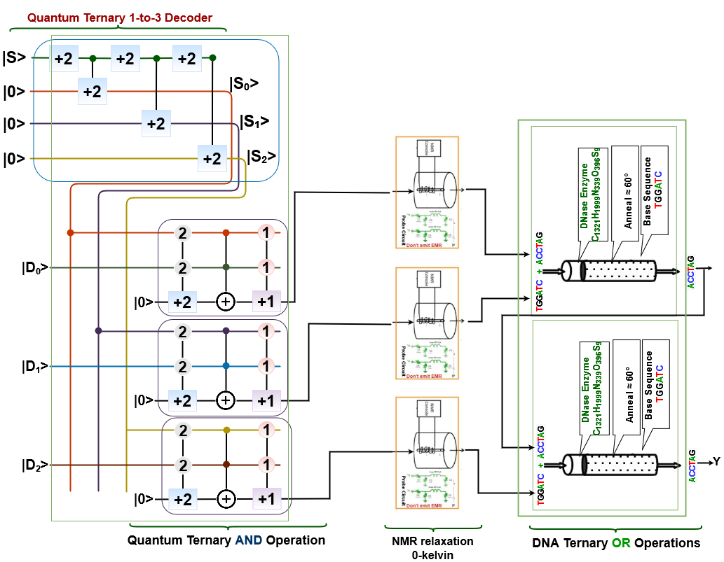

Figure 35: Quantum-DNA circuit for Multivalued 3:1 Multiplexer

From the Multivalued Quantum-DNA 3 to 1 multiplexer circuit in Figure 35, we find that 3 AND, 2 OR and 1 Decoder operational circuit performs to provide the output in DNA sequence. In this circuit 3 AND, one decoder performs with ternary quantum qubit and the rest performs with DNA sequences. The output of all Quantum operational gate goes through NMR relaxation at 0-kelvin. It produces DNA sequences as an output and it can be used as an input in all DNA operational circuit.

To find the required performing time of Quantum-DNA 3 to 1 multiplexer circuit, we divide it in three pipelines as some of the basic DNA gate operation are performing in parallel. All these pipelines are as follows:

1. Quantum (Decoder, AND), DNA (OR, OR)
2. Quantum (Decoder, AND), DNA (OR, OR)
3. Quantum (Decoder, AND), DNA OR

According to subsection 5.1, we can perceive that AND ternary quantum gate operation needs 60µs. And Decoder needs 13µs to perform. Among all pipelines input to output, first pipeline is the largest pipeline for providing output of the Quantum-DNA Ternary 3 to 1 multiplexer, we are taking it for measuring total required performing time. Others Quantum and DNA basic ternary operational gate will be performed within this time in parallel.

Required time for Quantum operation in Ternary 3 to 1 multiplexer is = (Decoder + AND) µs.

Where, required time for Ternary quantum Decoder = 13 µs,

required time for basic Ternary quantum AND gate = 60 µs.

Required time for Quantum operations is = (13+ 60) µs

= 73 µs.

Furthermore, form subsection 3.3, we can perceive that any ternary DNA basic gate (i.e., AND, OR, NOT and NOR) operation needs more or less 2hr to perform. In addition, we need 6hr for preparing any ternary DNA basic gate operation and 2hr for fluoresence detection which is fixed for any multi-(basic) gate operation.

So, required time for two (2) ternary basic gate operation in DNA is = (2+2)

= 4hr.

Where, performing time for ternary DNA gate (AND, OR, NOT and NOR) operation needs more or less 2hr.

The total performing time/ required time for performing DNA operations in 3 to 1 multiplexer circuit is summation of initial preparation time, fluoresence detection time and DNA gate operational time.

So, required time for DNA operations in 3 to 1 multiplexer circuit is = (Basic gate preparation time + four basic DNA gate operational time + fluoresence detection)

= (6 + 4 + 2) hr

= 12hr (approximately).

Thus, to find the expected output of Quantum-DNA Multivalued 3 to 1 multiplexer, the required time will be summation of Quantum operations and DNA operations.

So, total required time for Quantum-DNA Multivalued 3 to 1 multiplexer is

= (Required time for Quantum operation + Required time for DNA operation)

= (73 microseconds + 12hr)

= 12hr (approximately).

### 2.10 Speed Calculation in Multivalued DNA-Quantum Circuit

We may create a multivalued DNA-Quantum computation system to find a super-fast computation system with a lot of memory. The advantages of multivalued quantum computing and multivalued DNA computing can be combined in this multivalued DNA-Quantum computation system.

In a multivalued DNA-Quantum computing system, input is received as a DNA sequence, which is then converted into quantum qubits by NMR after passing through a specific number of quantum operational gates.

#### 2.10.1 Multivalued Half Subtractor at room temperature

A Multivalued Half Subtractor is a type of subtractor, an electronic circuit that performs the subtractions of ternary numbers. The half subtractor is able to subtract two single ternary digits and provide the output with a borrow value. It has two inputs, called A and B, and two outputs D (difference) and B (borrow). DNA-Quantum Multivalued or Ternary Half Subtractor will subtract two qubits as DNA sequence from the quantum ternary digit |0>, |1>, and |2> and produce two outputs as quantum difference |D> and quantum borrow bit |B>. The DNA-Quantum circuit for the Multivalued half subtractor is shown in Figure 35.

From the Multivalued DNA-Quantum Half Subtractor circuit in Figure 35, we find that 11 AND, 9 OR and 8 NOT operational circuit performs to provide the output in Quantum qubit. In this circuit nine AND, five OR and eight NOT DNA operational gate performs with DNA sequence and the rest performs with ternary Quantum qubits. The output of all DNA operational gate goes through NMR at room temperature. It produces Quantum qubits as an output and it can be used as an input in all Quantum operational circuit.

To find the required performing time of DNA-Quantum Ternary Half Subtractor, we can divide it in multiple pipelines, where just five of them are presented below. As well as, these five pipelines of DNA-Quantum ternary operations some of other basic Quantum and DNA ternary gate operations are performing in parallel. Five pipelines are as follows:

1. DNA (NOT, OR, NOT, AND, OR), Quantum (OR, OR)
2. DNA (NOT, NOT, OR, NOT, AND, OR), Quantum (OR, OR)
3. DNA (NOT, NOT, OR, NOT, AND, OR), Quantum (OR, AND, OR)
4. DNA (NOT, OR, NOT, AND, OR), Quantum (OR, AND)
5. DNA (NOT, NOT, OR, NOT, AND, OR), Quantum (OR, AND)

Among all pipelines input to output, third pipeline is the largest pipeline for providing output of the Ternary/Multivalued DNA-quantum Half Subtractor, we are taking it for measuring total required performing time. Other DNA and Quantum basic ternary operational gate will be performed within this time in parallel.

From subsection 3.3, we can find that any DNA basic operational gate (i.e., AND, OR, NOT and XOR) needs more or less 2hr to perform. In addition, we need 6hr for preparing any DNA basic gate operation and 2hr for fluoresence detection which is fixed for any multi-(basic) gate operation.

So, required time for DNA operations is = (6 x 2) hr

= 12 hr

The total performing time required for DNA operations is summation of initial preparation time, fluoresence detection time and DNA gate operational time.

So, required time for DNA operations is

= (Basic gate preparation time + DNA gate operational time + Fluoresence detection)

= (6 + 12 + 2)

= 20hr (approximately).

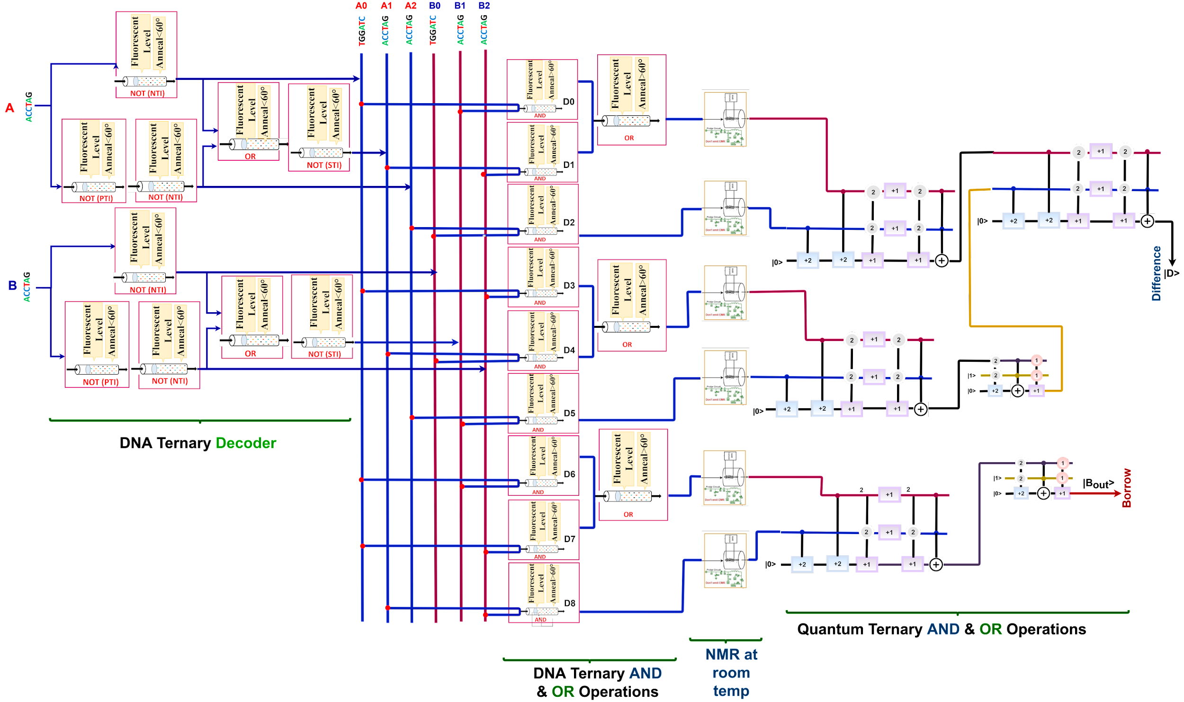

Figure 35: DNA-Quantum circuit for Multivalued Half Subtractor

According to subsection 5.1, we can perceive that AND and OR ternary quantum gate operation needs 60µs and 80µs respectively.

Required time for Quantum operation in Ternary Half Subtractor is = (OR + AND + OR) µs.

Where, required time for basic Ternary quantum AND gate = 60 µs,

required time for basic Ternary quantum OR gate = 80 µs,

Required time for Quantum operations is = (60 + 2 x 80) µs

= 220 µs.

Thus, to find the expected output of DNA-Quantum Multivalued Half Subtractor, the required time will be summation of Quantum operations and DNA operations.

So, total required time for DNA-Quantum Multivalued Half Subtractor is

= (Required time for DNA operation + Required time for Quantum operation)

= (220 microseconds + 20hr)

= 20hr (approximately).

### 3.11 Applications

This section describes some real-life applications of DNA and Quantum operation, where it is used and provides superior performance against classical computing systems. In case of different applications classical computing systems might fail but Quantum and DNA computing systems can show its capability.

***Encryption***:  The Data Encryption Standard (DES) employs a 56-bit key to encrypt 64-bit information. Breaking DES means we can find a key that maps the plain-text to the cipher-text given a (plain-text, cipher-text) pair. A traditional DES assault would need an exhaustive search of all 256 DES keys, which would take 10,000 years at a rate of 100,000 operations per second. As a result, molecular programs were developed, which needed around 4 months of laboratory work instead.

DNA computation is expected to provide significant benefits in terms of speed, energy efficiency, and cost-effective information storage. The number of operations per second in Adleman's model might be as high as 1.2 x 1018. This is around 1,200,000 times quicker than the most powerful supercomputer. Additionally, DNA computers have the potential to be extremely energy efficient. In theory, one joule is enough to do about 2 x 1019 1igation operations. This is surprising given that the second law of thermodynamics states that there may only be 34 x 1019 (irreversible) operations per joule in theory (at room temperature). Existing supercomputers are significantly less efficient, with 109 operations per joule at most. Finally, storing information in DNA molecules could allow for an information density of around 1 bit per cubic nanometer, compared to 1 bit per 1012 nm3 in current storage media.

***Traveling salesman problem***: The first theory of DNA computation was proposed by Leonard Adleman in 1994. He put his experimental theory into the test with a seven-point Hamiltonian path problem or also called the traveling salesman problem. The salesman in this problem needs to find the shortest path between seven cities whose distances are known in such a way that he crosses no city twice and returns to the original city. Adleman represented each city with a short DNA sequence with about 20 bases and a complementary strand with 20 bases as the street between the cities. All the fragments are capable of linking with each other. When the fragments were put in a tube and mixed, the natural bonding tendencies of the DNA created 109 formations or solutions in less than a second. Not all were correct and he took a week to extrapolate and filter out the shortest path through various techniques. Though this solution was not ideal, this demonstration opened floodgates to a wide range of possibilities and applications.

***Weather Forecasting***: Weather affects over 30% of US GDP ($6 trillion) directly or indirectly, affecting food production, transportation, and retail trade, among other things. The capacity to better predict the weather would be extremely beneficial in a variety of sectors, not to mention giving people more time to prepare for disasters. While scientists have long desired to do this, the equations controlling such processes involve a large number of variables, making traditional simulation time-consuming. "Using a classical computer to undertake such analysis might take longer than it takes for the actual weather to evolve!", said quantum researcher Seth Lloyd. This prompted Lloyd and colleagues at MIT to demonstrate that the weather equations have a hidden wave nature that can be solved by a quantum computer. Quantum computers could aid in the development of improved climate models, allowing us to gain a better understanding of how humans affect the ecosystem. These models form the foundation for our projections of future warming, and they assist us in determining what steps need to be taken now to avoid calamities.

### 3. 12 Summary

Quantum computing focuses on speedy technology based on quantum theoretical principles, which is the behavior of energy and matter of a qubit. Combination of qubits is used to perform any specific task in quantum computing. Quantum computers represent a significant advancement in computing capability, with enormous performance benefits for specific use cases. The ability of bits to be in several states at the same time gives the quantum computer a lot of computing capability and it is much faster than classical bitwise computing.

Furthermore, DNA computing uses biological molecules to do computations. The four-character genetic alphabet (A-adenine, G-guanine, C-cytosine, and T-thymine) is used in DNA computing.  Input of any DNA operation can be represented by DNA molecules with specific sequences. The instructions are carried out by laboratory operations on the molecules, and the result is defined as some property of the final set of molecules. DNA computing promises significant and meaningful linkages between computers and life systems, as well as massively parallel computations. DNA computing can actually carry out millions of operations at the same time.

To advance computation, we can make or use DNA-Quantum computing and Quantum-DNA computing systems, which will merge all the advantages of both DNA computing and Quantum computing.

Operational required time is an important property of any operation for computation. We have found that, in quantum computing operation, required time for performance is dependent on the number of qubits in the operational circuit. On the other hand, in DNA computing, total required time for a operational circuit depends on number of used operational gate.

### Reference:

1. Levitin, L. B., Toffoli, T., & Walton, Z. (2002). Operation time of quantum gates. *arXiv preprint quant-ph/0210076*.
2. Isailovic, N., Patel, Y., Whitney, M., & Kubiatowicz, J. (2006, June). Interconnection networks for scalable quantum computers. In *33rd International Symposium on Computer Architecture (ISCA'06)* (pp. 366-377). IEEE.
3. Thaker, D. D., Metodi, T. S., Cross, A. W., Chuang, I. L., & Chong, F. T. (2006, June). Quantum memory hierarchies: Efficient designs to match available parallelism in quantum computing. In *33rd International Symposium on Computer Architecture (ISCA'06)* (pp. 378-390). IEEE.
4. Metodi, T. S., Thaker, D. D., Cross, A. W., Chong, F. T., & Chuang, I. L. (2005, November). A quantum logic array microarchitecture: Scalable quantum data movement and computation. In *38th Annual IEEE/ACM International Symposium on Microarchitecture (MICRO'05)* (pp. 12-pp). IEEE.
5. Zheng, X., Yang, J., Zhou, C., Zhang, C., Zhang, Q., & Wei, X. (2019). Allosteric DNAzyme-based DNA logic circuit: Operations and dynamic analysis. *Nucleic acids research*, *47*(3), 1097-1109.

**Part 2**

**Overview about Heat Transfer, Data Conversion and Memory Management**

Our main objective is to provide information for transferring heat from Quantum circuit to DNA operational circuit, converting data for DNA and Quantum computation system and last one is to management of converted data.

According to the theory of thermodynamics, huge amounts of produced heat from quantum circuit can deteriorate its performance. On the other hand, in DNA operational circuit, to completion of each step we need a certain amount of heat. If we merge two these findings, we can provide a novel procedure to provide heat in DNA operational circuits by taking away the produced heat in Quantum operational circuits. The main objectives of chapter two are to transfer produced heat from Quantum operational circuit to DNA operational circuits by a heat conduction circuits in Quantum-DNA operational circuit and multivalued Quantum-DNA operational circuits. Heat transfer is important in protecting the environment by reducing emissions and pollutants. The heat conduction circuit receives heat from the Quantum operational gate. The NIS junctions produce heat flows between the normal-metal islands and the superconducting leads. Then, the electrons in the normal metal exchange heat with the phonon bath. In next, the islands exchange heat between each other by photons travelling in the transmission line. Finally, the model takes into account geometrical properties of the samples as well as properties specific to the measurement set-up. Basically, heat passes through the junction into metal then electron heated and this electron transfers the heat to photon bath on the coplanar waveguide channel and then it goes to one 1-meter distance.

For combining the advantages of both DNA and Quantum computation system, we can introduce DNA-quantum and Quantum-DNA computation system. It will be able to compute parallel operation at super-fast speed. In this, we need to convert data from quantum qubit to DNA sequence and further DNA sequence to Quantum qubits. In a Quantum-DNA and multivalued Quantum-DNA circuit, we will operate inputs in quantum operation and provide output in DNA sequence. For providing output, we have to use NMR relaxation for converting quantum qubit to DNA sequence. After getting qubit from quantum operation, we have to operate NMR relaxation. In NMR relaxation, we can use a room temperature probe or a cryogenic probe at 0-kelvin temperature. By NMR relaxation qubit of superposition state turns into normal ground state and we get the equivalent DNA sequence. In NMR relaxation at room temperature probes, decoherence problems, polarization, and scaling problems can occur thus cryogenic probe at 0-kelvin temperature can be preferred for Quantum-DNA computation system.

In a DNA-Quantum and multivalued DNA-Quantum circuit, we will operate inputs in DNA sequence and provide output in Quantum qubits. For providing output, we have to use NMR operation for converting DNA sequence to quantum qubits. After getting DNA sequence from DNA operation, we have to operate NMR process for convert it into Quantum qubits. In NMR process, we can use a room temperature probe or a cryogenic probe at 0-kelvin temperature. By applying NMR process for the DNA sequence, qubit of normal ground state turns into superposition state or ground state according to the input sequence in NMR. The output of the NMR process is Quantum qubit. In NMR at room temperature probes, decoherence problems, polarization, and scaling problems can occur, thus cryogenic probe at 0-kelvin temperature can also be preferred for DNA-Quantum computation system.

Both quantum and DNA computing approaches can be used to accomplish operations at a very high speed and efficiency. There is a critical issue that occurs when merging both computing systems for a single activity. Quantum computers are million times quicker than the world's fastest supercomputer as a result of this. As a result, quantum operations produce instantaneous results. However, DNA procedures take a long time to prepare. As a result, the quantum computer's output qubits cannot be instantly inserted into the DNA system. Thus, when working with the Quantum-DNA system, we need a temporary storage device or system where the qubits may be held for a very short time. So, a Quantum Cache memory is needed to operate a Quantum and DNA computing circuit for its operation, which can store data for a short amount of time and can pass it to another. The structure and working procedure of quantum and DNA cache memory is described in chapter five. Quantum D flip-flop is used for storing a qubit in each operational system where it works on two states, SET and RESET. To store 2 qubits, a 4x2 Quantum Cache memory, to store 3 qubits, a 8x3 Quantum Cache memory and to store 4 qubits, a 16x4 Quantum Cache memory.

# Chapter II

## Heat Transfer

### 2.1 **Introduction**

Combinatorics, a type of calculation that traditional computers have trouble with, is one such challenge. These calculations involve arranging elements in a way that achieves a particular objective. As the number of things increases, so does the number of possible combinations. To find the ideal arrangement, today's digital computers must loop through each permutation until an outcome is found, and then determine which is the most effective at achieving the goal. In many circumstances, this will demand a large number of calculations. Combinatorics calculations prove problematic in a variety of sectors, ranging from banking to pharmaceuticals. Quantum computers come into play here. Quantum computing reduces the cost of calculating difficult combinatorial problems in the same way as classical computers reduced the cost of arithmetic.

Quantum computing is a field of study that focuses on the creation of computer-based technologies based on quantum theoretical principles. On the quantum (atomic and subatomic) level, quantum theory describes the nature and behavior of energy and matter. To execute certain computational tasks, quantum computing employs a combination of qubits. All of this is done at a far higher rate than their traditional computing equipment. Quantum computers represent a significant advancement in computing capability, with enormous performance benefits for specific use cases. The ability of bits to be in several states at the same time gives the quantum computer a lot of computing capability. They can accomplish jobs with a mix of | 1 >, | 0 >, and both | 1 > and | 0 > at the same time. So, quantum computing can be defined as an area of computing which is focused on the development of computer technology based on the principles of quantum theory. In addition, quantum computing is much faster than classical bit-wise computing.

Quantum computing can be used in different sectors as chemical and biological engineering, cybersecurity, artificial intelligence, financial service and in complex manufacturing. The discovery and manipulation of molecules is a part of chemical and biological engineering. Chemicals are made with subatomic particles and thus it involves quantum mechanics. For almost a thousand years, combinatorics has been at the heart of cryptography. But using quantum computing cracking any encryption can be easier than other technology. Artificial intelligence frequently involves the combinatorics processing of very large amounts of data in order to make better predictions and decisions, and quantum computing is associated with this. Large amounts of data is the main domain of financial systems and manufacturing. Quantum computing has the potential to improve the speed of a critical set of financial calculations within a large amount of data. In recent years, billions of dollars have been invested in quantum computing because of its potential to tackle large-scale combinatorics problems faster and cheaper.

Every single cell that makes up a living organism contains information for various functions that are required for the cell's existence. Nucleic acids are molecules that contain genetic information in each cell. Deoxyribonucleic acid is the most stable type of nucleic acid (DNA). Each DNA strand forms helical structures, which are lengthy polymers made up of millions of nucleotides bonded together. One of four nitrogen bases, a five-carbon sugar, and a phosphate group make up these nucleotides. The genetic information is encoded by the nitrogen bases A (Adenine), T (Thymine), G (Guanine), and C (Cytosine), while the others offer structural stability. T with A and C with G are the base-pairing rules that connect the strands. The order in which these nucleotides are arranged is essential since it determines how different genes function.

So, DNA computing is a kind of natural computing that uses the molecular characteristics of DNA to conduct logical and arithmetic operations instead of typical carbon/silicon chips. The four-character genetic alphabet (A-adenine, G-guanine, C-cytosine, and T-thymine) is used in DNA computing instead of the binary alphabet (1 and 0) utilized by standard computers. This enables massively parallel computation, making it possible to answer difficult mathematical equations or problems in a fraction of the time. As a result, computation is far more efficient with a large volume of self-replicating DNA than with a standard computer, which would require a lot more hardware. Information or data will now be kept in the form of the bases A, T, G, and C, rather than binary digits. The capacity to generate short DNA sequences artificially allows these sequences to be used as inputs for algorithms. This is possible due to the ability to create small DNA molecules with any arbitrary sequence. Input of any DNA operation can be represented by DNA molecules with specific sequences. The instructions are carried out by laboratory operations on the molecules, and the result is defined as some property of the final set of molecules. DNA computing promises significant and meaningful linkages between computers and life systems, as well as massively parallel computations. DNA computing can actually carry out millions of operations at the same time.

DNA computing was introduced based on the usage of DNA and molecular biology hardware instead of the typical silicon-based technology. The molecular computers could take advantage of DNA's physical properties to store information and perform calculations. These include extremely dense information storage, enormous parallelism and extraordinary energy efficiency. DNA computing has an arresting performance on breaking Data Encryption Standards, Satisfiability problem solving and travelling salesman problem.

From the first chapter, we have found that during quantum computation qubits produce large amounts of heat. On the other hand, DNA computation needs energy or heat to perform its expected operations. To process one or multiple DNA sequences, we have to perform multiple steps using different levels of heat or temperature. Our objective is to provide heat from Quantum logical gate operation to DNA logical gate operations using a heat conduction system. Heat transfer is important in protecting the environment by reducing emissions and pollutants. In this chapter, we are going to introduce a heat transferring procedure for the Quantum-DNA computation system.

### 2.2 **Basic Definitions**

From Chapter 1, we have seen that each quantum operation with any number of qubits produce heat in that circuit. We have calculated these heat using laws of thermodynamics. In addition, this heat can transfer into DNA circuits using some basic operation of heat transfer. This section will discuss how we can transfer produced heat from the quantum operation to DNA circuits. Figure 1 describes Quantum heat conduction circuit using photon and nanotube.

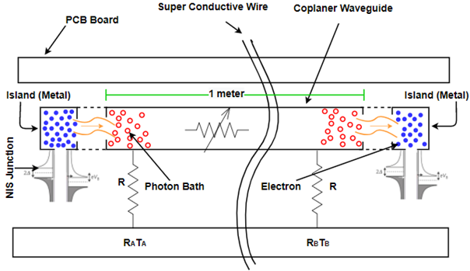

**Figure 1:** Quantum heat conduction circuit using photon and nanotube

***Designing Principle (Quantum Heat conductance Circuit):***

In this design we use nanotube photons for heat conduction. Here heat conduction will happen from one island to another island. The length of the coplanar waveguide is either 20 cm or 1 m, and it has a double-spiral structure on a silicon chip with a size of 1 × 1 cm2 or 2 × 2 cm2, respectively. In all samples, the normal-metal islands terminating the waveguide have two galvanic contacts to superconducting lines: one to the center conductor of the waveguide and the other to the ground plane.

In practice the two resistors are connected to each other symmetrically by two aluminum superconducting lines, interrupted by a DC-SQUID (superconducting quantum interference device) in each line. These nanostructures are fabricated with electron beam lithography. The two AuPd resistors are nominally identical—6.6 mm long, 0.8 mm wide and 15 nm thick. Their resistances are Ri < 200 V each. The register is also connected with the downstairs aluminum beam for thermometry and joule heating. On the upside the chip is attached to a sample holder containing a printed circuit board (PCB), to which the sample is connected by A1 bond wires. The PCB is connected to a room-temperature measurement set-up with lossy coaxial cables.

***Working Principle:***

The quantum of thermal conductance, GQ = πkB2T/6ℏ, provides the fundamental upper limit for heat conduction through a single channel. Here, **T** is the temperature, **kB** denotes the Boltzmann constant, and **ℏ** is the reduced Planck’s constant. From that equation we get a measurement of quantum conductance.

With the help of the circuit using photons our heat conduction limit will be in 1 meter. In this circuit in the nanotube, we use photons because we know photons, unlike many other carriers of heat, can travel macroscopic distances without significant scattering. For example, in case of optical fibers or superconducting waveguides.

Here heat conduction happens through a single channel formed by photons travelling in a long superconducting waveguide in a single transverse mode. This heat transport does not depend on only photon temperature rather it depends on control of the temperature. One island actually transports the heat to another island or we can say the temperature of each island is increasing when another island's temperature decreases.

The NIS superconducting junction is connected to islands, which is actually metal. NIS junction is sometimes used to cool or to heat the normal metal.

At first, the NIS junctions produce heat flows between the normal-metal islands and the superconducting leads. Secondly, the electrons in the normal metal exchange heat with the phonon bath. Then, the islands exchange heat between each other by photons travelling in the transmission line. Finally, the model takes into account geometrical properties of the samples as well as properties specific to the measurement set-up.

Here in this circuit heat passes through the junction into metal then electron heated and this electron transfers the heat to photon bath on the coplanar waveguide channel and then it goes to one 1-meter distance.

Now, we are going to transfer heat between basic quantum and DNA operational gates as AND, OR, XOR and NOT operational gates. These operational gates in quantum are prepared with Quantum basic gates as NOT, CNOT, V+, and V. On the other hand, operational gates in DNA are prepared with base DNA sequence and enzymes.

1. **Heat transfer from Quantum AND operation to DNA NOT operation**

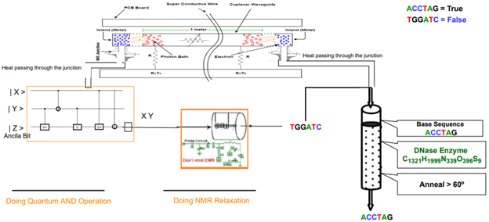

**Figure 2:** Quantum DNA NAND operation Circuit

***Design Procedure:***

The given circuit design describes a Quantum operational gate as AND and a DNA operational gate as NOT. In the AND gate we use three v+ and two NOT gates. It is a three-qubit gate and two qubits are input and one bit is an ancilla bit. From the quantum AND gate, we connect the junction to transfer heat to metal. The island is basically metal in a heat conduction circuit. There are two resistors and a photon bath working as a heat conductance at a distance of 1 meter. Then heat is transferred by junction into the DNA circuit. The output qubit produced from AND operational gate being relaxed using NMR relaxation process and becomes a DNA sequence which is the input in DNA NOT operational gate. Quantum AND gate and DNA NOT gate make together a NAND operational gate.

***Working Procedure:***

In the quantum AND operational circuit, we have used 2 qubits as input and an ancilla bit. Ancilla bit is used to reverse the operational gate. Ancilla qubit is also used for error correction and it is called check bit. Here in Quantum AND operational gate, we have used qubit as |0> because without this qubit we cannot reverse the gate and we will get an error in output without an ancilla qubit.

When qubits are started to operate as a gate operation, they create a huge temperature but quantum computers need an absolute zero temperature environment. With the junction heat transfer to metal molecules. Then molecules transfer the heat into the photon bath and then photons transfer heat through the channel. And finally, we get sequence by NMR relaxation from the first quantum operational gate and heat into the DNA NOT operational gate. In addition, for DNA operation we need some basic amount of heat such as mixing, melting and amplifying.

1. **Heat transfer from Quantum OR operation to DNA NOT operation**

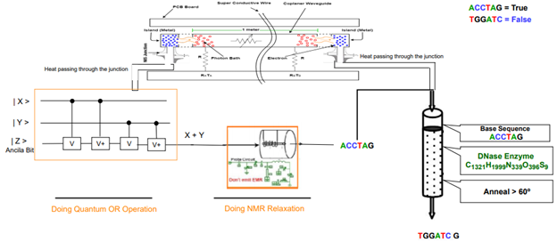

Figure 3: Quantum DNA NOR operation Circuit

***Design Procedure:***

The given circuit design describes a Quantum operational gate as OR and a DNA operational gate as NOT. In the OR gate we use two v+ and two v gates. It is a three-qubit gate and two qubits are input and one bit is an ancilla bit. From the quantum OR gate, we connect the junction to transfer heat to metal. The island is basically metal in a heat conduction circuit. There are two resistors and a photon bath working as a heat conductance at a distance of 1 meter. Then heat is transferred by junction into the DNA circuit. The output qubit produced from OR operational gate being relaxed using NMR relaxation process and becomes a DNA sequence which is the input in DNA NOT operational gate. Quantum OR gate and DNA NOT gate make together a NOR operational gate.

***Working Procedure:***

In the quantum OR operational circuit, we have used 2 qubits as input and an ancilla bit. Ancilla bit is used to reverse the operational gate. Ancilla qubit is also used for error correction and it is called check bit. Here in Quantum OR operational gate, we have used qubit as |0> because without this qubit we cannot reverse the gate and we will get an error in output without an ancilla qubit.

When qubits are started to operate as a gate operation, they create a huge temperature but quantum computers need an absolute zero temperature environment. With the junction heat transfer to metal molecules. Then molecules transfer the heat into photon bath and then photons transfer heat through the channel. And finally, we get sequence by NMR relaxation from the first quantum operational gate and heat into the DNA NOT operational gate. In addition, for DNA operation we need some basic amount of heat such as mixing, melting and amplifying.

1. **Heat transfer from Quantum XOR operation to DNA NOT operation**

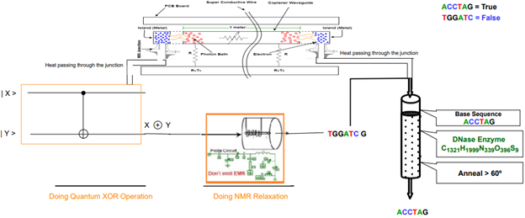

Figure 4: Quantum DNA XNOR operation Circuit

***Design Procedure:***

The given circuit design describes a Quantum operational gate as XOR and a DNA operational gate as NOT. In XOR gate we use one CNOT gate. It is a two-qubit gate and both are input. From the quantum XOR gate, we connect the junction to transfer heat to metal. The island is basically metal in a heat conduction circuit. There are two resistors and a photon bath working as a heat conductance at a distance of 1 meter. Heat is transferred by junction into the DNA circuit. The output qubit produced from XOR operational gate being relaxed using NMR relaxation process and becomes a DNA sequence which is the input in DNA NOT operational gate. Quantum XOR gate and DNA NOT gate make together a XNOR operational gate.

***Working Procedure:***

In the quantum XOR operational circuit, we have used 2 qubits as input. When qubits are started to operate as a gate operation, they create a huge temperature but quantum computers need an absolute zero temperature environment. With the junction heat transfer to metal molecules. Then molecules transfer the heat into photon bath and next, photons transfer heat through the channel. And finally, we get sequence by NMR relaxation from the first quantum operational gate and heat into the DNA NOT operational gate. In addition, for DNA operation we need some basic amount of heat such as mixing, melting and amplifying.

### 2.3 **Heat Transfer in Quantum-DNA Circuits**

According to quantum computing, quantum computation is faster than classical computation systems. Quantum computers are also more powerful than supercomputers in terms of computing. They are 1000 times faster than regular computers and supercomputers at processing data. Quantum computers can execute calculations that would take a regular computer 1000 years to complete in a matter of seconds. On the other hand, the use of DNA strands to compute has led to high parallel computation that makes up for the slow processing of the chip. Memory space required by DNA is around 1 bit per cubic nanometer which is much less when compared to regular storage systems Consumption of power is almost nil as the chemical bonds in DNA produce energy to build or repair new strands. So, for finding a super faster computation system with huge memory, we can develop a Quantum-DNA computation system. This Quantum-DNA computation system can merge all advantages of quantum computing and DNA computing.

In a Quantum-DNA computing system, input will be received as qubit and after performing in a certain number of quantum operational gates these qubits will be turned into DNA sequences by NMR relaxation.

#### 2.3.1 Heat Transfer in Quantum-DNA Full Adder

Full Adder is the adder which adds three inputs and produces two outputs. The first two inputs are A and B and the third input is an input carry as Cin. The output carry is designated as Cout and the normal output is designated as S which is Sum. A Full Adder logic is designated in such a manner that can take eight inputs together to create a qubit adder and cascade the carry qubit from one adder to the another. To create a Full Adder, one OR, tow AND and two XOR operational gates are required. Figure 5 describes the Quantum-DNA circuit of the Full Adder.

***Design procedure:***

To design a Quantum-DNA Full Adder for heat transfer we have to use Quantum and DNA operational gates so that we can operate the input qubit for their corresponding outputs. The Quantum operational gates will be used for receiving the input qubits and the DNA operational gates will be used to produce the final output against the corresponding set of inputs. Each time, the Quantum-DNA Full adder will receive three qubits as input. After operating in a certain number of Quantum operational gates, the qubit will be turned into corresponding DNA sequence by using NMR relaxation room temperature probe. By using a room temperature probe and corresponding components of NMR relaxation, the excited qubit turns into ground state and produces a DNA sequence. Then the DNA sequence is processed through DNA operational gates and outputs are received.

From the quantum operational gate, we connect the junction to metal for transferring heat. The island is basically metal in a heat conduction circuit. There are two resistors and a photon bath working as a heat conductance at a distance of 1 meter. Heat is transferred by junction into the DNA circuit. Here, Figure 5 describes Quantum-DNA Full adder using Quantum, DNA operational gates and heat conduction nanotubes.

From the figure, we find that the Quantum-DNA Full Adder consists of three Quantum operational gates and two DNA operational gates. Here, two AND and one XOR is used as Quantum operational gates and further one XOR and one OR DNA operational gates is used.

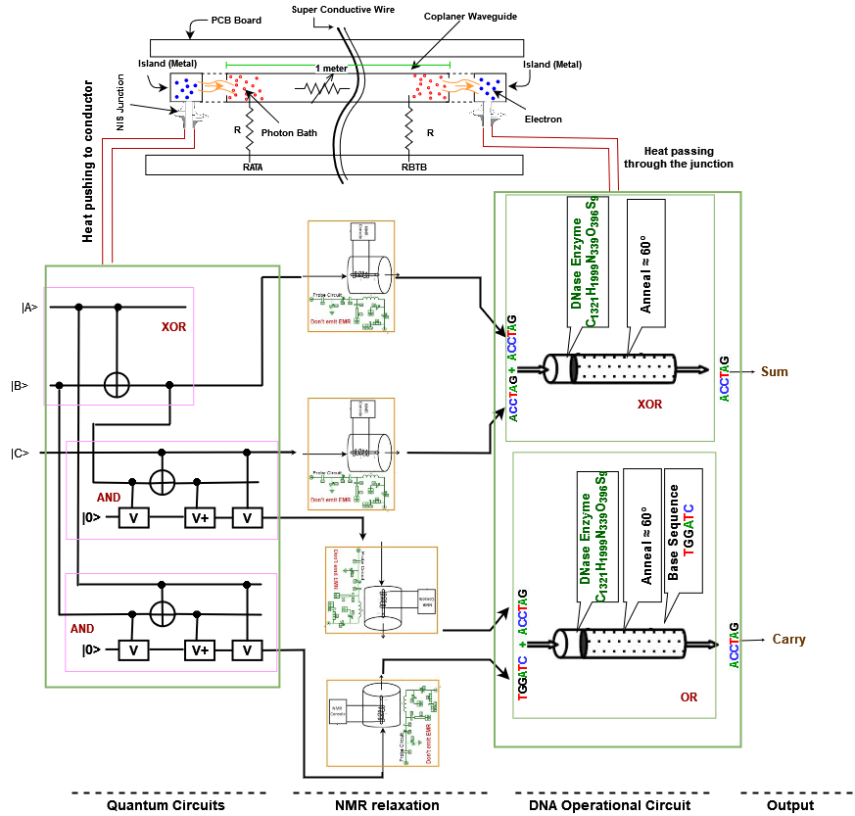

Figure 5: Quantum DNA Full Adder for Heat transfer

***Working procedure:***

Here, we are using DNA sequence ACCTAG = TRUE for Quantum qubit | 1 > and DNA sequence TGGATC = FLASE for Quantum qubit | 0 >.

The heat conduction circuit receives heat from the Quantum operational gate. Firstly, the NIS junctions produce heat flows between the normal-metal islands and the superconducting leads. Secondly, the electrons in the normal metal exchange heat with the phonon bath. Then, the islands exchange heat between each other by photons travelling in the transmission line. Finally, the model takes into account geometrical properties of the samples as well as properties specific to the measurement set-up.

Here in this circuit heat passes through the junction into metal then electron heated and this electron transfers the heat to photon bath on the coplanar waveguide channel and then it goes to one 1-meter distance.

Using NMR relaxation quantum qubits turned into DNA sequences. Further, these DNA sequences and supplied heat operate DNA operation of Full Adder. The working procedure of Full adder is also described in Chapter 3.

#### 2.3.2 Heat Transfer in Quantum-DNA Multiplier

A binary multiplier is a combinational logic circuit or digital device used for multiplying two binary numbers. The two numbers are more specifically known as multiplicand and multiplier and the result is known as a product. The multiplicand and multiplier can be of various bit sizes. The product’s bit size depends on the bit size of the multiplicand & multiplier. The bit size of the product is equal to the sum of the bit size of multiplier multiplicand. To create a Multiplication circuit, six AND and two XOR gates are required. Figure 6 describes the Quantum-DNA circuit of the 2-bit multiplication.

***Design procedure:***

To design a Quantum-DNA multiplier for heat transfer we have to use Quantum and DNA operational gates so that we can operate the input qubit for their corresponding outputs.

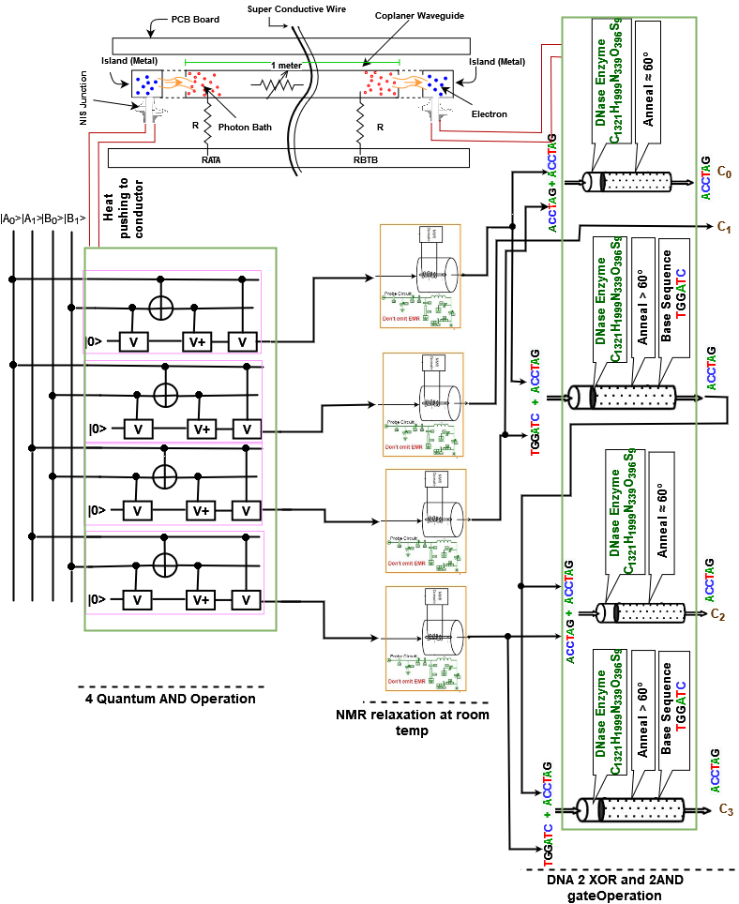

Figure 6: Quantum-DNA Multiplier for Heat transfer using nanotubes

The Quantum operational gates will be used for receiving the input qubits and the DNA operational gates will be used to produce the final output against the corresponding set of inputs. Each time, the Quantum-DNA Full adder will receive three qubits as input. After operating in a certain number of Quantum operational gates, the qubit will be turned into corresponding DNA sequence by using NMR relaxation room temperature probe. By using a room temperature probe and corresponding components of NMR relaxation, the excited qubit turns into ground state and produces a DNA sequence. Then the DNA sequence is processed through DNA operational gates and outputs are received.

From the quantum operational gate, we connect the junction to metal for transferring heat. The island is basically metal in a heat conduction circuit. There are two resistors and a photon bath working as a heat conductance at a distance of 1 meter. Heat is transferred by junction into the DNA circuit. Here, Figure 6 describes Quantum-DNA Full adder using Quantum, DNA operational gates and heat conduction nanotubes.

From the figure, we find that the Quantum-DNA Full Adder consists of four Quantum operational gates and four DNA operational gates. Here, four AND operational gates are used as Quantum operational gates and further two XOR and two AND DNA operational gates are used.

***Working procedure:***

Here, we are using DNA sequence ACCTAG = TRUE for Quantum qubit | 1 > and DNA sequence TGGATC = FLASE for Quantum qubit | 0 >.

The heat conduction circuit receives heat from the Quantum operational gate. Firstly, the NIS junctions produce heat flows between the normal-metal islands and the superconducting leads. Secondly, the electrons in the normal metal exchange heat with the phonon bath. Then, the islands exchange heat between each other by photons travelling in the transmission line. Finally, the model takes into account geometrical properties of the samples as well as properties specific to the measurement set-up.

Here in this circuit heat passes through the junction into metal then electron heated and this electron transfers the heat to photon bath on the coplanar waveguide channel and then it goes to one 1-meter distance.

Using NMR relaxation quantum qubits turned into DNA sequences. Further, these DNA sequences and supplied heat operate the DNA operation of Multiplier. The working procedure of Multiplier is also described in Chapter 3.

### 2.4 **Heat Transfer in Multi-valued Quantum-DNA Circuits**

Multivalued quantum computation, according to multivalued quantum computing, is far more advantageous than classical computation systems. Quantum computers are also more powerful in terms of computation than supercomputers. They process data 1000 times faster than normal computers and supercomputers. Quantum computers can perform computations in a fraction of a second that would take a traditional computer 1000 years to finish. Parallelism based on linear superposition of quantum states is a benefit of multivalued quantum computing. It has been demonstrated that multivalued quantum algorithms can solve some problems in fewer steps than conventional classical algorithms.

The use of multivalued (more than two DNA strands) DNA strands to compute, on the other hand, has resulted in high parallel computation, which compensates for the chip's slow processing. When compared to traditional storage systems, DNA requires just about 1 bit per cubic nanometer of memory space. The chemical interactions in DNA provide energy to make or repair new strands, therefore there is essentially no power use. As a result, we may create a multivalued Quantum-DNA computation system to find a super-fast computation system with a lot of memory.The advantages of multivalued quantum computing and multivalued DNA computing can be combined in this multivalued Quantum-DNA computation system.

In a multivalued Quantum-DNA computing system, input is received as a qubit, which is then converted into DNA sequences by NMR relaxation after passing through a specific number of quantum operational gates.

#### 2.4.1 Heat Transfer in Multivalued Quantum-DNA Full Subtractor (Difference)

A Multivalued Half Subtractor is a type of subtractor, an electronic circuit that performs the subtractions of ternary numbers. The half subtractor is able to subtract two single ternary digits and provide the output plus a borrow value. It has two inputs, called A and B, and two outputs D (difference) and B (borrow). Quantum-DNA multivalued Half Subtractor will subtract two bits from the quantum ternary digit |0>, |1>, and |2> and produce two outputs as difference |D> and borrow |B> in DNA sequence. The multivalued Quantum-DNA circuit for the ternary Full Subtractor is shown in Figure 7.

***Design procedure:***

To design a multivalued Quantum-DNA Full Subtractor for heat transfer we have to use Quantum and DNA operational gates so that we can operate the input qubit for their corresponding outputs. The Quantum operational gates will be used for receiving the input qubits and the DNA operational gates will be used to produce the final output against the corresponding set of inputs. Each time, the Quantum-DNA Full Subtractor will receive three qubits as input. After operating in a certain number of Quantum operational gates, the qubit will be turned into corresponding DNA sequence by using NMR relaxation room temperature probe. By using a room temperature probe and corresponding components of NMR relaxation, the excited qubit turns into ground state and produces a DNA sequence. Then the DNA sequence is processed through DNA operational gates and outputs are received.

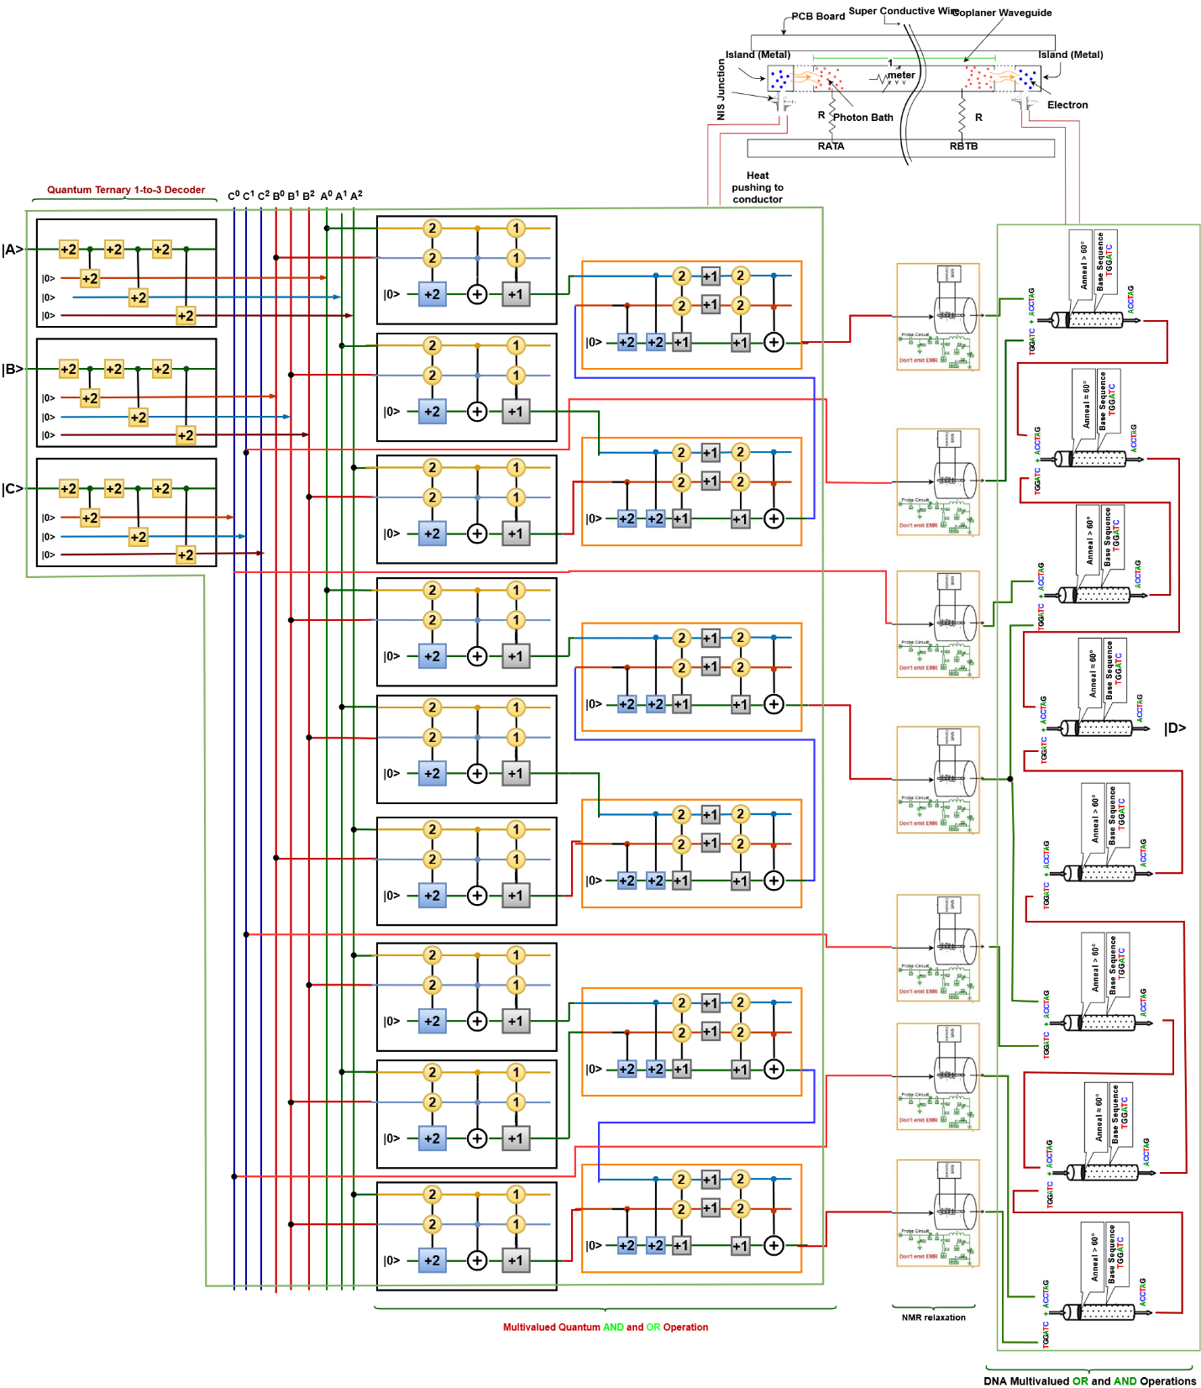

Figure 7: Multivalued Quantum-DNA Full Subtractor (Difference) for Heat transfer using nanotubes.

From the quantum operational gate, we connect the junction to metal for transferring heat. The island is basically metal in a heat conduction circuit. There are two resistors and a photon bath working as a heat conductance at a distance of 1 meter. Heat is transferred by junction into the DNA circuit. Here, Figure 7 describes a multivalued Quantum-DNA Full Subtractor using Quantum, DNA operational gates and heat conduction nanotubes.

From the figure, we find that the multivalued Quantum-DNA Full Subtractor consists of nineteen Quantum operational gates and eight DNA operational gates. Here, ten AND, six OR and three Decoder operational gates are used as Quantum operational gates and further six AND and two OR DNA operational gates are used.

***Working procedure:***

Here, we are using DNA sequence CCAGTC for Quantum qubit | 2 >, ACCTAG for Quantum qubit | 1 > and DNA sequence TGGATC for Quantum qubit | 0 >.

The heat conduction circuit receives heat from the Quantum operational gate. Firstly, the NIS junctions produce heat flows between the normal-metal islands and the superconducting leads. Secondly, the electrons in the normal metal exchange heat with the phonon bath. Then, the islands exchange heat between each other by photons travelling in the transmission line. Finally, the model takes into account geometrical properties of the samples as well as properties specific to the measurement set-up.

Here in this circuit heat passes through the junction into metal then electron heated and this electron transfers the heat to photon bath on the coplanar waveguide channel and then it goes to one 1-meter distance.

Using NMR relaxation quantum qubits turned into DNA sequences. Further, these DNA sequences and supplied heat operate the DNA operation of Multiplier. The working procedure of Multivalued Full Subtractor is also described in Chapter 3.

#### 2.4.2 Heat Transfer in Multivalued Quantum-DNA Half Adder

A multivalued Half Adder is a type of adder, an electronic circuit that performs the addition of ternary numbers. The half adder is able to add two single ternary digits and provide the output plus a carry value. It has two inputs, called A and B, and two outputs S (sum) and C (carry). Multivalued Quantum-DNA Half Adder will add two bits from the quantum ternary digit |0>, |1>, and |2> and produce two outputs as quantum sum |S> and quantum carry bit |C> in a DNA sequence. The multivalued Quantum-DNA circuit for the multivalued Half Adder is shown in Figure 8.

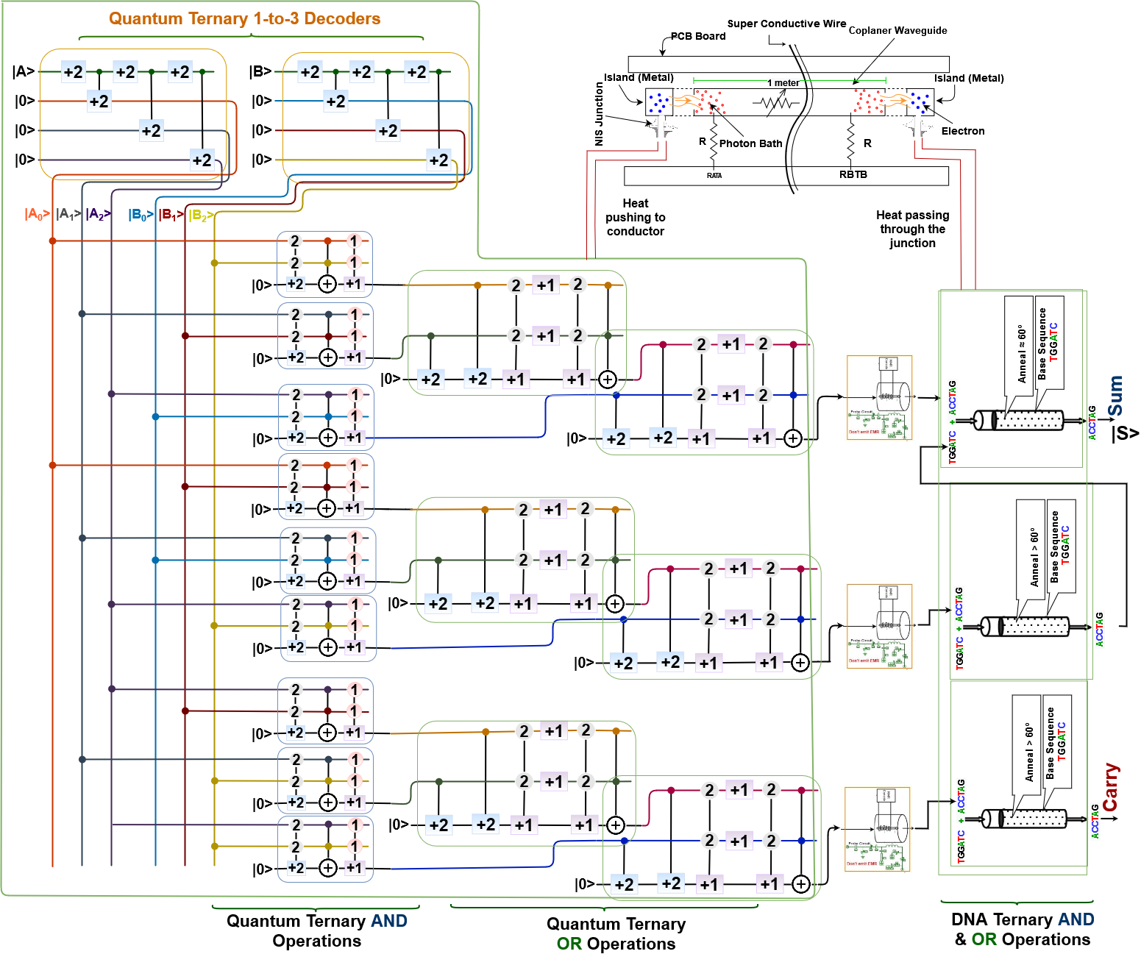

Figure 8: Multivalued Quantum-DNA Half Adder for Heat transfer using nanotubes.

***Design procedure:***

To design a multivalued Quantum-DNA Half Adder for heat transfer we have to use Quantum and DNA operational gates so that we can operate the input qubit for their corresponding outputs. The Quantum operational gates will be used for receiving the input qubits and the DNA operational gates will be used to produce the final output against the corresponding set of inputs. Each time, the Quantum-DNA Half Adder will receive two qubits as input. After operating in a certain number of Quantum operational gates, the qubit will be turned into corresponding DNA sequence by using NMR relaxation room temperature probe. By using a room temperature probe and corresponding components of NMR relaxation, the excited qubit turns into ground state and produces a DNA sequence. Then the DNA sequence is processed through DNA operational gates and outputs are received.

From the quantum operational gate, we connect the junction to metal for transferring heat. The island is basically metal in a heat conduction circuit. There are two resistors and a photon bath working as a heat conductance at a distance of 1 meter. Heat is transferred by junction into the DNA circuit. Here, Figure 8 describes a multivalued Quantum-DNA Full Subtractor using Quantum, DNA operational gates and heat conduction nanotubes.

From the figure, we find that the multivalued Quantum-DNA Full Subtractor consists of seven OR, eleven AND and two Decoder operational gates. In addition, seventeen quantum operational gates and three DNA operational gates are required to find the expected output from multivalued Quantum-DNA Half Adder.

***Working procedure:***

Here, we are using DNA sequence CCAGTC for Quantum qubit | 2 >, ACCTAG for Quantum qubit | 1 > and DNA sequence TGGATC for Quantum qubit | 0 >.

The heat conduction circuit receives heat from the Quantum operational gate. Firstly, the NIS junctions produce heat flows between the normal-metal islands and the superconducting leads. Secondly, the electrons in the normal metal exchange heat with the phonon bath. Then, the islands exchange heat between each other by photons travelling in the transmission line. Finally, the model takes into account geometrical properties of the samples as well as properties specific to the measurement set-up.

Here in this circuit heat passes through the junction into metal then electron heated and this electron transfers the heat to photon bath on the coplanar waveguide channel and then it goes to one 1-meter distance.

Using NMR relaxation quantum qubits turned into DNA sequences. Further, these DNA sequences and supplied heat operate the DNA operation of Multiplier. The working procedure of Multivalued Full Subtractor is also described in Chapter 3.

### 2.5 Applications

This section describes some real-life applications of DNA and Quantum operation, where it is used and provides superior performance against classical computing systems. In case of different applications classical computing systems might fail but Quantum and DNA computing systems can show its capability.

***Scheduling***: A DNA computing-based algorithm was presented to solve the job scheduling problem. In order to explain the model with six tasks, it can be demonstrated the working operations, mimicking the method used for the Hamiltonian Path problem. This however was not the first time, Watada in early 2000 used DNA algorithms to work out elevator schedule systems and rearrangement of Flexible Manufacturing System. However, due to a lack of theoretical base, only medium-sized tasks were taken into consideration.

***Clustering***: Clustering deals with deriving highly meaningful relationships in a complex collection of data by creating a structure using various concepts and algorithms. DNA- based clustering involves using strands to assign edges and vertices. Iterative calculations are performed for every produced cluster to improve quality. This method is of particular interest when dealing with large heterogeneous data with an unknown number of clusters. It helps in reducing the time complexity by high parallelism features of DNA.

***Encryption***: The Data Encryption Standard (DES) employs a 56-bit key to encrypt 64-bit information. Breaking DES means we can find a key that maps the plain-text to the cipher-text given a (plain-text, cipher-text) pair. A traditional DES assault would need an exhaustive search of all 256 DES keys, which would take 10,000 years at a rate of 100,000 operations per second. As a result, molecular programs were developed, which need around 4 months of laboratory work instead.

DNA computation is expected to provide significant benefits in terms of speed, energy efficiency, and cost-effective information storage. The number of operations per second in Adleman's model might be as high as 1.2 x 1018. This is around 1,200,000 times quicker than the most powerful supercomputer. Additionally, DNA computers have the potential to be extremely energy efficient. In theory, one joule is enough to do about 2 x 1019 1igation operations. This is surprising given that the second law of thermodynamics states that there may only be 34 x 1019 (irreversible) operations per joule in theory (at room temperature). Existing supercomputers are significantly less efficient, with 109 operations per joule at most. Finally, storing information in DNA molecules could allow for an information density of around 1 bit per cubic nanometer, compared to 1 bit per 1012 nm3 in current storage media.

***Weather Forecasting***: Weather affects over 30% of US GDP ($6 trillion) directly or indirectly, affecting food production, transportation, and retail trade, among other things. The capacity to better predict the weather would be extremely beneficial in a variety of sectors, not to mention giving people more time to prepare for disasters. While scientists have long desired to do this, the equations controlling such processes involve a large number of variables, making traditional simulation time-consuming. "Using a classical computer to undertake such analysis might take longer than it takes for the actual weather to evolve!", said quantum researcher Seth Lloyd. This prompted Lloyd and colleagues at MIT to demonstrate that the weather equations have a hidden wave nature that can be solved by a quantum computer. Quantum computers could aid in the development of improved climate models, allowing us to gain a better understanding of how humans affect the ecosystem. These models form the foundation for our projections of future warming, and they assist us in determining what steps need to be taken now to avoid calamities.

### 2.6 Summary

Quantum computing focuses on speedy technology based on quantum theoretical principles, which is the behavior of energy and matter of a qubit. Combination of qubits is used to perform any specific task in quantum computing. Quantum computers represent a significant advancement in computing capability, with enormous performance benefits for specific use cases. The ability of bits to be in several states at the same time gives the quantum computer a lot of computing capability and it is much faster than classical bitwise computing.

Furthermore, DNA computing uses biological molecules to do computations. The four-character genetic alphabet (A-adenine, G-guanine, C-cytosine, and T-thymine) is used in DNA computing. Input of any DNA operation can be represented by DNA molecules with specific sequences. The instructions are carried out by laboratory operations on the molecules, and the result is defined as some property of the final set of molecules. DNA computing promises significant and meaningful linkages between computers and life systems, as well as massively parallel computations. DNA computing can actually carry out millions of operations at the same time.

To advance computation, we can make or use DNA-Quantum computing systems, which will merge all the advantages of both DNA computing and Quantum computing.

Heat is an important property of any operation for computation. We have found that, in quantum computing operation, much heat is produced by circuits, which is dependent on the number of qubits in the operational circuit. On the other hand, in DNA computing, we have to provide heat in the test tube to execute the operation. Its different stage needs different amounts of time and heat, which is calculated in chapter 1. Here, we have used the heat transfer circuit to pass the produced heat of quantum computing operations in the DNA computing operation**.** The heat conduction circuit receives heat from the Quantum operational gate. The NIS junctions produce heat flows between the normal-metal islands and the superconducting leads. The electrons of normal metal exchange heat with the phonon bath. Then, the islands exchange heat between each other by photons travelling in the transmission line. In every circuit heat passes through the junction into metal then electron heated and this electron transfers the heat to photon bath on the coplanar waveguide channel and then it goes to one 1-meter distance.

### References:

1. Partanen, M., Tan, K. Y., Govenius, J., Lake, R. E., Mäkelä, M. K., Tanttu, T., & Möttönen, M. (2016). Quantum-limited heat conduction over macroscopic distances. *Nature physics*, *12*(5), 460-464.
2. Partanen, M., Tan, K. Y., Govenius, J., Lake, R. E., Mäkelä, M. K., Tanttu, T., & Möttönen, M. (2016). Quantum-limited heat conduction over macroscopic distances. *Nature physics*, *12*(5), 460-464.
3. Meschke, M., Guichard, W., & Pekola, J. P. (2006). Single-mode heat conduction by photons. *Nature*, *444*(7116), 187-190.
4. Tagore, S., Bhattacharya, S., Islam, M., & Islam, M. L. (2010). DNA computation: application and perspectives. *J. Proteomics Bioinform*, *3*(07).
5. Kelemen, A., Abraham, A., & Chen, Y. (Eds.). (2008). *Computational intelligence in bioinformatics* (Vol. 94). Springer.

# Chapter IV

## Data Conversion

### 4.1 **Introduction**

Traditional computers have troubles with combination and permutation related problems. These mathematical problems involve arranging elements in a way that achieves a particular objective. As the number of particles increases, so does the number of possible combinations also increase. To find the ideal arrangement, today's digital computers must use loop through each permutation until an outcome is found, and then determine which is the most effective at achieving the goal. In many circumstances, this will demand a large number of calculations. Combinatorics calculations prove problematic in a variety of sectors, ranging from banking to pharmaceuticals. Quantum computers come into play here. Quantum computing reduces the cost of calculating difficult combinatorial problems in the same way as classical computers reduced the cost of arithmetic.

Quantum computing can be defined as a field of study that focuses on the creation of computer-based technologies grounded on quantum theoretical principles. On the quantum (atomic and subatomic) level, quantum theory describes the nature and behavior of energy and matter. To execute certain computational tasks, quantum computing employs a combination of qubits. All of this is done at a far higher rate than their traditional computing equipment. Quantum computers represent a significant advancement in computing capability, with enormous performance benefits for specific use cases. The ability of bits to be in several states at the same time gives the quantum computer a lot of computing capability. They can accomplish jobs with a mix of | 1 >, | 0 >, and both | 1 > and | 0 > at the same time. So, quantum computing can be defined as an area of computing which is focused on the development of computer technology based on the principles of quantum theory. In addition, quantum computing is much faster than classical bit-wise computing.

Quantum computers are frequently referred to as a revolutionary advancement that is revolutionizing the world. It is extremely quick and efficient. They can conduct calculations that today's supercomputers would take decades or perhaps millennia to complete. Quantum supremacy is another term used by specialists to describe this occurrence. Quantum computing can be used in different sectors as chemical and biological engineering, cybersecurity, artificial intelligence, financial service and in complex manufacturing. The discovery and manipulation of molecules is a part of chemical and biological engineering. Chemicals are made with subatomic particles and thus it involves quantum mechanics. For almost a thousand years, combinatorics has been at the heart of cryptography. But using quantum computing cracking any encryption can be easier than other technology. Artificial intelligence frequently involves the combinatorics processing of very large amounts of data in order to make better predictions and decisions, and quantum computing is associated with this. Large amounts of data is the main domain of financial systems and manufacturing. Quantum computing has the potential to improve the speed of a critical set of financial calculations within a large amount of data. In recent years, billions of dollars have been invested in quantum computing because of its potential to tackle large-scale combinatorics problems faster and cheaper.

Deoxyribonucleic acid is the most stable type of nucleic acid (DNA). Each DNA strand forms helical structures, which are lengthy polymers made up of millions of nucleotides bonded together. It contains information for various functions that are required for the cell's existence. Nucleic acids are molecules that contain genetic information in each cell. One of four nitrogen bases, a five-carbon sugar, and a phosphate group make up these nucleotides and form DNA. Four nitrogen bases are A (Adenine), T (Thymine), G (Guanine), and C (Cytosine).

DNA computing is a kind of natural computing that uses the molecular characteristics of DNA to conduct logical and arithmetic operations instead of typical carbon/silicon chips. The four-character genetic alphabet is used in DNA computing instead of the binary alphabet (1 and 0) utilized by standard computers. This enables massively parallel computation, making it possible to answer difficult mathematical equations or problems in a fraction of the time. As a result, computation is far more efficient with a large volume of self-replicating DNA than with a standard computer, which would require a lot more hardware. Information or data will now be kept in the form of the bases A, T, G, and C, rather than binary digits. The capacity to generate short DNA sequences artificially allows these sequences to be used as inputs for algorithms. This is possible due to the ability to create small DNA molecules with any arbitrary sequence. Input of any DNA operation can be represented by DNA molecules with specific sequences. The instructions are carried out by laboratory operations on the molecules, and the result is defined as some property of the final set of molecules. DNA computing promises significant and meaningful linkages between computers and life systems, as well as massively parallel computations. DNA computing can actually carry out millions of operations at the same time.

The performance rate of DNA strands can be increased exponentially by doing millions of operations at the same time. DNA computers' massively parallel processing capabilities have the ability to speed up big, but otherwise solvable, polynomial time problems with few operations. A mixture of 1,018 strands of DNA, for example, might run at 10,000 times the speed of today's fastest supercomputers. Traditional storage mediums, such as videotapes, require 10^12 cubic nanometers of area to store a single bit of data, but DNA molecules only require one cubic nanometer. To put it another way, a single cubic centimeter of DNA can store more data than a trillion CDs. This is due to the fact that DNA molecules have a storage density of around 18 Mbits per inch, whereas today's computer hard drives can only store about 1/100,000 of this data in the same amount of space.

In previous chapters, we have introduced Quantum-DNA and DNA-Quantum computing circuits. In this chapter, we will describe how to convert data from quantum qubit to DNA sequence and how we can convert DNA sequence to quantum qubits. The question, why we need DNA-Quantum computing system and Quantum-DNA computing system will also be answered in this chapter.

### 4.2 **Data Conversion in Quantum-DNA Circuits**

The fastest computation system can be defined as Quantum computation system, which works with qubits | 1 >, | 0 >, and both | 1 > and | 0 > at the same time. On the other hand, In place of standard silicon-based computer technology, DNA computing uses biological components such as DNA, biochemistry, and molecular biology. When applied to issues that can be separated into independent, non-sequential tasks, the DNA computer has demonstrable benefits over conventional computers. The reason for this is because DNA strands can store a lot of data and do numerous operations at the same time, allowing them to solve decomposable issues considerably faster. Again, Quantum computer calculations are especially promising for analyzing or simulating extremely complicated processes involving large volumes of data.

So, for finding a super faster computation system with huge memory, we can develop a Quantum-DNA computation system. This Quantum-DNA computation system can merge all advantages of quantum computing and DNA computing. It will be able to compute parallel operation at super-fast speed.

In a Quantum-DNA circuit, we will operate inputs in quantum operation and provide output in DNA sequence. In this case, we have to use NMR relaxation for converting quantum qubit to DNA sequence. Section 4.2.1 will describe the procedure for converting quantum qubit to DNA sequence.

#### 4.2.1 NMR relaxation at Room Temperature

NMR relaxation is the process by which an excited magnetic state returns to its equilibrium distribution. When a molecule drops into the NMR probe as a sample then it goes to an excited state by the help of a magnetic field. When we don't emit the electromagnetic resonance then the magnetic field becomes weak then the superposition state molecule loses its energy and comes into ground state and this process is called NMR relaxation. Different components of NMR relaxation are as follows:

1. *Magnet*: In magnet, superconducting magnets as shim coils, liquid helium, nitrogen container can be used.
2. *Probe*: One important part of the probe is RF coil. It controls temperature and molecules become super positioned by the impact of this component. Figure 2 describes the circuit of the probe. There are two types of NMR probes which are going to be described in the following subsection.
3. *Console*: Electronics for generating RF pulse, power and gradient amplifiers, lock system, temperature control with almost all the components of NMR controlled by the console.
4. *Computer*: When we get all the data from the console then we see the computer as a spectrum. Basically, we use computers for data storage, processing, analysis and communicating with other components.

##### 4.2.1.1 Structure of NMR relaxation at Room Temperature

NMR relaxation is one part of the NMR process. Figure 1 describes the circuit structure NMR relaxation.

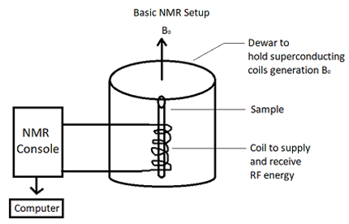

Figure 1: Circuit structure of NMR relaxation

Here, we are representing the basic schematic setup of the NMR relaxation process. The box shown here in the schematic figure actually holds superconducting coil generations or a magnet. In this NMR relaxation process, we provide data or qubit into the tube where RF coils exist. RF coil is basically transmitting a signal into a sample. After collecting the signal from the components, the console digitalized the data and the computer visualized this data as a spectrum.

The probe contains the radiofrequency (RF) coils, tuned at specific frequencies for specific nuclei in a given magnetic field.

There are two types of Probes. Those are as follows:

1. Room temperature Probe
2. Cryogenic Probe.

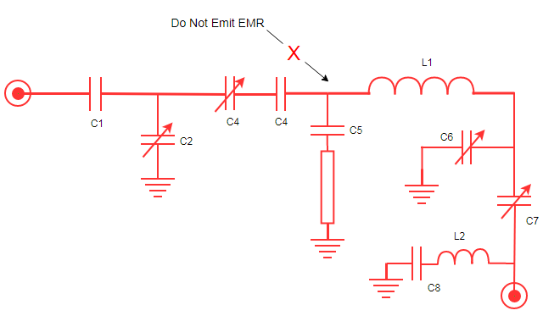

Figure 2: Circuit of Room temperature probe

There is a little difference in the room temperature probe in NMR relaxation. In NMR, we need strong magnetic fields to give more energy to the NMR solvent and push them into an excited state that's why we emit EMR. But in relaxation we are not going to emit EMR and the reason behind it will be explained in the working principal section in detail.

Same as like room temperature probe cryogenic probes don't need EMR in NMR relaxation process. Figure 3 describes inner RF coil and outer RF coil for Cryogenic probe.

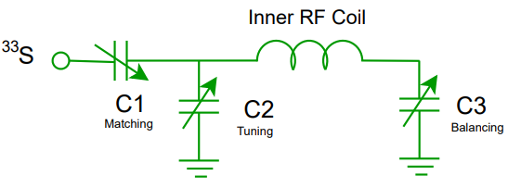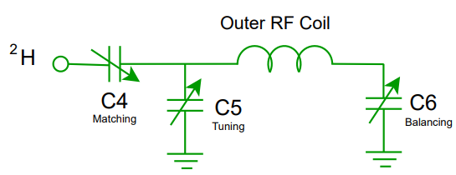

(a) (b)

Figure 3: Circuit of (a) Inner RF coil (b) Outer RF Coil in Cryogenic probe

##### 4.2.1.2 Working principle of NMR relaxation at Room Temperature

NMR is an analytical chemistry technique that creates a strong magnetic field and makes molecules nucleus excited then molecules exist in superposition.

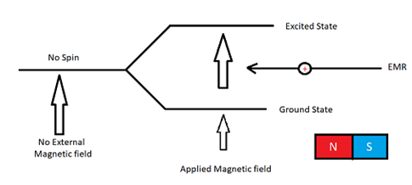

Figure 4: Spin state realization.

Here from the Figure, we can understand that at first molecules have no spin. When molecules are provided into NMR relaxation Probe as a sample then molecules are bound by a magnetic field. Molecules' nuclear spin started spinning but they exist in ground state still because the magnetic field didn’t create a strong magnetic field. So, we don't need to emit EMR.

But in NMR relaxation we have to do the reverse process of EMR. we need molecules back to the ground state. So, if we do not emit EMR and the magnetic field does not get strong then molecules start to lose their energy and come to ground state position.

There are two procedures for NMR relaxation. They are as follows:

1. *Spin lattice Relaxation*: If the excited molecule transfers energy to the vector present molecule in the surrounding environment, then the excited molecule will lose the energy nearby solvent molecules.
2. *Spin Spin Relaxation*: In this system superposition state molecules transfer energy to other molecules nucleus and then molecules come into ground state but other molecules stay in superposition.

Shortly, we can understand that from the above discussion, if we do not produce a strong magnetic field using EMR then we will find molecules in ground state. Figure 5 describes the overall conversion of quantum qubit into DNA sequence.

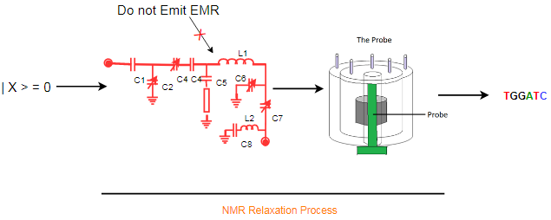

Figure 5: Conversion of qubit into DNA sequence.

##### 4.2.1.3 Quantum-DNA AND operation at room temperature

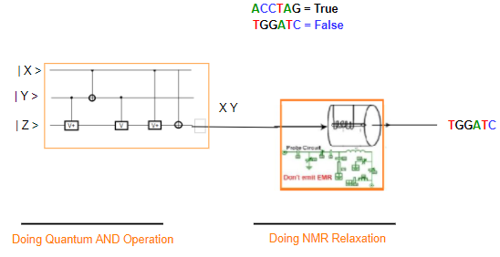

Figure 6: Conversion of qubit into DNA sequence from an AND operation.

***Design Procedure:***

Quantum AND operation circuit is prepared using two V+ and two NOT and one V gate. We have three qubits |A0> and |A1> and a constant qubit (ancilla) |0>. From |A0> and |A1> inputs, two lines to constant output and we have the target output line (|Q>). After getting qubit from quantum AND operation, we have to do NMR relaxation. In NMR relaxation, we have used a room temperature probe. By NMR relaxation qubit of superposition state turns into normal ground state and we get the DNA sequence.

***Working Procedure:***

At first, in this Quantum AND operational circuit, we take three inputs as qubits, two qubits are input and other is the ancilla qubit. Ancilla qubit is used here to reverse the gate. Ancilla qubit is also used for error correction and it is called check bit. Here in Quantum AND gate we use 1 because without this qubit we cannot reverse the gate and we will get an error in output without an ancilla qubit.

After processing input going through the Quantum AND operational gate, it's getting some output as qubit. The provided output from Quantum AND operation will be used as an input in NMR relaxation and we find ground state. When any molecule comes to ground state then we get the real sequence. DNA sequence is used for DNA logic gate operation. Here we are doing NMR relaxation at room temperature and in relaxation we don't need to emit EMR.

Here, we are using DNA sequence ACCTAG = TRUE for Quantum qubit | 1 > and DNA sequence TGGATC = FLASE for Quantum qubit | 0 >. The outputs for different combinations of input are given in Table 1.

Table 1: Outputs of Data Conversion for Quantum AND operation.

|  |  |  |  |
| --- | --- | --- | --- |
| |A0> | |A1> | |Q> | DNA sequence |
| |0> | |0> | |0> | TGGATC |
| |0> | |1> | |0> | TGGATC |
| |1> | |0> | |0> | TGGATC |
| |1> | |1> | |1> | ACCTAG |

##### 4.2.1.4 Quantum-DNA OR operation at room temperature

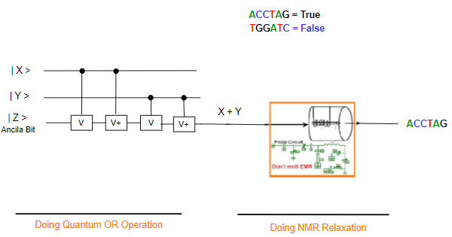

Figure 7: Conversion of qubit into DNA sequence from a Quantum OR operation.

***Design Procedure:***

Quantum OR operation circuit is prepared using two V+ and two V gates. We have three qubits |X> and |Y> and a constant qubit (ancilla) | 0 >. From | X > and | Y > inputs, two lines to constant output and we have the target output line (|Q>) can be expressed as X+Y. After getting qubit from quantum OR operation, we have to do NMR relaxation. In NMR relaxation, we have used a room temperature probe. By NMR relaxation qubit of superposition state turns into normal ground state and we get the DNA sequence.

***Working Procedure:***

At first, in this Quantum OR operational circuit, we take three inputs as qubits, two qubits are input and other is the ancilla qubit. Here in Quantum OR gate, we use |0> as an ancilla qubit because without this qubit we cannot reverse the gate and we will get an error in output without an ancilla qubit.

After processing input going through the Quantum OR operational gate, it's getting some output as qubit. The provided output from Quantum OR operation will be used as an input in NMR relaxation and we find ground state. When any molecule comes to ground state then we get the real sequence. DNA sequence is used for DNA logic gate operation. Here we are doing NMR relaxation at room temperature and in relaxation we don't need to emit EMR.

Here, we are using DNA sequence ACCTAG = TRUE for Quantum qubit | 1 > and DNA sequence TGGATC = FLASE for Quantum qubit | 0 >. The outputs for different combinations of input are given in Table 2.

Table 2: Outputs of Data Conversion for Quantum OR operation.

|  |  |  |  |
| --- | --- | --- | --- |
| |A0> | |A1> | |Q> | DNA sequence |
| |0> | |0> | |0> | TGGATC |
| |0> | |1> | |1> | ACCTAG |
| |1> | |0> | |1> | ACCTAG |
| |1> | |1> | |1> | ACCTAG |

##### 4.2.1.5 Quantum-DNA NOT operation at room temperature

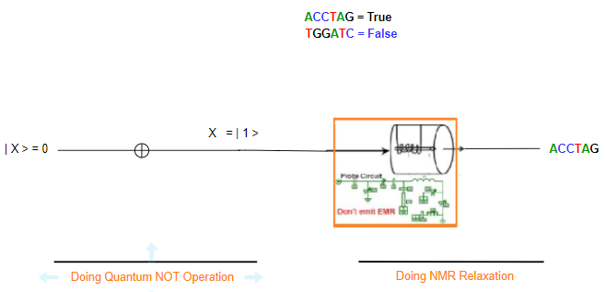

Figure 8: Conversion of qubit into DNA sequence from a Quantum NOT operation.

***Design Procedure:***

Quantum NOT operation circuit is prepared using one NOT gate. We have one qubit |X> as an input. From the input, the target output line ( |Q> ) can be expressed as the inverse of the input. After getting qubit from quantum NOT operation, we have to do NMR relaxation. In NMR relaxation, we have used a room temperature probe. By NMR relaxation qubit of superposition state turns into normal ground state and we get the DNA sequence.

***Working Procedure:***

At first, in this Quantum NOT operational circuit, we take one input as qubit. Here in Quantum NOT gate, we do not need any ancilla qubit.

After processing input going through the Quantum NOT operational gate, it's getting some output as qubit. The provided output from Quantum NOT operation will be used as an input in NMR relaxation and we find ground state. When any molecule comes to ground state then we get the real sequence. DNA sequence is used for DNA logic gate operation. Here we are doing NMR relaxation at room temperature and in relaxation we don't need to emit EMR.

Here, we are using DNA sequence ACCTAG = TRUE for Quantum qubit | 1 > and DNA sequence TGGATC = FLASE for Quantum qubit | 0 >. The outputs for different combinations of input are given in Table 3.

Table 3: Outputs of Data Conversion for Quantum NOT operation.

|  |  |  |
| --- | --- | --- |
| |A0> | |Q> | DNA sequence |
| |0> | |1> | ACCTAG |
| |1> | |0> | TGGATC |

##### 4.2.1.6 Quantum-DNA XOR operation at room temperature

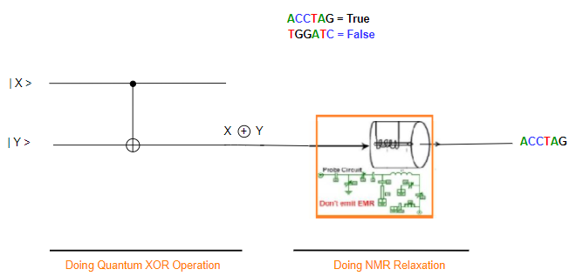

Figure 9: Conversion of qubit into DNA sequence from a Quantum XOR operation.

***Design Procedure:***

Quantum XOR operation circuit is prepared using one Controlled NOT or CNOT gate. We have two qubits |X> and |Y>. From | Y > inputs, one line goes through the output and we have the target output X XOR Y. After getting qubit from quantum XOR operation, we have to do NMR relaxation. In NMR relaxation, we have used a room temperature probe. By NMR relaxation qubit of superposition state turns into normal ground state and we get the DNA sequence.

***Working Procedure:***

At first, in this Quantum XOR operational circuit, we take two inputs as qubits and do not need any ancilla qubit. After processing input going through the Quantum XOR operational gate, it's getting some output as qubit. The provided output from Quantum OR operation will be used as an input in NMR relaxation and we find ground state. When any molecule comes to ground state then we get the real sequence. DNA sequence is used for DNA logic gate operation. Here we are doing NMR relaxation at room temperature and in relaxation we don't need to emit EMR.

Here, we are using DNA sequence ACCTAG = TRUE for Quantum qubit | 1 > and DNA sequence TGGATC = FLASE for Quantum qubit | 0 >. The outputs for different combinations of inputs are given in Table 4.

Table 4: Outputs of Data Conversion for Quantum XOR operation.

|  |  |  |  |
| --- | --- | --- | --- |
| |A0> | |A1> | |Q> | DNA sequence |
| |0> | |0> | |0> | TGGATC |
| |0> | |1> | |1> | ACCTAG |
| |1> | |0> | |1> | ACCTAG |
| |1> | |1> | |0> | TGGATC |

##### 4.2.1.7 Quantum-DNA Full Adder at room temperature

Full Adder is the adder which adds three inputs and produces two outputs. The first two inputs are A and B and the third input is an input carry as Cin. The output carry is designated as Cout and the normal output is designated as S which is Sum. A Full Adder logic is designated in such a manner that can take eight inputs together to create a qubit adder and cascade the carry qubit from one adder to the another. To create a Full Adder, one OR, tow AND and two XOR operational gates are required. Figure 10 describes the Quantum-DNA circuit of the Full Adder.

***Design procedure:***

To design a Quantum-DNA Full Adder we have to use Quantum and DNA operational gates so that we can operate the input qubit for their corresponding outputs. The Quantum operational gates will be used for receiving the input qubits and the DNA operational gates will be used to produce the final output against the corresponding set of inputs. Each time, the Quantum-DNA Full adder will receive three qubits as input. After operating in a certain number of Quantum operational gates, the qubit will be turned into corresponding DNA sequence by using NMR relaxation room temperature probe. The process of producing a DNA sequence against a qubit state is explained in Section 4.2.1. By using a room temperature probe and corresponding components of NMR relaxation, the excited qubit turns into ground state and produces a DNA sequence. Then the DNA sequence is processed through DNA operational gates and outputs are received. Here, Figure 10 describes Quantum-DNA Full adder using Quantum and DNA operational gates.

From the figure, we find that the Quantum-DNA Full Adder consists of three Quantum operational gates and two DNA operational gates. Here, two AND and one XOR is used as Quantum operational gates and further one XOR and one OR DNA operational gates is used.



Figure 10: Quantum-DNA Full Adder.

***Working procedure:***

The working procedure of the Quantum-DNA Full adder is given below for each pattern of input qubits. Here, we are using DNA sequence ACCTAG = TRUE for Quantum qubit | 1 > and DNA sequence TGGATC = FLASE for Quantum qubit | 0 >.

The working procedure of the Quantum-DNA Full Adder is given below for 6 patterns of input qubits and the outputs for different combinations of inputs are given in Table 5.

1. For input A, B, C = 0,

**Sum** = DNA XOR (Quantum XOR (A, B), C)

= DNA XOR (Quantum XOR (0, 0), 0)

= DNA XOR (0, 0)

= DNA XOR (TGGATC, TGGATC) [Using NMR relaxation]

= TGGATC

**Carry** = DNA OR (Quantum AND (C, XOR (A,B)), Quantum AND (A,B))

= DNA OR (Quantum AND (0, XOR (0,0)), Quantum AND (0,0))

= DNA OR (Quantum AND (0, XOR (0,0)), Quantum AND (0,0))

= DNA OR (0, 0)

= DNA OR (TGGATC, TGGATC) [Using NMR relaxation]

= TGGATC

1. For input A, B, C = 0, 0, 1

**Sum** = DNA XOR (Quantum XOR (A, B), C)

= DNA XOR (Quantum XOR (0, 0), 1)

= DNA XOR (0, 1)

= DNA XOR (TGGATC, ACCTAG) [Using NMR relaxation]

= ACCTAG

**Carry** = DNA OR (Quantum AND (C, XOR (A,B)), Quantum AND (A,B))

= DNA OR (Quantum AND (1, XOR (0,0)), Quantum AND (0,0))

= DNA OR (Quantum AND (1, 0), 0)

= DNA OR (0, 0)

= DNA OR (TGGATC, TGGATC) [Using NMR relaxation]

= TGGATC

1. For input A, B, C = 0, 1, 0

**Sum** = DNA XOR (Quantum XOR (A, B), C)

= DNA XOR (Quantum XOR (0, 1), 0)

= DNA XOR (1, 0)

= DNA XOR (ACCTAG, TGGATC) [Using NMR relaxation]

= ACCTAG

**Carry** = DNA OR (Quantum AND (C, XOR (A, B)), Quantum AND (A, B))

= DNA OR (Quantum AND (0, XOR (0,1)), Quantum AND (0,1))

= DNA OR (Quantum AND (0, 1), 0)

= DNA OR (0, 0)

= DNA OR (TGGATC, TGGATC) [Using NMR relaxation]

= TGGATC

1. For input A, B, C = 0, 1, 1

**Sum** = DNA XOR (Quantum XOR (A, B), C)

= DNA XOR (Quantum XOR (0, 1), 1)

= DNA XOR (1, 1)

= DNA XOR (ACCTAG, ACCTAG) [Using NMR relaxation]

= TGGATC

**Carry** = DNA OR (Quantum AND (C, XOR (A,B)), Quantum AND (A,B))

= DNA OR (Quantum AND (1, XOR (0,1)), Quantum AND (0,1))

= DNA OR (Quantum AND (1, 1), 0)

= DNA OR (1, 0)

= DNA OR (ACCTAG, TGGATC) [Using NMR relaxation]

= ACCTAG

1. For input A, B, C = 1, 0, 0

**Sum** = DNA XOR (Quantum XOR (A, B), C)

= DNA XOR (Quantum XOR (1, 0), 0)

= DNA XOR (1, 0)

= DNA XOR (ACCTAG, TGGATC) [Using NMR relaxation]

= ACCTAG

**Carry** = DNA OR (Quantum AND (C, XOR (A,B)), Quantum AND (A,B))

= DNA OR (Quantum AND (0, XOR (1,0)), Quantum AND (1,0))

= DNA OR (Quantum AND (0, 1), 0)

= DNA OR (0, 0)

= DNA OR (TGGATC, TGGATC) [Using NMR relaxation]

= TGGATC

1. For input A, B, C = 1, 0, 1

**Sum** = DNA XOR (Quantum XOR (A, B), C)

= DNA XOR (Quantum XOR (1, 0), 1)

= DNA XOR (1, 0)

= DNA XOR (ACCTAG, TGGATC) [Using NMR relaxation]

= ACCTAG

**Carry** = DNA OR (Quantum AND (C, XOR (A,B)), Quantum AND (A,B))

= DNA OR (Quantum AND (1, XOR (1,0)), Quantum AND (1,0))

= DNA OR (Quantum AND (1, 1), 0)

= DNA OR (1, 0)

= DNA OR (ACCTAG, TGGATC) [Using NMR relaxation]

= ACCTAG

Table 5: Outputs of Quantum-DNA Full Adder operation.

|  |  |  |  |  |
| --- | --- | --- | --- | --- |
| |A0> | |A1> | |Q> | SUM | Carry |
| |0> | |0> | |0> | TGGATC | TGGATC |
| |0> | |0> | |1> | ACCTAG | TGGATC |
| |0> | |1> | |0> | ACCTAG | TGGATC |
| |0> | |1> | |1> | TGGATC | ACCTAG |
| |1> | |0> | |0> | ACCTAG | TGGATC |
| |1> | |0> | |1> | TGGATC | ACCTAG |
| |1> | |1> | |0> | TGGATC | ACCTAG |
| |1> | |1> | |1> | ACCTAG | ACCTAG |

##### 4.2.1.8 Quantum-DNA Full Subtractor at room temperature

A full subtractor is a combinational circuit that performs subtraction of two qubits, one is minuend and other is subtrahend, taking into account borrow of the previous adjacent lower minuend qubit. This circuithas three inputs and two outputs. The three inputs A, B and Bin, denote the minuend, subtrahend, and previous borrow, respectively. The two outputs, D and Bout represent the difference and output borrows, respectively. To create a full subtractor, one OR, two AND, two OR and 2 XOR gates are required. Figure 11 describes the Quantum-DNA circuit of Full Subtractor.

***Design procedure:***

To design a Quantum-DNA Full Subtractor, we have to use Quantum and DNA operational gates so that we can operate the input qubit for their corresponding outputs. The Quantum operational gates will be used for receiving the input qubits and the DNA operational gates will be used to produce the final output against the corresponding set of inputs. Each time, the Quantum-DNA Full Subtractor will receive three qubits as input. After operating in a certain number of Quantum operational gates, the qubit will be turned into corresponding DNA sequence by using NMR relaxation room temperature probe. The process of producing a DNA sequence against a qubit state is explained in Section 4.2.1. By using a room temperature probe and corresponding components of NMR relaxation, the excited qubit turns into ground state and produces a DNA sequence. Then the DNA sequence is processed through DNA operational gates and outputs are received. Here, Figure 11 describes Quantum-DNA Full Subtractor using Quantum and DNA operational gates.

From the figure, we find that the Quantum-DNA Full Subtractor consists of three Quantum operational gates and two DNA operational gates. Here, two AND and one XOR is used as Quantum operational gates and further one XOR and one OR DNA operational gates is used.

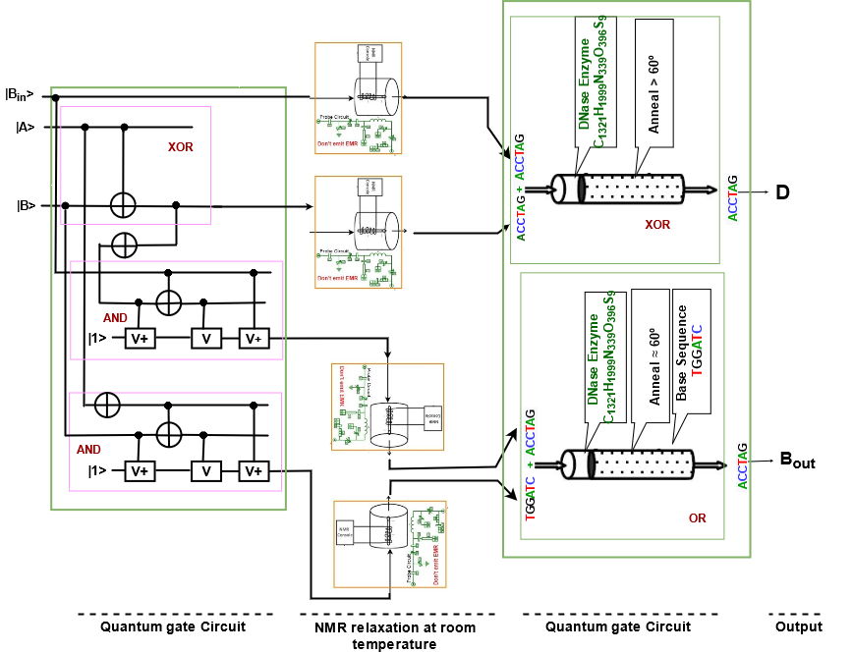

Figure 11: Quantum-DNA Full Subtractor.

***Working procedure:***

The working procedure of the Quantum-DNA Full Subtractor is given below for each pattern of input qubits. Here, we are using DNA sequence ACCTAG = TRUE for Quantum qubit | 1 > and DNA sequence TGGATC = FLASE for Quantum qubit | 0 >.

The working procedure of the Quantum-DNA Full Subtractor is given below for 4 patterns of input qubits and the outputs for different combinations of inputs are given in Table 6.

1. For input A, B, Bin = 0,

**Sum** = DNA XOR (Quantum XOR (A, B), Bin)

= DNA XOR (Quantum XOR (0, 0), 0)

= DNA XOR (0, 0)

= DNA XOR (TGGATC, TGGATC) [Using NMR relaxation]

= TGGATC

**Carry** = DNA OR (Quantum AND (Bin, NOT (XOR (A,B))), Quantum AND ( NOT (A), B))

= DNA OR (Quantum AND (0, 1), Quantum AND (1,0))

= DNA OR (0, 0)

= DNA OR (TGGATC, TGGATC) [Using NMR relaxation]

= TGGATC

1. For input A, B, Bin = 0, 0, 1

**Sum** = DNA XOR (Quantum XOR (A, B), Bin)

= DNA XOR (Quantum XOR (0, 0), 1)

= DNA XOR (0, 1)

= DNA XOR (TGGATC, ACCTAG) [Using NMR relaxation]

= ACCTAG

**Carry** = DNA OR (Quantum AND (Bin, NOT (XOR (A, B))), Quantum AND (NOT (A), B))

= DNA OR (Quantum AND (1, 1), Quantum AND (1,0))

= DNA OR (1, 0)

= DNA OR (ACCTAG, TGGATC) [Using NMR relaxation]

= ACCTAG

1. For input A, B, Bin = 0, 1, 0

**Sum** = DNA XOR (Quantum XOR (A, B), Bin)

= DNA XOR (Quantum XOR (0, 1), 0)

= DNA XOR (1, 0)

= DNA XOR (ACCTAG, TGGATC) [Using NMR relaxation]

= ACCTAG

**Carry** = DNA OR (Quantum AND (Bin, NOT (XOR (A, B))), Quantum AND ( NOT (A), B))

= DNA OR (Quantum AND (0, 1), Quantum AND (1, 1))

= DNA OR (Quantum AND (0, 1), 1)

= DNA OR (0, 1)

= DNA OR (TGGATC, ACCTAG) [Using NMR relaxation]

= ACCTAG

1. For input A, B, Bin = 0, 1, 1

**Sum** = DNA XOR (Quantum XOR (A, B), Bin)

= DNA XOR (Quantum XOR (0, 1), 1)

= DNA XOR (1, 1)

= DNA XOR (ACCTAG, ACCTAG) [Using NMR relaxation]

= TGGATC

**Carry** = DNA OR (Quantum AND (Bin, NOT (XOR (A,B))), Quantum AND ( NOT (A), B))

= DNA OR (Quantum AND (1, 0), Quantum AND (1, 1))

= DNA OR (Quantum AND (1, 0), 1)

= DNA OR (0, 1)

= DNA OR (ACCTAG, TGGATC) [Using NMR relaxation]

= ACCTAG

Table 6: Outputs of Quantum-DNA Full Subtractor operation.

|  |  |  |  |  |
| --- | --- | --- | --- | --- |
| |A0> | |A1> | |Q> | SUM | Carry |
| |0> | |0> | |0> | TGGATC | TGGATC |
| |0> | |0> | |1> | ACCTAG | ACCTAG |
| |0> | |1> | |0> | ACCTAG | ACCTAG |
| |0> | |1> | |1> | TGGATC | ACCTAG |
| |1> | |0> | |0> | ACCTAG | TGGATC |
| |1> | |0> | |1> | TGGATC | TGGATC |
| |1> | |1> | |0> | TGGATC | TGGATC |
| |1> | |1> | |1> | ACCTAG | ACCTAG |

##### 4.2.1.9 Quantum-DNA 2 to 1 Multiplexer circuit at room temperature

A multiplexer (MUX) is a device that can receive multiple input signals and synthesize a single output signal in a recoverable manner for each input signal. It is also an integrated system that usually contains a certain number of data inputs and a single output. To create a Multiplexer, one NOT, two AND, and an OR gate is required. Figure 12 describes the Quantum-DNA circuit of Multiplexer. A Multiplexer receives three inputs and produces one output containing “Y”.

***Design procedure:***

To design a Quantum-DNA 2 to 1 Multiplexer, we have to use Quantum and DNA operational gates so that we can operate the input qubit for their corresponding outputs. The Quantum operational gates will be used for receiving the input qubits and the DNA operational gates will be used to produce the final output against the corresponding set of inputs. Each time, the Quantum-DNA Multiplexer will receive three qubits as input. After operating in a certain number of Quantum operational gates, the qubit will be turned into corresponding DNA sequence by using NMR relaxation room temperature probe. The process of producing a DNA sequence against a qubit state is explained in Section 4.2.1. By using a room temperature probe and corresponding components of NMR relaxation, the excited qubit turns into ground state and produces a DNA sequence. Then the DNA sequence is processed through DNA operational gates and outputs are received. Here, Figure 12 describes Quantum-DNA Multiplexer using Quantum and DNA operational gates.

From the figure, we find that the Quantum-DNA 2 to 1 Multiplexer consists of three Quantum operational gates and one DNA operational gates. Here, two AND and one NOT is used as Quantum operational gates and further one OR DNA operational gates is used.

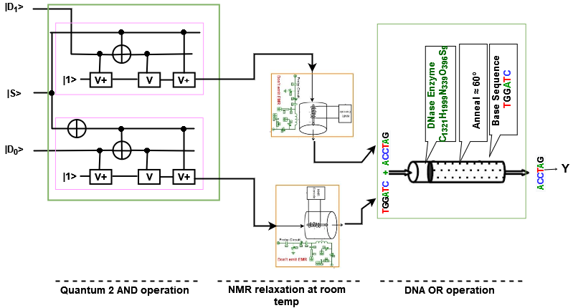

Figure 12: Quantum-DNA 2 to 1 Multiplexer.

***Working procedure:***

The working procedure of the Quantum-DNA 2 to 1 Multiplexer is given below for each pattern of input qubits. Here, we are using DNA sequence ACCTAG = TRUE for Quantum qubit | 1 > and DNA sequence TGGATC = FLASE for Quantum qubit | 0 >.

The working procedure of the Quantum-DNA 2 to 1 Multiplexer is given below for 4 patterns of input qubits and the outputs for different combinations of inputs are given in Table 7.

1. For input S, D1, D0 = 0,

**Y** = DNA OR (Quantum AND (D1, S), AND (NOT (S), D0))

= DNA OR (Quantum AND (0, 0), AND (NOT (0), 0)

= DNA OR (0, 0)

= DNA OR (TGGATC, TGGATC) [Using NMR relaxation]

= TGGATC

1. For input S, D0, D1 = 0, 0, 1

**Y** = DNA OR (Quantum AND (D1, S), AND (NOT (S), D0))

= DNA OR (Quantum AND (1, 0), AND (NOT (0), 0)

= DNA OR (0, 0)

= DNA OR (TGGATC, TGGATC) [Using NMR relaxation]

= TGGATC

1. For input S, D0, D1 = 0, 1, 0

**Y** = DNA OR (Quantum AND (D1, S), AND (NOT (S), D0))

= DNA OR (Quantum AND (0, 0), AND (NOT (0), 1))

= DNA OR (0, AND (1, 1)

= DNA OR (0, 1)

= DNA OR (TGGATC, ACCTAG) [Using NMR relaxation]

= ACCTAG

1. For input S, D0, D1 = 0, 1, 1

**Y** = DNA OR (Quantum AND (D1, S), AND (NOT (S), D0))

= DNA OR (Quantum AND (1, 0), AND (NOT (0), 1))

= DNA OR (0, AND (1, 1))

= DNA OR (0, 1)

= DNA XOR (TGGATC, ACCTAG) [Using NMR relaxation]

= ACCTAG

Table 7: Outputs of Quantum-DNA 2 to 1 Multiplexer operation.

|  |  |  |  |
| --- | --- | --- | --- |
| |S> | |D1> | |D0> | Y |
| |0> | |0> | |0> | TGGATC |
| |0> | |0> | |1> | TGGATC |
| |0> | |1> | |0> | ACCTAG |
| |0> | |1> | |1> | ACCTAG |
| |1> | |0> | |0> | TGGATC |
| |1> | |0> | |1> | ACCTAG |
| |1> | |1> | |0> | TGGATC |
| |1> | |1> | |1> | ACCTAG |

#### 4.2.2 NMR relaxation at 0-kelvin

NMR room temperature relaxation process is not fully suitable. In NMR relaxation at room temperature probes, decoherence problems, polarization, and scaling problems can occur. Because we know that noise is proportional to temperature. If noise is high then temperature will be high. In room temperature NMR relaxation processes have high temperatures that's why noise can be reached at high and that's not give us a full recovery sequence. And this problem solves the Cryogenic probe which operates in 0 kelvin temperature. Here, the provided temperature is small and the noise is tiny. So, we will get more recovery sequences from the superposition state.

##### 4.2.2.1 Quantum-DNA AND operation at 0-kelvin temperature

***Design Procedure:***

Quantum AND operation circuit is prepared using two V+ and two NOT and one V gate. We have three qubits |A0> and |A1> and a constant qubit (ancilla) |0>. From |A0> and |A1> inputs, two lines to constant output and we have the target output line (|Q>). After getting qubit from quantum AND operation, we have to do NMR relaxation. In NMR relaxation, we have used a room temperature probe. By NMR relaxation qubit of superposition state turns into normal ground state and we get the DNA sequence.

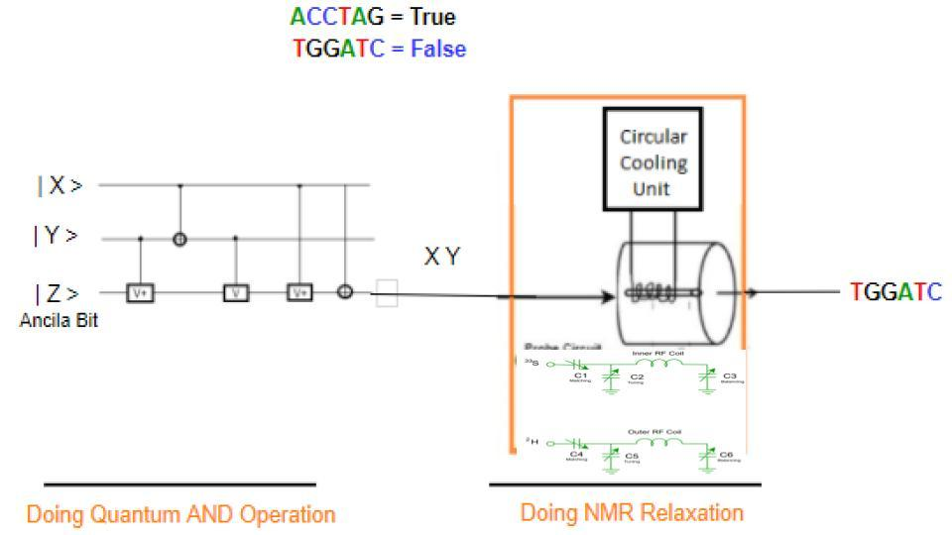

Figure 13: Quantum-DNA AND operation using Cryogenic probe at 0-kelvin.

***Working Procedure:***

At first, in this Quantum AND operational circuit, we take three inputs as qubits, two qubits are input and other is the ancilla qubit. Ancilla qubit is used here to reverse the gate. Ancilla qubit is also used for error correction and it is called check bit. Here in Quantum AND gate we use 1 because it helps to reverse the gate otherwise, we will get an error in output without an ancilla qubit.

After processing input going through the Quantum AND operational gate, it provides some output as qubit. The provided output from Quantum AND operation will be used as an input in NMR relaxation and we find ground state. When any molecule comes to ground state then we get the real sequence. DNA sequence is used for DNA logic gate operation. Here we are doing NMR relaxation using cryogenic probe at 0-kelvin temperature and in relaxation we don't need to emit EMR.

Here, we are using DNA sequence ACCTAG = TRUE for Quantum qubit | 1 > and DNA sequence TGGATC = FLASE for Quantum qubit | 0 >. The outputs for different combinations of input are given in Table 8.

Table 8: Outputs of Data Conversion for Quantum AND operation.

|  |  |  |  |
| --- | --- | --- | --- |
| |A0> | |A1> | |Q> | DNA sequence |
| |0> | |0> | |0> | TGGATC |
| |0> | |1> | |0> | TGGATC |
| |1> | |0> | |0> | TGGATC |
| |1> | |1> | |1> | ACCTAG |

##### 4.2.2.2 Quantum-DNA OR operation at 0-kelvin

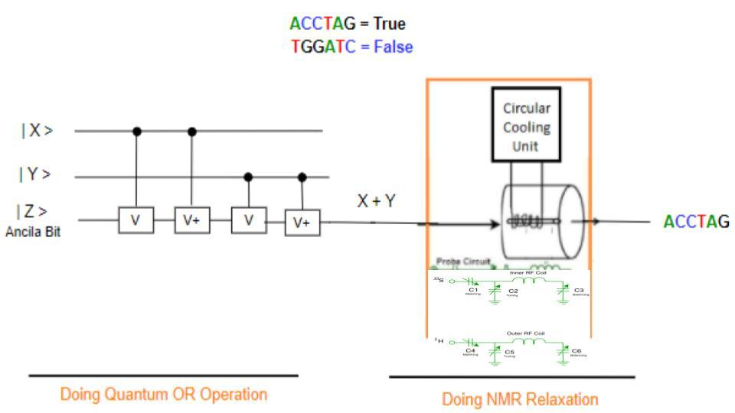

Figure 14: Quantum-DNA OR operation using Cryogenic probe at 0-kelvin.

***Design Procedure:***

Quantum OR operation circuit is prepared using two V+ and two V gates. We have three qubits |X> and |Y> and a constant qubit (ancilla) | 0 >. From | X > and | Y > inputs, two lines to constant output and we have the target output line ( |Q> ) can be expressed as X+Y. After getting qubit from quantum OR operation, we have to do NMR relaxation. In NMR relaxation, we have used a room temperature probe. By NMR relaxation qubit of superposition state turns into normal ground state and we get the DNA sequence.

***Working Procedure:***

At first, in this Quantum OR operational circuit, we take three inputs as qubits, two qubits are input and other is the ancilla qubit. Here in Quantum OR gate, we use |0> as an ancilla qubit because without this qubit we cannot reverse the gate and we will get an error in output without an ancilla qubit.

After processing input going through the Quantum OR operational gate, it's getting some output as qubit. The provided output from Quantum OR operation will be used as an input in NMR relaxation and we find ground state. When any molecule comes to ground state then we get the real sequence. DNA sequence is used for DNA logic gate operation. Here we are doing NMR relaxation using a cryogenic probe at 0-kelvin and in relaxation we don't need to emit EMR.

Here, we are using DNA sequence ACCTAG = TRUE for Quantum qubit | 1 > and DNA sequence TGGATC = FLASE for Quantum qubit | 0 >. The outputs for different combinations of input are given in Table 2.

##### 4.2.2.3 Quantum-DNA XOR operation at 0-kelvin

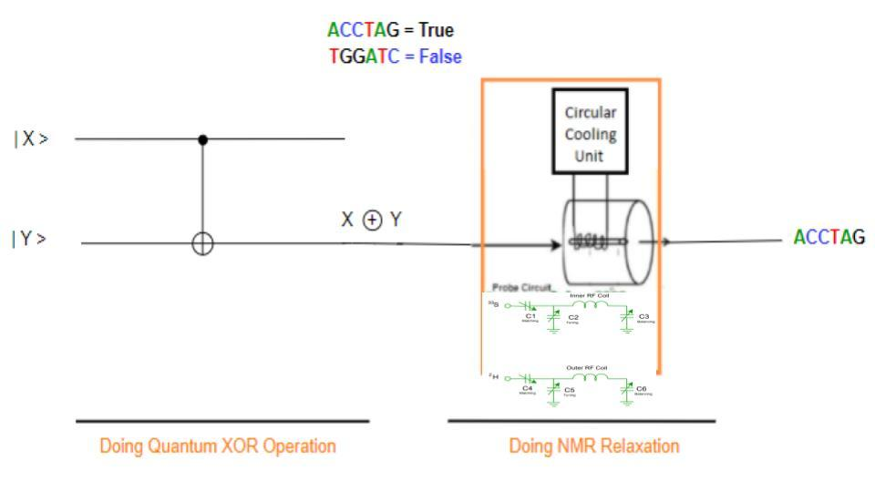

Figure 15: Quantum-DNA XOR operation using Cryogenic probe at 0-kelvin.

***Design Procedure:***

Quantum XOR operation circuit is prepared using one Controlled NOT or CNOT gate. We have two qubits |X> and |Y>. From | Y > inputs, one line goes through the output and we have the target output X XOR Y. After getting qubit from quantum XOR operation, we have to do NMR relaxation. In NMR relaxation, we have used a room temperature probe. By NMR relaxation qubit of superposition state turns into normal ground state and we get the DNA sequence.

***Working Procedure:***

At first, in this Quantum XOR operational circuit, we take two inputs as qubits and do not need any ancilla qubit. After processing input going through the Quantum XOR operational gate, it's getting some output as qubit. The provided output from Quantum OR operation will be used as an input in NMR relaxation and we find ground state. When any molecule comes to ground state then we get the real sequence. DNA sequence is used for DNA logic gate operation. Here we are doing NMR relaxation using a cryogenic probe at 0-kelvin and in relaxation we don't need to emit EMR.

Here, we are using DNA sequence ACCTAG = TRUE for Quantum qubit | 1 > and DNA sequence TGGATC = FLASE for Quantum qubit | 0 >. The outputs for different combinations of inputs are given in Table 4.

##### 4.2.2.4 Quantum-DNA Full Adder at 0-kelvin

In Section 4.2.1, we already described Quantum-DNA Full Adder and its working procedure but here we are going to describe the design procedure of Quantum-DNA Full Adder using Cryogenic probe. The output of different combinations is also shown in Table 5.

***Design procedure:***

To design a Quantum-DNA Full Adder, we have to use Quantum and DNA operational gates so that we can operate the input qubit for their corresponding outputs. The Quantum operational gates will be used for receiving the input qubits and the DNA operational gates will be used to produce the final output against the corresponding set of inputs. Each time, the Quantum-DNA Full Subtractor will receive three qubits as input. After operating in a certain number of Quantum operational gates, the qubit will be turned into corresponding DNA sequence by NMR relaxation using cryogenic probe at 0-kelvin. The process of producing a DNA sequence against a qubit state is explained in Section 4.2.1. By using a cryogenic probe at 0-kelvin and corresponding components of NMR relaxation, the excited qubit turns into ground state and produces a DNA sequence. Then the DNA sequence is processed through DNA operational gates and outputs are received. Here, Figure 16 describes Quantum-DNA Full Adder using Quantum and DNA operational gates.

From the figure, we find that the Quantum-DNA Full Adder consists of three Quantum operational gates and two DNA operational gates. Here, two AND and one XOR is used as Quantum operational gates and further one XOR and one OR DNA operational gates is used.



Figure 16: Quantum-DNA Full Adder using Cryogenic probe at 0-kelvin

##### 4.2.2.5 Quantum-DNA Full Subtractor at 0-kelvin

In Section 4.2.1, we already described Quantum-DNA Full Subtractor and its working procedure but here we are going to describe the design procedure of Quantum-DNA Full Subtractor using Cryogenic probe. The output of different combinations is also shown in Table 6.

To design a Quantum-DNA Full Subtractor, we have to use Quantum and DNA operational gates so that we can operate the input qubit for their corresponding outputs. The Quantum operational gates will be used for receiving the input qubits and the DNA operational gates will be used to produce the final output against the corresponding set of inputs. Each time, the Quantum-DNA Full Subtractor will receive three qubits as input.



Figure 17: Quantum-DNA Full Subtractor using Cryogenic probe at 0-kelvin

After operating in a certain number of Quantum operational gates, the qubit will be turned into corresponding DNA sequence by using NMR relaxation using Cryogenic probe at 0-kelvin. The process of producing a DNA sequence against a qubit state is explained in Section 4.2.1. By using Cryogenic probe at 0-kelvin and corresponding components of NMR relaxation, the excited qubit turns into ground state and produces a DNA sequence. Then the DNA sequence is processed through DNA operational gates and outputs are received. Here, Figure 17 describes Quantum-DNA Full Subtractor using Quantum and DNA operational gates.

From the figure, we find that the Quantum-DNA Full Subtractor consists of three Quantum operational gates and two DNA operational gates. Here, two AND and one XOR is used as Quantum operational gates and further one XOR and one OR DNA operational gates is used.

##### 4.2.2.6 Quantum-DNA 2 to 1 Multiplexer circuit at 0-kelvin

In Section 4.2.1, we already described Quantum-DNA 2 to 1 Multiplexer and its working procedure but here we are going to describe the design procedure of Quantum-DNA Multiplexer using Cryogenic probe. The output of different combinations is also shown in Table 7.



Figure 18: Quantum-DNA Full 2 to 1 Multiplexer using Cryogenic probe at 0-kelvin

To design a Quantum-DNA 2 to 1 Multiplexer, we have to use Quantum and DNA operational gates so that we can operate the input qubit for their corresponding outputs. The Quantum operational gates will be used for receiving the input qubits and the DNA operational gates will be used to produce the final output against the corresponding set of inputs. Each time, the Quantum-DNA Multiplexer will receive three qubits as input. After operating in a certain number of Quantum operational gates, the qubit will be turned into corresponding DNA sequence by NMR relaxation using Cryogenic probe at 0-kelvin. The process of producing a DNA sequence against a qubit state is explained in Section 4.2.1. By using Cryogenic probe at 0-kelvin and corresponding components of NMR relaxation, the excited qubit turns into ground state and produces a DNA sequence. Then the DNA sequence is processed through DNA operational gates and outputs are received. Here, Figure 18 describes Quantum-DNA Multiplexer using Quantum and DNA operational gates.

From the figure, we find that the Quantum-DNA 2 to 1 Multiplexer consists of three Quantum operational gates and one DNA operational gates. Here, two AND, one NOT is used as Quantum operational gates and further one OR DNA operational gates is used.

### 4.3 **Data Conversion in DNA-Quantum Circuits**

In place of standard silicon-based computer technology, DNA computing uses biological components such as DNA, biochemistry, and molecular biology. When applied to issues that can be separated into independent, non-sequential tasks, the DNA computer has demonstrable benefits over conventional computers. The reason for this is because DNA strands can store a lot of data and do numerous operations at the same time, allowing them to solve decomposable issues considerably faster. On the other hand, the fastest computation system can be defined as Quantum computation system, which works with qubits | 1 >, | 0 >, and both | 1 > and | 0 > at the same time. In addition, Quantum computer calculations are especially promising for analyzing or simulating extremely complicated processes involving large volumes of data.

So, for finding a super faster computation system with huge memory, we can develop a DNA-Quantum computation system. This DNA-Quantum computation system can merge all advantages of quantum computing and DNA computing. It will be able to compute parallel operation at super-fast speed.

In a DNA-Quantum circuit, we will operate inputs by DNA operational gates and provide output in Quantum qubits. In this case, we have to use NMR for converting DNA sequences to quantum qubits. Section 4.3.1 will describe the procedure for converting DNA sequence to quantum qubit.

#### 4.3.1 Nuclear Magnetic Resonance (NMR)

The acronym NMR stands for Nuclear Magnetic Resonance, which is an analytical chemical technique that allows us to examine comprehensive information about molecules. NMR is a technique for observing how molecules behave and interact in a variety of materials. NMR is used in quality control and research to determine the content and purity of a sample as well as its molecular structure. NMR is a physical phenomenon in which electromagnetic radiation is absorbed and emitted by the nucleus under a magnetic field. NMR generates a strong magnetic field, which excites the nucleus of molecules, causing them to exist in superposition. This energy has a specific resonance frequency that is determined by the strength of the magnetic field as well as the magnetic characteristics of the atom’s isotopes. The detection of certain quantum mechanical magnetic characteristics of the atomic nucleus is possible with NMR. Different components of NMR relaxation are as follows:

1. *Magnet*: In magnet, superconducting magnets as shim coils, liquid helium, nitrogen container can be used.
2. *Probe*: One important part of the probe is RF coil. It controls temperature and molecules become super positioned by the impact of this component. Figure 2 describes the circuit of the probe. There are two types of NMR probes which are going to be described in the following subsection.
3. *Console*: Electronics for generating RF pulse, power and gradient amplifiers, lock system, temperature control with almost all the components of NMR controlled by the console.
4. *Computer*: When we get all the data from the console then we see the computer as a spectrum. Basically, we use computers for data storage, processing, analysis component and communicate between other components.

#### 4.3.2 Structure of NMR

Here we are discussing the basic schematic setup of NMR. Figure 18 shows here the schematic figure, which actually holds superconducting coil generations or magnets. In this NMR we provide samples into the tube where RF coils exist. RF coil works for transmitting a signal into a sample. After collecting the signal from the components, the console digitalized the data and the computer visualized this data as a spectrum. Further, Figure 19 is the outfit and inner structure of NMR. In NMR, the probe contains the radiofrequency (RF) coils, tuned at specific frequencies for specific nuclei in a given magnetic field.



Figure 19: Schematic figure of NMR

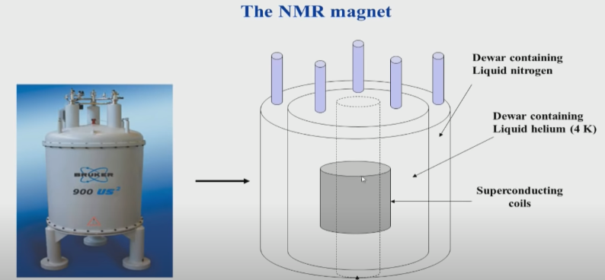

Figure 20: Outfit and inner structure of NMR

There are two types of probes for NMR. Those are,

1. Room temperature Probe
2. Cryogenic Probe.

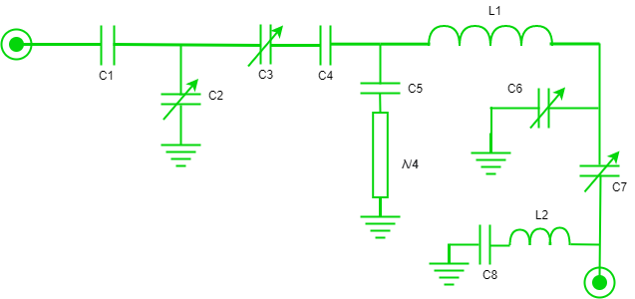

Figure 21: Room temperature probe of NMR

Cryogenic probes main characteristic is that its working temperature is very low. Cryogenic probes have two different coils compared to room temperature probes, Inner coil and outer coil, which is described in Figure 21. Figure 20 describes the room temperature probe of NMR. Same as like room temperature probe cryogenic probes need EMR in NMR process. In NMR, we need strong magnetic fields to give more energy to the NMR solvent and push them into an excited state that's why we emit EMR.



(a) (b)

Figure 22: Circuit of (a) Inner RF coil (b) Outer RF Coil in Cryogenic probe

#### 4.3.3 Working procedure of NMR

NMR is an analytical chemistry technique that creates a strong magnetic field and makes molecules nucleus excited then molecules exist in superposition.

Figure 22 describes a molecule that does not have any spin at the beginning of the NMR process. When molecules are provided into NMR Probe as a sample then molecules are bound by a magnetic field. Molecules' nuclear spin started spinning but they exist in ground state still because the magnetic field didn’t create a strong magnetic field.



Figure 23: Spins states realization of a qubit

To activate the probe and to make the magnetic field stronger we need to emit Electron Magnetic Resonance, EMR. After selecting the molecule to pass through the NMR process, we need to use this molecule as a sample in NMR to produce qubit. An NMR probe is the part of an NMR spectrometer, which works in terms of exciting the nuclear spins, and detecting the NMR signal. The probe goes into the center of the magnetic field, and the sample is inserted into the probe to perform the NMR experiment. The probe contains the radiofrequency (RF) coils, tuned at specific frequencies for specific nuclei in a given magnetic field. The probe also contains the necessary hardware to control the sample temperature. From the probe molecules make themselves in superposition.

For going, ground state to excited state molecules needs more energy. Measurement of energy from the formula we know that,

E = hv (1) By emitting the Electron Magnetic Resonance (EMR), the magnetic field becomes strong and molecules become excited and jump into excited and superposition states. By using NMR only two states of the molecule can go to the superposition state. So, we can say that only molecules can have the superposition state which molecules I = ½.

We know that,

Nucleus = proton + electron

So, if protons and neutrons both numbers are odd then I = 1 and if both numbers are even then I = 0 but if one is odd and one is even then I = 1/2, 3/2, 5/2. But I = ½ can be only NMR solvent.

Because, the formula, m = 2l + 1, defines the state of a molecule. Where, m is the magnetic quantum number.

So, for l=1

= 2.1 + 1

= 3

So, if I = 1 then there will be three states.

If, I=0

= 2.0 + 1

= 1

So, if I = 0 then there will be only 1 state.

But when I = ½

= 2 $×$ 1/2 + 1

=2

So, the states are plus ½ and -½. That's why when I = ½, then superposition can occur in the molecule. As a result, we can use DNA sequence molecules because in DNA molecules we have hydrogen.

#### 4.3.3 DNA sequence to Quantum qubits using NMR

DNA computing is the emerging field for the researcher and it contains biology and molecular biology. Researchers right now find another interesting and useful topic for the future called quantum biology. Quantum biology is mainly a study between quantum computing and DNA computing.

DNA has the characteristics of enabling classical logical operation using DNA sequence. DNA prefers to be in double stranded form, while single stranded DNA naturally migrates towards complementary sequences to form double stranded complexes. Complementary sequences pair the bases adenine (A) with thymine (T) and cytosine (C) with guanine (G). DNA sequences pair in an antiparallel manner, with the 5’ end of one sequence pairing with the 3’ end of the complementary sequence.

We can use DNA for performing different operations as NOT, AND, OR, NAND, XOR, NOR and XNOR, which are called DNA operational gates. Each DNA operational gate input will be the single standard sequence, which if we assume true then the complementary DNA sequence will be false. Suppose ACTCGT is the input sequence then the complementary sequence TGAGCA. In DNA computing, when we design the logic gate, a predetermined single strand sequence can be supplied to induce appropriate chemical reaction. This sequence also helps to evaluate output value whether it is true or false.

Fluorescent labels can be used to detect the presence or absence of the double stranded sequence. The presence of a fluorescently labeled double stranded sequence will only work if the single stranded labeled sequences are removed. This can be accomplished using deoxyribonuclease (DNAse) enzymes.

##### 4.3.3.1 DNA operational gates

DNA-based computing can do billions of operations simultaneously which is more than digital computers capability. In addition, DNA computing can provide huge memory in small spaces. The base of DNA computing is nothing but DNA operational gates. In this section, different types of DNA operational gates will be described.

1. *DNA Circuit for NOT operation*

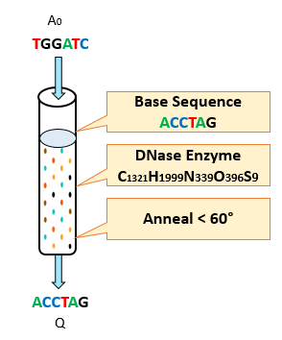

Figure 24. DNA-Based Implementation of the NOT Gate

**Circuit Design:**

Only one input is supplied, and the output is the corresponding complementary sequence. Firstly, we need to choose the base mixture carefully. If the base mixture contains the sequence TGGATC it will work as a buffer. If the base mixture would contain the sequence ACCTAG it will work as NOT gate operation.

Table 9: Inputs and outputs DNA NOT operation.

|  |  |
| --- | --- |
| **A0** | **Q** |
| TGGATC | ACCTAG |
| ACCTAG | TGGATC |

**Working Procedure:**

We see previously where the sequence ACCTAG represents a “true” input and the sequence TGGATC represents a “false” input. The NOT gate, often referred to as an inverter, is one of the simplest DNA-based logic gates. If the input sequence is “false,” then TGGATC will bind with the provided ACCTAG sequence to form a double stranded sequence. DNAase will have no effect on the sequences, and the double stranded sequence will be observed, representing a “true” evaluation. Conversely, if the input sequence is “true”, then ACCTAG will not bind with the provided ACCTAG sequence. Introducing DNAase will destroy both sequences, and no double stranded sequences will be observed, representing a “false” evaluation.

1. *DNA Circuit for OR operation*

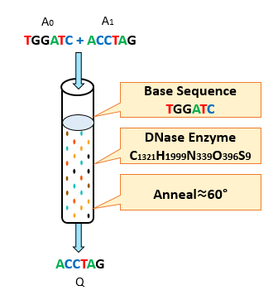

Figure 25. DNA-Based Implementation of the OR Gate

Table 10: Inputs and outputs DNA OR operation.

|  |  |  |
| --- | --- | --- |
| **A0** | **A1** | **Q** |
| TGGATC | TGGATC | TGGATC |
| TGGATC | ACCTAG | ACCTAG |
| ACCTAG | TGGATC | ACCTAG |
| ACCTAG | ACCTAG | ACCTAG |

**Circuit Design:**

First we need to choose the base mixture carefully. Then check each combination of input with base mixture to match the OR gate output. If the base mixture would contain the sequence ACCTAG it would work as a NAND gate. If the base mixture contains the sequence TGGATC, for each combination of input sequences it works as OR gate operation.

**Working Procedure:**

Consider the example above where the sequence ACCTAG represents a “true” input and the sequence TGGATC represents a “false” input. The OR gate evaluates “true” if one or both of the gate inputs are “true.” If a double stranded sequence is observed, then the result is “true”; otherwise, the result is “false.” If both of the input sequences are “true” ACCTAG sequences, then one sequence will combine with the supplied “false” TGGATC sequence to produce a double stranded sequence. DNAase will destroy the remaining input sequence and the double stranded sequence will result in a “true” evaluation. If one input sequence is “false” and the other is “true,” then the “true” ACCTAG sequence will combine with either of the “false” TGGATC sequences to produce a double stranded sequence. DNAase will destroy the remaining “false” sequence and the gate will result in a “true” evaluation. If both input sequences are “false” TGGATC sequences, then neither will combine with the supplied “false” sequence. DNAase will destroy all sequences in the mixture, resulting in a “false” evaluation of the gate.

1. *DNA Circuit for NOR operation*

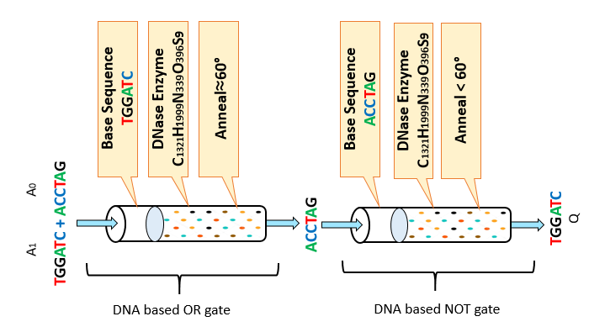

Figure 26. DNA-Based Implementation of the NOR Gate

Table 11: Inputs and outputs DNA NOR operation.

|  |  |  |
| --- | --- | --- |
| **A0** | **A1** | **Q** |
| TGGATC | TGGATC | ACCTAG |
| TGGATC | ACCTAG | TGGATC |
| ACCTAG | TGGATC | TGGATC |
| ACCTAG | ACCTAG | TGGATC |

**Circuit Design:**

NOR gate is the combination of OR and NOT gate. The output of the OR gate will go through the NOT gate to generate NOR gate output. First, we need to choose an OR gate (describe fig: 3) and then choose a NOT gate (describe fig: 1). Then check each combination of input with base mixture of OR gate and the output of the OR gate check with the base mixture of NOT gate to match the NOR gate output.

**Working Procedure:**

The NOR gate, which evaluates “true” only when both inputs are “false”, is created by applying the NOT gate to the output of the OR gate. Continuing with the example above, if both of the input sequences are “false” TGGATC sequences, then one will combine with the supplied “false” TGGATC sequence in OR gate to produce a double stranded molecule. DNAase will destroy the remaining input sequence and the double stranded sequence will generate a “false” TGGATC sequence. This “false” sequence will go thought NOT gate and result in a “true” evaluation. If one input sequence is “false” and the other is “true”, the “false” TGGATC input sequence will combine with either the “true” ACCTAG sequences in OR gate to produce the necessary double stranded sequence. DNAase will then destroy the remaining “false” sequence and the double stranded sequence will generate a “true” ACCTAG sequence. This “true” sequence will go thought NOT gate and result in a “false” evaluation. Finally, if both input sequences are “true” ACCTAG sequences, then neither will combine with the supplied “false” sequence in OR gate. DNAase will destroy all sequences in the mixture, resulting in a “true” sequence. This “true” sequence will go thought NOT gate and result in a “false” evaluation.

1. *DNA Circuit for NAND operation*

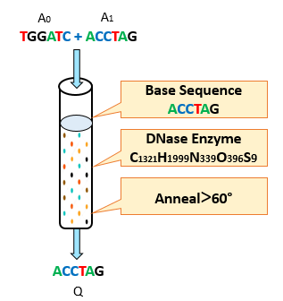

Figure 27. DNA-Based Implementation of the NAND Gate

Table 12: Inputs and outputs DNA NAND operation.

|  |  |  |
| --- | --- | --- |
| **A0** | **A1** | **Q** |
| TGGATC | TGGATC | ACCTAG |
| TGGATC | ACCTAG | ACCTAG |
| ACCTAG | TGGATC | ACCTAG |
| ACCTAG | ACCTAG | TGGATC |

**Circuit Design:**

Firstly, we need to choose the base mixture carefully. Then check each combination of input with base mixture to match the NAND gate output. If the base mixture contains the sequence TGGATC it will work as OR gate. If the base mixture would contain the sequence ACCTAG, for each combination of input sequences it works as a NAND gate operation.

**Working Procedure:**

The NAND gate evaluates “true” if inputs are not both “true.” Thus, introducing the “true” sequence in the base mixture will require at least one of the inputs be “false” to form a double stranded sequence. DNAase will destroy any single stranded sequence in the mixture. Continuing with the example above, if both of the input sequences are “false” TGGATC sequences, then one will combine with the supplied “true” ACCTAG sequence to produce a double stranded molecule. DNAase will destroy the remaining input sequence and the double stranded sequence will result in a “true” evaluation. If one input sequence is “false” and the other is “true”, the “false” TGGATC input sequence will combine with either the “true” ACCTAG sequences to produce the necessary double stranded sequence. DNAase will then destroy the remaining “false” sequence and the gate will result in a “true” evaluation. Finally, if both input sequences are “true” ACCTAG sequences, then neither will combine with the supplied “true” sequence. DNAase will destroy all sequences in the mixture, resulting in a “false” evaluation.

1. *DNA Circuit for AND operation*

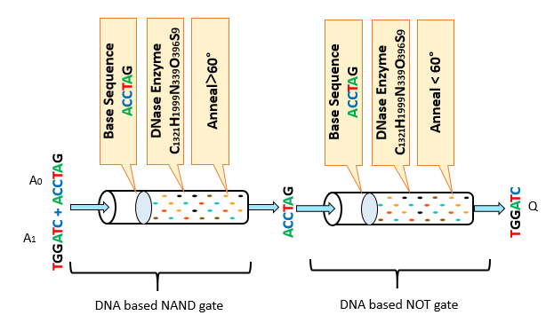

Figure 28: DNA-Based AND Gate

Table 13: Inputs and outputs DNA AND operation.

|  |  |  |
| --- | --- | --- |
| **A0** | **A1** | **Q** |
| TGGATC | TGGATC | TGGATC |
| TGGATC | ACCTAG | TGGATC |
| ACCTAG | TGGATC | TGGATC |
| ACCTAG | ACCTAG | ACCTAG |

**Circuit Design:**

AND gate is the combination of NAND and NOT gate. The output of the NAND gate will go through the NOT gate to generate AND gate output. First, we need to choose a NAND gate (describe fig: 3) and then choose a NOT gate (describe fig: 1). Then check each combination of input with base mixture of NAND gate and the output of the NAND gate check with the base mixture of NOT gate to match the AND gate output.

**Working Procedure:**

The AND gate, which evaluates “true” only when both inputs are “true”, is created by applying the NOT gate to the output of the NAND gate. Continuing with the example above, if both of the input sequences are “false” TGGATC sequences, then one will combine with the supplied “true” ACCTAG sequence in NAND gate to produce a double stranded molecule. DNAase will destroy the remaining input sequence and the double stranded sequence will generate a “true” ACCTAG sequence. This “true” sequence will go thought NOT gate and result in a “false” evaluation. If one input sequence is “false” and the other is “true”, the “false” TGGATC input sequence will combine with either the “true” ACCTAG sequences in NAND gate to produce the necessary double stranded sequence. DNAase will then destroy the remaining “false” sequence and the double stranded sequence will generate a “true” ACCTAG sequence. This “true” sequence will go thought NOT gate and result in a “false” evaluation. Finally, if both input sequences are “true” ACCTAG sequences, then neither will combine with the supplied “true” sequence in NAND gate. DNAase will destroy all sequences in the mixture, resulting in a “false” sequence. This “false” sequence will go thought NOT gate and result in a “true” evaluation.

1. *DNA Circuit for XOR operation*

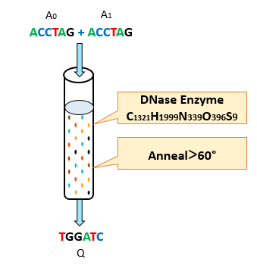

Figure 29. DNA-Based Implementation of the XOR Gate

Table 14: Inputs and outputs DNA XOR operation.

|  |  |  |
| --- | --- | --- |
| **A0** | **A1** | **Q** |
| TGGATC | TGGATC | TGGATC |
| TGGATC | ACCTAG | ACCTAG |
| ACCTAG | TGGATC | ACCTAG |
| ACCTAG | ACCTAG | TGGATC |

**Circuit Design:**

For XOR gate design there is no need for any base mixture as none of the sequences produce the XOR output. We need to check the input sequence. In order for sequences to have opposite values, they are complementary, and will bind together to form a double stranded sequence. For each combination of input sequence, we will match the output.

**Working Procedure:**

The XOR gate evaluates “true” only if exactly one of the input sequences evaluates “true.” In DNA-based logic gates, the XOR gate is the most simplistic design in that no external sequences need to be supplied to the gate. In order for sequences to have opposite values TGGATC and ACCTAG, they are complementary, and will bind together to form a double stranded sequence and the output is “true”. If the inputs are not complementary (TGGATC, TGGATC or ACCTAG, ACCTAG), sequences will not bind to one another and DNAase will destroy both input sequences and the output is “false”.

1. *DNA Circuit for XNOR operation*

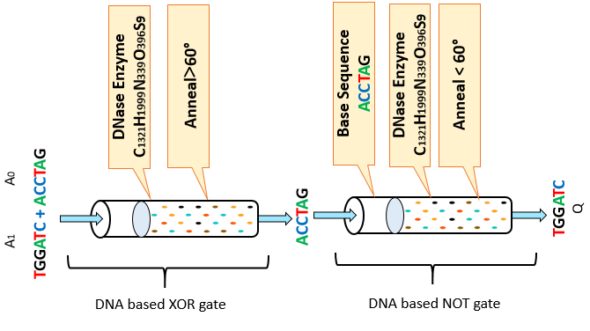

Figure 30. DNA-Based Implementation of the XNOR Gate

Table 15: Inputs and outputs DNA XNOR operation.

|  |  |  |
| --- | --- | --- |
| **A0** | **A1** | **Q** |
| TGGATC | TGGATC | ACCTAG |
| TGGATC | ACCTAG | TGGATC |
| ACCTAG | TGGATC | TGGATC |
| ACCTAG | ACCTAG | ACCTAG |

**Circuit Design:**

XNOR gate is the combination of XOR and NOT gate. The output of the XOR gate will go through the NOT gate to generate XNOR gate output. Firstly, we need to choose a XOR gate and then choose a NOT gate. Then check the input sequence of XOR. In order for sequences to have opposite values, they are complementary, and will bind together to form a double stranded sequence then the output of the XOR gate checks with the base mixture of NOT gate to match the XNOR gate output.

**Working Procedure:**

The XNOR gate, which evaluates “false” only when any inputs are “false”, is created by applying the NOT gate to the output of the XOR gate. The XOR gate evaluates “true” only if exactly one of the input sequences evaluates “true.” In DNA-based logic gates, the XOR gate is the most simplistic design in that no external sequences need to be supplied to the gate. In order for sequences to have opposite values TGGATC and ACCTAG, they are complementary, and will bind together to form a double stranded sequence and the output is “true”. This “true” sequence will go though NOT gate and result in a “false” evaluation. If the inputs are not complementary (TGGATC, TGGATC or ACCTAG, ACCTAG), sequences will not bind to one another and DNAase will destroy both input sequences and the output is “false”. This “false” sequence will go though NOT gate and result in a “true” evaluation.

##### 4.3.3.2 DNA-Quantum operational gates using NMR at room temperature

DNA-Quantum computing merges all the advantages of individual DNA computing and Quantum computing. DNA-based computing is mostly chosen for its simultaneous operation capability. On the other hand, Quantum computing is an emergent process of speedy computing which is more than digital computers capability. In addition, Quantum computing can perform calculations in a few seconds for which today’s supercomputer would take ages or decades. DNA computing can provide huge memory in small spaces. So, large memory and fast computation can be possible by using the DNA-Quantum computing process. The base of DNA-Quantum computing is nothing but DNA and Quantum operational gates. In this section, different types of DNA-Quantum operational gates will be described.

1. *DNA-Quantum NOT operational gate*

***Design Procedure:***

DNA NOT operation prepared to produce output as a complementary sequence of input. To produce output, we need a single input which contains single strands of DNA sequence. We also need a base sequence and anneal temperature for the DNA operation. After getting the output DNA sequence from DNA NOT operation, we have to provide it through the NMR process. In NMR, we have used a room temperature probe. By doing NMR for the DNA sequence, qubit of normal ground state turns into superposition state or ground state according to the input sequence in NMR. The output of the NMR process is Quantum qubit.

***Working Procedure:***

The DNA-Quantum NOT operational gate is the inverter operation, which is one of the simplest DNA-Quantum logic operations. If the input DNA sequence is “false”, TGGATC will bind with the provided ACCTAG sequence to form a double stranded sequence. DNAase will have no effect on the sequences, and the double stranded sequence will be observed, representing a “true” evaluation. Conversely, if the input sequence is “true”, then ACCTAG will not bind with the provided ACCTAG sequence. Introducing DNAase will destroy both sequences, and no double stranded sequences will be observed, representing a “false” evaluation.

When we get the DNA sequence from DNA NOT operational gate then this sequence will go through NMR as a sample and dive into the probe. Using the NMR process at room temperature and by emitting EMR this biomolecule will get a superposition state and become a qubit.

Here, we are using DNA sequence ACCTAG = TRUE for Quantum qubit | 1 > and DNA sequence TGGATC = FLASE for Quantum qubit | 0 >. The outputs for different combinations of input are given in Table 16.

Table 16: Input and Output of DNA-Quantum NOT operation.

|  |  |  |
| --- | --- | --- |
| Input | Output | Quantum qubit |
| TGGATC | ACCTAG | |1> |
| ACCTAG | TGGATC | |0> |

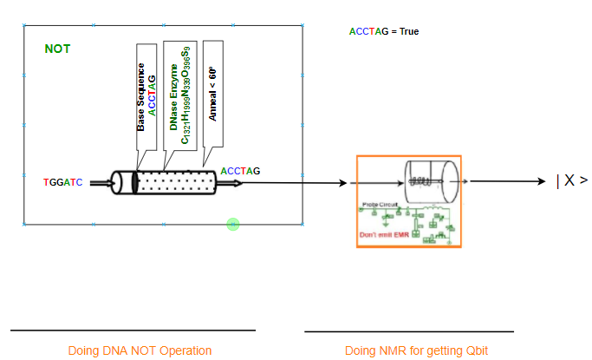

Figure 31: DNA-Quantum NOT operation

1. *DNA-Quantum OR operational gate*

***Circuit Design:***

To produce output, we need two inputs which contain single strands of DNA sequence. We also need a base sequence and anneal temperature for the DNA operation. To produce expected output for OR operation we have to choose the base mixture carefully. Then check each combination of input with base mixture to match the OR gate output. If the base mixture would contain the sequence ACCTAG it would work as a NAND gate. If the base mixture contains the sequence TGGATC, for each combination of input sequences it works as OR gate operation.

After getting the output DNA sequence from DNA OR operation, we have to provide it through the NMR process. In NMR, we have used a room temperature probe. By doing NMR for the DNA sequence, qubit of normal ground state turns into superposition state or ground state according to the input sequence in NMR. The output of the NMR process is Quantum qubit.

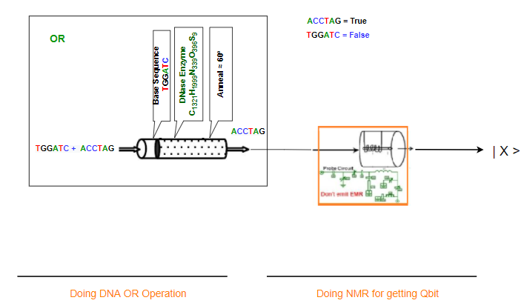

Figure 32: DNA-Quantum OR operation

***Working Procedure:***

The DNA-Quantum OR operational gate is the most important DNA-Quantum logic operation. Let us assume two sequence ACCTAG represents a “true” input and the sequence TGGATC represents a “false” input. The OR gate evaluates “true” if one or both of the gate inputs are “true.” If a double stranded sequence is observed, then the result is “true”; otherwise, the result is “false.” If both of the input sequences are “true” ACCTAG sequences, then one sequence will combine with the supplied “false” TGGATC sequence to produce a double stranded sequence. DNAase will destroy the remaining input sequence and the double stranded sequence will result in a “true” evaluation. If one input sequence is “false” and the other is “true,” then the “true” ACCTAG sequence will combine with either of the “false” TGGATC sequences to produce a double stranded sequence. DNAase will destroy the remaining “false” sequence and the gate will result in a “true” evaluation. If both input sequences are “false” TGGATC sequences, then neither will combine with the supplied “false” sequence. DNAase will destroy all sequences in the mixture, resulting in a “false” evaluation of the gate.

When we get the DNA sequence from DNA OR operational gate then this sequence will go through NMR as a sample and dive into the probe. Using the NMR process at room temperature and by emitting EMR this biomolecule will get a superposition state and become a qubit.

Here, we are using DNA sequence ACCTAG = TRUE for Quantum qubit | 1 > and DNA sequence TGGATC = FLASE for Quantum qubit | 0 >. The outputs for different combinations of input are given in Table 17.

Table 17: Input and Output of DNA-Quantum OR operation.

|  |  |  |  |
| --- | --- | --- | --- |
| Input1 | Input2 | Output | Quantum qubit |
| TGGATC | TGGATC | TGGATC | |0> |
| TGGATC | ACCTAG | ACCTAG | |1> |
| ACCTAG | TGGATC | ACCTAG | |1> |
| ACCTAG | ACCTAG | ACCTAG | |1> |

1. *DNA-Quantum XOR operational gate*

***Circuit Design:***

To produce output, we need two inputs which contain single strands of DNA sequence. We do not need a base sequence. But we need anneal temperature for the DNA XOR operation. We need to check the input sequence. In order for sequences to have opposite values, they are complementary, and will bind together to form a double stranded sequence. For each combination of input sequence, we will match the output.

After getting the output DNA sequence from DNA XOR operation, we have to provide it through the NMR process. In NMR, we have used a room temperature probe. By doing NMR for the DNA sequence, qubit of normal ground state turns into superposition state or ground state according to the input sequence in NMR. The output of the NMR process is Quantum qubit.

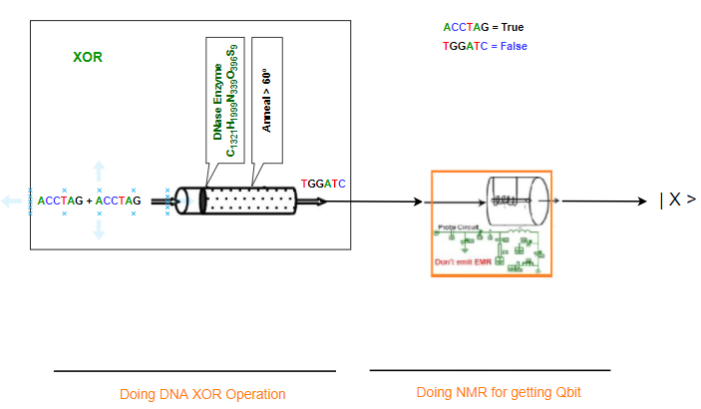

Figure 33: DNA-Quantum XOR operation

***Working Procedure:***

The DNA-Quantum XOR operational gate is the another most important DNA-Quantum logic operation. Let us assume two sequence ACCTAG represents a “true” input and the sequence TGGATC represents a “false” input. The XOR gate evaluates “true” if both sequence of the gate inputs are complementary to each other. They make a double stranded DNA sequence. If a double stranded sequence is observed, then the result is “true”; otherwise, the result is “false.” If both of the input sequences are different to each other ACCTAG and TGGATC sequences, then these sequences will combine and produce a double stranded sequence. DNAase will destroy the remaining input sequence and the double stranded sequence will result in a “true” evaluation. If both input sequence is “false” or “true,” then the sequence will not combine with each other. DNAase will destroy all sequences in the mixture, resulting in a “false” evaluation of the operation.

When we get the DNA sequence from DNA XOR operational gate then this sequence will go through NMR as a sample and dive into the probe. Using the NMR process at room temperature and by emitting EMR this biomolecule will get a superposition state and become a qubit.

Here, we are using DNA sequence ACCTAG = TRUE for Quantum qubit | 1 > and DNA sequence TGGATC = FLASE for Quantum qubit | 0 >. The outputs for different combinations of input are given in Table 18.

Table 18: Input and Output of DNA-Quantum XOR operation.

|  |  |  |  |
| --- | --- | --- | --- |
| Input1 | Input2 | Output | Quantum qubit |
| TGGATC | TGGATC | TGGATC | |0> |
| TGGATC | ACCTAG | ACCTAG | |1> |
| ACCTAG | TGGATC | ACCTAG | |1> |
| ACCTAG | ACCTAG | TGGATC | |0> |

1. *DNA-Quantum AND operational gate*

***Circuit Design:***

To produce output, we need two inputs which contain single strands of DNA sequence. We also need a base sequence and anneal temperature for the DNA operation. To produce expected output for AND operation we have to choose the base mixture carefully. Then check each combination of input with base mixture to match the AND gate output. If the base mixture contains the sequence TGGATC it will work as NOR gate. If the base mixture would contain the sequence ACCTAG, for each combination of input sequences it works as AND gate operation.

After getting the output DNA sequence from DNA AND operation, we have to provide it through the NMR process. In NMR, we have used a room temperature probe. By doing NMR for the DNA sequence, qubit of normal ground state turns into superposition state or ground state according to the input sequence in NMR. The output of the NMR process is Quantum qubit.

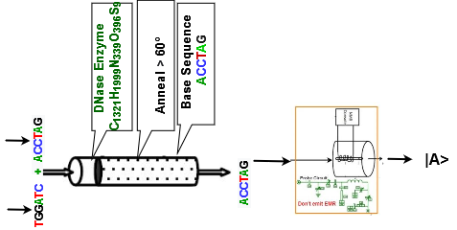

Figure 34: DNA-Quantum AND operation

***Working Procedure:***

The DNA-Quantum AND operational gate is the most important DNA-Quantum logic operation. Let us assume two sequence ACCTAG represents a “true” input and the sequence TGGATC represents a “false” input. The AND gate evaluates “true” if both of the gate inputs are “true.” If one of the sequences is “false” then the output will be “false”. DNAase will destroy the remaining input sequence and the double stranded sequence will result in a “true” evaluation. If one input sequence is “false” and the other is “true,” then the “true” ACCTAG sequence will combine with either of the “false” TGGATC sequences to produce a double stranded sequence. DNAase will destroy the remaining “false” sequence and the gate will result in a “true” evaluation. If both input sequences are “false” TGGATC sequences, then neither will combine with the supplied “false” sequence. DNAase will destroy all sequences in the mixture, resulting in a “false” evaluation of the gate.

When we get the DNA sequence from DNA AND operational gate then this sequence will go through NMR as a sample and dive into the probe. Using the NMR process at room temperature and by emitting EMR this biomolecule will get a superposition state and become a qubit.

Here, we are using DNA sequence ACCTAG = TRUE for Quantum qubit | 1 > and DNA sequence TGGATC = FLASE for Quantum qubit | 0 >. The outputs for different combinations of input are given in Table 19.

Table 19: Input and Output of DNA-Quantum AND operation.

|  |  |  |  |
| --- | --- | --- | --- |
| Input1 | Input2 | Output | Quantum qubit |
| TGGATC | TGGATC | TGGATC | |0> |
| TGGATC | ACCTAG | TGGATC | |0> |
| ACCTAG | TGGATC | TGGATC | |0> |
| ACCTAG | ACCTAG | ACCTAG | |1> |

1. *DNA-Quantum Full Adder at room temperature*

Full Adder is the adder which adds three inputs and produces two outputs. The first two inputs are A and B and the third input is an input carry as Cin. The output carry is designated as Cout and the normal output is designated as S which is Sum. A Full Adder logic is designated in such a manner that can take eight inputs together to create a qubit adder and cascade the carry qubit from one adder to the another. To create a Full Adder, one OR, two AND and two XOR operational gates are required. Figure 35 describes the DNA-Quantum circuit of the Full Adder.

***Circuit Design:***

To design a DNA-Quantum Full Adder we have to use DNA and Quantum operational gates so that we can operate the input DNA sequence for their corresponding output qubits. The DNA operational gates will be used for receiving the input sequence and the Quantum operational gates will be used to produce the final output against the corresponding set of inputs. Each time, the DNA-Quantum Full adder will receive three DNA sequences as input. After operating in a certain number of DNA operational gates, the qubit will be turned into corresponding Quantum qubits by using NMR at room temperature probe. The process of producing a quantum qubit against a DNA sequence is explained in Section 4.3.2. By using a room temperature probe and corresponding components of the NMR process, the stable or grounded state qubits get excited by using EMR to provide an output as a quantum qubit. Then the qubits are processed through quantum operational gates and outputs are received. Here, Figure 35 describes DNA-Quantum Full adder using DNA and Quantum operational gates.

From the figure, we find that the DNA- Quantum Full Adder consists of three DNA operational gates and two Quantum operational gates. Here, two AND and one XOR is used as DNA operational gates and further one XOR and one OR Quantum operational gates is used.



Figure 35: DNA-Quantum Full Adder at room temperature

***Working procedure:***

The working procedure of the DNA-Quantum Full adder is given below for each pattern of input DNA sequence. Here, we are using DNA sequence ACCTAG = TRUE for Quantum qubit | 1 > and DNA sequence TGGATC = FLASE for Quantum qubit | 0 >.

The working procedure of the Quantum-DNA Full Adder is given below for 4 out of 8 patterns of input DNA sequence. In addition, all the inputs and outputs combinations are tabulated in Table 20.

1. For input A, B, C = TGGATC,

**Sum** = Quantum XOR (DNA XOR (A, B), C)

= Quantum XOR (DNA XOR (TGGATC, TGGATC), TGGATC)

= Quantum XOR (TGGATC, TGGATC)

= Quantum XOR (0, 0) [Using NMR]

= 0

**Carry** = Quantum OR (DNA AND (C, XOR (A, B)), DNA AND (A,B))

= Quantum OR (DNA AND (TGGATC, XOR (TGGATC, TGGATC)), DNA AND (TGGATC, TGGATC))

= Quantum OR (DNA AND (TGGATC, XOR (TGGATC, TGGATC)), DNA AND (TGGATC, TGGATC))

= Quantum OR (TGGATC, TGGATC)

= Quantum OR (0, 0) [Using NMR]

= 0

1. For input A, B, C = TGGATC, TGGATC, ACCTAG

**Sum** = Quantum XOR (DNA XOR (A, B), C)

= Quantum XOR (DNA XOR (TGGATC, TGGATC), ACCTAG)

= Quantum XOR (TGGATC, ACCTAG)

= Quantum XOR (0, 1) [Using NMR]

= 1

**Carry** = Quantum OR (DNA AND (C, XOR (A, B)), DNA AND (A, B))

= Quantum OR (DNA AND (ACCTAG, XOR (TGGATC, TGGATC)), DNA AND (TGGATC, TGGATC))

= Quantum OR (DNA AND (ACCTAG, TGGATC), TGGATC)

= Quantum OR (TGGATC, TGGATC)

= Quantum OR (0, 0) [Using NMR]

= 0

1. For input A, B, C = TGGATC, ACCTAG, TGGATC

**Sum** = Quantum XOR (DNA XOR (A, B), C)

= Quantum XOR (DNA XOR (TGGATC, ACCTAG), TGGATC)

= Quantum XOR (ACCTAG, TGGATC)

= Quantum XOR (1, 0) [Using NMR]

= 1

**Carry** = Quantum OR (DNA AND (C, XOR (A, B)), DNA AND (A, B))

= Quantum OR (DNA AND (TGGATC, XOR (TGGATC, ACCTAG)), DNA AND (TGGATC, ACCTAG))

= Quantum OR (DNA AND (TGGATC, ACCTAG), TGGATC)

= Quantum OR (TGGATC, TGGATC)

= Quantum OR (0, 0) [Using NMR]

= 0

1. For input A, B, C = TGGATC, ACCTAG, ACCTAG

**Sum** = Quantum XOR (DNA XOR (A, B), C)

= Quantum XOR (DNA XOR (TGGATC, ACCTAG), ACCTAG)

= Quantum XOR (ACCTAG, ACCTAG)

= Quantum XOR (1, 1) [Using NMR]

= 0

**Carry** = Quantum OR (DNA AND (C, XOR (A, B)), DNA AND (A, B))

= Quantum OR (DNA AND (ACCTAG, XOR (TGGATC, ACCTAG)), DNA AND (TGGATC, ACCTAG))

= Quantum OR (DNA AND (ACCTAG, ACCTAG), TGGATC)

= Quantum OR (ACCTAG, TGGATC)

= Quantum OR (1, 0) [Using NMR]

= 1

Table 20: Outputs of Quantum-DNA Full Adder operation.

|  |  |  |  |  |
| --- | --- | --- | --- | --- |
| |A0> | |A1> | |Q> | SUM | Carry |
| TGGATC | TGGATC | TGGATC | |0> | |0> |
| TGGATC | TGGATC | ACCTAG | |1> | |0> |
| TGGATC | ACCTAG | TGGATC | |1> | |0> |
| TGGATC | ACCTAG | ACCTAG | |0> | |1> |
| ACCTAG | TGGATC | TGGATC | |1> | |0> |
| ACCTAG | TGGATC | ACCTAG | |0> | |1> |
| ACCTAG | ACCTAG | TGGATC | |0> | |1> |
| ACCTAG | ACCTAG | ACCTAG | |1> | |1> |

1. *DNA-Quantum Full Subtractor at room temperature*

A full subtractor is a combinational circuit that performs subtraction of two qubits, one is minuend and other is subtrahend, taking into account borrow of the previous adjacent lower minuend qubit. This circuithas three inputs and two outputs. The three inputs A, B and Bin, denote the minuend, subtrahend, and previous borrow, respectively. The two outputs, D and Bout represent the difference and output borrows, respectively. To create a full subtractor, one OR, two AND, two OR and 2 XOR gates are required. Figure 36 describes the DNA-Quantum circuit of Full Subtractor.

***Design procedure:***

To design a DNA-Quantum Full Subtractor, we have to use DNA and Quantum operational gates so that we can operate the input qubit for their corresponding outputs. The DNA operational gates will be used for receiving the input DNA sequence and the Quantum operational gates will be used to produce the final output against the corresponding set of inputs. Each time, the DNA-Quantum Full Subtractor will receive three DNA sequences as input. After operating in a certain number of DNA operational gates, the DNA sequence will be turned into corresponding quantum qubits by using NMR at room temperature probe. The process of producing a Quantum qubit against a DNA sequence is explained in Section 4.3.2. By using a room temperature probe and corresponding components of NMR, the ground qubit turns on/off excited state and produces a Quantum qubit for emitting EMR. Then the Quantum qubits are processed through Quantum operational gates and outputs are received. Here, Figure 36 describes DNA-Quantum Full Subtractor using DNA and Quantum operational gates.

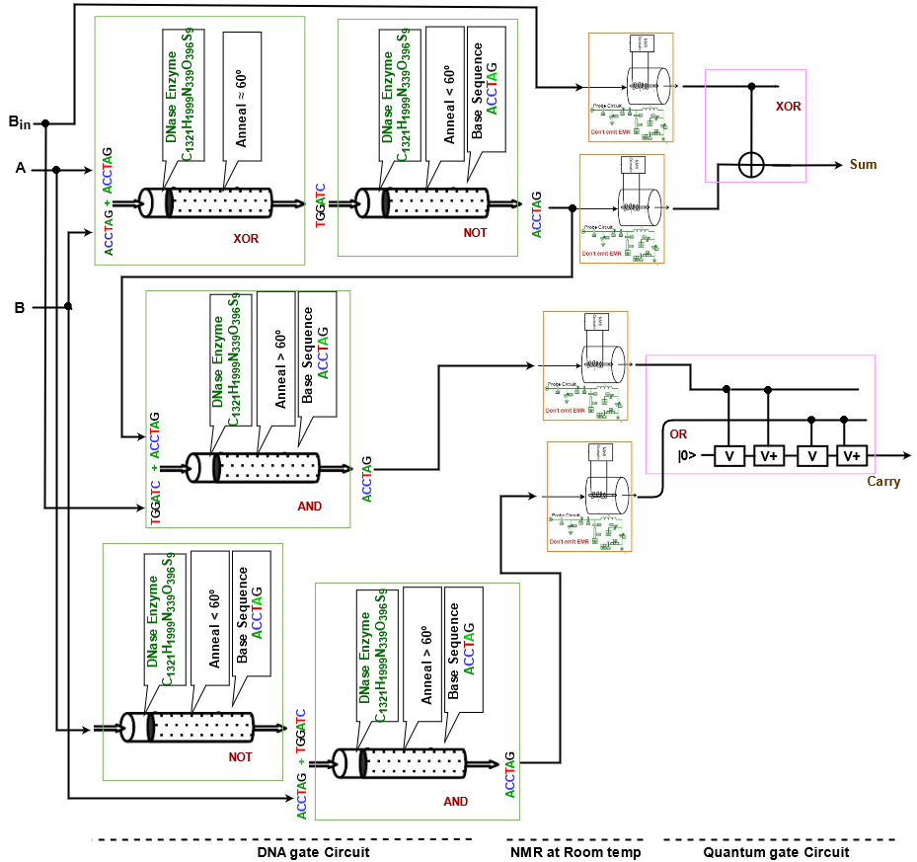

Figure 36: DNA-Quantum Full Subtractor at room temperature

From the figure, we find that the DNA-Quantum Full Subtractor consists of three DNA operational gates and two Quantum operational gates. Here, two AND and one XOR is used as DNA operational gates and further one XOR and one OR Quantum operational gates is used.

***Working procedure:***

The working procedure of the DNA-Quantum Full Subtractor is given below for each pattern of input qubits. Here, we are using DNA sequence ACCTAG = TRUE for Quantum qubit | 1 > and DNA sequence TGGATC = FLASE for Quantum qubit | 0 >.

The working procedure of the DNA-Quantum Full Subtractor is given below for 4 out of 8 patterns of input DNA sequence. In addition, the inputs and outputs of different combinations are tabulated in Table 21.

1. For input A, B, Bin = TGGATC,

**Sum** = Quantum XOR (DNA XOR (A, B), Bin)

= Quantum XOR (DNA XOR (TGGATC, TGGATC), TGGATC)

= Quantum XOR (TGGATC, TGGATC)

= Quantum XOR (0, 0) [Using NMR]

= 0

**Carry** = Quantum OR (DNA AND (Bin, NOT (XOR (A,B))), DNA AND ( NOT (A), B))

= Quantum OR (DNA AND (TGGATC, ACCTAG), DNA AND (ACCTAG, TGGATC))

= Quantum OR (TGGATC, TGGATC)

= Quantum OR (0, 0) [Using NMR]

= 0

1. For input A, B, Bin = TGGATC, TGGATC, ACCTAG

**Sum** = Quantum XOR (DNA XOR (A, B), Bin)

= Quantum XOR (DNA XOR (TGGATC, TGGATC), ACCTAG)

= Quantum XOR (TGGATC, ACCTAG)

= Quantum XOR (0, 1) [Using NMR]

= 1

**Carry** = Quantum OR (DNA AND (Bin, NOT (XOR (A, B))), DNA AND (NOT (A), B))

= Quantum OR (DNA AND (ACCTAG, ACCTAG), DNA AND (ACCTAG, TGGATC))

= Quantum OR (ACCTAG, 0)

= Quantum OR (1, 0) [Using NMR]

= 1

1. For input A, B, Bin = TGGATC, ACCTAG, TGGATC

**Sum** = Quantum XOR (DNA XOR (A, B), Bin)

= Quantum XOR (DNA XOR (0, ACCTAG), 0)

= Quantum XOR (ACCTAG, 0)

= Quantum XOR (1, 0) [Using NMR]

= 1

**Carry** = Quantum OR (DNA AND (Bin, NOT (XOR (A, B))), DNA AND ( NOT (A), B))

= Quantum OR (DNA AND (TGGATC, ACCTAG), DNA AND (ACCTAG, ACCTAG))

= Quantum OR (DNA AND (TGGATC, ACCTAG), ACCTAG)

= Quantum OR (TGGATC, ACCTAG)

= Quantum OR (0, 1) [Using NMR]

= 1

1. For input A, B, Bin = TGGATC, ACCTAG, ACCTAG

**Sum** = Quantum XOR (DNA XOR (A, B), Bin)

= Quantum XOR (DNA XOR (TGGATC, ACCTAG), ACCTAG)

= Quantum XOR (ACCTAG, ACCTAG)

= Quantum XOR (1, 1) [Using NMR]

= 0

**Carry** = Quantum OR (DNA AND (Bin, NOT (XOR (A, B))), DNA AND (NOT (A), B))

= Quantum OR (DNA AND (ACCTAG, TGGATC), DNA AND (ACCTAG, ACCTAG))

= Quantum OR (DNA AND (ACCTAG, TGGATC), ACCTAG)

= Quantum OR (TGGATC, ACCTAG)

= Quantum OR (1, 0) [Using NMR]

= 1

Table 21: Outputs of DNA-Quantum Full Subtractor operation.

|  |  |  |  |  |
| --- | --- | --- | --- | --- |
| |A> | |B> | |Bin> | SUM | Carry |
| TGGATC | TGGATC | TGGATC | |0> | |0> |
| TGGATC | TGGATC | ACCTAG | |1> | |1> |
| TGGATC | ACCTAG | TGGATC | |1> | |1> |
| TGGATC | ACCTAG | ACCTAG | |0> | |1> |
| ACCTAG | TGGATC | TGGATC | |1> | |0> |
| ACCTAG | TGGATC | ACCTAG | |0> | |0> |
| ACCTAG | ACCTAG | TGGATC | |0> | |0> |
| ACCTAG | ACCTAG | ACCTAG | |1> | |1> |

1. *DNA-Quantum 2 to 1 Multiplexer at room temperature*

A multiplexer (MUX) is a device that can receive multiple input signals and synthesize a single output signal in a recoverable manner for each input signal. It is also an integrated system that usually contains a certain number of data inputs and a single output. To create a Multiplexer, one NOT, two AND, and an OR gate is required. Figure 37 describes the DNA-Quantum circuit of Multiplexer. A Multiplexer receives three inputs and produces one output containing “Y”.

***Design procedure:***

To design a DNA-Quantum 2 to 1 Multiplexer, we have to use DNA and Quantum operational gates so that we can operate the input DNA sequence for their corresponding outputs. The DNA operational gates will be used for receiving the input DNA sequence and the Quantum operational gates will be used to produce the final output against the corresponding set of inputs. Each time, the DNA-Quantum Multiplexer will receive three qubits as input. After operating in a certain number of DNA operational gates, the sequence will be turned into corresponding quantum qubits by using NMR at room temperature probe. The process of producing a quantum qubit against a DNA sequence is explained in Section 4.3.2. By using a room temperature probe and corresponding components of NMR, the ground qubit turns on/off excited state and produces a Quantum qubit for emitting EMR. Then the Quantum qubits are processed through Quantum operational gates and outputs are received. Here, Figure 37 describes DNA-Quantum Multiplexer using DNA and Quantum operational gates.

From the figure, we find that the Quantum-DNA 2 to 1 Multiplexer consists of three DNA operational gates and one Quantum operational gates. Here, two AND and one NOT are used as DNA operational gates and further one OR Quantum operational gates are used.

***Working procedure:***

The working procedure of the Quantum-DNA 2 to 1 Multiplexer is given below for each pattern of input DNA sequence. Here, we are using DNA sequence ACCTAG = TRUE for Quantum qubit | 1 > and DNA sequence TGGATC = FLASE for Quantum qubit | 0 >.

The working procedure of the DNA-Quantum 2 to 1 Multiplexer is given below for 4 out of 8 patterns of input DNA sequence. In addition, the inputs and outputs of different combinations are tabulated in Table 22.

1. For input S, D1, D0 = TGGATC,

**Y** = Quantum OR (DNA AND (D1, S), AND (NOT (S), D0))

= Quantum OR (DNA AND (TGGATC, TGGATC), AND (NOT (TGGATC), TGGATC)

= Quantum OR (TGGATC, TGGATC)

= Quantum OR (0, 0) [Using NMR]

= 0

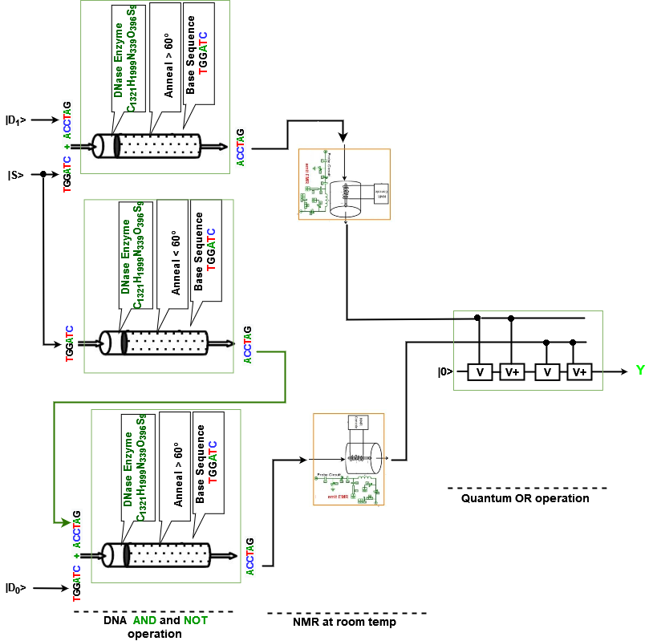

Figure 37: DNA-Quantum 2 to 1 Multiplexer at room temperature

1. For input S, D0, D1 = TGGATC, TGGATC, ACCTAG

**Y** = Quantum OR (DNA AND (D1, S), AND (NOT (S), D0))

= Quantum OR (DNA AND (ACCTAG, TGGATC), AND (NOT (TGGATC), TGGATC)

= Quantum OR (TGGATC, TGGATC)

= Quantum OR (0, 0) [Using NMR]

= 1

1. For input S, D0, D1 = TGGATC, ACCTAG, TGGATC

**Y** = Quantum OR (DNA AND (D1, S), AND (NOT (S), D0))

= Quantum OR (DNA AND (TGGATC, TGGATC), AND (NOT (TGGATC), ACCTAG))

= Quantum OR (TGGATC, AND (ACCTAG, ACCTAG)

= Quantum OR (TGGATC, ACCTAG)

= Quantum OR (0, 1) [Using NMR]

= 1

1. For input S, D0, D1 = TGGATC, ACCTAG, ACCTAG

**Y** = Quantum OR (DNA AND (D1, S), AND (NOT (S), D0))

= Quantum OR (DNA AND (ACCTAG, TGGATC), AND (NOT (TGGATC), ACCTAG))

= Quantum OR (TGGATC, AND (ACCTAG, ACCTAG))

= Quantum OR (TGGATC, ACCTAG)

= Quantum XOR (0, 1) [Using NMR]

= 1

Table 22: Outputs of Quantum-DNA 2 to 1 Multiplexer operation.

|  |  |  |  |
| --- | --- | --- | --- |
| |S> | |D1> | |D0> | Y |
| |0> | |0> | |0> | TGGATC |
| |0> | |0> | |1> | TGGATC |
| |0> | |1> | |0> | ACCTAG |
| |0> | |1> | |1> | ACCTAG |
| |1> | |0> | |0> | TGGATC |
| |1> | |0> | |1> | ACCTAG |
| |1> | |1> | |0> | TGGATC |
| |1> | |1> | |1> | ACCTAG |

#### 4.3.4 NMR at 0-kelvin by using Cryogenic probe

The availability of state polarization decreases as the number of qubits rises, which is an evident challenge in building large NMR quantum computers. While the exact polarization achieved relies on experimental details, the population difference between the lowest and highest energy states can be used to approximate an upper limit.

The amount of polarization accessible diminishes exponentially as the size of the system grows. If the size of the NMR sample is kept constant, the signal strength will go off exponentially with the number of qubits; conversely, exponentially large samples would be required to maintain a constant signal size. Some other problems can happen while using a room temperature probe as dechorrence problem and scaling problem.

For solving all mentioned problems, we can use the cryogenic probe and pseudo liquid mixture. The cryogenic probe works at cool temperatures and temperature is proportional to noise. So, if we use cryogenic probes, then the dechorrence problem will be solved as per several studies. But if we use many bits then we will be facing a polarization problem. Different DNA-Quantum operational gates are described here at 0-kelvin temperature using cryogenic probes.

1. *DNA-Quantum NOT operational gate at 0-kelvin*

***Design Procedure:***

DNA NOT operation prepared to produce output as a complementary sequence of input. To produce output, we need a single input which contains single strands of DNA sequence. We also need a base sequence and anneal temperature for the DNA operation. After getting the output DNA sequence from DNA NOT operation, we have to provide it through the NMR process. In NMR, we have used a cryogenic probe at 0-kelvin. By doing NMR for the DNA sequence, qubit of normal ground state turns into superposition state or ground state according to the input sequence in NMR. The output of the NMR process is Quantum qubit.

***Working Procedure:***

The DNA-Quantum NOT operational gate is the inverter operation, which is one of the simplest DNA-Quantum logic operations. If the input DNA sequence is “false”, TGGATC will bind with the provided ACCTAG sequence to form a double stranded sequence. DNAase will have no effect on the sequences, and the double stranded sequence will be observed, representing a “true” evaluation. Conversely, if the input sequence is “true”, then ACCTAG will not bind with the provided ACCTAG sequence. Introducing DNAase will destroy both sequences, and no double stranded sequences will be observed, representing a “false” evaluation.

When we get the DNA sequence from DNA NOT operational gate then this sequence will go through NMR as a sample and dive into the probe. Using the NMR process using cryogenic probe at 0-kelvin and by emitting EMR this biomolecule will get a superposition state and become a qubit.

Here, we are using DNA sequence ACCTAG = TRUE for Quantum qubit | 1 > and DNA sequence TGGATC = FLASE for Quantum qubit | 0 >. The outputs for different combinations of input are given in Table 16.

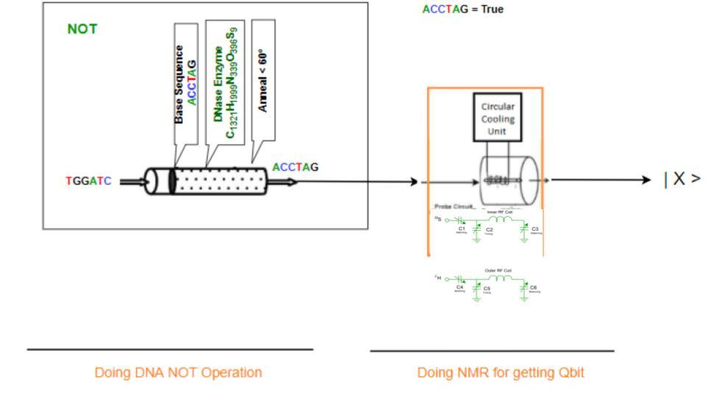

Figure 38: DNA-Quantum NOT operation at 0-kelvin

1. *DNA-Quantum OR operational gate at 0-kelvin*

***Circuit Design:***

To produce output, we need two inputs which contain single strands of DNA sequence. We also need a base sequence and anneal temperature for the DNA operation. To produce expected output for OR operation we have to choose the base mixture carefully. Then check each combination of input with base mixture to match the OR gate output. If the base mixture would contain the sequence ACCTAG it would work as NOR gate. If the base mixture contains the sequence TGGATC, for each combination of input sequences it works as OR gate operation.

After getting the output DNA sequence from DNA OR operation, we have to provide it through the NMR process. In NMR, we are using a cryogenic probe at 0-kelvin. By doing NMR for the DNA sequence, qubit of normal ground state turns into superposition state or ground state according to the input sequence in NMR. The output of the NMR process is Quantum qubit.

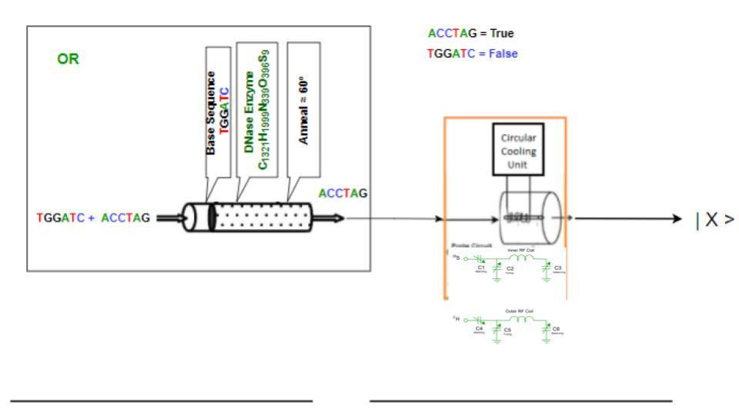

Figure 39: DNA-Quantum OR operation at 0-kelvin

***Working Procedure:***

The DNA-Quantum OR operational gate is the most important DNA-Quantum logic operation. Let us assume two sequence ACCTAG represents a “true” input and the sequence TGGATC represents a “false” input. The OR gate evaluates “true” if one or both of the gate inputs are “true.” If a double stranded sequence is observed, then the result is “true”; otherwise, the result is “false.” If both of the input sequences are “true” ACCTAG sequences, then one sequence will combine with the supplied “false” TGGATC sequence to produce a double stranded sequence. DNAase will destroy the remaining input sequence and the double stranded sequence will result in a “true” evaluation. If one input sequence is “false” and the other is “true,” then the “true” ACCTAG sequence will combine with either of the “false” TGGATC sequences to produce a double stranded sequence. DNAase will destroy the remaining “false” sequence and the gate will result in a “true” evaluation. If both input sequences are “false” TGGATC sequences, then neither will combine with the supplied “false” sequence. DNAase will destroy all sequences in the mixture, resulting in a “false” evaluation of the gate.

When we get the DNA sequence from DNA OR operational gate then this sequence will go through NMR as a sample and dive into the probe. Using the NMR process at 0-kelvin and by emitting EMR this biomolecule will get a superposition state and become a qubit.

Here, we are using DNA sequence ACCTAG = TRUE for Quantum qubit | 1 > and DNA sequence TGGATC = FLASE for Quantum qubit | 0 >. The outputs for different combinations of input are given in Table 17.

1. *DNA-Quantum XOR operational gate at 0-kelvin*

***Circuit Design:***

To produce output, we need two inputs which contain single strands of DNA sequence. We do not need a base sequence. But we need anneal temperature for the DNA XOR operation. We need to check the input sequence. In order for sequences to have opposite values, they are complementary, and will bind together to form a double stranded sequence. For each combination of input sequence, we will match the output.

After getting the output DNA sequence from DNA XOR operation, we have to provide it through the NMR process. In NMR, we have used a room temperature probe. By doing NMR for the DNA sequence, qubit of normal ground state turns into superposition state or ground state according to the input sequence in NMR. The output of the NMR process is Quantum qubit.

***Working Procedure:***

The DNA-Quantum XOR operational gate is the another most important DNA-Quantum logic operation. Let us assume two sequence ACCTAG represents a “true” input and the sequence TGGATC represents a “false” input. The XOR gate evaluates “true” if both sequence of the gate inputs are complementary to each other. They make a double stranded DNA sequence. If a double stranded sequence is observed, then the result is “true”; otherwise, the result is “false.” If both of the input sequences are different to each other ACCTAG and TGGATC sequences, then these sequences will combine and produce a double stranded sequence. DNAase will destroy the remaining input sequence and the double stranded sequence will result in a “true” evaluation. If both input sequence is “false” or “true,” then the sequence will not combine with each other. DNAase will destroy all sequences in the mixture, resulting in a “false” evaluation of the operation.

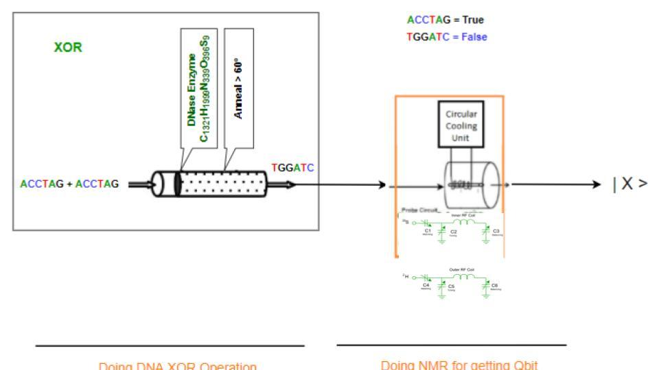

Figure 40: DNA-Quantum XOR operation

When we get the DNA sequence from DNA XOR operational gate then this sequence will go through NMR as a sample and dive into the probe. Using the NMR process at room temperature and by emitting EMR this biomolecule will get a superposition state and become a qubit.

Here, we are using DNA sequence ACCTAG = TRUE for Quantum qubit | 1 > and DNA sequence TGGATC = FLASE for Quantum qubit | 0 >. The outputs for different combinations of input are given in Table 18.

1. *DNA-Quantum Full Adder at 0-kelvin*

In Section 4.3.3, we already described DNA-Quantum Full Adder and its working procedure but here we are going to describe the design procedure of DNA-Quantum Full Adder using Cryogenic probe. The output of different combinations is also shown in Table 20.

***Design procedure:***

To design a DNA-Quantum Full Adder, we have to use DNA and Quantum operational gates so that we can operate the input DNA sequence for their corresponding outputs. The DNA operational gates will be used for receiving the input DNA sequence and the Quantum operational gates will be used to produce the final output against the corresponding set of inputs. Each time, the DNA-Quantum Full Subtractor will receive three DNA sequences as input. After operating in a certain number of DNA operational gates, the DNA sequence will be turned into corresponding Quantum qubits by using NMR process, which uses a cryogenic probe at 0-kelvin. The process of producing a quantum qubit against a DNA sequence is explained in Section 4.3.2. By using cryogenic probe at 0-kelvin and corresponding components of NMR, a qubit can reach into the excited state or grounded state. To find the qubit into an excited state one has to emit EMR. After processing through the NMR, a DNA sequence converted into corresponding quantum qubits and outputs are received. Here, Figure 41 describes DNA-Quantum Full Adder by using DNA and Quantum operational gates.



Figure 41: DNA-Quantum Full Adder at 0-kelvin

From the figure, we find that the DNA-Quantum Full Adder consists of three DNA operational gates and two Quantum operational gates. Here, two AND and one XOR is used as DNA operational gates and further one XOR and one OR Quantum operational gates is used.

1. *DNA-Quantum XOR Full Subtractor at 0-kelvin*

In Section 4.3.2, we already described DNA-Quantum Full Subtractor and its working procedure but here we are going to describe the design procedure of DNA-Quantum Full Subtractor using Cryogenic probe at 0-kelvin. The output of different combinations is also shown in Table 21.

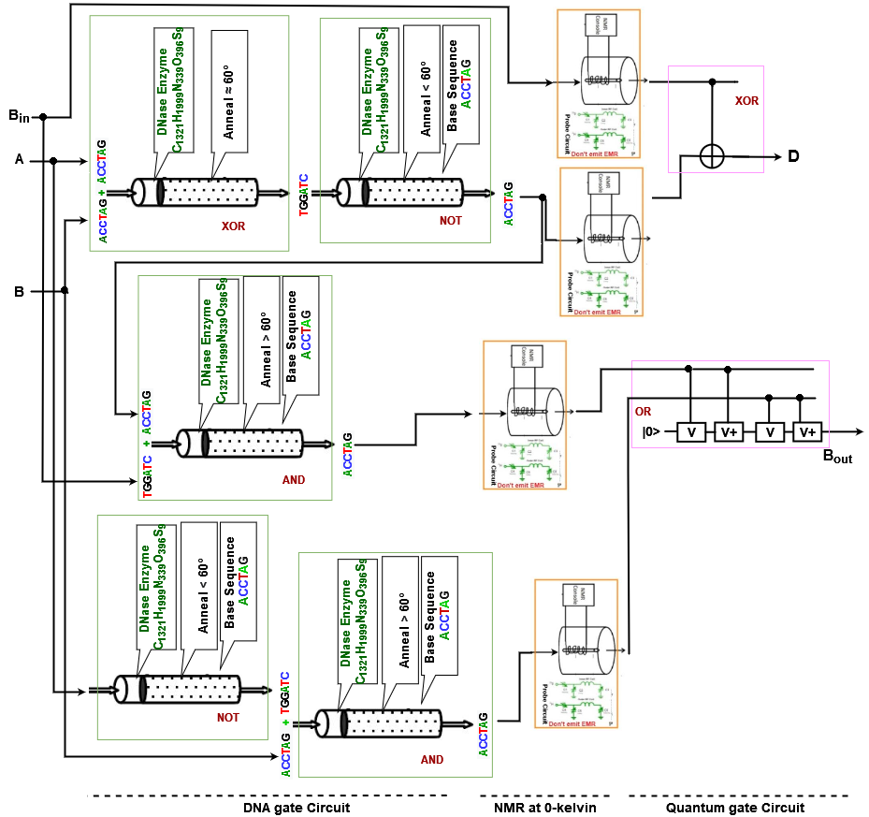

Figure 42: DNA-Quantum Full Subtractor at 0-kelvin

To design a DNA-Quantum Full Subtractor, we have to use DNA and Quantum operational gates so that we can operate the input qubit for their corresponding outputs. The DNA operational gates will be used for receiving the input DNA sequence and the Quantum operational gates will be used to produce the final output against the corresponding set of inputs. Each time, the DNA-Quantum Full Subtractor will receive three DNA sequences as input.

After operating in a certain number of DNA operational gates, the DNA sequence will be turned into corresponding Quantum qubits by NMR by using Cryogenic probe at 0-kelvin. The process of producing a Quantum qubit against DNA sequence is explained in Section 4.3.2. By using Cryogenic probe at 0-kelvin and corresponding components of NMR, the neutral qubit goes to an excited state for emitting EMR. Then the Quantum qubit is processed through Quantum operational gates and outputs are received. Here, Figure 42 describes DNA-Quantum Full Subtractor using DNA and Quantum operational gates.

From the figure, we find that the DNA-Quantum Full Subtractor consists of three DNA operational gates and two Quantum operational gates. Here, two AND and one XOR is used as DNA operational gates and further one XOR and one OR Quantum operational gates is used.

1. *DNA-Quantum 2 to 1 Multiplexer at 0-kelvin*

In Section 4.3.2, we already described DNA-Quantum 2 to 1 Multiplexer and its working procedure but here we are going to describe the design procedure of DNA-Quantum Multiplexer using Cryogenic probe at 0-kelvin. The output of different combinations is also shown in Table 22.

To design a DNA-Quantum 2 to 1 Multiplexer, we have to use DNA and Quantum operational gates so that we can operate the input DNA sequence for their corresponding outputs. The DNA operational gates will be used for receiving the input sequence and the Quantum operational gates will be used to produce the final output against the corresponding set of inputs. Each time, the DNA -Quantum Multiplexer will receive three DNA sequences as input. After operating in a certain number of DNA operational gates, the sequence will be turned into corresponding quantum qubits by using NMR. The NMR process will be operated by using a Cryogenic probe at 0-kelvin. The process of producing a quantum qubit against a DNA sequence is explained in Section 4.3.2. By using Cryogenic probe at 0-kelvin and corresponding components of NMR, the grounded qubit turns into super-positioned. Then the Quantum qubit is processed through Quantum operational gates and outputs are received. Here, Figure 43 describes Quantum-DNA Multiplexer using DNA and Quantum operational gates.

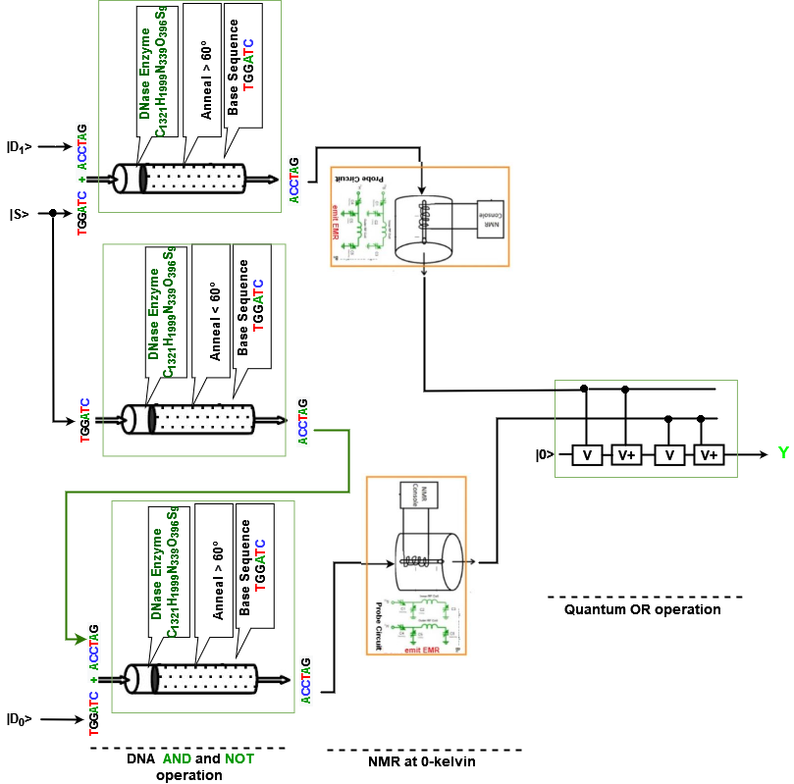

Figure 43: DNA-Quantum 2 to 1 Multiplexer at 0-kelvin

From the figure, we find that the DNA-Quantum 2 to 1 Multiplexer consists of three DNA operational gates and one Quantum operational gates. Here, two AND, one NOT is used as DNA operational gates and further one OR Quantum operational gates is used.

### 4.4 Summary

Quantum computer calculations are especially promising for analyzing or simulating extremely complicated processes with large volumes of data. Natural science fields, in particular, see significant potential here, in addition to digital marketing. Quantum computers may help researchers gain a better and more detailed understanding of how specific particles, components, and processes interact in live cells. However, there are possible medical applications. Most importantly, experts believe quantum computers will advance artificial intelligence (AI) significantly. These could then safely and reliably take over tasks such as data evaluation or forecasting in the future.

Furthermore, DNA computing is a new technology that uses DNA molecules to create computers that are quicker than the most powerful human-built computers on the market. The DNA computers of the future will be able to work in a massive parallel fashion, completing several calculations at the same time. In practically every sector, DNA computers have made significant development.

To advance computation, we can make or use DNA-Quantum computing systems, which will merge all the advantages of both DNA computing and Quantum computing. In DNA-Quantum computing, input data is in quantum qubit and the output is in DNA sequence. It uses NMR to convert DNA sequences into quantum qubits. Again, in Quantum-DNA computing, input data is in DNA sequences and provided output is in quantum qubits. Quantum-DNA uses NMR relaxation to convert quantum qubits into DNA sequences. We have used different types of operation as Full Adder, Half Subtractor, Full Subtractor, Multiplier, Parity checker and Multiplexer to show both DNA-Quantum and Quantum-DNA computing processes.

### Reference:

1. Takahashi, Y., & Tani, S. (2021). Power of uninitialized qubits in shallow quantum circuits. *Theoretical Computer Science*, *851*, 129-153.
2. Anders, J., Oi, D. K., Kashefi, E., Browne, D. E., & Andersson, E. (2010). Ancilla-driven universal quantum computation. *Physical Review A*, *82*(2), 020301.
3. Auguin, D., Catherinot, V., Malliavin, T. E., Pons, J. L., & Delsuc, M. A. (2003). Superposition of chemical shifts in NMR spectra can be overcome to determine automatically the structure of a protein. *Spectroscopy*, *17*(2, 3), 559-568.
4. Hobo, F., Takahashi, M., & Maeda, H. (2009). S 33 NMR cryogenic probe for taurine detection. *Review of Scientific Instruments*, *80*(3), 036106.
5. Jones, J. A. (2001). Quantum computing and nuclear magnetic resonance. *PhysChemComm*, *4*(11), 49-56.
6. Kodibagkar, V. D., & Conradi, M. S. (2000). Remote tuning of NMR probe circuits. *Journal of Magnetic Resonance*, *144*(1), 53-57.
7. Marx, R., Fahmy, A. F., Myers, J. M., Bermel, W., & Glaser, S. J. (2000). Approaching five-bit NMR quantum computing. *Physical Review A*, *62*(1), 012310.

# Chapter V

## Data Management

### 5.1 **Introduction**

Quantum computing is a branch of computing that focuses on improving computer technology using quantum theory's principles and postulates (which emphasizes the behavior of energy and material on the atomic and subatomic levels). Quantum computing uses quantum qubits rather than binary bits. It supplies subatomic particles with the one-of-a-kind ability to exist in several states (i.e., a 1 and a 0 at the same time). DNA Computing is another advanced computing approach that uses living molecules rather than regular silicon chips to execute computations. The four-character genetic alphabet (A [adenine], G [guanine], C [cytosine], and T [thymine]) is used in DNA computing instead of the binary alphabet (1 and 0) utilized by standard computers. Small DNA molecules of any arbitrary sequence may be manufactured to order any data, which can solve memory limitation problems for any computing.

Both quantum and DNA computing approaches can be used to accomplish operations at a very high speed and efficiency. There is a critical issue that occurs when merging both computing systems for a single activity. According to IBM, quantum computing is so quick that the system completed a theoretically defined computation in 200 seconds that would take the world's most powerful supercomputer 10,000 years to complete. Quantum computers are 158 million times quicker than the world's fastest supercomputer as a result of this. As a result, quantum operations produce instantaneous results. However, DNA procedures take a long time to prepare. As a result, the quantum computer's output qubits cannot be instantly inserted into the DNA system. As a result, when working with the Quantum-DNA system, we need a temporary storage device or system where the qubits may be held for a very short time. So, a Quantum Cache memory is needed to operate a Quantum and DNA computing circuit for its operation, which can store data for a short amount of time and can pass it to another.

### 5.2 Basic Definition

Cache memory is a supplementary memory system that temporarily stores frequently used instructions and data for quicker processing. It is an extremely fast memory type that holds frequently requested data and instructions so that they are immediately available for further processing. In most microprocessors, Static Random-Access Memory (SRAM) is used as cache memory as SRAM has a very high speed. Due to this high speed, we can use cache memory to store data temporarily, which will be designed for the quantum computer.

We can design a cache memory using the D flip-flops which will create a one-bit SRAM along with *Read/Write* and *select* bit as input. A Delay flip flop of D flip flop is an electronic circuit used to delay the change of state of its output signal (Q) until the next rising edge of a clock timing input signal occurs. Here Figure 1 shows the logic for a D flip-flop. Further Figure 2 shows the circuit diagram of Quantum D flip-flop.

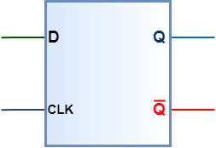

**Figure 2:** Logic symbol of D flip-flop

D flip-flip works on two states, SET and RESET. The following truth table will show the operations of a D flip-flop.

Table 1: Input output table of D flip flop.

|  |  |  |  |
| --- | --- | --- | --- |
| **|D>** | **|CLK>** | **|Q>** | **|** |
| |0> | |1> | |0> | |1> |
| |1> | |1> | |1> | |0> |
| X | 0 | Q | $$\underline{Q}$$ |

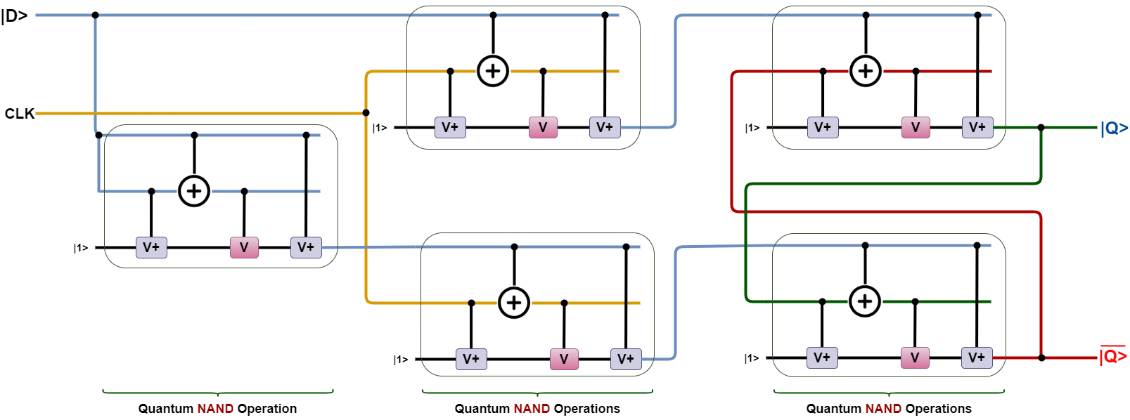

**Figure 2:** Circuit Diagram of Quantum D Flip-Flop

***Design Procedure:***

Cache memory can be used in the quantum system due to its speed and reliability. It can pass and get data very frequently. The mapping and swapping techniques in the cache memory are much optimized. We already knew that cache memory is nothing but SRAM which is made out of D flip-flops and other gates. Figure 2 describes the design of D flip-flop, which needs two inputs |D> and |CLK> pulse.

To design the quantum D flip-flop, we used 5 quantum NAND operations including a clock pulse. Here, |D> is the quantum qubits that are |0> and |1>. When CLK pulse is 1 then the quantum D flip-flop transfers the |D> input to output |Q> and if the CLK pulse is 0, then the output remains unchanged.

**5.2.1 Quantum 1-qubit Cache memory**

We are going to design a one-bit quantum cache memory using the previously designed quantum D flip-flop. The circuit diagram of the quantum one-qubit cache memory can be shown in Figure 3.

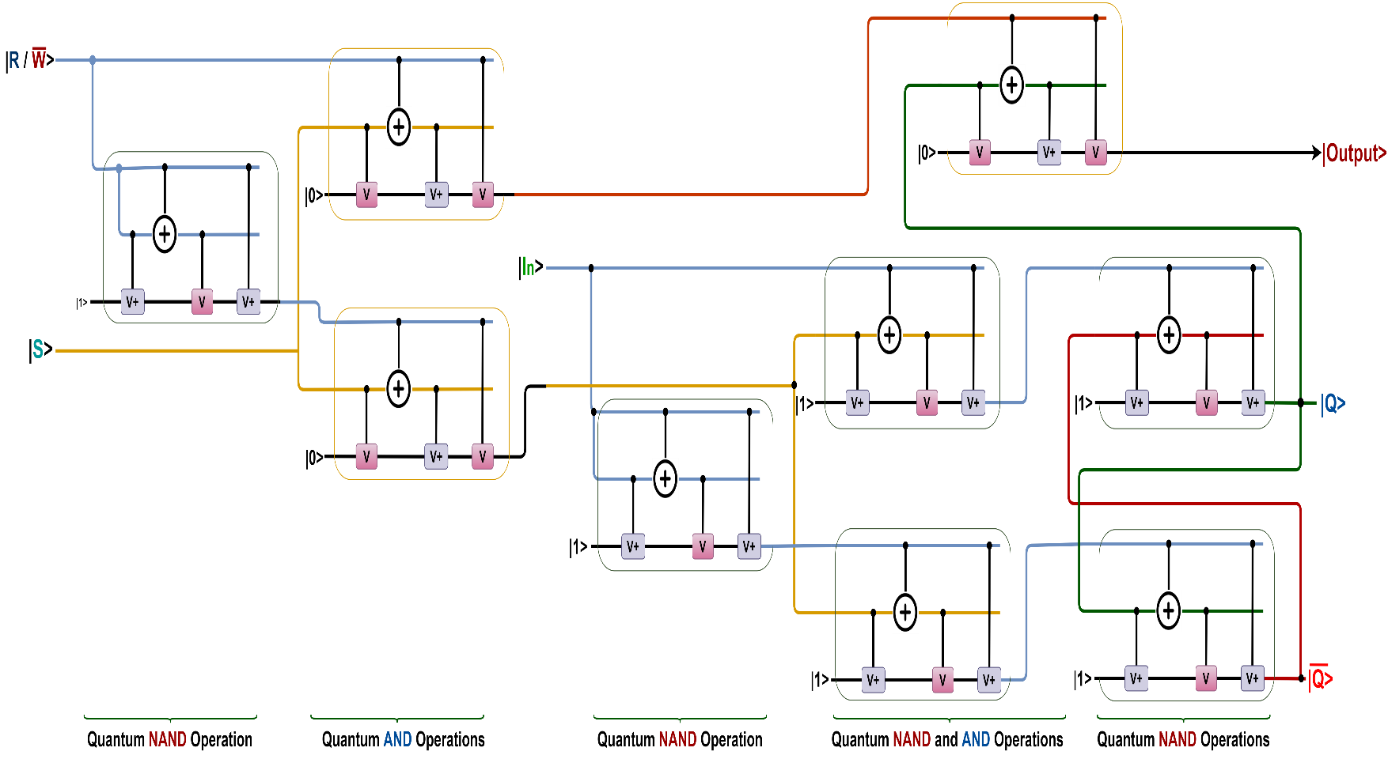

**Figure 3:** The circuit diagram of one-bit quantum cache memory

The circuit of one-bit quantum cache memory contains 6 quantum NAND and 3 quantum AND operations. Again, | R/ > = |1> indicates the READ operation and | R/ > = |0> indicates the WRITE operation. Here, |S> indicates the select qubit where |S> = |1> means the memory is selected.

**5.2.2 Quantum 8-qubit Cache memory**

We can form a 4x2 quantum cache memory using 8 quantum cache memory cells (1-qubit quantum cache memory). Figure 4 shows a 4x2 quantum cache memory that contains 8 quantum cache memory cells, providing 2-qubit output and four locations (00, 01, 10, 11).

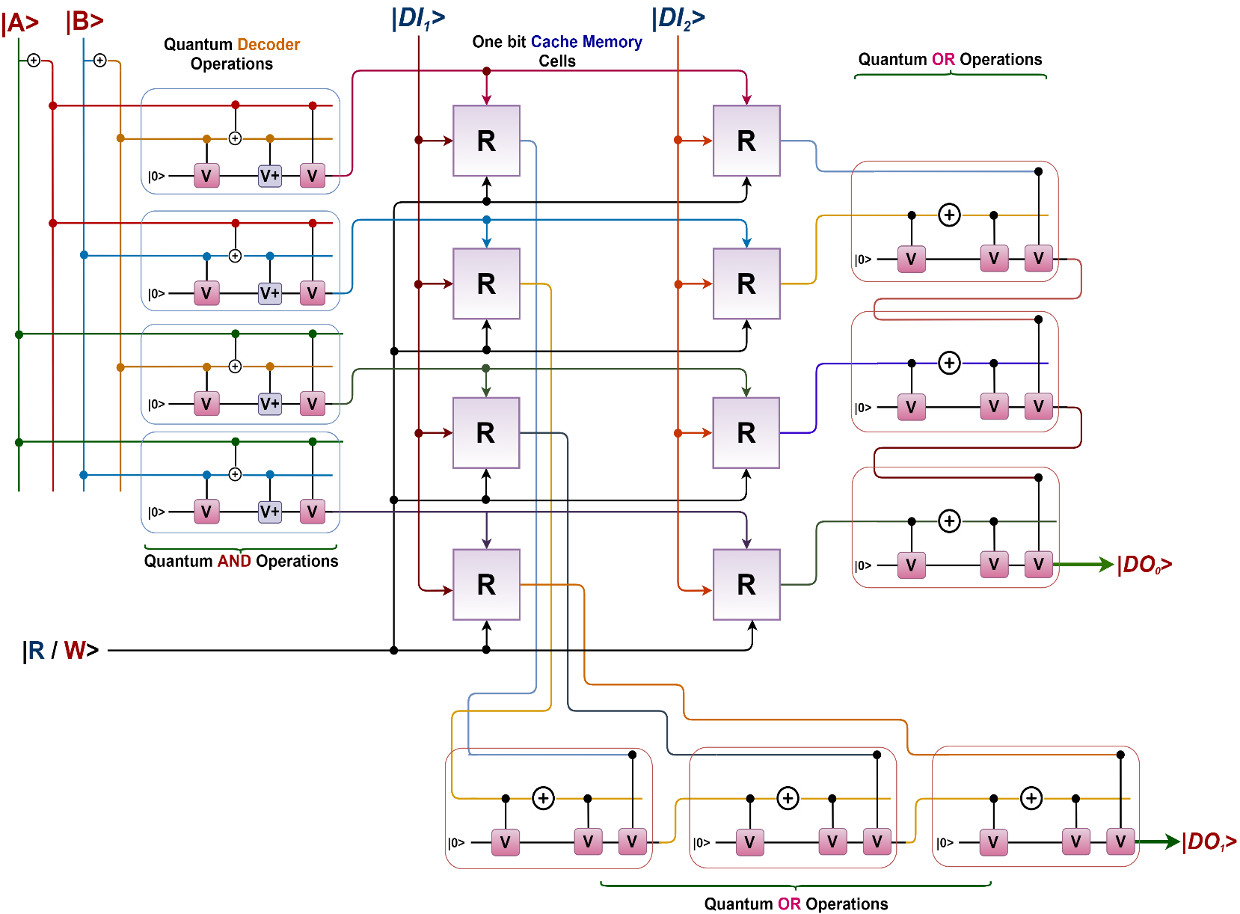

Figure 4: The circuit diagram of Quantum 4x2 Cache Memory

The quantum 4x2 cache memory contains a quantum 2x4 decoder which decodes the input qubits into 4 output qubits. Here, R indicates the quantum cache memory cell. The circuit of the quantum 4x2 cache memory includes a 2x4 decoder, 8 quantum cache memory cells, 6 quantum OR operations, where inputs are two qubits and |R/ $\underline{W}$ > signal.

***Working Procedure of the Quantum Cache Memory:***

Figure 4 shows a 4 x 2 quantum cache memory. It includes 8 quantum cache memory cells providing 2-qubit output and 4 locations. The cache memory contains a 2 x 4 quantum decoder and 8 quantum cache memory cells implemented with quantum D flip-flops and quantum gates. The four locations (00, 01, 10, 11) in the cache memory are addressed by 2 qubits (A1, A0). In order to read from location 00, the address A1A0 = 00 and |R/> = |1>. The decoder selects |0>, high. |R/ $\underline{W}$ > = 1 will apply 0 at the clock inputs of the two quantum cache memory cells of the top row and will apply 1 at the inputs of the output quantum AND operations, thus transferring the outputs of the two quantum D flip-flops to the inputs of the two quantum OR operations. The other inputs of the quantum OR operations will be 0.

Thus, the outputs of the two quantum cache memory cells of the top row will be transferred to DO1, and DO0, performing a READ operation.

On the other hand, consider a WRITE operation; the 2-qubit data to be written is presented at |DI1> |DI0>. Suppose |A1> |A0> = |0> |0>. The top row is selected (00 = 1). Input bits at |DI1> and |DI0> will respectively be applied at the inputs of the D flip-flops of the top row. Because |R/> = |>, the clock inputs of both the quantum D flip-flops of the top row are |1>; thus, the D inputs are transferred to the outputs of the flip-flops.

Therefore, data at DI1 DI0 will be written into the Quantum Cache Memory. In addition, the block diagram for a quantum cache memory can be shown as Figure 5.

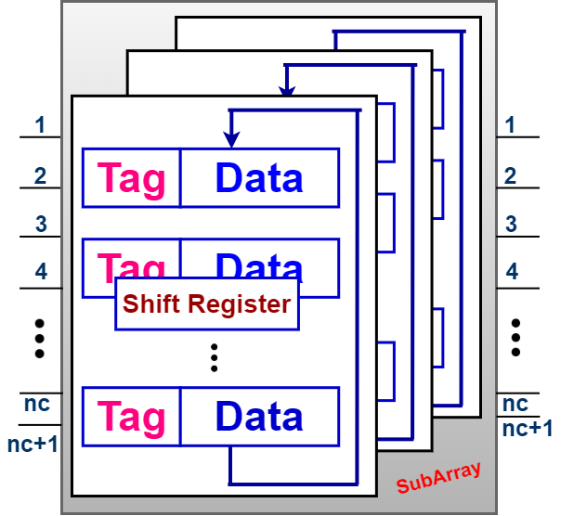

**Figure 5:** Block Diagram of a Quantum Cache Memory

### 5.3 Data management in Quantum-DNA circuits

According to quantum computing, quantum computation is faster than classical computation systems. Quantum computers are also more powerful than supercomputers in terms of computing. They are thousands of times faster than regular computers and supercomputers at processing data. Quantum computers can execute calculations that would take a regular computer 1000 years to complete in a matter of seconds. On the other hand, the use of DNA strands to compute has led to high parallel computation that makes up for the slow processing of the chip. Memory space required by DNA is around 1 bit per cubic nanometer which is much less when compared to regular storage systems Consumption of power is almost nil as the chemical bonds in DNA produce energy to build or repair new strands. So, for finding a super faster computation system with huge memory, we can develop a Quantum-DNA computation system. This Quantum-DNA computation system can merge all advantages of quantum computing and DNA computing.

In a Quantum-DNA computing system, input will be received as qubit and after performing in a certain number of quantum operational gates these qubits will be turned into DNA sequences by NMR relaxation.

#### 5.3.1 Data Management in Quantum-DNA Full Adder

Full Adder is the adder which adds three inputs and produces two outputs. The first two inputs are A and B and the third input is an input carry as Cin. The output carry is designated as Cout and the normal output is designated as S which is Sum. A Full Adder logic is designated in such a manner that can take eight inputs together to create a qubit adder and cascade the carry qubit from one adder to the another. To create a Full Adder, one OR, two AND and two XOR operational gates are required. Figure 6 describes the Quantum-DNA circuit of the Full Adder.

***Design procedure:***

To design a Quantum-DNA Full Adder we have to use Quantum and DNA operational gates so that we can operate the input qubit for their corresponding outputs. The Quantum operational gates will be used for receiving the input qubits and the DNA operational gates will be used to produce the final output against the corresponding set of inputs. Each time, the Quantum-DNA Full adder will receive three qubits as input. After operating in a certain number of Quantum operational gates, the qubit will be stored in Cache memory. To store 4 qubits, we need a 16x4 Quantum Cache memory.

After getting the qubits from cache memory, it will be turned into corresponding DNA sequence by using NMR relaxation room temperature probe. By using a room temperature probe and corresponding components of NMR relaxation, the excited qubit turns into ground state and produces a DNA sequence. Then the DNA sequence is processed through DNA operational gates and outputs are received. Here, Figure 5 describes Quantum-DNA Full adder using Quantum and DNA operational gates.

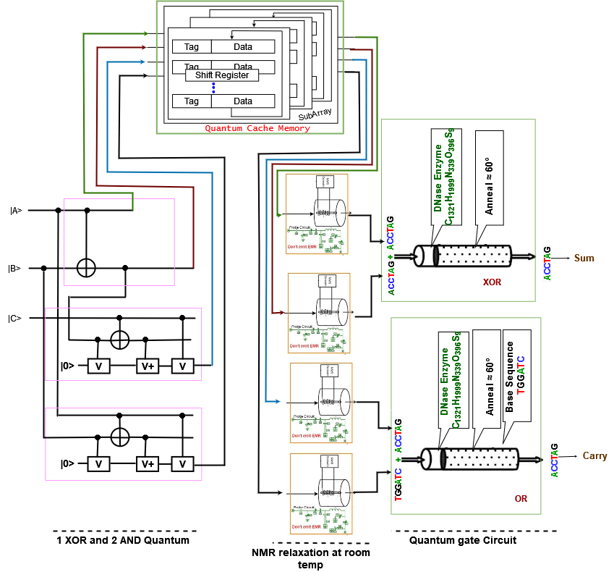

**Figure 5:** Circuit of Quantum-DNA Full Adder with Cache Memory

From the figure, we find that the Quantum-DNA Full Adder consists of three Quantum operational gates, two DNA operational gates and a 16x4 cache memory. Here, two AND and one XOR is used as Quantum operational gates and further one XOR and one OR DNA operational gates is used.

***Working procedure:***

The working procedure of the Quantum-DNA Full adder is given below for each pattern of input qubits. Here, we are using DNA sequence ACCTAG = TRUE for Quantum qubit | 1 > and DNA sequence TGGATC = FLASE for Quantum qubit | 0 >.

To store qubits in cache memory, we need 4 locations select line (A, B, C and D), one CLK input line, one |R/> | input line and 4 input qubit lines in cache memory (DI1, DI2, DI3, and DI4). The output from the cache memory will be DO0, DO1, DO2, and DO3.

The working procedure of the Quantum-DNA Full Adder within Cache memory is given below for one pattern of input qubits. Here, we are finding the input of cache memory from the quantum gates as follows:

1. For input A, B, C = 0,

**DI1** = A = 0

**DI2** = Quantum XOR (A, B)

= Quantum XOR (0, 0)

= 0

**DI3** = Quantum XOR (XOR (A, B), C)

= Quantum XOR (XOR (0, 0), 0)

= Quantum XOR (0, 0)

= 0

**DI4** = Quantum AND (A, B)

= Quantum AND (0, 0)

= 0

Output of Quantum cache memory will be converted into DNA sequence using NMR relaxation. For qubit |0> DNA sequence is TGGATC.

**Sum** = DNA XOR (DO0, DO1)

= DNA XOR (TGGATC, TGGATC)

= TGGATC

**Carry** = DNA OR (DO2, DO3)

= DNA XOR (TGGATC, TGGATC)

= TGGATC

#### 5.3.2 Data Management in Quantum-DNA Multiplier

A binary multiplier is a combinational logic circuit or digital device used for multiplying two binary numbers. The two numbers are more specifically known as multiplicand and multiplier and the result is known as a product. The multiplicand and multiplier can be of various bit sizes. The product’s bit size depends on the bit size of the multiplicand & multiplier. The bit size of the product is equal to the sum of the bit size of multiplier multiplicand. To create a Multiplication circuit, six AND and two XOR operational gates are required. Figure 6 describes the Quantum-DNA circuit of the 2-bit multiplication.

***Design procedure:***

To design a Quantum-DNA Multiplier we have to use Quantum and DNA operational gates so that we can operate the input qubit for their corresponding outputs. The Quantum operational gates will be used for receiving the input qubits and the DNA operational gates will be used to produce the final output against the corresponding set of inputs. Each time, the Quantum-DNA Multiplier will receive four qubits as input. After operating in a certain number of Quantum operational gates, the qubit will be stored in Cache memory. To store 4 qubits, we need a 16x4 Quantum Cache memory.

After getting the qubits from cache memory, it will be turned into corresponding DNA sequence by using NMR relaxation room temperature probe. By using a room temperature probe and corresponding components of NMR relaxation, the excited qubit turns into ground state and produces a DNA sequence. Then the DNA sequence is processed through DNA operational gates and outputs are received. Here, Figure 6 describes Quantum-DNA Multiplier using Quantum and DNA operational gates.

From the figure, we find that the Quantum-DNA Multiplier consists of four Quantum operational gates, four DNA operational gates and a 16x4 cache memory. Here, four AND operational gates are used in Quantum operation and storing qubits in Cache memory and further two XOR and two AND DNA operational gates to provide the output.

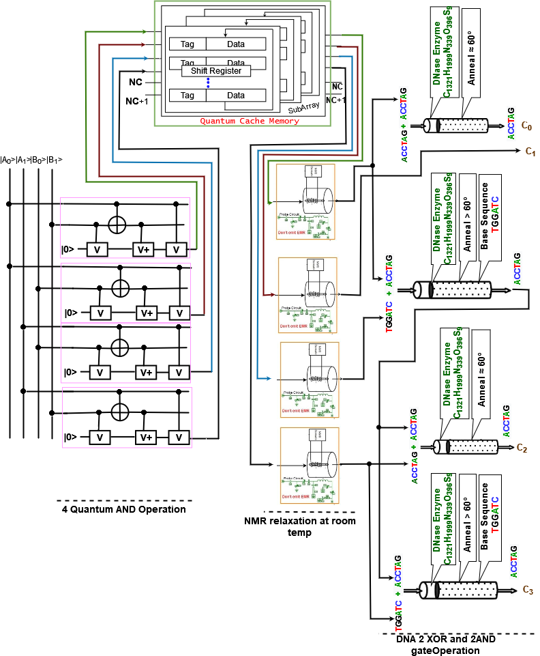

**Figure 6:** Circuit of Quantum-DNA Multiplier with Cache Memory

***Working procedure:***

The working procedure of the Quantum-DNA Multiplier is given below for each pattern of input qubits. Here, we are using DNA sequence ACCTAG = TRUE for Quantum qubit | 1 > and DNA sequence TGGATC = FLASE for Quantum qubit | 0 >.

To store qubits in cache memory, we need 4 locations select line (A, B, C and D), one CLK input line, one |R/> | input line and 4 input qubit lines in cache memory (DI1, DI2, DI3, and DI4). The output from the cache memory will be DO0, DO1, DO2, and DO3.

The working procedure of the Quantum-DNA Multiplier within Cache memory is given below for one pattern of input qubits. Here, we are finding the input of cache memory from the quantum gates as follows:

1. For input A0, A1, B0, B1 = 0,

**DI1** = Quantum AND (A0, B1)

= Quantum AND (0, 0)

= 0

**DI2** = Quantum AND (A0, B0)

= Quantum AND (0, 0)

= 0

**DI3** = Quantum AND (A1, B0)

= Quantum AND (0, 0)

= 0

**DI4** = Quantum AND (A1, B1)

= Quantum AND (0, 0)

= 0

Output of Quantum cache memory will be converted into DNA sequence using NMR relaxation at room temperature. For qubit |0> DNA sequence is TGGATC.

**C0** = DNA XOR (DO0, DO2)

= DNA XOR (TGGATC, TGGATC)

= TGGATC

**C1** = TGGATC

**C2** = DNA XOR (AND (DO1, DO2), DO3)

= DNA XOR (AND (TGGATC, TGGATC), TGGATC)

= DNA XOR (TGGATC, TGGATC)

= TGGATC

**C3** = DNA XOR (AND (DO1, DO2), DO3)

= DNA XOR (AND (TGGATC, TGGATC), TGGATC)

= DNA XOR (TGGATC, TGGATC)

= TGGATC

#### 5.3.3 Data Management in Quantum-DNA Half Subtractor

A Half Subtractor is a type of subtractor, an electronic circuit that performs the subtractions of numbers. The half subtractor is able to subtract two single digits and provide the output plus a borrow value. It has two inputs, called A and B, and two outputs D (difference) and B (borrow). Quantum-DNA Half Subtractor will subtract two qubits from the quantum digit |0>, and |1> and produce two outputs as DNA difference |D> and DNA borrow sequence |B>. The Quantum-DNA circuit for the half subtractor is shown in figure 7.

***Design procedure:***

To design a Quantum-DNA Half Subtractor, we have to use Quantum and DNA operational gates so that we can operate the input qubit for their corresponding outputs. The Quantum operational gates will be used for receiving the input qubits and the DNA operational gates will be used to produce the final output against the corresponding set of inputs. Each time, the Quantum-DNA Half Subtractor will receive two qubits as input. After operating in a certain number of Quantum operational gates, the qubit will be stored in Cache memory. To store 3 qubits, we need a 8x3 Quantum Cache memory.

After getting the qubits from cache memory, it will be turned into corresponding DNA sequence by using NMR relaxation room temperature probe. By using a room temperature probe and corresponding components of NMR relaxation, the excited qubit turns into ground state and produces a DNA sequence. Then the DNA sequence is processed through DNA operational gates and outputs are received. Here, Figure 7 describes Quantum-DNA Half Subtractor using Quantum and DNA operational gates.

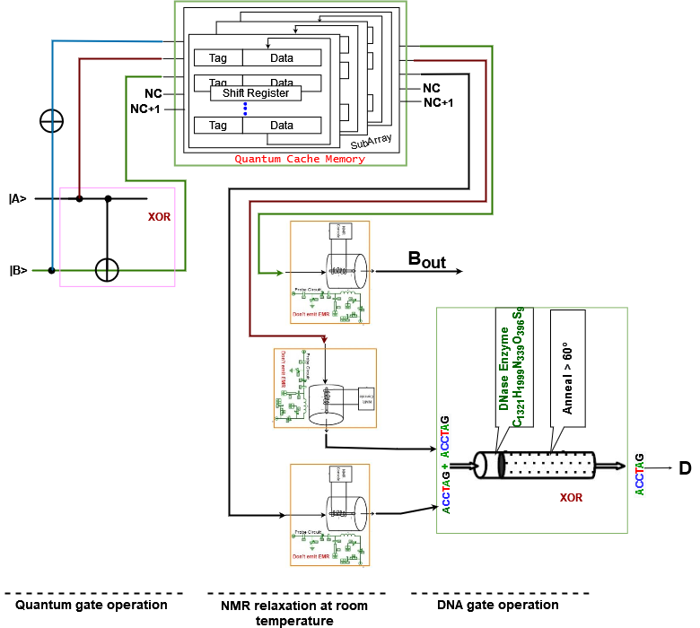

**Figure 7:** Circuit of Quantum-DNA Half Subtractor with Cache Memory

From the figure, we find that the Quantum-DNA Multiplier consists of two Quantum operational gate, one DNA operational gate and a 8x3 cache memory. Here, one XOR, one NOT operational gate is used in Quantum operation and storing qubits in Cache memory and further one XOR DNA operational gates to provide the output.

***Working procedure:***

The working procedure of the Quantum-DNA Half Subtractor is given below for each pattern of input qubits. Here, we are using DNA sequence ACCTAG = TRUE for Quantum qubit | 1 > and DNA sequence TGGATC = FLASE for Quantum qubit | 0 >.

To store qubits in cache memory, we need 3 locations select line (A, B and C), one CLK input line, one |R/> | input line and 3 input qubit lines in cache memory (DI1, DI2 and DI3). The output from the cache memory will be DO0, DO1, and DO2.

The working procedure of the Quantum-DNA Half Subtractor within Cache memory is given below for one pattern of input qubits. Here, we are finding the input of cache memory from the quantum gates as follows:

1. For input A = 1, B= 0,

**DI1** = Quantum NOT (B)

= Quantum NOT (0)

= 1

**DI2** = A = 1

**DI3** = Quantum XOR (A, B)

= Quantum AND (1, 0)

= 1

Output of Quantum cache memory will be converted into DNA sequence using NMR relaxation at room temperature. For qubit |1> DNA sequence is ACCTAG.

**Bout** = DO0 = ACCTAG.

**D** = DNA XOR (DO1, DO2)

= DNA XOR (ACCTAG, ACCTAG)

= TGGATC

#### 5.3.4 Data Management in Quantum-DNA Full Subtractor

A full subtractor is a combinational circuit that performs subtraction of two qubits, one is minuend and other is subtrahend, taking into account borrow of the previous adjacent lower minuend qubit. This circuithas three inputs and two outputs. The three inputs A, B and Bin, denote the minuend, subtrahend, and previous borrow, respectively. The two outputs, D and Bout represent the difference and output borrows, respectively. To create a Full Subtractor, one OR, two AND, two OR and 2 XOR operational gates are required. Figure 8 describes the Quantum-DNA circuit of Full Subtractor.

***Design procedure:***

To design a Quantum-DNA Full Subtractor we have to use Quantum and DNA operational gates so that we can operate the input qubit for their corresponding outputs. The Quantum operational gates will be used for receiving the input qubits and the DNA operational gates will be used to produce the final output against the corresponding set of inputs. Each time, the Quantum-DNA Full Subtractor will receive three qubits as input. After operating in a certain number of Quantum operational gates, the qubit will be stored in Cache memory. To store 4 qubits, we need a 16x4 Quantum Cache memory.

After getting the qubits from cache memory, it will be turned into corresponding DNA sequence by using NMR relaxation room temperature probe. By using a room temperature probe and corresponding components of NMR relaxation, the excited qubit turns into ground state and produces a DNA sequence. Then the DNA sequence is processed through DNA operational gates and outputs are received. Here, Figure 8 describes Quantum-DNA Full Subtractor using Quantum and DNA operational gates.

From the figure, we find that the Quantum-DNA Full Subtractor consists of four Quantum operational gates, two DNA operational gates and a 16x4 cache memory. Here, two AND, one XOR and one NOT Quantum operational gate are used in Quantum operation and storing qubits in Cache memory and further one XOR and one OR DNA operational gates to provide the output.

***Working procedure:***

The working procedure of the Quantum-DNA Full Subtractor is given below for each pattern of input qubits. Here, we are using DNA sequence ACCTAG = TRUE for Quantum qubit | 1 > and DNA sequence TGGATC = FLASE for Quantum qubit | 0 >.

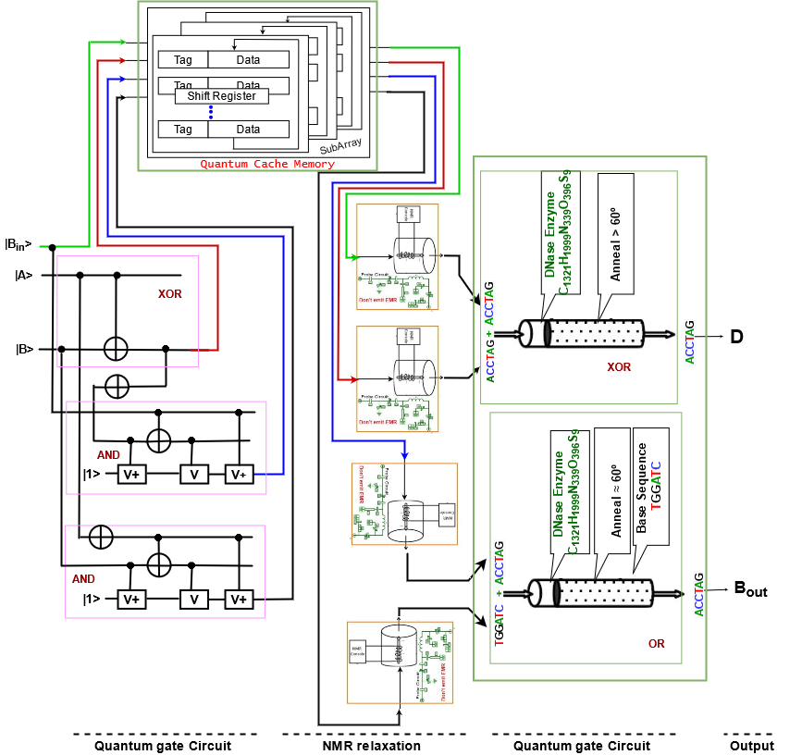

**Figure 8:** Circuit of Quantum-DNA Full Subtractor with Cache Memory

To store qubits in cache memory, we need 4 locations select line (A, B, C and D), one CLK input line, one |R/> | input line and 4 input qubit lines in cache memory (DI1, DI2, DI3, and DI4). The output from the cache memory will be DO0, DO1, DO2, and DO3.

The working procedure of the Quantum-DNA Full Subtractor within Cache memory is given below for one pattern of input qubits. Here, we are finding the input of cache memory from the quantum gates as follows:

1. For input A, B, Bin = 1, 1, 0,

**DI1** = Bin = 0

**DI2** = Quantum XOR (A, B)

= Quantum AND (1, 1)

= 1

**DI3** = Quantum AND (NOT (XOR (A, B), B)

= Quantum AND (NOT (XOR (1, 1), 1)

= Quantum AND (NOT (0), 1)

= Quantum AND (1, 1)

= 1

**DI4** = Quantum AND (NOT (A), B)

= Quantum AND (NOT (1), 1)

= Quantum AND (0, 1)

= 0

Output of Quantum cache memory will be converted into DNA sequence using NMR relaxation at room temperature. For qubit |0> DNA sequence is TGGATC and for |1> DNA sequence is ACCTAG.

**Bout** = DNA OR (DO2, DO3)

= DNA OR (ACCTAG, TGGATC)

= ACCTAG

**D** = DNA XOR (DO0, DO1)

= DNA XOR (ACCTAG, ACCTAG)

= TGGATC

### 5.4 Data management in DNA-Quantum circuits

The usage of DNA strands to calculate, has resulted in high parallel computation, which compensates for the chip's slow processing. When compared to traditional storage systems, DNA requires just about 1 bit per cubic nanometer of memory space. The chemical interactions in DNA provide energy to make or repair new strands, therefore there is essentially no power use. On the other hand, quantum computation, according to quantum computing, is faster than traditional processing systems. Quantum computers are also more powerful in terms of computation than supercomputers. They process data thousands of times faster than normal computers and supercomputers. As a result, we may create a DNA-Quantum computation system to find a super-fast computation system with a lot of memory. This DNA-Quantum computation device combines the benefits of both quantum and DNA computing.

In a DNA-Quantum computing system, input will be received in DNA sequences and after performing in a certain number of DNA operational gates these DNA sequences will be turned into quantum qubits by NMR process.

#### 5.4.1 Data Management in DNA-Quantum Full Adder

Full Adder is the adder which adds three inputs and produces two outputs. The first two inputs are A and B and the third input is an input carry as Cin. The output carry is designated as Cout and the normal output is designated as S which is Sum. A Full Adder logic is designated in such a manner that can take eight inputs together to create a qubit adder and cascade the carry qubit from one adder to the another. To create a Full Adder, one OR, two AND and two XOR operational gates are required. Figure 9 describes the DNA-Quantum circuit of the Full Adder.

***Design procedure:***

To design a DNA-Quantum Full Adder we have to use DNA and Quantum operational gates so that we can operate the input DNA sequence for their corresponding outputs. The DNA operational gates will be used for receiving the input DNA sequence and the Quantum operational gates will be used to produce the final output against the corresponding set of inputs. Each time, the DNA-Quantum Full adder will receive three DNA sequences as input. After operating in a certain number of DNA operational gates, the DNA sequence will be turned into corresponding Quantum qubits by using NMR room temperature probe. By using a room temperature probe and corresponding components of NMR, the neutralized qubit turns into the ground or excited state and produces a Quantum qubit. That qubit will be stored in Cache memory. To store 4 qubits, we need a 16x4 Quantum Cache memory.

After getting the qubits from cache memory, it will be processed through Quantum operational gates and outputs are received. Here, Figure 9 describes DNA-Quantum Full adder using DNA and Quantum operational gates.

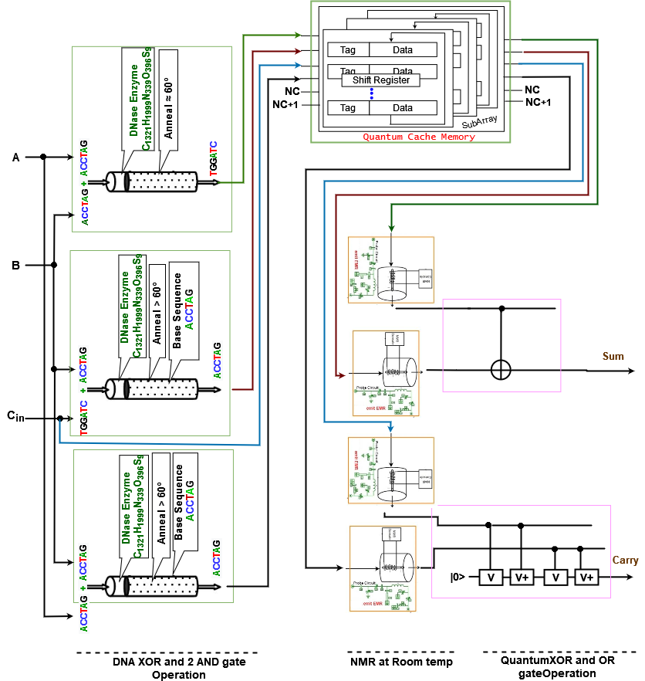

**Figure 9:** Circuit of DNA-Quantum Full Adder with Cache Memory

***Working procedure:***

The working procedure of the DNA-Quantum Full adder is given below for each pattern of input qubits. Here, we are using DNA sequence ACCTAG = TRUE for Quantum qubit | 1 > and DNA sequence TGGATC = FLASE for Quantum qubit | 0 >.

To store qubits in quantum cache memory, we need 4 locations select line (A, B, C and D), one CLK input line, one |R/> | input line and 4 input qubit lines in cache memory (DI1, DI2, DI3, and DI4). The output from the cache memory will be DO0, DO1, DO2, and DO3.

The working procedure of the DNA-Quantum Full Adder within Cache memory is given below for one pattern of input qubits. Here, we are finding the input of cache memory from the quantum gates as follows:

1. For input A, B, Cin = TGGATC,

**DI1** = DNA XOR (A, B)

= DNA XOR (TGGATC, TGGATC)

= TGGATC

**DI2** = DNA AND (Cin, B)

= DNA AND (TGGATC, TGGATC)

= TGGATC

**DI3** = Cin = TGGATC

**DI4** = DNA AND (A, B)

= DNA AND (TGGATC, TGGATC)

= TGGATC

Output of DNA operational gates will be converted into Quantum qubits using NMR at room temperature. For DNA sequence TGGATC qubit is |0>.

**Sum** = Quantum XOR (DO0, DO1)

= Quantum XOR (0, 0)

= 0

**Carry** = Quantum OR (DO2, DO3)

= DNA OR (0, 0)

= 0

#### 5.4.2 Data Management in DNA-Quantum Full Subtractor

A full subtractor is a combinational circuit that performs subtraction of two qubits, one is minuend and other is subtrahend, taking into account borrow of the previous adjacent lower minuend qubit. This circuithas three inputs and two outputs. The three inputs A, B and Bin, denote the minuend, subtrahend, and previous borrow, respectively. The two outputs, D and Bout represent the difference and output borrows, respectively. To create a Full Subtractor, one OR, two AND, two OR and 2 XOR operational gates are required. Figure 10 describes the DNA-Quantum circuit of Full Subtractor.

***Design procedure:***

To design a DNA-Quantum Full Subtractor we have to use DNA and Quantum operational gates so that we can operate the input qubit for their corresponding outputs. The DNA operational gates will be used for receiving the input DNA sequence and the Quantum operational gates will be used to produce the final output against the corresponding set of inputs. Each time, the DNA-Quantum Full Subtractor will receive three DNA sequences as input. After operating in a certain number of DNA operational gates, the DNA sequence will be turned into corresponding Quantum qubits by using NMR room temperature probe. By using a room temperature probe and corresponding components of NMR, the neutralized qubit turns into ground or excited state and produces a quantum qubit. stored in Cache memory. That qubit will be stored in quantum Cache memory. To store 4 qubits, we need a 16x4 Quantum Cache memory.

After getting the qubits from cache memory, it will be processed through DNA operational gates and outputs are received. Here, Figure 10 describes DNA-Quantum Full Subtractor using Quantum and DNA operational gates.

From the figure, we find that the DNA-Quantum Full Subtractor consists of five DNA operational gates, two quantum operational gates and a 16x4 cache memory. Here, two AND, one XOR and two NOT DNA operational gates are used in DNA operation and storing qubits in Cache memory and further one XOR and one OR Quantum operational gates are used to provide the output.

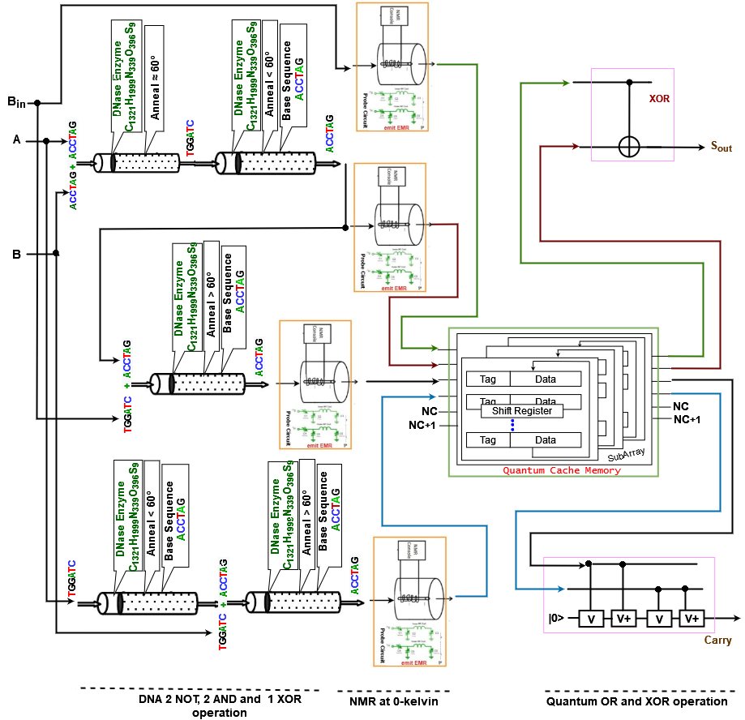

**Figure 10:** Circuit of DNA-Quantum Full Subtractor with Cache Memory

***Working procedure:***

The working procedure of the DNA-Quantum Full Subtractor is given below for each pattern of input qubits. Here, we are using DNA sequence ACCTAG = TRUE for Quantum qubit | 1 > and DNA sequence TGGATC = FLASE for Quantum qubit | 0 >.

To store qubits in cache memory, we need 4 locations select line (A, B, C and D), one CLK input line, one |R/> | input line and 4 input qubit lines in cache memory (DI1, DI2, DI3, and DI4). The output from the cache memory will be DO0, DO1, DO2, and DO3.

The working procedure of the DNA-Quantum Full Subtractor within Cache memory is given below for one pattern of input DNA sequence. Here, we are finding the input of cache memory from the quantum gates as follows:

1. For input A, B, Bin = TGGATC,

**DI1** = Bin = TGGATC

**DI2** = DNA NOT (XOR (A, B))

= DNA NOT (XOR (TGGATC, TGGATC))

= DNA NOT (TGGATC)

= DNA NOT (TGGATC)

= ACCTAG

**DI3** = DNA AND (NOT (XOR (A, B), Bin)

= DNA AND (NOT (XOR (TGGATC, TGGATC), TGGATC)

= DNA AND (NOT (TGGATC), TGGATC)

= DNA AND (ACCTAG, TGGATC)

= TGGATC

**DI4** = Quantum NOT (AND (A, B))

= Quantum NOT (AND (TGGATC, TGGATC))

= Quantum NOT (TGGATC)

= ACCTAG

Output of DNA operational gates will be converted into Quantum qubits using NMR at room temperature. For DNA sequence TGGATC qubit is |0> and for |1> DNA sequence is ACCTAG.

**Bout** = Quantum XOR (DO0, DO1)

= Quantum XOR (0, 0)

= 0

**D** = Quantum OR (DO2, DO3)

= Quantum OR (0, 0)

= 0

#### 5.4.3 Data Management in DNA-Quantum 2 to 1 Multiplexer

A multiplexer (MUX) is a device that can receive multiple input signals and synthesize a single output signal in a recoverable manner for each input signal. It is also an integrated system that usually contains a certain number of data inputs and a single output. To create a Multiplexer, one NOT, two AND, and an OR gate is required. Figure 36 describes the DNA-Quantum circuit of Multiplexer. A Multiplexer receives three inputs and produces one output containing “Y”.

***Design procedure:***

To design a DNA-Quantum Multiplexer we have to use DNA and Quantum operational gates so that we can operate the input DNA sequence for their corresponding outputs. The DNA operational gates will be used for receiving the input DNA sequence and the Quantum operational gates will be used to produce the final output against the corresponding set of inputs. Each time, the DNA- Quantum Multiplexer will receive two DNA sequences as input. After operating in a certain number of DNA operational gates, the DNA sequence will be turned into corresponding Quantum qubits by using NMR room temperature probe. By using a room temperature probe and corresponding components of NMR, the grounded qubit turns into ground or excited state and produces a quantum qubit. These qubits will be stored in Cache memory. To store 2 qubits, we need a 4x2 Quantum Cache memory.

After getting the qubits from cache memory, it will be processed through Quantum operational gates and outputs are received. Here, Figure 11 describes DNA-Quantum Multiplexer using Quantum and DNA operational gates.

From the figure, we find that the DNA-Quantum Multiplexer consists of three DNA operational gates, one Quantum operational gates and a 4x2 cache memory. Here, two AND and one NOT Quantum operational gate are used in DNA operation and storing qubits in Cache memory and further one OR Quantum operational gates to provide the output.

***Working procedure:***

The working procedure of the Quantum-DNA Multiplexer is given below for each pattern of input DNA sequence. Here, we are using DNA sequence ACCTAG = TRUE for Quantum qubit | 1 > and DNA sequence TGGATC = FLASE for Quantum qubit | 0 >.

To store qubits in cache memory, we need 4 locations select line (A and B), one CLK input line, one |R/> | input line and 2 input qubit lines in cache memory (DI1 and DI2). The output from the cache memory will be DO0 and DO1.

The working procedure of the DNA-Quantum Multiplexer within Cache memory is given below for one pattern of input DNA sequence. Here, we are finding the input of cache memory from the quantum gates as follows:

1. For input D0, S, D1 = TGGATC

**DI1** = DNA AND (S, D0)

= DNA AND (TGGATC, TGGATC)

= TGGATC

**DI2** = DNA AND (NOT (S), D1)

= DNA AND (NOT (TGGATC), TGGATC)

= DNA AND (ACCTAG, TGGATC)

= TGGATC

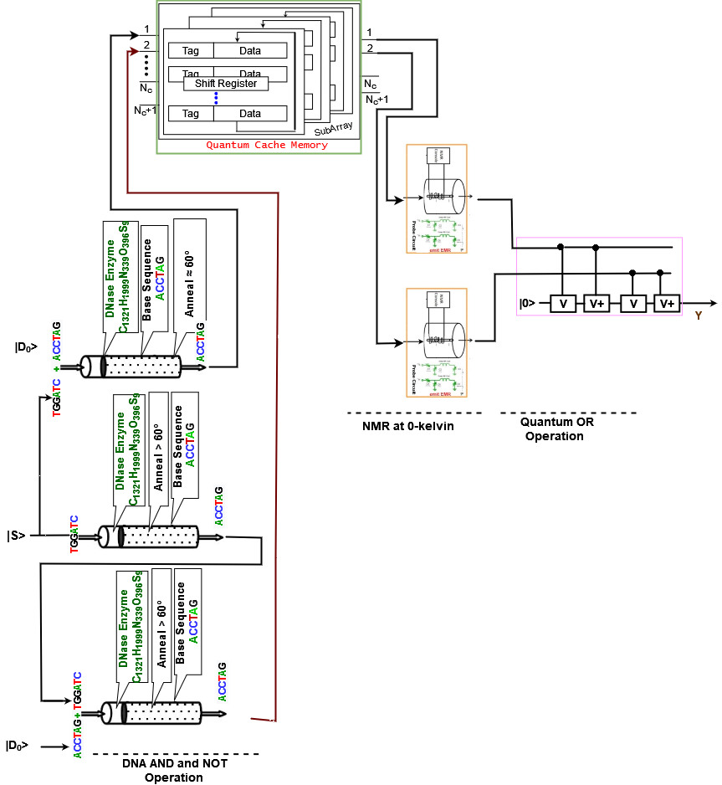

**Figure 11:** Circuit of DNA-Quantum Multiplexer with Cache Memory

Output of DNA operational gates will be converted into Quantum qubits using NMR at room temperature. For DNA sequence TGGATC qubit is |0> and for |1> DNA sequence is ACCTAG.

**Y** = Quantum OR (DO0, DO1)

= Quantum OR (0, 0)

= 0

### 5.5 Applications

This section discusses several real-world applications of DNA and quantum operations, including how they are used and how they outperform traditional computing systems. Classical computing systems may fail in certain scenarios; however, quantum and DNA computing systems can demonstrate their capacity.

***Logistics Optimization***: A wide range of companies will be able to improve their logistics and scheduling procedures related with supply-chain management thanks to improved data analysis and sophisticated modeling. The operating models must calculate and recalculate ideal routes for traffic management, fleet operations, air traffic control, shipping and allocation on a constant basis, which may have a significant impact on applications. Normally, traditional computing is employed to complete these jobs; however, some of them may become too complex for an ideal computer solution, whereas a quantum technique may be able to complete them. Quantum annealing and universal quantum computers are two common quantum techniques that can be utilized to solve such challenges. Quantum annealing is a cutting-edge optimization technology that promises to outperform regular computers. Universal quantum computers, on the other hand, are capable of addressing any form of computational issue and are not yet commercially available.

***Traveling salesman problem***: The first theory of DNA computation was proposed by Leonard Adleman in 1994. He put his experimental theory into the test with a seven-point Hamiltonian path problem or also called the traveling salesman problem. The salesman in this problem needs to find the shortest path between seven cities whose distances are known in such a way that he crosses no city twice and returns to the original city. Adleman represented each city with a short DNA sequence with about 20 bases and a complementary strand with 20 bases as the street between the cities. All the fragments are capable of linking with each other. When the fragments were put in a tube and mixed, the natural bonding tendencies of the DNA created 109 formations or solutions in less than a second. Not all were correct and he took a week to extrapolate and filter out the shortest path through various techniques. Though this solution was not ideal, this demonstration opened floodgates to a wide range of possibilities and applications.

***Scheduling***: A DNA computing-based algorithm was presented to solve the job scheduling problem. In order to explain the model with six tasks, it can be demonstrated the working operations, mimicking the method used for the Hamiltonian Path problem. This however was not the first time, Watada in early 2000 used DNA algorithms to work out elevator schedule systems and rearrangement of Flexible Manufacturing System. However, due to a lack of theoretical base, only medium-sized tasks were taken into consideration.

***Clustering***: Clustering deals with deriving highly meaningful relationships in a complex collection of data by creating a structure using various concepts and algorithms. DNA- based clustering involves using strands to assign edges and vertices. Iterative calculations are performed for every produced cluster to improve quality. This method is of particular interest when dealing with large heterogeneous data with an unknown number of clusters. It helps in reducing the time complexity by high parallelism features of DNA.

***Weather Forecasting***: Weather affects over 30% of US GDP ($6 trillion) directly or indirectly, affecting food production, transportation, and retail trade, among other things. The capacity to better predict the weather would be extremely beneficial in a variety of sectors, not to mention giving people more time to prepare for disasters. While scientists have long desired to do this, the equations controlling such processes involve a large number of variables, making traditional simulation time-consuming. "Using a classical computer to undertake such analysis might take longer than it takes for the actual weather to evolve!", said quantum researcher Seth Lloyd. This prompted Lloyd and colleagues at MIT to demonstrate that the weather equations have a hidden wave nature that can be solved by a quantum computer. Quantum computers could aid in the development of improved climate models, allowing us to gain a better understanding of how humans affect the ecosystem. These models form the foundation for our projections of future warming, and they assist us in determining what steps need to be taken now to avoid calamities.

### 5.6 Summary

Quantum computing focuses on speedy technology based on quantum theoretical principles, which is the behavior of energy and matter of a qubit. Combination of qubits is used to perform any specific task in quantum computing. Quantum computers represent a significant advancement in computing capability, with enormous performance benefits for specific use cases. The ability of bits to be in several states at the same time gives the quantum computer a lot of computing capability and it is much faster than classical bitwise computing.

Furthermore, DNA computing uses biological molecules to do computations. The four-character genetic alphabet (A-adenine, G-guanine, C-cytosine, and T-thymine) is used in DNA computing. Input of any DNA operation can be represented by DNA molecules with specific sequences. The instructions are carried out by laboratory operations on the molecules, and the result is defined as some property of the final set of molecules. DNA computing promises significant and meaningful linkages between computers and life systems, as well as massively parallel computations. DNA computing can actually carry out millions of operations at the same time.

To advance computation, we can make or use DNA-Quantum computing and Quantum-DNA computing systems, which will merge all the advantages of both DNA computing and Quantum computing. Both quantum and DNA computing approaches can be used to accomplish operations at a very high speed and efficiency. quantum operations produce instantaneous results. However, DNA procedures take a long time to prepare. The quantum computer's output qubits cannot be instantly inserted into the DNA system. As a result, when working with the Quantum-DNA system, we need a temporary storage device or system where the qubits may be held for a very short time. So, a Quantum Cache memory operates in a Quantum-DNA and DNA-Quantum computing circuit for its operation, which can store data for a short amount of time and can pass it to another. In Quantum cache memory, we have used different numbers of quantum D-flip flop for storing a qubit for a clock time. Based on number of inputs in DNA-Quantum and Quantum-DNA computing operation, we have used 4 x 2, 8 x 3 and 16 x 4 quantum cache memory.

### Reference:

1. Steane, Andrew. "Quantum computing." *Reports on Progress in Physics* 61.2 (1998): 117.
2. Hirvensalo, Mika. *Quantum computing*. Springer Science & Business Media, 2013.
3. National Academies of Sciences, Engineering, and Medicine. (2019). *Quantum computing: progress and prospects*. National Academies Press.
4. Mavroeidis, V., Vishi, K., Zych, M. D., & Jøsang, A. (2018). The impact of quantum computing on present cryptography. *arXiv preprint arXiv:1804.00200*.
5. Chatterjee, G., Dalchau, N., Muscat, R. A., Phillips, A., & Seelig, G. (2017). A spatially localized architecture for fast and modular DNA computing. *Nature nanotechnology*, *12*(9), 920-927.
6. Tao, J., Zhang, R., & Zhu, Y. (2020). *DNA Computing Based Genetic Algorithm*. Springer Singapore.
7. Elbaz, J., Lioubashevski, O., Wang, F., Remacle, F., Levine, R. D., & Willner, I. (2010). DNA computing circuits using libraries of DNAzyme subunits. *Nature nanotechnology*, *5*(6), 417-422.